2.11 Small Group · Group 2 — Homework
Lesson 2-11-group2 • Standard 6.NOS.3
Name: ______________________ Period: ______ Date: ____________

Today's Goals
Content: I can add and subtract decimals by lining up the place values and the decimal points, explain why the method works, and use it on a problem I have not seen before.
Language: I can justify my answer to a skeptic and connect it to a second strategy or representation.

Key Words
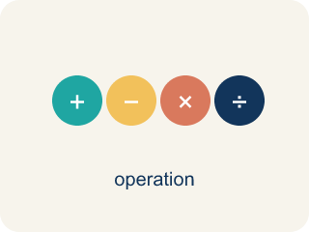
Add and Subtract Decimals (Sumar y restar decimales) — Combine or find the difference between decimals by lining up equal place values.
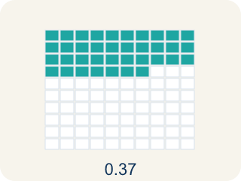
Decimal (Decimal) — A number with a dot, like 0.5, that shows a part less than one.
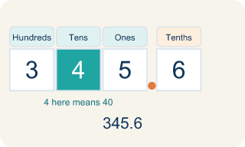
Place value (Valor posicional) — What a digit is worth based on where it sits in a number.
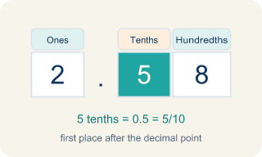
Tenths (Décimas) — The first spot after the decimal point. It shows parts out of 10.
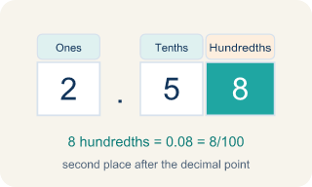
Hundredths (Centésimas) — The second spot after the decimal point. It shows parts out of 100.

Annex zeros (Agregar ceros) — Adding zeros at the end of a decimal so numbers line up evenly.

Practice
Show your work. Use the blank space under each problem.
1. A student buys items costing $4.59, $12.75, and $3.80. What is the total cost?
A. $21.14
B. $20.14
C. $21.04
D. $21.24
______________________________________________________________________
2. Spot the Mistake — Subtracting Without a Placeholder
Step 1 (Problem): Subtract 12.5 − 3.45
Step 2 (Set up): Left 12.5 as one decimal place instead of annexing a zero
Step 3 (Subtract): 12.5 − 3.45 = 9.5
Step 4 (Final answer): 9.5
Which step has the mistake? Explain and fix it:
______________________________________________________________________
______________________________________________________________________
______________________________________________________________________
3. Find Tasha's Mistake
Step 1 (Problem): 15.7 − 8.36
Step 2 (Set up): 15.7 − 8.36
Step 3 (Subtract): 15.7 − 8.36 = 7.41
Step 4 (Final answer): 7.41
Which step has the mistake? Explain and fix it:
______________________________________________________________________
______________________________________________________________________
______________________________________________________________________
4. A runner's lap times are 2.45 minutes, 2.6 minutes, and 2.38 minutes. Her personal record is 7.5 minutes total. Did she beat her record? Show all your work with decimal alignment and explain.
Sentence starter: First I lined up the decimals: 2.45 + 2.60 + 2.38 = ___. Compared to 7.50, the runner ___ beat her record because ___.
______________________________________________________________________
______________________________________________________________________
______________________________________________________________________
______________________________________________________________________

Answer Key (Teacher)
1. A. $21.14
4.59 + 12.75 + 3.80 = 21.14. Line up decimal points and add column by column.
Watch for: A common mistake in Add and Subtract Decimals is lining up the last digits (the right edges) of each number instead of lining up the decimal points — for example, adding 8.3 and 2.45 as if the 3 and the 5 belong in the same column. Before you add or subtract, add zeros so every number has the same number of decimal places (write 8.3 as 8.30), then check that the decimal points sit directly above one another.
2. Spot the Mistake — Subtracting Without a Placeholder
The mistake is in Step 2.
Correct work: The student did not annex a zero, so the hundredths place had nothing to subtract from. Write 12.5 as 12.50, then line up the decimal points: 12.50 − 3.45. Hundredths: 0 − 5 → borrow → 10 − 5 = 5. Tenths: 4 − 4 = 0 (after borrowing). Ones: 2 − 3 → borrow → 12 − 3 = 9. Tens: 0 (after borrowing). The correct difference is 9.05.
Watch for: The Set up step is the problem: 12.5 was left with one decimal place while 3.45 has two, so the hundredths column had nothing to subtract from. Write 12.5 as 12.50 and subtract with the points aligned — 0 − 5 needs a borrow, giving 5 hundredths, then 4 − 4 = 0 tenths and 12 − 3 = 9 ones. The correct difference is 9.05, not 9.5.
3. Find Tasha's Mistake
The mistake is in Step 3.
Correct work: Tasha did not write 15.7 as 15.70 before subtracting. With proper alignment: 15.70 − 8.36 = 7.34. She got 7.41 because she subtracted hundredths incorrectly without the placeholder zero.
Watch for: The Subtract step is where Tasha's answer goes wrong. She treated 15.7 as if it already had a hundredths digit, so her hundredths column was invented rather than computed. Written as 15.70 − 8.36, the hundredths need a borrow: 10 − 6 = 4, then 6 − 3 = 3 tenths and 15 − 8 = 7 ones, so the difference is 7.34, not 7.41.
4. Open response — answers will vary.
Look for key words: decimal, align, annex zero, sum, 7.43, compare, place value.

