Add and Subtract Decimals — Homework
Lesson 2-11 • Standard 6.NOS.3
Name: ______________________ Period: ______ Date: ____________

Today's Goals
Content: I can add and subtract decimals by lining up the place values and the decimal points.
Language: I can explain my steps using the words decimal, place value, tenths, hundredths, and add zeros.

Key Words
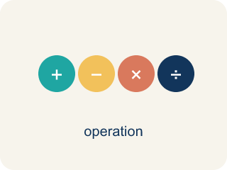
Add and Subtract Decimals (Sumar y restar decimales) — Combine or find the difference between decimals by lining up equal place values.
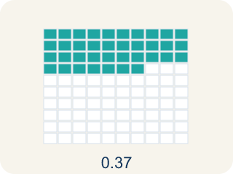
Decimal (Decimal) — A number with a dot, like 0.5, that shows a part less than one.
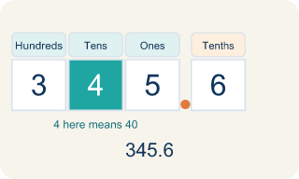
Place value (Valor posicional) — What a digit is worth based on where it sits in a number.
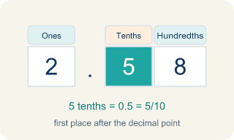
Tenths (Décimas) — The first spot after the decimal point. It shows parts out of 10.
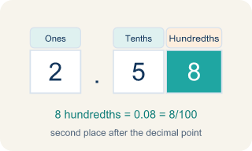
Hundredths (Centésimas) — The second spot after the decimal point. It shows parts out of 100.

Annex zeros (Agregar ceros) — Adding zeros at the end of a decimal so numbers line up evenly.

Practice
Show your work. Use the blank space under each problem.
1. What is 14.6 + 3.85?
A. 18.45
B. 18.35
C. 17.45
D. 18.55
______________________________________________________________________
2. What is 20.3 − 7.48?
A. 12.82
B. 13.82
C. 12.92
D. 12.18
______________________________________________________________________
3. Compute each decimal sum or difference.
Problem | Answer
5.63 + 2.7
12.4 − 8.56
9.08 + 4.925
25.1 − 13.47
7.006 + 3.94
______________________________________________________________________
4. Estimate each sum or difference by rounding to the nearest whole number, then sort: is the result greater than 10 or less than 10?
Groups: Result Greater Than 10 | Result Less Than 10
• 7.8 + 3.45 → __________________
• 6.25 + 5.9 → __________________
• 15.3 − 4.7 → __________________
• 8.4 − 2.15 → __________________
• 5.6 + 3.82 → __________________
• 12.1 − 4.95 → __________________
______________________________________________________________________
5. A student buys items costing $4.59, $12.75, and $3.80. What is the total cost?
A. $21.14
B. $20.14
C. $21.04
D. $21.24
______________________________________________________________________
6. Match each expression to its answer.
Item | Answer choices
____ 8.5 + 3.75 | F. 6.5
____ 15.2 − 6.8 | E. 10
____ 4.06 + 7.94 | D. 6.55
____ 20 − 13.45 | C. 12
____ 9.99 + 0.01 | B. 8.4
____ 11.3 − 4.8 | A. 12.25
______________________________________________________________________
7. Spot the Mistake — Subtracting Without a Placeholder
Step 1 (Problem): Subtract 12.5 − 3.45
Step 2 (Set up): Left 12.5 as one decimal place instead of annexing a zero
Step 3 (Subtract): 12.5 − 3.45 = 9.5
Step 4 (Final answer): 9.5
Which step has the mistake? Explain and fix it:
______________________________________________________________________
______________________________________________________________________
______________________________________________________________________
8. Case File: A crew member's snack receipt shows $27.60 for dried fruit and $15.45 for protein bars. What is the total on the receipt?
A. $43.05
B. $42.05
C. $43.15
D. $42.95
______________________________________________________________________
9. Case File: The oxygen gauge dropped from 9.6 units to a new reading after the crew used 4.75 units. How much oxygen is left?
A. 4.85
B. 5.85
C. 4.95
D. 5.15
______________________________________________________________________
10. Case File: A supply log started the shift with $48.00 in the station snack fund. By the end, $31.27 had been spent. How much is left in the fund?
A. $16.73
B. $17.73
C. $16.83
D. $17.27
______________________________________________________________________

Answer Key (Teacher)
1. A. 18.45
Line up decimals: 14.60 + 3.85. Hundredths: 0 + 5 = 5. Tenths: 6 + 8 = 14, write 4 carry 1. Ones: 4 + 3 + 1 = 8. Tens: 1. Answer: 18.45.
Watch for: A common mistake in Add and Subtract Decimals is lining up the last digits (the right edges) of each number instead of lining up the decimal points — for example, adding 8.3 and 2.45 as if the 3 and the 5 belong in the same column. Before you add or subtract, add zeros so every number has the same number of decimal places (write 8.3 as 8.30), then check that the decimal points sit directly above one another.
2. A. 12.82
Rewrite as 20.30 − 7.48. Annex a zero so both have two decimal places. Work carefully with borrowing: 20.30 − 7.48 = 12.82.
Watch for: A common mistake in Add and Subtract Decimals is lining up the last digits (the right edges) of each number instead of lining up the decimal points — for example, adding 8.3 and 2.45 as if the 3 and the 5 belong in the same column. Before you add or subtract, add zeros so every number has the same number of decimal places (write 8.3 as 8.30), then check that the decimal points sit directly above one another.
3. Compute each decimal sum or difference.
5.63 + 2.7 → 8.33
12.4 − 8.56 → 3.84
9.08 + 4.925 → 14.005
25.1 − 13.47 → 11.63
7.006 + 3.94 → 10.946

4. Correct groups:
7.8 + 3.45 → Result Greater Than 10
6.25 + 5.9 → Result Greater Than 10
15.3 − 4.7 → Result Greater Than 10
8.4 − 2.15 → Result Less Than 10
5.6 + 3.82 → Result Less Than 10
12.1 − 4.95 → Result Less Than 10

5. A. $21.14
4.59 + 12.75 + 3.80 = 21.14. Line up decimal points and add column by column.
Watch for: A common mistake in Add and Subtract Decimals is lining up the last digits (the right edges) of each number instead of lining up the decimal points — for example, adding 8.3 and 2.45 as if the 3 and the 5 belong in the same column. Before you add or subtract, add zeros so every number has the same number of decimal places (write 8.3 as 8.30), then check that the decimal points sit directly above one another.
6. Matches:
8.5 + 3.75 → 12.25
15.2 − 6.8 → 8.4
4.06 + 7.94 → 12
20 − 13.45 → 6.55
9.99 + 0.01 → 10
11.3 − 4.8 → 6.5

7. Spot the Mistake — Subtracting Without a Placeholder
The mistake is in Step 2.
Correct work: The student did not annex a zero, so the hundredths place had nothing to subtract from. Write 12.5 as 12.50, then line up the decimal points: 12.50 − 3.45. Hundredths: 0 − 5 → borrow → 10 − 5 = 5. Tenths: 4 − 4 = 0 (after borrowing). Ones: 2 − 3 → borrow → 12 − 3 = 9. Tens: 0 (after borrowing). The correct difference is 9.05.
Watch for: The Set up step is the problem: 12.5 was left with one decimal place while 3.45 has two, so the hundredths column had nothing to subtract from. Write 12.5 as 12.50 and subtract with the points aligned — 0 − 5 needs a borrow, giving 5 hundredths, then 4 − 4 = 0 tenths and 12 − 3 = 9 ones. The correct difference is 9.05, not 9.5.
8. A. $43.05
Line up the decimal points: 27.60 + 15.45. Hundredths: 0 + 5 = 5. Tenths: 6 + 4 = 10, write 0 carry 1. Ones: 7 + 5 + 1 = 13, write 3 carry 1. Tens: 2 + 1 + 1 = 4. Total: $43.05.
Watch for: A common mistake in Add and Subtract Decimals is lining up the last digits (the right edges) of each number instead of lining up the decimal points — for example, adding 8.3 and 2.45 as if the 3 and the 5 belong in the same column. Before you add or subtract, add zeros so every number has the same number of decimal places (write 8.3 as 8.30), then check that the decimal points sit directly above one another.
9. A. 4.85
Annex a zero so 9.6 becomes 9.60, then subtract: 9.60 − 4.75 = 4.85 units. Borrow in the hundredths and tenths places to subtract correctly.
Watch for: A common mistake in Add and Subtract Decimals is lining up the last digits (the right edges) of each number instead of lining up the decimal points — for example, adding 8.3 and 2.45 as if the 3 and the 5 belong in the same column. Before you add or subtract, add zeros so every number has the same number of decimal places (write 8.3 as 8.30), then check that the decimal points sit directly above one another.
10. A. $16.73
Write 48.00 − 31.27 with points lined up. Hundredths: 0 − 7 → borrow → 10 − 7 = 3. Tenths: 9 − 2 = 7 (after borrowing). Ones: 7 − 1 = 6. Tens: 4 − 3 = 1. Answer: $16.73.
Watch for: A common mistake in Add and Subtract Decimals is lining up the last digits (the right edges) of each number instead of lining up the decimal points — for example, adding 8.3 and 2.45 as if the 3 and the 5 belong in the same column. Before you add or subtract, add zeros so every number has the same number of decimal places (write 8.3 as 8.30), then check that the decimal points sit directly above one another.

