2.12 Small Group · Group 1 — Homework
Lesson 2-12-group1 • Standard 6.NOS.3
Name: ______________________ Period: ______ Date: ____________

Today's Goals
Content: With my small group, I can multiply decimals and place the decimal point correctly in the product — one step at a time, with support.
Language: I can talk through each step out loud using a sentence frame and the lesson's key words.

Key Words
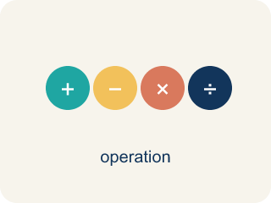
Multiply Decimals (Multiplicar decimales) — Find the product of decimals, then use place value to place the decimal point.
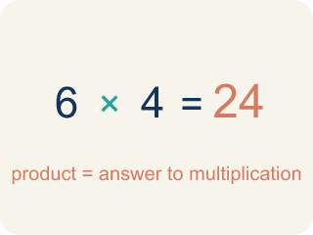
Product (Producto) — The answer when you multiply.
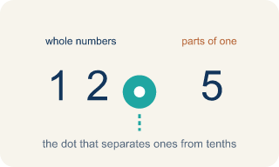
Decimal point (Punto decimal) — The dot that splits the whole number from the part after it.
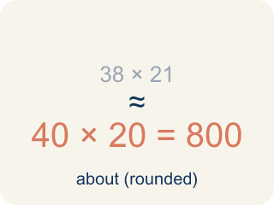
Estimate (Estimar) — A close answer you get by rounding first.
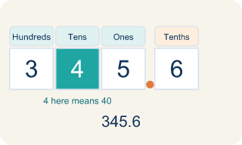
Place value (Valor posicional) — What a digit is worth based on where it sits in a number.
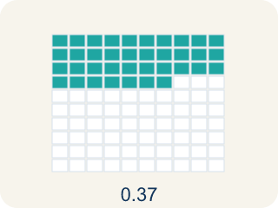
Decimal places (Cifras decimales) — How many digits come after the decimal point.

Practice
Show your work. Use the blank space under each problem.
1. What is 3.4 × 2.6?
A. 8.84
B. 88.4
C. 0.884
D. 8.48
______________________________________________________________________
2. What is 0.7 × 1.5?
A. 1.05
B. 10.5
C. 0.105
D. 1.50
______________________________________________________________________
3. Spot the Common Mistake — Placing the Decimal Point
Step 1 (Problem): 1.5 × 2.4
Step 2 (Multiply as whole numbers): 15 × 24 = 360
Step 3 (Count decimal places): 1.5 has 1 decimal place and 2.4 has 1 decimal place → 2 total
Step 4 (Place the decimal point): Move the point 2 places in 360 to get 0.36
Which step has the mistake? Explain and fix it:
______________________________________________________________________
______________________________________________________________________
______________________________________________________________________
4. A customer orders 3 taco baskets at $4.25 each. What is the total before tax?
A. $12.75
B. $12.15
C. $1.275
D. $127.50
______________________________________________________________________
5. Each lemonade uses 0.6 of a cup of sugar, and sugar costs $0.40 per cup. How much sugar cost is in one lemonade? (0.6 × 0.4)
A. $0.24
B. $2.40
C. $0.024
D. $24.00
______________________________________________________________________
6. The truck sells 2.5 pounds of fries, and each pound earns $1.20 in profit. What is the total profit? (2.5 × 1.2)
A. $3.00
B. $30.00
C. $0.30
D. $3.70
______________________________________________________________________
7. Level 2 Extension — Find the Cashier's Mistake
Step 1 (Order): 2 burrito bowls at $6.45 each: 2 × 6.45
Step 2 (Multiply as whole numbers): 2 × 645 = 1,290
Step 3 (Count decimal places): 6.45 has 2 decimal places → 2 total
Step 4 (Place the decimal point): 129.0, so the total is $129.00
Which step has the mistake? Explain and fix it:
______________________________________________________________________
______________________________________________________________________
______________________________________________________________________
8. Find Kai's Mistake
Step 1 (Problem): 2.4 × 3.15
Step 2 (Multiply as whole numbers): 24 × 315 = 7,560
Step 3 (Count decimal places): 2.4 has 1 decimal place, 3.15 has 2 decimal places → 2 total
Step 4 (Place decimal): 75.60
Which step has the mistake? Explain and fix it:
______________________________________________________________________
______________________________________________________________________
______________________________________________________________________

Answer Key (Teacher)
1. A. 8.84
34 × 26 = 884. There are 2 total decimal places (1 + 1), so place the decimal to get 8.84.
Watch for: A common mistake in Multiply Decimals is counting decimal places from only one factor instead of adding the decimal places from BOTH factors. For example, in 0.4 × 0.06, a student multiplies 4 × 6 = 24, then places the decimal point using just one factor's place count (1 place), writing 0.24 instead of the correct answer: 0.4 has 1 decimal place and 0.06 has 2 decimal places, for a total of 3, so 24 becomes 0.024. Before you submit, count the decimal places in EACH factor separately and add them together — that total is how many decimal places belong in your final answer.
2. A. 1.05
7 × 15 = 105. There are 2 total decimal places (1 + 1), so place the decimal to get 1.05.
Watch for: A common mistake in Multiply Decimals is counting decimal places from only one factor instead of adding the decimal places from BOTH factors. For example, in 0.4 × 0.06, a student multiplies 4 × 6 = 24, then places the decimal point using just one factor's place count (1 place), writing 0.24 instead of the correct answer: 0.4 has 1 decimal place and 0.06 has 2 decimal places, for a total of 3, so 24 becomes 0.024. Before you submit, count the decimal places in EACH factor separately and add them together — that total is how many decimal places belong in your final answer.
3. Spot the Common Mistake — Placing the Decimal Point
The mistake is in Step 4.
Correct work: The whole-number product 15 × 24 = 360 and the count of 2 decimal places are both correct. The mistake is in placing the point: moving it 2 places from the right in 360 gives 3.60, not 0.36. So 1.5 × 2.4 = 3.6. An estimate of 2 × 2 = 4 confirms 3.6 is reasonable, while 0.36 is far too small.
Watch for: The digits 15 × 24 = 360 and the count of 2 decimal places are both correct; only the placement is off. Counting 2 places from the right end of 360 lands the point between the 3 and the 6, giving 3.60 = 3.6. An estimate of 2 × 2 = 4 confirms that 3.6 is the reasonable size and 0.36 is about ten times too small.
4. A. $12.75
3 × 425 = 1,275. The factor $4.25 has 2 decimal places, so 3 × $4.25 = $12.75.
Watch for: A common mistake in Multiply Decimals is counting decimal places from only one factor instead of adding the decimal places from BOTH factors. For example, in 0.4 × 0.06, a student multiplies 4 × 6 = 24, then places the decimal point using just one factor's place count (1 place), writing 0.24 instead of the correct answer: 0.4 has 1 decimal place and 0.06 has 2 decimal places, for a total of 3, so 24 becomes 0.024. Before you submit, count the decimal places in EACH factor separately and add them together — that total is how many decimal places belong in your final answer.
5. A. $0.24
6 × 4 = 24. There are 2 total decimal places (1 + 1), so 0.6 × 0.4 = 0.24, which is $0.24.
Watch for: A common mistake in Multiply Decimals is counting decimal places from only one factor instead of adding the decimal places from BOTH factors. For example, in 0.4 × 0.06, a student multiplies 4 × 6 = 24, then places the decimal point using just one factor's place count (1 place), writing 0.24 instead of the correct answer: 0.4 has 1 decimal place and 0.06 has 2 decimal places, for a total of 3, so 24 becomes 0.024. Before you submit, count the decimal places in EACH factor separately and add them together — that total is how many decimal places belong in your final answer.
6. A. $3.00
25 × 12 = 300. There are 2 total decimal places (1 + 1), so 2.5 × 1.2 = 3.00 = $3.00.
Watch for: A common mistake in Multiply Decimals is counting decimal places from only one factor instead of adding the decimal places from BOTH factors. For example, in 0.4 × 0.06, a student multiplies 4 × 6 = 24, then places the decimal point using just one factor's place count (1 place), writing 0.24 instead of the correct answer: 0.4 has 1 decimal place and 0.06 has 2 decimal places, for a total of 3, so 24 becomes 0.024. Before you submit, count the decimal places in EACH factor separately and add them together — that total is how many decimal places belong in your final answer.
7. Level 2 Extension — Find the Cashier's Mistake
The mistake is in Step 4.
Correct work: The whole-number product 1,290 and the count of 2 decimal places are both correct. The mistake is placing the decimal point: move it 2 places from the right in 1,290 to get 12.90, so the total is $12.90 — not $129.00.
Watch for: The digits 2 × 645 = 1,290 and the count of 2 decimal places are both right, so only the placement is wrong. Counting 2 places from the right end of 1,290 puts the point between the 2 and the 9, giving $12.90. Two bowls at about $6 each should cost around $13, so $129.00 is ten times too big.
8. Find Kai's Mistake
The mistake is in Step 3.
Correct work: Kai wrote a total of 2 decimal places, but the factors have 1 + 2 = 3 decimal places between them, so the product needs 3. Move the decimal 3 places in 7560 to get 7.560 = 7.56.
Watch for: Kai's whole-number product 24 × 315 = 7,560 is fine, but the place count is not: 2.4 has 1 decimal place and 3.15 has 2, so the total is 1 + 2 = 3 places, not 2. Moving the point 3 places from the right in 7560 gives 7.560 = 7.56, which matches the estimate 2 × 3 = 6.

