2.12 Small Group · Group 2 — Homework
Lesson 2-12-group2 • Standard 6.NOS.3
Name: ______________________ Period: ______ Date: ____________

Today's Goals
Content: I can multiply decimals and place the decimal point correctly in the product, explain why the method works, and use it on a problem I have not seen before.
Language: I can justify my answer to a skeptic and connect it to a second strategy or representation.

Key Words
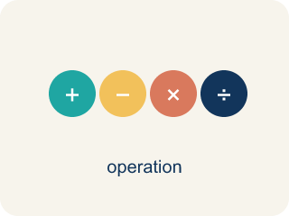
Multiply Decimals (Multiplicar decimales) — Find the product of decimals, then use place value to place the decimal point.
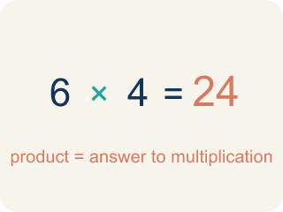
Product (Producto) — The answer when you multiply.
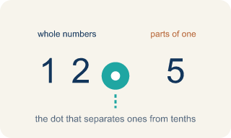
Decimal point (Punto decimal) — The dot that splits the whole number from the part after it.
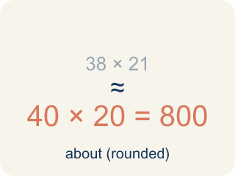
Estimate (Estimar) — A close answer you get by rounding first.
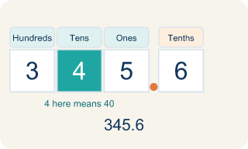
Place value (Valor posicional) — What a digit is worth based on where it sits in a number.
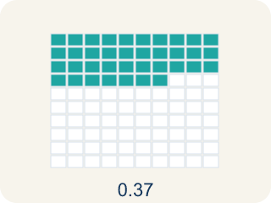
Decimal places (Cifras decimales) — How many digits come after the decimal point.

Practice
Show your work. Use the blank space under each problem.
1. A car travels 55.5 miles per hour for 2.4 hours. How far does it go?
A. 133.2 miles
B. 13.32 miles
C. 1,332 miles
D. 57.9 miles
______________________________________________________________________
2. Spot the Common Mistake — Placing the Decimal Point
Step 1 (Problem): 1.5 × 2.4
Step 2 (Multiply as whole numbers): 15 × 24 = 360
Step 3 (Count decimal places): 1.5 has 1 decimal place and 2.4 has 1 decimal place → 2 total
Step 4 (Place the decimal point): Move the point 2 places in 360 to get 0.36
Which step has the mistake? Explain and fix it:
______________________________________________________________________
______________________________________________________________________
______________________________________________________________________
3. Find Kai's Mistake
Step 1 (Problem): 2.4 × 3.15
Step 2 (Multiply as whole numbers): 24 × 315 = 7,560
Step 3 (Count decimal places): 2.4 has 1 decimal place, 3.15 has 2 decimal places → 2 total
Step 4 (Place decimal): 75.60
Which step has the mistake? Explain and fix it:
______________________________________________________________________
______________________________________________________________________
______________________________________________________________________
4. A driver buys 9.5 gallons of gas at $3.40 per gallon. Show how to find the total cost. Use estimation to check if your answer is reasonable.
Sentence starter: The total cost is $___ because 9.5 × $3.40 = ___. I can estimate: ___ × ___ = ___, which is close to my exact answer, so it is reasonable.
______________________________________________________________________
______________________________________________________________________
______________________________________________________________________
______________________________________________________________________

Answer Key (Teacher)
1. A. 133.2 miles
555 × 24 = 13,320. Total decimal places: 1 + 1 = 2. Answer: 133.20 = 133.2 miles.
Watch for: A common mistake in Multiply Decimals is counting decimal places from only one factor instead of adding the decimal places from BOTH factors. For example, in 0.4 × 0.06, a student multiplies 4 × 6 = 24, then places the decimal point using just one factor's place count (1 place), writing 0.24 instead of the correct answer: 0.4 has 1 decimal place and 0.06 has 2 decimal places, for a total of 3, so 24 becomes 0.024. Before you submit, count the decimal places in EACH factor separately and add them together — that total is how many decimal places belong in your final answer.
2. Spot the Common Mistake — Placing the Decimal Point
The mistake is in Step 4.
Correct work: The whole-number product 15 × 24 = 360 and the count of 2 decimal places are both correct. The mistake is in placing the point: moving it 2 places from the right in 360 gives 3.60, not 0.36. So 1.5 × 2.4 = 3.6. An estimate of 2 × 2 = 4 confirms 3.6 is reasonable, while 0.36 is far too small.
Watch for: The digits 15 × 24 = 360 and the count of 2 decimal places are both correct; only the placement is off. Counting 2 places from the right end of 360 lands the point between the 3 and the 6, giving 3.60 = 3.6. An estimate of 2 × 2 = 4 confirms that 3.6 is the reasonable size and 0.36 is about ten times too small.
3. Find Kai's Mistake
The mistake is in Step 3.
Correct work: Kai wrote a total of 2 decimal places, but the factors have 1 + 2 = 3 decimal places between them, so the product needs 3. Move the decimal 3 places in 7560 to get 7.560 = 7.56.
Watch for: Kai's whole-number product 24 × 315 = 7,560 is fine, but the place count is not: 2.4 has 1 decimal place and 3.15 has 2, so the total is 1 + 2 = 3 places, not 2. Moving the point 3 places from the right in 7560 gives 7.560 = 7.56, which matches the estimate 2 × 3 = 6.
4. Open response — answers will vary.
Look for key words: multiply, decimal, product, 32.30, estimate, round, reasonable.

