Multiply Decimals — Homework
Lesson 2-12 • Standard 6.NOS.3
Name: ______________________ Period: ______ Date: ____________

Today's Goals
Content: I can multiply decimals and place the decimal point correctly in the product.
Language: I can explain my work using the words product, decimal point, estimate, and decimal places.

Key Words
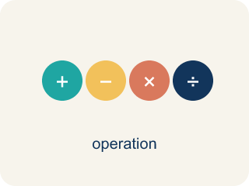
Multiply Decimals (Multiplicar decimales) — Find the product of decimals, then use place value to place the decimal point.
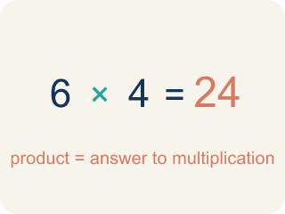
Product (Producto) — The answer when you multiply.
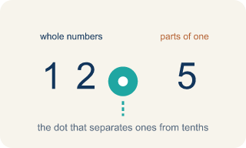
Decimal point (Punto decimal) — The dot that splits the whole number from the part after it.
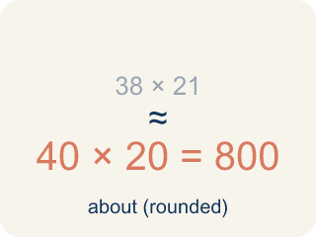
Estimate (Estimar) — A close answer you get by rounding first.
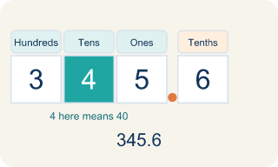
Place value (Valor posicional) — What a digit is worth based on where it sits in a number.
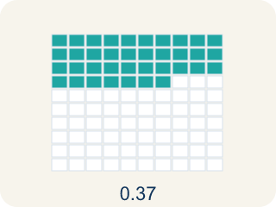
Decimal places (Cifras decimales) — How many digits come after the decimal point.

Practice
Show your work. Use the blank space under each problem.
1. What is 3.4 × 2.6?
A. 8.84
B. 88.4
C. 0.884
D. 8.48
______________________________________________________________________
2. What is 0.7 × 1.5?
A. 1.05
B. 10.5
C. 0.105
D. 1.50
______________________________________________________________________
3. Match each expression to its product.
Item | Answer choices
____ 2.5 × 4 | F. 9
____ 1.2 × 0.3 | E. 0.48
____ 3.6 × 0.5 | D. 12
____ 4.8 × 2.5 | C. 1.8
____ 0.6 × 0.8 | B. 0.36
____ 7.5 × 1.2 | A. 10
______________________________________________________________________
4. Complete each decimal multiplication.
Problem | Product
6.4 × 3.5
0.25 × 0.4
8.3 × 2.1
12.5 × 0.8
______________________________________________________________________
5. A car travels 55.5 miles per hour for 2.4 hours. How far does it go?
A. 133.2 miles
B. 13.32 miles
C. 1,332 miles
D. 57.9 miles
______________________________________________________________________
6. Sort: when you multiply two decimals, is the product GREATER than both factors, or LESS than at least one factor?
Groups: Product Greater Than Both Factors | Product Less Than at Least One Factor
• 3.5 × 4 = 14 (greater than both) → __________________
• 6 × 2.5 = 15 (greater than both) → __________________
• 10 × 1.5 = 15 (greater than both) → __________________
• 0.5 × 8 = 4 (less than 8) → __________________
• 0.3 × 0.4 = 0.12 (less than both) → __________________
• 0.7 × 6 = 4.2 (less than 6) → __________________
______________________________________________________________________
7. Spot the Common Mistake — Placing the Decimal Point
Step 1 (Problem): 1.5 × 2.4
Step 2 (Multiply as whole numbers): 15 × 24 = 360
Step 3 (Count decimal places): 1.5 has 1 decimal place and 2.4 has 1 decimal place → 2 total
Step 4 (Place the decimal point): Move the point 2 places in 360 to get 0.36
Which step has the mistake? Explain and fix it:
______________________________________________________________________
______________________________________________________________________
______________________________________________________________________
8. A customer orders 3 taco baskets at $4.25 each. What is the total before tax?
A. $12.75
B. $12.15
C. $1.275
D. $127.50
______________________________________________________________________
9. Each lemonade uses 0.6 of a cup of sugar, and sugar costs $0.40 per cup. How much sugar cost is in one lemonade? (0.6 × 0.4)
A. $0.24
B. $2.40
C. $0.024
D. $24.00
______________________________________________________________________
10. The truck sells 2.5 pounds of fries, and each pound earns $1.20 in profit. What is the total profit? (2.5 × 1.2)
A. $3.00
B. $30.00
C. $0.30
D. $3.70
______________________________________________________________________

Answer Key (Teacher)
1. A. 8.84
34 × 26 = 884. There are 2 total decimal places (1 + 1), so place the decimal to get 8.84.
Watch for: A common mistake in Multiply Decimals is counting decimal places from only one factor instead of adding the decimal places from BOTH factors. For example, in 0.4 × 0.06, a student multiplies 4 × 6 = 24, then places the decimal point using just one factor's place count (1 place), writing 0.24 instead of the correct answer: 0.4 has 1 decimal place and 0.06 has 2 decimal places, for a total of 3, so 24 becomes 0.024. Before you submit, count the decimal places in EACH factor separately and add them together — that total is how many decimal places belong in your final answer.
2. A. 1.05
7 × 15 = 105. There are 2 total decimal places (1 + 1), so place the decimal to get 1.05.
Watch for: A common mistake in Multiply Decimals is counting decimal places from only one factor instead of adding the decimal places from BOTH factors. For example, in 0.4 × 0.06, a student multiplies 4 × 6 = 24, then places the decimal point using just one factor's place count (1 place), writing 0.24 instead of the correct answer: 0.4 has 1 decimal place and 0.06 has 2 decimal places, for a total of 3, so 24 becomes 0.024. Before you submit, count the decimal places in EACH factor separately and add them together — that total is how many decimal places belong in your final answer.
3. Matches:
2.5 × 4 → 10
1.2 × 0.3 → 0.36
3.6 × 0.5 → 1.8
4.8 × 2.5 → 12
0.6 × 0.8 → 0.48
7.5 × 1.2 → 9

4. Complete each decimal multiplication.
6.4 × 3.5 → 22.4
0.25 × 0.4 → 0.1
8.3 × 2.1 → 17.43
12.5 × 0.8 → 10

5. A. 133.2 miles
555 × 24 = 13,320. Total decimal places: 1 + 1 = 2. Answer: 133.20 = 133.2 miles.
Watch for: A common mistake in Multiply Decimals is counting decimal places from only one factor instead of adding the decimal places from BOTH factors. For example, in 0.4 × 0.06, a student multiplies 4 × 6 = 24, then places the decimal point using just one factor's place count (1 place), writing 0.24 instead of the correct answer: 0.4 has 1 decimal place and 0.06 has 2 decimal places, for a total of 3, so 24 becomes 0.024. Before you submit, count the decimal places in EACH factor separately and add them together — that total is how many decimal places belong in your final answer.
6. Correct groups:
3.5 × 4 = 14 (greater than both) → Product Greater Than Both Factors
6 × 2.5 = 15 (greater than both) → Product Greater Than Both Factors
10 × 1.5 = 15 (greater than both) → Product Greater Than Both Factors
0.5 × 8 = 4 (less than 8) → Product Less Than at Least One Factor
0.3 × 0.4 = 0.12 (less than both) → Product Less Than at Least One Factor
0.7 × 6 = 4.2 (less than 6) → Product Less Than at Least One Factor

7. Spot the Common Mistake — Placing the Decimal Point
The mistake is in Step 4.
Correct work: The whole-number product 15 × 24 = 360 and the count of 2 decimal places are both correct. The mistake is in placing the point: moving it 2 places from the right in 360 gives 3.60, not 0.36. So 1.5 × 2.4 = 3.6. An estimate of 2 × 2 = 4 confirms 3.6 is reasonable, while 0.36 is far too small.
Watch for: The digits 15 × 24 = 360 and the count of 2 decimal places are both correct; only the placement is off. Counting 2 places from the right end of 360 lands the point between the 3 and the 6, giving 3.60 = 3.6. An estimate of 2 × 2 = 4 confirms that 3.6 is the reasonable size and 0.36 is about ten times too small.
8. A. $12.75
3 × 425 = 1,275. The factor $4.25 has 2 decimal places, so 3 × $4.25 = $12.75.
Watch for: A common mistake in Multiply Decimals is counting decimal places from only one factor instead of adding the decimal places from BOTH factors. For example, in 0.4 × 0.06, a student multiplies 4 × 6 = 24, then places the decimal point using just one factor's place count (1 place), writing 0.24 instead of the correct answer: 0.4 has 1 decimal place and 0.06 has 2 decimal places, for a total of 3, so 24 becomes 0.024. Before you submit, count the decimal places in EACH factor separately and add them together — that total is how many decimal places belong in your final answer.
9. A. $0.24
6 × 4 = 24. There are 2 total decimal places (1 + 1), so 0.6 × 0.4 = 0.24, which is $0.24.
Watch for: A common mistake in Multiply Decimals is counting decimal places from only one factor instead of adding the decimal places from BOTH factors. For example, in 0.4 × 0.06, a student multiplies 4 × 6 = 24, then places the decimal point using just one factor's place count (1 place), writing 0.24 instead of the correct answer: 0.4 has 1 decimal place and 0.06 has 2 decimal places, for a total of 3, so 24 becomes 0.024. Before you submit, count the decimal places in EACH factor separately and add them together — that total is how many decimal places belong in your final answer.
10. A. $3.00
25 × 12 = 300. There are 2 total decimal places (1 + 1), so 2.5 × 1.2 = 3.00 = $3.00.
Watch for: A common mistake in Multiply Decimals is counting decimal places from only one factor instead of adding the decimal places from BOTH factors. For example, in 0.4 × 0.06, a student multiplies 4 × 6 = 24, then places the decimal point using just one factor's place count (1 place), writing 0.24 instead of the correct answer: 0.4 has 1 decimal place and 0.06 has 2 decimal places, for a total of 3, so 24 becomes 0.024. Before you submit, count the decimal places in EACH factor separately and add them together — that total is how many decimal places belong in your final answer.

