2.2 Small Group · Group 2 — Homework
Lesson 2-2-group2 • Standard 6.DS.5
Name: ______________________ Period: ______ Date: ____________

Today's Goals
Content: I can make and read a histogram to display data in intervals, explain why the method works, and use it on a problem I have not seen before.
Language: I can justify my answer to a skeptic and connect it to a second strategy or representation.

Key Words
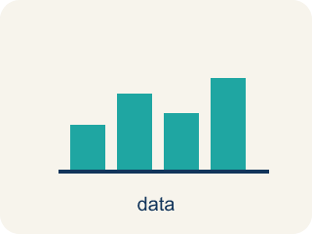
Display Data with Histograms (Representar datos con histogramas) — Group numerical data into intervals and show each interval's frequency with a bar.
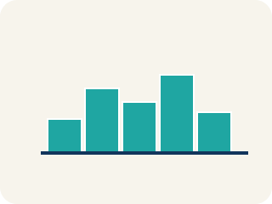
Histogram (Histograma) — A bar graph that groups data into equal ranges. The bars touch.
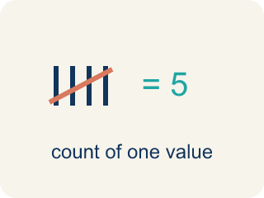
Frequency (Frecuencia) — How many times a value shows up.

Interval (Intervalo) — A range of numbers used to group data.
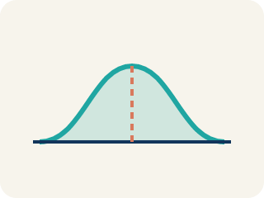
Distribution (Distribución) — How the data is spread out.
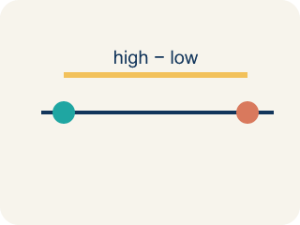
Variability (Variabilidad) — How spread out the numbers are.

Practice
Show your work. Use the blank space under each problem.
1. A histogram of test scores shows: 50–59: 2, 60–69: 5, 70–79: 10, 80–89: 8, 90–99: 3. Which interval has the most students?
A. 90–99 with 3 students
B. 70–79 with 10 students
C. 80–89 with 8 students
D. 60–69 with 5 students
______________________________________________________________________
2. A histogram of goals-per-game shows: 0–1: 9 players, 2–3: 6, 4–5: 3, 6–7: 1. What shape is this distribution?
A. Perfectly symmetric
B. Flat / uniform (all bars equal)
C. Skewed right (most players low, tail toward high values)
D. Skewed left (most players high, tail toward low values)
______________________________________________________________________
3. Spot the Interval Mistake
Step 1 (Data (assists per game)): 1, 4, 6, 9, 12, 15, 18
Step 2 (Intervals the student chose): 0–5, 6–10, 12–18
Step 3 (Frequency count): 0–5: 2, 6–10: 2, 12–18: 3
Step 4 (Conclusion): The student drew three bars and said the histogram was complete.
Which step has the mistake? Explain and fix it:
______________________________________________________________________
______________________________________________________________________
______________________________________________________________________
4. Find the Histogram Error
Step 1 (Data): Test scores: 55, 62, 68, 70, 72, 75, 78, 80, 82, 85, 88, 90, 95
Step 2 (Intervals): 50–59, 60–69, 70–79, 80–89, 90–100
Step 3 (Frequency table): 50–59: 1, 60–69: 2, 70–79: 3, 80–89: 4, 90–100: 2
Step 4 (Conclusion): The histogram is symmetric because the bars go 1, 2, 3, 4, 2.
Which step has the mistake? Explain and fix it:
______________________________________________________________________
______________________________________________________________________
______________________________________________________________________

Answer Key (Teacher)
1. B. 70–79 with 10 students
The 70–79 interval has the highest frequency of 10 students.
Watch for: A common mistake in Display Data: Histograms is counting a boundary value in two intervals at once — for example, putting the value 10 in both the '0–9' bin and the '10–19' bin. Each data value belongs to exactly ONE interval. Before you submit, add up all your frequencies and check that the total matches the number of data values you started with.
2. C. Skewed right (most players low, tail toward high values)
The tallest bars are at the low end (0–1) and the bars shrink as goals increase — the tail points right, so it is skewed right.
Watch for: A common mistake in Display Data: Histograms is counting a boundary value in two intervals at once — for example, putting the value 10 in both the '0–9' bin and the '10–19' bin. Each data value belongs to exactly ONE interval. Before you submit, add up all your frequencies and check that the total matches the number of data values you started with.
3. Spot the Interval Mistake
The mistake is in Step 2.
Correct work: The intervals are not equal in width and they leave a gap. 0–5 and 6–10 each cover 6 values, but 12–18 covers 7 values and the value 11 has no bin at all. Histogram intervals must be equal-width and cover every value with no gaps. Using equal intervals of 5 (0–4, 5–9, 10–14, 15–19) gives frequencies 0–4: 2 (the 1 and 4), 5–9: 2 (the 6 and 9), 10–14: 1 (the 12), and 15–19: 2 (the 15 and 18), totaling 7.
Watch for: The problem starts at the interval-choosing step: 0–5 and 6–10 are 6 wide, 12–18 is 7 wide, and the value 11 has nowhere to go. Equal-width bins of 5 fix both problems — 0–4: 2, 5–9: 2, 10–14: 1, 15–19: 2, totaling all 7 assist values.
4. Find the Histogram Error
The mistake is in Step 4.
Correct work: The frequencies are correct (1, 2, 3, 4, 2), but this is NOT symmetric. In a symmetric histogram, the bars rise and fall evenly from the center. Here the bars increase from left to right and only drop at the end — the data is skewed LEFT (most scores are on the higher end).
Watch for: The frequency table is right; the Conclusion step is what fails. Symmetric means the left half mirrors the right half, but 1, 2, 3, 4, 2 climbs steadily and peaks at 80–89 near the right end, so the data is skewed left with most scores on the high side.

