2.3 Small Group · Group 1 — Homework
Lesson 2-3-group1 • Standard 6.DS.4
Name: ______________________ Period: ______ Date: ____________

Today's Goals
Content: With my small group, I can find the mean, median, and mode of a data set — one step at a time, with support.
Language: I can talk through each step out loud using a sentence frame and the lesson's key words.

Key Words
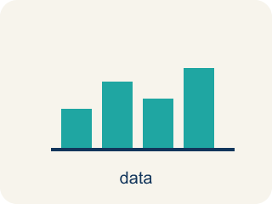
Mean, Median, and Mode (Media, mediana y moda) — Measures that describe a data set's center: average, middle value, and most frequent value.
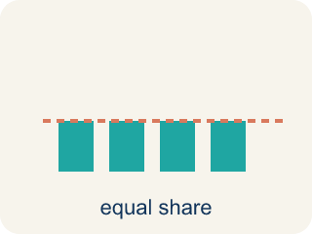
Mean (Media) — The average. Add all the numbers, then divide by how many there are.
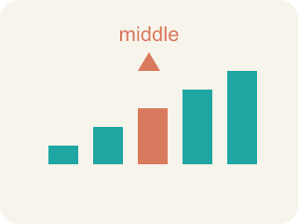
Median (Mediana) — The middle number when you put them in order.
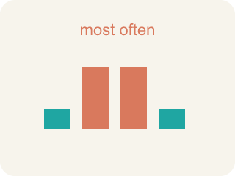
Mode (Moda) — The number that shows up most often.
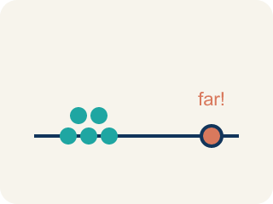
Outlier (Valor atípico) — A number that is much bigger or smaller than the rest.
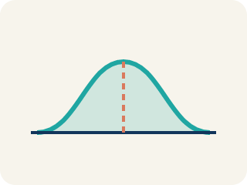
Data distribution (Distribución de datos) — How the data looks: where it sits and how spread out it is.
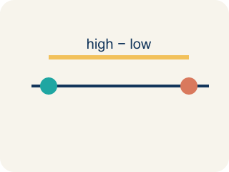
Variability (Variabilidad) — How spread out the numbers are.

Practice
Show your work. Use the blank space under each problem.
1. Find the mean of: 10, 14, 8, 12, 16
A. 12
B. 14
C. 10
D. 60
______________________________________________________________________
2. Find the median of: 3, 7, 2, 9, 5
A. 5
B. 3
C. 7
D. 5.2
______________________________________________________________________
3. The Even-Count Median Mistake
Step 1 (Data set): Points per game, in order: 3, 8, 10, 14, 16, 20 (6 values)
Step 2 (Goal): Find the MEDIAN number of points.
Step 3 (Pick the middle): With 6 values the student grabs a single middle number and says median = 10.
Step 4 (Answer): Median = 10
Which step has the mistake? Explain and fix it:
______________________________________________________________________
______________________________________________________________________
______________________________________________________________________
4. A player scored 4, 8, 6, 10, and 2 points across five quarters. What is the MEAN number of points?
A. 6
B. 8
C. 30
D. 10
______________________________________________________________________
5. A goalie made 3, 7, 9, 2, and 5 saves in five games. What is the MEDIAN number of saves?
A. 5
B. 9
C. 7
D. 2
______________________________________________________________________
6. A team scored 4, 4, 7, and 9 goals in four matches. What is the MODE?
A. 4
B. 7
C. 9
D. 6
______________________________________________________________________
7. One game was a 55-point outlier. Which measure of center best shows a TYPICAL game?
A. The median, because the outlier barely moves the middle value
B. The mean, because it uses every score
C. The mode, because it is always the typical value
D. The range, because it shows the spread
______________________________________________________________________
8. Level 2 Extension — The Median Mistake
Step 1 (Data set): Points per game: 9, 4, 7, 2, 6
Step 2 (Goal): Find the median number of points.
Step 3 (Pick the middle): The number in the middle of the list is 7, so the median = 7.
Step 4 (Answer): Median = 7
Which step has the mistake? Explain and fix it:
______________________________________________________________________
______________________________________________________________________
______________________________________________________________________

Answer Key (Teacher)
1. A. 12
Sum = 10 + 14 + 8 + 12 + 16 = 60. Mean = 60 ÷ 5 = 12.
Watch for: A common mistake in Mean, Median, and Mode is finding the median without ordering the data first — students pick the middle number straight from the list as given (for 9, 4, 7, 2, 6 they say the median is 7, the middle position in that original order) instead of sorting least to greatest (2, 4, 6, 7, 9) and finding the true middle value, 6. Before finalizing a median, always reorder the data smallest to largest, then count to the middle position — and if there is an even number of values, average the two middle numbers.
2. A. 5
Ordered: 2, 3, 5, 7, 9. The middle value is 5.
Watch for: A common mistake in Mean, Median, and Mode is finding the median without ordering the data first — students pick the middle number straight from the list as given (for 9, 4, 7, 2, 6 they say the median is 7, the middle position in that original order) instead of sorting least to greatest (2, 4, 6, 7, 9) and finding the true middle value, 6. Before finalizing a median, always reorder the data smallest to largest, then count to the middle position — and if there is an even number of values, average the two middle numbers.
3. The Even-Count Median Mistake
The mistake is in Step 3.
Correct work: When a data set has an EVEN number of values there is no single middle number. You must average the TWO middle values. Here the 3rd and 4th values are 10 and 14, so the median = (10 + 14) ÷ 2 = 12, not 10.
Watch for: With 6 values there is no single number sitting in the middle — positions 3 and 4 tie for the center. The 3rd and 4th values are 10 and 14, so the median is their average, (10 + 14) ÷ 2 = 12, not just the lower one.
4. A. 6
Add the points: 4 + 8 + 6 + 10 + 2 = 30. Divide by 5 quarters: 30 ÷ 5 = 6.
Watch for: A common mistake in Mean, Median, and Mode is finding the median without ordering the data first — students pick the middle number straight from the list as given (for 9, 4, 7, 2, 6 they say the median is 7, the middle position in that original order) instead of sorting least to greatest (2, 4, 6, 7, 9) and finding the true middle value, 6. Before finalizing a median, always reorder the data smallest to largest, then count to the middle position — and if there is an even number of values, average the two middle numbers.
5. A. 5
Order the saves first: 2, 3, 5, 7, 9. The middle (3rd) value is 5, so the median is 5.
Watch for: A common mistake in Mean, Median, and Mode is finding the median without ordering the data first — students pick the middle number straight from the list as given (for 9, 4, 7, 2, 6 they say the median is 7, the middle position in that original order) instead of sorting least to greatest (2, 4, 6, 7, 9) and finding the true middle value, 6. Before finalizing a median, always reorder the data smallest to largest, then count to the middle position — and if there is an even number of values, average the two middle numbers.
6. A. 4
The mode is the value that appears most often. 4 shows up twice; every other value appears once. So the mode is 4.
Watch for: A common mistake in Mean, Median, and Mode is finding the median without ordering the data first — students pick the middle number straight from the list as given (for 9, 4, 7, 2, 6 they say the median is 7, the middle position in that original order) instead of sorting least to greatest (2, 4, 6, 7, 9) and finding the true middle value, 6. Before finalizing a median, always reorder the data smallest to largest, then count to the middle position — and if there is an even number of values, average the two middle numbers.
7. A. The median, because the outlier barely moves the middle value
A high outlier pulls the mean upward, making it larger than most games. The median is the middle of the ordered data, so one unusual game barely changes it — it best describes a typical game.
Watch for: A common mistake in Mean, Median, and Mode is finding the median without ordering the data first — students pick the middle number straight from the list as given (for 9, 4, 7, 2, 6 they say the median is 7, the middle position in that original order) instead of sorting least to greatest (2, 4, 6, 7, 9) and finding the true middle value, 6. Before finalizing a median, always reorder the data smallest to largest, then count to the middle position — and if there is an even number of values, average the two middle numbers.
8. Level 2 Extension — The Median Mistake
The mistake is in Step 3.
Correct work: You must ORDER the data before finding the middle. Ordered least to greatest: 2, 4, 6, 7, 9. The true middle (3rd) value is 6, so the median = 6, not 7.
Watch for: The 7 sits in the middle of the list as written, but the list was never sorted. Ordered least to greatest the data is 2, 4, 6, 7, 9, so the true third value — and the median — is 6.

