2.3 Small Group · Group 2 — Homework
Lesson 2-3-group2 • Standard 6.DS.4
Name: ______________________ Period: ______ Date: ____________

Today's Goals
Content: I can find the mean, median, and mode of a data set, explain why the method works, and use it on a problem I have not seen before.
Language: I can justify my answer to a skeptic and connect it to a second strategy or representation.

Key Words
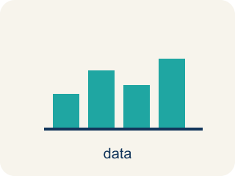
Mean, Median, and Mode (Media, mediana y moda) — Measures that describe a data set's center: average, middle value, and most frequent value.
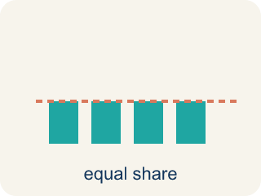
Mean (Media) — The average. Add all the numbers, then divide by how many there are.
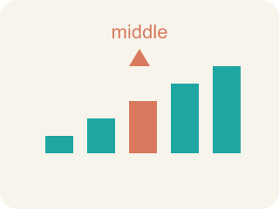
Median (Mediana) — The middle number when you put them in order.
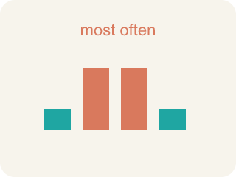
Mode (Moda) — The number that shows up most often.
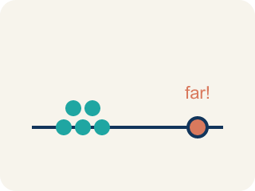
Outlier (Valor atípico) — A number that is much bigger or smaller than the rest.
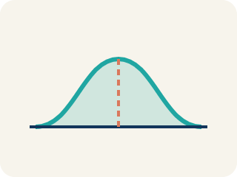
Data distribution (Distribución de datos) — How the data looks: where it sits and how spread out it is.
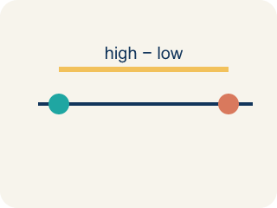
Variability (Variabilidad) — How spread out the numbers are.

Practice
Show your work. Use the blank space under each problem.
1. Data set: 4, 6, 6, 8, 10, 12. What is the median?
A. 7
B. 6
C. 8
D. 7.67
______________________________________________________________________
2. The Even-Count Median Mistake
Step 1 (Data set): Points per game, in order: 3, 8, 10, 14, 16, 20 (6 values)
Step 2 (Goal): Find the MEDIAN number of points.
Step 3 (Pick the middle): With 6 values the student grabs a single middle number and says median = 10.
Step 4 (Answer): Median = 10
Which step has the mistake? Explain and fix it:
______________________________________________________________________
______________________________________________________________________
______________________________________________________________________
3. Find the Stats Error
Step 1 (Data set): 12, 15, 18, 15, 20
Step 2 (Find mean): Sum = 80, Count = 5, Mean = 80 ÷ 5 = 16
Step 3 (Find median): Ordered: 12, 15, 15, 18, 20 → Median = 15
Step 4 (Find mode): Mode = 18 (the biggest number)
Which step has the mistake? Explain and fix it:
______________________________________________________________________
______________________________________________________________________
______________________________________________________________________
4. A basketball player scored 15, 18, 16, 42, and 14 points in 5 games. Find the mean and median. Which better represents the player's typical game? Explain how the outlier affects each measure.
Sentence starter: Mean = ___. Median = ___. The ___ better represents a typical game because the outlier (___) pulls the ___ toward it, making it ___ than most scores. The median is not affected because ___.
______________________________________________________________________
______________________________________________________________________
______________________________________________________________________
______________________________________________________________________

Answer Key (Teacher)
1. A. 7
With 6 values, the median is the average of the 3rd and 4th values: (6 + 8) ÷ 2 = 7.
Watch for: A common mistake in Mean, Median, and Mode is finding the median without ordering the data first — students pick the middle number straight from the list as given (for 9, 4, 7, 2, 6 they say the median is 7, the middle position in that original order) instead of sorting least to greatest (2, 4, 6, 7, 9) and finding the true middle value, 6. Before finalizing a median, always reorder the data smallest to largest, then count to the middle position — and if there is an even number of values, average the two middle numbers.
2. The Even-Count Median Mistake
The mistake is in Step 3.
Correct work: When a data set has an EVEN number of values there is no single middle number. You must average the TWO middle values. Here the 3rd and 4th values are 10 and 14, so the median = (10 + 14) ÷ 2 = 12, not 10.
Watch for: With 6 values there is no single number sitting in the middle — positions 3 and 4 tie for the center. The 3rd and 4th values are 10 and 14, so the median is their average, (10 + 14) ÷ 2 = 12, not just the lower one.
3. Find the Stats Error
The mistake is in Step 4.
Correct work: Mode = 15 (appears twice, more than any other value). Mode is the most frequent value, not the largest.
Watch for: The mean and median steps are both correct; the mode step picks 18 because it is the biggest number. Mode means most often, not most, and in 12, 15, 15, 18, 20 only 15 repeats, so the mode is 15.
4. Open response — answers will vary.
Look for key words: mean, median, outlier, 42, pulls, higher, middle value, typical.

