2.4 Small Group · Group 1 — Homework
Lesson 2-4-group1 • Standard 6.DS.5
Name: ______________________ Period: ______ Date: ____________

Today's Goals
Content: With my small group, I can make and read a box plot to summarize a data set — one step at a time, with support.
Language: I can talk through each step out loud using a sentence frame and the lesson's key words.

Key Words
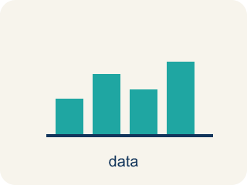
Display Data with Box Plots (Representar datos con diagramas de caja) — Show a data set's five-number summary in a box-and-whisker display.
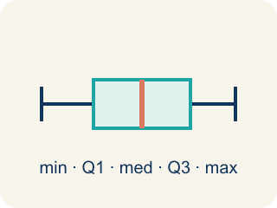
Box Plot (Diagrama de caja) — A graph that shows how data is spread using five key numbers.
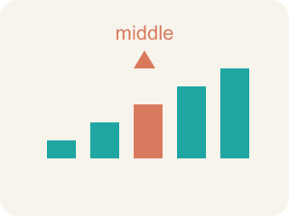
Median (Mediana) — The middle number when you put them in order.
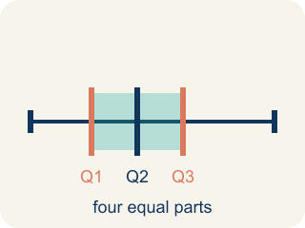
Quartile (Cuartil) — Numbers that split the data into four equal parts.
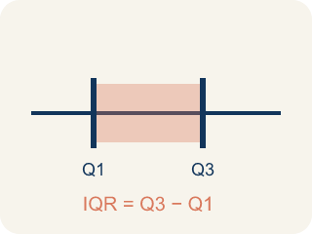
Interquartile Range (Rango intercuartílico) — The spread of the middle half of the data (Q3 − Q1).
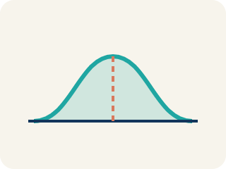
Data distribution (Distribución de datos) — How the data looks: where it sits and how spread out it is.
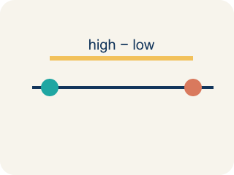
Variability (Variabilidad) — How spread out the numbers are.

Practice
Show your work. Use the blank space under each problem.
1. A box plot shows: Min = 10, Q1 = 15, Median = 20, Q3 = 28, Max = 35. What is the interquartile range (IQR)?
A. 13
B. 25
C. 10
D. 20
______________________________________________________________________
2. On a box plot, what does the line inside the box represent?
A. The median
B. The mean
C. The mode
D. The range
______________________________________________________________________
3. The Quartile-Is-One-Value Mistake
Step 1 (Data (ordered)): Eagles' game scores: 4, 8, 10, 14, 18, 22, 26, 30 (8 values)
Step 2 (Median): With 8 values, Median = (14 + 18) ÷ 2 = 16 ✓
Step 3 (Q1): Lower half = 4, 8, 10, 14 → Q1 = 10
Step 4 (Q3): Upper half = 18, 22, 26, 30 → Q3 = (22 + 26) ÷ 2 = 24
Which step has the mistake? Explain and fix it:
______________________________________________________________________
______________________________________________________________________
______________________________________________________________________
4. The Hawks' points per quarter are 2, 4, 5, 7, 8, 10, 12. Resting on the scoreboard, what are the minimum, median, and maximum?
A. Minimum 2, median 7, maximum 12
B. Minimum 2, median 5, maximum 12
C. Minimum 0, median 7, maximum 12
D. Minimum 2, median 8, maximum 10
______________________________________________________________________
5. The Comets scored 6, 10, 14, 18, 22, 26, 30, 34 across 8 games. After ordering, what are Q1 and Q3?
A. Q1 = 12, Q3 = 28
B. Q1 = 10, Q3 = 30
C. Q1 = 14, Q3 = 26
D. Q1 = 20, Q3 = 34
______________________________________________________________________
6. A box plot for the Rockets shows Min = 8, Q1 = 15, Median = 22, Q3 = 30, Max = 38. The middle 50% of their scores falls between which two values?
A. Between 15 and 30
B. Between 8 and 38
C. Between 8 and 22
D. Between 22 and 38
______________________________________________________________________
7. Level 2 Extension — The Skipped Ordering Mistake
Step 1 (Data (as recorded)): Falcons' scores: 17, 5, 21, 9, 29, 13, 25
Step 2 (Minimum and maximum): Min = 5, Max = 29 ✓
Step 3 (Median): The middle value of the list is 9, so Median = 9
Step 4 (Q1 and Q3): Lower half = 17, 5, 21 → Q1 = 5. Upper half = 13, 25 → Q3 = 25
Which step has the mistake? Explain and fix it:
______________________________________________________________________
______________________________________________________________________
______________________________________________________________________
8. Find the Box Plot Error
Step 1 (Data): 3, 7, 9, 12, 15, 18, 21
Step 2 (Min and Max): Min = 3, Max = 21
Step 3 (Median): Middle value = 12 ✓
Step 4 (Q1 and Q3): Q1 = 9, Q3 = 18
Which step has the mistake? Explain and fix it:
______________________________________________________________________
______________________________________________________________________
______________________________________________________________________

Answer Key (Teacher)
1. A. 13
IQR = Q3 − Q1 = 28 − 15 = 13.
Watch for: A common mistake in Display Data: Box Plots is treating a quartile as just one data point instead of the median of a half — for the lower half 4, 8, 10, 14, some students pick 10 (the last value) as Q1 instead of finding the median of that half: Q1 = (8 + 10) ÷ 2 = 9. A second common slip is finding IQR by adding the quartiles instead of subtracting, writing IQR = Q3 + Q1 (like 30 + 18 = 48) instead of IQR = Q3 − Q1 (30 − 18 = 12) — always order the data first, then subtract Q1 from Q3 to find the spread of the middle 50%.
2. A. The median
The line inside the box of a box plot always represents the median.
Watch for: A common mistake in Display Data: Box Plots is treating a quartile as just one data point instead of the median of a half — for the lower half 4, 8, 10, 14, some students pick 10 (the last value) as Q1 instead of finding the median of that half: Q1 = (8 + 10) ÷ 2 = 9. A second common slip is finding IQR by adding the quartiles instead of subtracting, writing IQR = Q3 + Q1 (like 30 + 18 = 48) instead of IQR = Q3 − Q1 (30 − 18 = 12) — always order the data first, then subtract Q1 from Q3 to find the spread of the middle 50%.
3. The Quartile-Is-One-Value Mistake
The mistake is in Step 3.
Correct work: Q1 is the MEDIAN of the lower half, not just one of its values. The lower half is 4, 8, 10, 14 — an even-sized group — so Q1 = (8 + 10) ÷ 2 = 9, not 10. The student grabbed a single value instead of averaging the two middle numbers of the half.
Watch for: The Q1 step grabbed a single number out of the lower half instead of finding that half's median. The lower half 4, 8, 10, 14 has an even count, so Q1 averages its two middle values: (8 + 10) ÷ 2 = 9 — the same averaging move already used correctly for the median and for Q3.
4. A. Minimum 2, median 7, maximum 12
The data is already in order. The smallest value is 2 and the largest is 12. There are 7 values, so the median is the 4th value, which is 7.
Watch for: A common mistake in Display Data: Box Plots is treating a quartile as just one data point instead of the median of a half — for the lower half 4, 8, 10, 14, some students pick 10 (the last value) as Q1 instead of finding the median of that half: Q1 = (8 + 10) ÷ 2 = 9. A second common slip is finding IQR by adding the quartiles instead of subtracting, writing IQR = Q3 + Q1 (like 30 + 18 = 48) instead of IQR = Q3 − Q1 (30 − 18 = 12) — always order the data first, then subtract Q1 from Q3 to find the spread of the middle 50%.
5. A. Q1 = 12, Q3 = 28
With 8 values the median splits the data into a lower half (6, 10, 14, 18) and an upper half (22, 26, 30, 34). Q1 is the median of the lower half: (10 + 14) ÷ 2 = 12. Q3 is the median of the upper half: (26 + 30) ÷ 2 = 28.
Watch for: A common mistake in Display Data: Box Plots is treating a quartile as just one data point instead of the median of a half — for the lower half 4, 8, 10, 14, some students pick 10 (the last value) as Q1 instead of finding the median of that half: Q1 = (8 + 10) ÷ 2 = 9. A second common slip is finding IQR by adding the quartiles instead of subtracting, writing IQR = Q3 + Q1 (like 30 + 18 = 48) instead of IQR = Q3 − Q1 (30 − 18 = 12) — always order the data first, then subtract Q1 from Q3 to find the spread of the middle 50%.
6. A. Between 15 and 30
The box of a box plot stretches from Q1 to Q3, and that box always holds the middle 50% of the data. Here the box goes from Q1 = 15 to Q3 = 30.
Watch for: A common mistake in Display Data: Box Plots is treating a quartile as just one data point instead of the median of a half — for the lower half 4, 8, 10, 14, some students pick 10 (the last value) as Q1 instead of finding the median of that half: Q1 = (8 + 10) ÷ 2 = 9. A second common slip is finding IQR by adding the quartiles instead of subtracting, writing IQR = Q3 + Q1 (like 30 + 18 = 48) instead of IQR = Q3 − Q1 (30 − 18 = 12) — always order the data first, then subtract Q1 from Q3 to find the spread of the middle 50%.
7. Level 2 Extension — The Skipped Ordering Mistake
The mistake is in Step 3.
Correct work: The data must be ordered from least to greatest FIRST: 5, 9, 13, 17, 21, 25, 29. There are 7 values, so the median is the 4th value, which is 17 (not 9). The lower half is 5, 9, 13, so Q1 = 9, and the upper half is 21, 25, 29, so Q3 = 25. The student found the 'middle of the list' without ordering the data first, which gave the wrong median and quartiles.
Watch for: The median step used whichever number happened to sit in the middle of the unsorted list. Once the scores are ordered as 5, 9, 13, 17, 21, 25, 29, the 4th value is 17, so the median is 17, the lower half 5, 9, 13 gives Q1 = 9, and the upper half 21, 25, 29 gives Q3 = 25.
8. Find the Box Plot Error
The mistake is in Step 4.
Correct work: Q1 is the median of the lower half (3, 7, 9), which is 7. Q3 is the median of the upper half (15, 18, 21), which is 18. The student used the wrong value for Q1 — they picked 9 (the last value in the lower half) instead of the median of that half.
Watch for: The quartile step used 9, the last number in the lower half, instead of the middle of that half. The lower half is 3, 7, 9, so its median — and therefore Q1 — is 7. Q3 = 18 was already right, since 18 sits in the middle of 15, 18, 21.

