2.4 Small Group · Group 2 — Homework
Lesson 2-4-group2 • Standard 6.DS.5
Name: ______________________ Period: ______ Date: ____________

Today's Goals
Content: I can make and read a box plot to summarize a data set, explain what each part stands for, and build one for a situation I have not seen before.
Language: I can justify my answer to a skeptic and connect it to a second strategy or representation.

Key Words
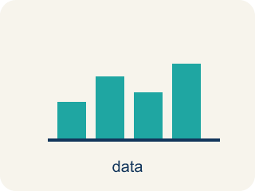
Display Data with Box Plots (Representar datos con diagramas de caja) — Show a data set's five-number summary in a box-and-whisker display.
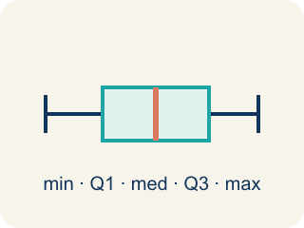
Box Plot (Diagrama de caja) — A graph that shows how data is spread using five key numbers.
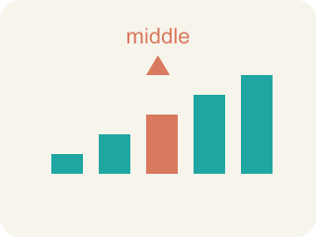
Median (Mediana) — The middle number when you put them in order.
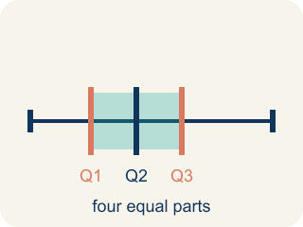
Quartile (Cuartil) — Numbers that split the data into four equal parts.
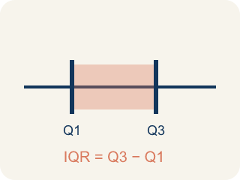
Interquartile Range (Rango intercuartílico) — The spread of the middle half of the data (Q3 − Q1).
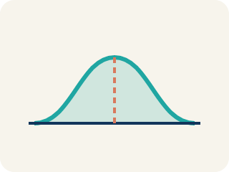
Data distribution (Distribución de datos) — How the data looks: where it sits and how spread out it is.
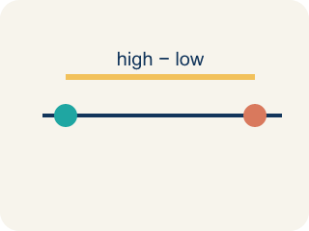
Variability (Variabilidad) — How spread out the numbers are.

Practice
Show your work. Use the blank space under each problem.
1. Two box plots show: Team A has IQR = 8, Team B has IQR = 22. What does this tell you?
A. Team A's middle 50% is more consistent; Team B's is more spread out
B. Team B is a better team
C. Team A has a higher median
D. The IQRs don't tell you about consistency
______________________________________________________________________
2. The Quartile-Is-One-Value Mistake
Step 1 (Data (ordered)): Eagles' game scores: 4, 8, 10, 14, 18, 22, 26, 30 (8 values)
Step 2 (Median): With 8 values, Median = (14 + 18) ÷ 2 = 16 ✓
Step 3 (Q1): Lower half = 4, 8, 10, 14 → Q1 = 10
Step 4 (Q3): Upper half = 18, 22, 26, 30 → Q3 = (22 + 26) ÷ 2 = 24
Which step has the mistake? Explain and fix it:
______________________________________________________________________
______________________________________________________________________
______________________________________________________________________
3. Find the Box Plot Error
Step 1 (Data): 3, 7, 9, 12, 15, 18, 21
Step 2 (Min and Max): Min = 3, Max = 21
Step 3 (Median): Middle value = 12 ✓
Step 4 (Q1 and Q3): Q1 = 9, Q3 = 18
Which step has the mistake? Explain and fix it:
______________________________________________________________________
______________________________________________________________________
______________________________________________________________________
4. Two basketball teams played 9 games each. Team A: 40, 42, 44, 46, 48, 50, 52, 54, 56. Team B: 30, 35, 40, 45, 48, 50, 55, 60, 65. Find the five-number summary and IQR for each team. Which team is more consistent? Which has a wider spread in the middle 50%?
Sentence starter: Team A: Min=___, Q1=___, Median=___, Q3=___, Max=___, IQR=___. Team B: Min=___, Q1=___, Median=___, Q3=___, Max=___, IQR=___. Team ___ is more consistent because its IQR is ___.
______________________________________________________________________
______________________________________________________________________
______________________________________________________________________
______________________________________________________________________

Answer Key (Teacher)
1. A. Team A's middle 50% is more consistent; Team B's is more spread out
A smaller IQR means the middle 50% of data is more tightly clustered. Team A's scoring is more consistent in the middle range.
Watch for: A common mistake in Display Data: Box Plots is treating a quartile as just one data point instead of the median of a half — for the lower half 4, 8, 10, 14, some students pick 10 (the last value) as Q1 instead of finding the median of that half: Q1 = (8 + 10) ÷ 2 = 9. A second common slip is finding IQR by adding the quartiles instead of subtracting, writing IQR = Q3 + Q1 (like 30 + 18 = 48) instead of IQR = Q3 − Q1 (30 − 18 = 12) — always order the data first, then subtract Q1 from Q3 to find the spread of the middle 50%.
2. The Quartile-Is-One-Value Mistake
The mistake is in Step 3.
Correct work: Q1 is the MEDIAN of the lower half, not just one of its values. The lower half is 4, 8, 10, 14 — an even-sized group — so Q1 = (8 + 10) ÷ 2 = 9, not 10. The student grabbed a single value instead of averaging the two middle numbers of the half.
Watch for: The Q1 step grabbed a single number out of the lower half instead of finding that half's median. The lower half 4, 8, 10, 14 has an even count, so Q1 averages its two middle values: (8 + 10) ÷ 2 = 9 — the same averaging move already used correctly for the median and for Q3.
3. Find the Box Plot Error
The mistake is in Step 4.
Correct work: Q1 is the median of the lower half (3, 7, 9), which is 7. Q3 is the median of the upper half (15, 18, 21), which is 18. The student used the wrong value for Q1 — they picked 9 (the last value in the lower half) instead of the median of that half.
Watch for: The quartile step used 9, the last number in the lower half, instead of the middle of that half. The lower half is 3, 7, 9, so its median — and therefore Q1 — is 7. Q3 = 18 was already right, since 18 sits in the middle of 15, 18, 21.
4. Open response — answers will vary.
Look for key words: five-number summary, Q1, Q3, IQR, consistent, spread, middle 50%.

