8.4–8.7 Catch-Up — Homework
Lesson 2-5-catchup • Standard 6.DS.3
Name: ______________________ Period: ______ Date: ____________

Today's Goals
Content: I can show I am caught up on Lessons 8.4–8.7 by using each lesson's big idea in mixed practice.
Language: I can explain which lesson's big idea I used and how, using key vocabulary from Lessons 8.4–8.7.

Key Words
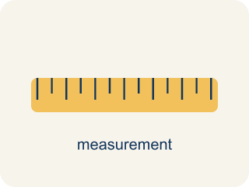
Appropriate Measures of Center (Medidas de centro apropiadas) — A mean, median, or mode chosen because it describes a data set fairly.
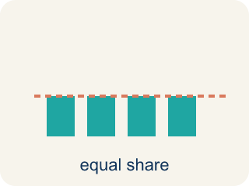
Mean (Media) — The average. Add all the numbers, then divide by how many there are.
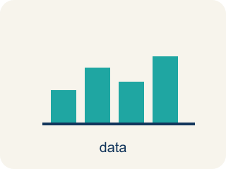
Display Data with Box Plots (Representar datos con diagramas de caja) — Show a data set's five-number summary in a box-and-whisker display.
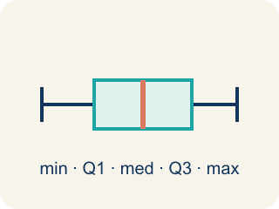
Box Plot (Diagrama de caja) — A graph that shows how data is spread using five key numbers.

Display Data with Histograms (Representar datos con histogramas) — Group numerical data into intervals and show each interval's frequency with a bar.
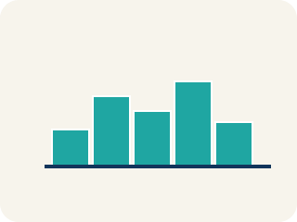
Histogram (Histograma) — A bar graph that groups data into equal ranges. The bars touch.
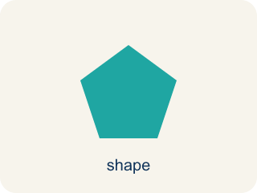
Shape of Data Distributions (Forma de las distribuciones de datos) — The overall pattern of data, such as symmetric, skewed, clustered, or containing gaps.
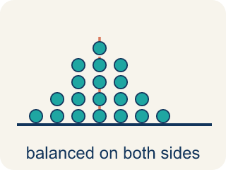
Symmetric (Simétrico) — Data that looks about the same on the left and right.
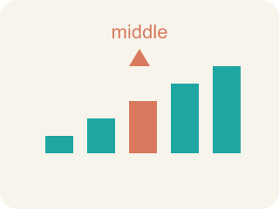
Median (Mediana) — The middle number when you put them in order.
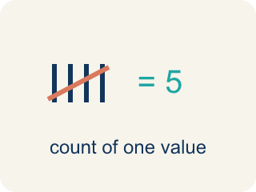
Frequency (Frecuencia) — How many times a value shows up.
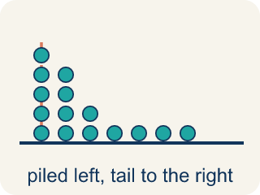
Skewed (Sesgado) — When most data sits on one side with a tail on the other.

Practice
Show your work. Use the blank space under each problem.
1. (Lesson 8.4) A gymnast's scores are: 8.5, 8.8, 8.7, 8.6, 8.9. There are no outliers. Which measure best represents a typical score?
A. Mean
B. Median
C. Neither — the data is too small
D. Both are equally bad
______________________________________________________________________
2. (Lesson 8.4) A runner's mile times are: 7:10, 7:15, 7:12, 7:20, 12:00. The 12:00 was due to a cramp. Which measure best represents a typical mile?
A. Median — the outlier 12:00 pulls the mean too high
B. Mean — it uses all the data
C. Mode — it shows the most common time
D. Neither measure works
______________________________________________________________________
3. (Lesson 8.4) A baseball player's batting averages over 6 seasons are: .280, .295, .290, .285, .300, .110. The .110 was an injury-shortened season. Which measure better represents the player's typical batting average?
A. Median, because the .110 outlier pulls the mean down
B. Mean, because it uses all the data
C. Mean, because .110 is a real season
D. Neither measure works
______________________________________________________________________
4. (Lesson 8.4) Spot the Mistake — Choosing the Mean Despite an Outlier
Step 1 (Data): A receiver's catches per game: 12, 14, 13, 15, 11, 60 (the 60 was a record-setting playoff game).
Step 2 (Find the mean): Sum = 125, Count = 6, Mean = 125 ÷ 6 ≈ 20.8.
Step 3 (Find the median): Ordered: 11, 12, 13, 14, 15, 60 → Median = (13 + 14) ÷ 2 = 13.5.
Step 4 (Choose a measure): The student reports the mean (≈ 20.8) as the typical number of catches because it uses every game.
Which step has the mistake? Explain and fix it:
______________________________________________________________________
______________________________________________________________________
______________________________________________________________________
5. (Lesson 8.5) Two box plots show: Team A has IQR = 8, Team B has IQR = 22. What does this tell you?
A. Team A's middle 50% is more consistent; Team B's is more spread out
B. Team B is a better team
C. Team A has a higher median
D. The IQRs don't tell you about consistency
______________________________________________________________________
6. (Lesson 8.5) The Quartile-Is-One-Value Mistake
Step 1 (Data (ordered)): Eagles' game scores: 4, 8, 10, 14, 18, 22, 26, 30 (8 values)
Step 2 (Median): With 8 values, Median = (14 + 18) ÷ 2 = 16 ✓
Step 3 (Q1): Lower half = 4, 8, 10, 14 → Q1 = 10
Step 4 (Q3): Upper half = 18, 22, 26, 30 → Q3 = (22 + 26) ÷ 2 = 24
Which step has the mistake? Explain and fix it:
______________________________________________________________________
______________________________________________________________________
______________________________________________________________________
7. (Lesson 8.6) A histogram of test scores shows: 50–59: 2, 60–69: 5, 70–79: 10, 80–89: 8, 90–99: 3. Which interval has the most students?
A. 90–99 with 3 students
B. 70–79 with 10 students
C. 80–89 with 8 students
D. 60–69 with 5 students
______________________________________________________________________
8. (Lesson 8.6) A histogram of goals-per-game shows: 0–1: 9 players, 2–3: 6, 4–5: 3, 6–7: 1. What shape is this distribution?
A. Perfectly symmetric
B. Flat / uniform (all bars equal)
C. Skewed right (most players low, tail toward high values)
D. Skewed left (most players high, tail toward low values)
______________________________________________________________________
9. (Lesson 8.7) A dot plot of goals scored per game shows: 0(5 dots), 1(7 dots), 2(4 dots), 3(2 dots), 4(1 dot). What is the shape?
A. Skewed right — most values at the low end with a tail to the right
B. Symmetric — equal on both sides
C. Skewed left — most values at the high end
D. Uniform — all bars the same height
______________________________________________________________________
10. (Lesson 8.7) Spot the Common Mistake
Step 1 (Data): Player salaries (millions): 1, 1, 2, 2, 2, 3, 3, 40.
Step 2 (Shape): Most salaries cluster at 1–3 million with one value way out at 40 million, so the distribution is skewed right. ✓
Step 3 (Best measure): The student picks the MEAN to describe a typical salary because the shape is skewed right.
Which step has the mistake? Explain and fix it:
______________________________________________________________________
______________________________________________________________________
______________________________________________________________________

Answer Key (Teacher)
1. A. Mean
The data is symmetric with no outliers, so the mean (8.7) best represents the typical score.
Watch for: A common mistake in Shape of Data Distributions is naming the skew by looking at where the TALLEST bar (the peak) sits, instead of looking at which way the TAIL stretches. For example, given bar heights 8, 5, 3, 1 (tall on the left, trailing off to the right), students often say "skewed left" because the peak is on the left — but the correct name is skewed right, because skew is always named for the direction the tail points, not the peak.
2. A. Median — the outlier 12:00 pulls the mean too high
The 12:00 is an outlier that pulls the mean up. The median (7:15) better represents the runner's typical time.
Watch for: A common mistake in Shape of Data Distributions is naming the skew by looking at where the TALLEST bar (the peak) sits, instead of looking at which way the TAIL stretches. For example, given bar heights 8, 5, 3, 1 (tall on the left, trailing off to the right), students often say "skewed left" because the peak is on the left — but the correct name is skewed right, because skew is always named for the direction the tail points, not the peak.
3. A. Median, because the .110 outlier pulls the mean down
The .110 is an outlier that pulls the mean down to .260. The median (.2875) better represents typical performance because it isn't affected by the extreme value.
Watch for: A common mistake in Shape of Data Distributions is naming the skew by looking at where the TALLEST bar (the peak) sits, instead of looking at which way the TAIL stretches. For example, given bar heights 8, 5, 3, 1 (tall on the left, trailing off to the right), students often say "skewed left" because the peak is on the left — but the correct name is skewed right, because skew is always named for the direction the tail points, not the peak.
4. (Lesson 8.4) Spot the Mistake — Choosing the Mean Despite an Outlier
The mistake is in Step 4.
Correct work: The student should report the median (13.5), not the mean. The 60-catch game is an outlier that pulls the mean up to about 20.8 — higher than 5 of the 6 games. The median (13.5) is resistant to that outlier and better represents a typical game.
Watch for: Using every value is exactly the problem here: the 60-catch playoff game pulls the mean up to about 20.8, which is higher than five of the six games. The median 13.5 sits inside the cluster of 11 to 15 and is not moved by that extreme value, so it is the better report of a typical game.
5. A. Team A's middle 50% is more consistent; Team B's is more spread out
A smaller IQR means the middle 50% of data is more tightly clustered. Team A's scoring is more consistent in the middle range.
Watch for: A common mistake in Shape of Data Distributions is naming the skew by looking at where the TALLEST bar (the peak) sits, instead of looking at which way the TAIL stretches. For example, given bar heights 8, 5, 3, 1 (tall on the left, trailing off to the right), students often say "skewed left" because the peak is on the left — but the correct name is skewed right, because skew is always named for the direction the tail points, not the peak.
6. (Lesson 8.5) The Quartile-Is-One-Value Mistake
The mistake is in Step 3.
Correct work: Q1 is the MEDIAN of the lower half, not just one of its values. The lower half is 4, 8, 10, 14 — an even-sized group — so Q1 = (8 + 10) ÷ 2 = 9, not 10. The student grabbed a single value instead of averaging the two middle numbers of the half.
Watch for: The Q1 step grabbed a single number out of the lower half instead of finding that half's median. The lower half 4, 8, 10, 14 has an even count, so Q1 averages its two middle values: (8 + 10) ÷ 2 = 9 — the same averaging move already used correctly for the median and for Q3.
7. B. 70–79 with 10 students
The 70–79 interval has the highest frequency of 10 students.
Watch for: A common mistake in Shape of Data Distributions is naming the skew by looking at where the TALLEST bar (the peak) sits, instead of looking at which way the TAIL stretches. For example, given bar heights 8, 5, 3, 1 (tall on the left, trailing off to the right), students often say "skewed left" because the peak is on the left — but the correct name is skewed right, because skew is always named for the direction the tail points, not the peak.
8. C. Skewed right (most players low, tail toward high values)
The tallest bars are at the low end (0–1) and the bars shrink as goals increase — the tail points right, so it is skewed right.
Watch for: A common mistake in Shape of Data Distributions is naming the skew by looking at where the TALLEST bar (the peak) sits, instead of looking at which way the TAIL stretches. For example, given bar heights 8, 5, 3, 1 (tall on the left, trailing off to the right), students often say "skewed left" because the peak is on the left — but the correct name is skewed right, because skew is always named for the direction the tail points, not the peak.
9. A. Skewed right — most values at the low end with a tail to the right
The data peaks at 0–1 goals and tails off toward 4. Most data is on the left with fewer values stretching right — this is skewed right.
Watch for: A common mistake in Shape of Data Distributions is naming the skew by looking at where the TALLEST bar (the peak) sits, instead of looking at which way the TAIL stretches. For example, given bar heights 8, 5, 3, 1 (tall on the left, trailing off to the right), students often say "skewed left" because the peak is on the left — but the correct name is skewed right, because skew is always named for the direction the tail points, not the peak.
10. (Lesson 8.7) Spot the Common Mistake
The mistake is in Step 3.
Correct work: The shape is correct (skewed right), but the MEDIAN — not the mean — is the better measure for skewed data. The single 40-million salary is an extreme value in the right tail that pulls the mean up to about 6.75 million, far above what most players earn. The median is 2 million, which truly represents a typical salary. Use the median whenever data is skewed.
Watch for: The shape call was correct, but the measure of center was not. The single 40-million salary sits far out in the right tail and drags the mean up to about 6.75 million, higher than every other player actually earns. The median of 2 million truly describes a typical salary, so skewed data should be summarized with the median.

