2.5 Small Group · Group 1 — Homework
Lesson 2-5-group1 • Standard 6.DS.3
Name: ______________________ Period: ______ Date: ____________

Today's Goals
Content: With my small group, I can describe the shape of a data distribution as symmetric, skewed, or having clusters and gaps — one step at a time, with support.
Language: I can talk through each step out loud using a sentence frame and the lesson's key words.

Key Words
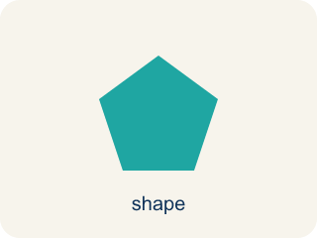
Shape of Data Distributions (Forma de las distribuciones de datos) — The overall pattern of data, such as symmetric, skewed, clustered, or containing gaps.
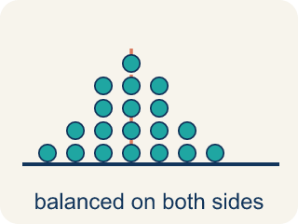
Symmetric (Simétrico) — Data that looks about the same on the left and right.
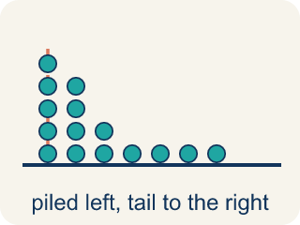
Skewed (Sesgado) — When most data sits on one side with a tail on the other.
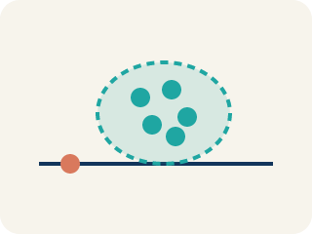
Cluster (Agrupamiento) — A group of numbers that are close together.
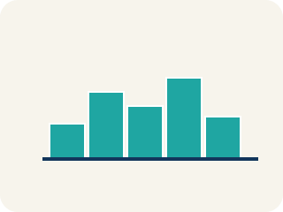
Gap (Hueco (espacio)) — A big empty space where there is no data.
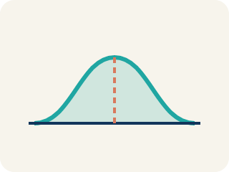
Data distribution (Distribución de datos) — How the data looks: where it sits and how spread out it is.
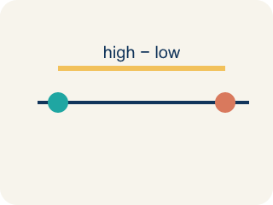
Variability (Variabilidad) — How spread out the numbers are.

Practice
Show your work. Use the blank space under each problem.
1. A histogram of basketball players' ages shows: most players are 22–28, with a long tail of older players up to age 40. What is the shape of this distribution?
A. Skewed right
B. Symmetric
C. Skewed left
D. Uniform
______________________________________________________________________
2. A data set is symmetric. What is likely true about the mean and median?
A. They are approximately equal
B. The mean is much higher than the median
C. The median is much higher than the mean
D. They are always exactly the same
______________________________________________________________________
3. A dot plot has one peak in the middle and even sides. What shape is it?
A. Symmetric with one cluster around the peak
B. Skewed right
C. Skewed left
D. Has a large gap
______________________________________________________________________
4. A histogram: most players are at 70-85%, a gap sits at 50-65%, and a few are at 40-50%. Name the shape and features.
A. A cluster (70-85%), a gap (50-65%), and a left tail — so skewed left
B. A symmetric display with no gaps
C. A right tail of high values — so skewed right
D. Two equal peaks with no cluster or gap
______________________________________________________________________
5. Level 2 Extension — Name the Skew by Its Tail
Step 1 (Display): Analytics screen: minutes played per game. Bar heights left to right: 12, 8, 4, 2, 1.
Step 2 (Cluster): Most players are bunched on the left (low minutes).
Step 3 (Tail): The short bars trail off toward the right (high minutes).
Step 4 (Shape claim): Because the tall bars (the peak) are on the LEFT, this display is left-skewed.
Which step has the mistake? Explain and fix it:
______________________________________________________________________
______________________________________________________________________
______________________________________________________________________
6. Find the Shape Error
Step 1 (Data): Sprint times (seconds): 10.2, 10.5, 10.8, 11.0, 11.1, 11.2, 11.3, 11.5, 14.8
Step 2 (Histogram): 10.0–10.9: 3, 11.0–11.9: 5, 12.0–12.9: 0, 13.0–13.9: 0, 14.0–14.9: 1
Step 3 (Shape): Skewed left because the tall bar is on the right side
Step 4 (Best measure): Use the mean because skewed data uses the mean
Which step has the mistake? Explain and fix it:
______________________________________________________________________
______________________________________________________________________
______________________________________________________________________
7. A teacher shows two dot plots of quiz scores from two different classes. Class A's data is symmetric with a cluster around 80. Class B's data is skewed right with most scores between 60–70 and a few scores near 100. Compare the classes: which has a higher median? Which has a higher mean? In which class does the mean better represent a typical score?
Sentence starter: Class A is ___ with scores clustered around ___. Class B is skewed ___ with most scores at ___. Class A likely has a ___ median. Class B's mean is pulled ___ by the high scores. The mean better represents a typical score in Class ___ because ___.
______________________________________________________________________
______________________________________________________________________
______________________________________________________________________
______________________________________________________________________

Answer Key (Teacher)
1. A. Skewed right
Most data is on the left (younger ages) with a tail stretching right (older ages). This is skewed right.
Watch for: A common mistake in Shape of Data Distributions is naming the skew by looking at where the TALLEST bar (the peak) sits, instead of looking at which way the TAIL stretches. For example, given bar heights 8, 5, 3, 1 (tall on the left, trailing off to the right), students often say "skewed left" because the peak is on the left — but the correct name is skewed right, because skew is always named for the direction the tail points, not the peak.
2. A. They are approximately equal
In a symmetric distribution, the mean and median are approximately equal because the data is balanced on both sides.
Watch for: A common mistake in Shape of Data Distributions is naming the skew by looking at where the TALLEST bar (the peak) sits, instead of looking at which way the TAIL stretches. For example, given bar heights 8, 5, 3, 1 (tall on the left, trailing off to the right), students often say "skewed left" because the peak is on the left — but the correct name is skewed right, because skew is always named for the direction the tail points, not the peak.
3. A. Symmetric with one cluster around the peak
One peak in the middle with roughly even sides means the data mirrors around the center, so it is symmetric with a single cluster at the peak.
Watch for: A common mistake in Shape of Data Distributions is naming the skew by looking at where the TALLEST bar (the peak) sits, instead of looking at which way the TAIL stretches. For example, given bar heights 8, 5, 3, 1 (tall on the left, trailing off to the right), students often say "skewed left" because the peak is on the left — but the correct name is skewed right, because skew is always named for the direction the tail points, not the peak.
4. A. A cluster (70-85%), a gap (50-65%), and a left tail — so skewed left
The data clusters at the high end (70-85%), there is an empty gap (50-65%), and the few low values form a tail on the left, so the display is skewed left.
Watch for: A common mistake in Shape of Data Distributions is naming the skew by looking at where the TALLEST bar (the peak) sits, instead of looking at which way the TAIL stretches. For example, given bar heights 8, 5, 3, 1 (tall on the left, trailing off to the right), students often say "skewed left" because the peak is on the left — but the correct name is skewed right, because skew is always named for the direction the tail points, not the peak.
5. Level 2 Extension — Name the Skew by Its Tail
The mistake is in Step 4.
Correct work: This display is skewed RIGHT, not left. Skew is named for the direction the TAIL points, not where the peak sits. The peak is on the left, but the long tail of short bars stretches to the right, so it is skewed right. (A correct claim-evidence-reasoning answer: 'The distribution is skewed right because I see the tail stretching toward the high values on the right.')
Watch for: The claim was based on where the peak sits instead of where the tail points. The bar heights 12, 8, 4, 2, 1 pile up on the left and shrink toward the right, so the tail stretches right and the display is skewed right. Skew is always named for the tail direction, never the peak.
6. Find the Shape Error
The mistake is in Step 3.
Correct work: This is skewed RIGHT, not left. The cluster of data is on the left (10–11 seconds) and the tail with the extreme value (14.8) stretches to the right. Also, for skewed data the MEDIAN is the better measure, not the mean, because the mean is pulled toward the tail.
Watch for: The shape was named from the tall bar instead of the tail. The histogram clusters at 10–11 seconds, shows empty intervals at 12 and 13, and then has one lone value at 14.8, so the stretched-out tail points right — skewed right. And because the data is skewed, the median describes a typical sprint time better than the mean, which the 14.8 pulls upward.
7. Open response — answers will vary.
Look for key words: symmetric, skewed right, median, mean, pulled, higher, typical, tail.

