2.5 Small Group · Group 2 — Homework
Lesson 2-5-group2 • Standard 6.DS.3
Name: ______________________ Period: ______ Date: ____________

Today's Goals
Content: I can describe the shape of a data distribution as symmetric, skewed, or having clusters and gaps, explain how I can tell, and judge a case I have not seen before.
Language: I can justify my answer to a skeptic and connect it to a second strategy or representation.

Key Words
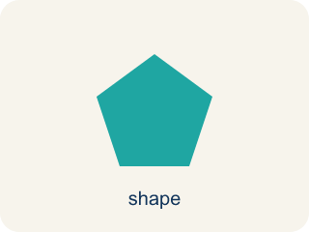
Shape of Data Distributions (Forma de las distribuciones de datos) — The overall pattern of data, such as symmetric, skewed, clustered, or containing gaps.
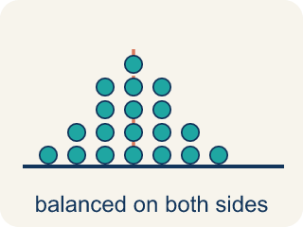
Symmetric (Simétrico) — Data that looks about the same on the left and right.
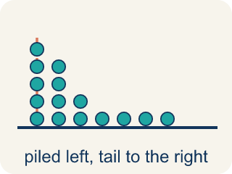
Skewed (Sesgado) — When most data sits on one side with a tail on the other.
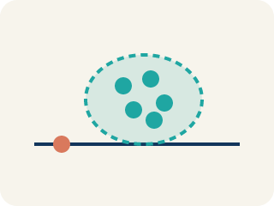
Cluster (Agrupamiento) — A group of numbers that are close together.
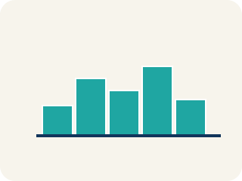
Gap (Hueco (espacio)) — A big empty space where there is no data.
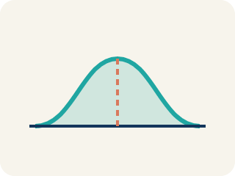
Data distribution (Distribución de datos) — How the data looks: where it sits and how spread out it is.
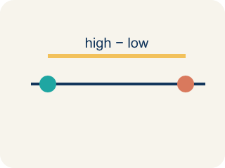
Variability (Variabilidad) — How spread out the numbers are.

Practice
Show your work. Use the blank space under each problem.
1. A dot plot of goals scored per game shows: 0(5 dots), 1(7 dots), 2(4 dots), 3(2 dots), 4(1 dot). What is the shape?
A. Skewed right — most values at the low end with a tail to the right
B. Symmetric — equal on both sides
C. Skewed left — most values at the high end
D. Uniform — all bars the same height
______________________________________________________________________
2. Spot the Common Mistake
Step 1 (Data): Player salaries (millions): 1, 1, 2, 2, 2, 3, 3, 40.
Step 2 (Shape): Most salaries cluster at 1–3 million with one value way out at 40 million, so the distribution is skewed right. ✓
Step 3 (Best measure): The student picks the MEAN to describe a typical salary because the shape is skewed right.
Which step has the mistake? Explain and fix it:
______________________________________________________________________
______________________________________________________________________
______________________________________________________________________
3. Find the Shape Error
Step 1 (Data): Sprint times (seconds): 10.2, 10.5, 10.8, 11.0, 11.1, 11.2, 11.3, 11.5, 14.8
Step 2 (Histogram): 10.0–10.9: 3, 11.0–11.9: 5, 12.0–12.9: 0, 13.0–13.9: 0, 14.0–14.9: 1
Step 3 (Shape): Skewed left because the tall bar is on the right side
Step 4 (Best measure): Use the mean because skewed data uses the mean
Which step has the mistake? Explain and fix it:
______________________________________________________________________
______________________________________________________________________
______________________________________________________________________
4. A teacher shows two dot plots of quiz scores from two different classes. Class A's data is symmetric with a cluster around 80. Class B's data is skewed right with most scores between 60–70 and a few scores near 100. Compare the classes: which has a higher median? Which has a higher mean? In which class does the mean better represent a typical score?
Sentence starter: Class A is ___ with scores clustered around ___. Class B is skewed ___ with most scores at ___. Class A likely has a ___ median. Class B's mean is pulled ___ by the high scores. The mean better represents a typical score in Class ___ because ___.
______________________________________________________________________
______________________________________________________________________
______________________________________________________________________
______________________________________________________________________

Answer Key (Teacher)
1. A. Skewed right — most values at the low end with a tail to the right
The data peaks at 0–1 goals and tails off toward 4. Most data is on the left with fewer values stretching right — this is skewed right.
Watch for: A common mistake in Shape of Data Distributions is naming the skew by looking at where the TALLEST bar (the peak) sits, instead of looking at which way the TAIL stretches. For example, given bar heights 8, 5, 3, 1 (tall on the left, trailing off to the right), students often say "skewed left" because the peak is on the left — but the correct name is skewed right, because skew is always named for the direction the tail points, not the peak.
2. Spot the Common Mistake
The mistake is in Step 3.
Correct work: The shape is correct (skewed right), but the MEDIAN — not the mean — is the better measure for skewed data. The single 40-million salary is an extreme value in the right tail that pulls the mean up to about 6.75 million, far above what most players earn. The median is 2 million, which truly represents a typical salary. Use the median whenever data is skewed.
Watch for: The shape call was correct, but the measure of center was not. The single 40-million salary sits far out in the right tail and drags the mean up to about 6.75 million, higher than every other player actually earns. The median of 2 million truly describes a typical salary, so skewed data should be summarized with the median.
3. Find the Shape Error
The mistake is in Step 3.
Correct work: This is skewed RIGHT, not left. The cluster of data is on the left (10–11 seconds) and the tail with the extreme value (14.8) stretches to the right. Also, for skewed data the MEDIAN is the better measure, not the mean, because the mean is pulled toward the tail.
Watch for: The shape was named from the tall bar instead of the tail. The histogram clusters at 10–11 seconds, shows empty intervals at 12 and 13, and then has one lone value at 14.8, so the stretched-out tail points right — skewed right. And because the data is skewed, the median describes a typical sprint time better than the mean, which the 14.8 pulls upward.
4. Open response — answers will vary.
Look for key words: symmetric, skewed right, median, mean, pulled, higher, typical, tail.

