2.6 Small Group · Group 1 — Homework
Lesson 2-6-group1 • Standard 6.NOS.2
Name: ______________________ Period: ______ Date: ____________

Today's Goals
Content: With my small group, I can divide multi-digit whole numbers and explain the meaning of the quotient and remainder — one step at a time, with support.
Language: I can talk through each step out loud using a sentence frame and the lesson's key words.

Key Words
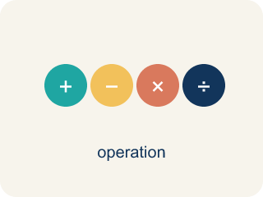
Divide Multi-Digit Numbers (Dividir números de varias cifras) — Separate a multi-digit number into equal groups to find a quotient.
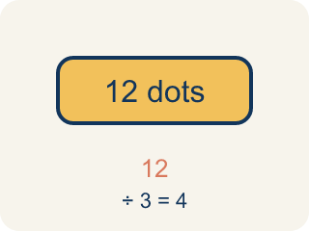
Dividend (Dividendo) — The number you are splitting up in a division problem.
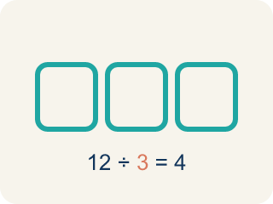
Divisor (Divisor) — The number you split by in a division problem.
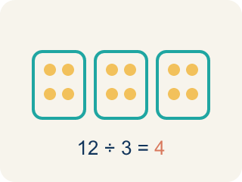
Quotient (Cociente) — The answer when you divide.
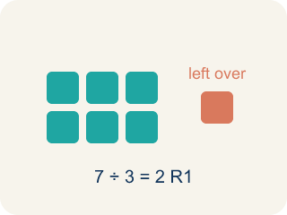
Remainder (Residuo) — What is left over when a number does not divide evenly.
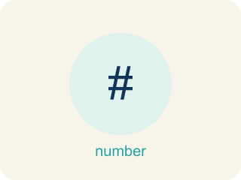
Long division (División larga) — A method that repeats four steps — divide, multiply, subtract, bring down — until there are no digits left to bring down.

Bring down (Bajar el dígito) — The fourth step of long division: move the next digit of the dividend down next to what is left, then start the cycle again.

Practice
Show your work. Use the blank space under each problem.
1. What is 936 ÷ 12?
A. 78
B. 87
C. 68
D. 76
______________________________________________________________________
2. What is 2,485 ÷ 5?
A. 497
B. 487
C. 507
D. 496
______________________________________________________________________
3. Spot the Mistake in 2,058 ÷ 14
Step 1 (Problem): Divide 2,058 ÷ 14 with long division. Dividend = 2,058, divisor = 14.
Step 2 (Divide, Multiply, Subtract): 14 does not fit into 2, so start with 20. 20 ÷ 14 → 1. 1 × 14 = 14, and 20 − 14 = 6
Step 3 (Bring down, repeat): Bring down the 5 to make 65. 65 ÷ 14 → 4. 4 × 14 = 56, and 65 − 56 = 9
Step 4 (Bring down, repeat): Bring down the 8 to make 98. 98 ÷ 14 → 8. 8 × 14 = 112, and 98 − 112 = −14
Step 5 (Final answer): Quotient = 148
Which step has the mistake? Explain and fix it:
______________________________________________________________________
______________________________________________________________________
______________________________________________________________________
4. What is 4,896 ÷ 12?
A. 408
B. 48
C. 480
D. 380
______________________________________________________________________
5. What is 7,225 ÷ 25?
A. 289
B. 29
C. 2,890
D. 389
______________________________________________________________________
6. A school orders 3,648 pencils packed 24 to a box. How many boxes are there?
A. 152
B. 148
C. 160
D. 144
______________________________________________________________________
7. What is 5,084 ÷ 31?
A. 164
B. 154
C. 174
D. 164 r2
______________________________________________________________________
8. Path 1: The first arcade door shows 4,928 ÷ 7. Which quotient lights the correct path?
A. 704
B. 74
C. 740
D. 703 r7
______________________________________________________________________

Answer Key (Teacher)
1. A. 78
12 × 78 = 936. You can verify: 12 × 70 = 840, 12 × 8 = 96, 840 + 96 = 936.
Watch for: A common mistake in Divide Multi-Digit Numbers is skipping a placeholder zero in the quotient when a digit doesn't divide evenly, which shifts every digit after it out of place. For example, dividing 3,216 ÷ 3: 3 ÷ 3 = 1, but the next digit 2 doesn't divide by 3, so a 0 must be written before continuing — bring down the 1 to make 21 ÷ 3 = 7, then bring down 6 ÷ 3 = 2, giving the correct quotient 1,072. A student who skips writing that 0 and jumps straight to 21 ÷ 3 = 7 ends up with 172 instead of 1,072 — an answer off by a factor of ten. Always check: does a digit in your quotient go missing every time you 'can't divide'? If so, you dropped a placeholder zero.
2. A. 497
5 × 497 = 2,485. Running the cycle: 24 ÷ 5 → 4 with 4 left, 48 ÷ 5 → 9 with 3 left, 35 ÷ 5 → 7 with 0 left, so the quotient is 497 and the remainder is 0.
Watch for: A common mistake in Divide Multi-Digit Numbers is skipping a placeholder zero in the quotient when a digit doesn't divide evenly, which shifts every digit after it out of place. For example, dividing 3,216 ÷ 3: 3 ÷ 3 = 1, but the next digit 2 doesn't divide by 3, so a 0 must be written before continuing — bring down the 1 to make 21 ÷ 3 = 7, then bring down 6 ÷ 3 = 2, giving the correct quotient 1,072. A student who skips writing that 0 and jumps straight to 21 ÷ 3 = 7 ends up with 172 instead of 1,072 — an answer off by a factor of ten. Always check: does a digit in your quotient go missing every time you 'can't divide'? If so, you dropped a placeholder zero.
3. Spot the Mistake in 2,058 ÷ 14
The mistake is in Step 4.
Correct work: The DIVIDE step in the last cycle chose a digit that is too big: 8 × 14 = 112 is more than the 98 you have to subtract from, and you can never subtract more than the working number. The right digit is 7, since 7 × 14 = 98 and 98 − 98 = 0. The quotient is 147 with remainder 0, and 14 × 147 = 2,058 rebuilds the dividend.
Watch for: The last DIVIDE step is where it breaks: the student wrote 8, but 8 × 14 = 112 is larger than the 98 they had to subtract from, so the difference came out negative. The largest digit that fits is 7, since 7 × 14 = 98 leaves 0, so the quotient is 147 and 14 × 147 = 2,058 checks out.
4. A. 408
12 × 408 = 4,896.
Watch for: A common mistake in Divide Multi-Digit Numbers is skipping a placeholder zero in the quotient when a digit doesn't divide evenly, which shifts every digit after it out of place. For example, dividing 3,216 ÷ 3: 3 ÷ 3 = 1, but the next digit 2 doesn't divide by 3, so a 0 must be written before continuing — bring down the 1 to make 21 ÷ 3 = 7, then bring down 6 ÷ 3 = 2, giving the correct quotient 1,072. A student who skips writing that 0 and jumps straight to 21 ÷ 3 = 7 ends up with 172 instead of 1,072 — an answer off by a factor of ten. Always check: does a digit in your quotient go missing every time you 'can't divide'? If so, you dropped a placeholder zero.
5. A. 289
25 × 289 = 7,225.
Watch for: A common mistake in Divide Multi-Digit Numbers is skipping a placeholder zero in the quotient when a digit doesn't divide evenly, which shifts every digit after it out of place. For example, dividing 3,216 ÷ 3: 3 ÷ 3 = 1, but the next digit 2 doesn't divide by 3, so a 0 must be written before continuing — bring down the 1 to make 21 ÷ 3 = 7, then bring down 6 ÷ 3 = 2, giving the correct quotient 1,072. A student who skips writing that 0 and jumps straight to 21 ÷ 3 = 7 ends up with 172 instead of 1,072 — an answer off by a factor of ten. Always check: does a digit in your quotient go missing every time you 'can't divide'? If so, you dropped a placeholder zero.
6. A. 152
3,648 ÷ 24 = 152 boxes.
Watch for: A common mistake in Divide Multi-Digit Numbers is skipping a placeholder zero in the quotient when a digit doesn't divide evenly, which shifts every digit after it out of place. For example, dividing 3,216 ÷ 3: 3 ÷ 3 = 1, but the next digit 2 doesn't divide by 3, so a 0 must be written before continuing — bring down the 1 to make 21 ÷ 3 = 7, then bring down 6 ÷ 3 = 2, giving the correct quotient 1,072. A student who skips writing that 0 and jumps straight to 21 ÷ 3 = 7 ends up with 172 instead of 1,072 — an answer off by a factor of ten. Always check: does a digit in your quotient go missing every time you 'can't divide'? If so, you dropped a placeholder zero.
7. A. 164
31 × 164 = 5,084 exactly, so there is no remainder.
Watch for: A common mistake in Divide Multi-Digit Numbers is skipping a placeholder zero in the quotient when a digit doesn't divide evenly, which shifts every digit after it out of place. For example, dividing 3,216 ÷ 3: 3 ÷ 3 = 1, but the next digit 2 doesn't divide by 3, so a 0 must be written before continuing — bring down the 1 to make 21 ÷ 3 = 7, then bring down 6 ÷ 3 = 2, giving the correct quotient 1,072. A student who skips writing that 0 and jumps straight to 21 ÷ 3 = 7 ends up with 172 instead of 1,072 — an answer off by a factor of ten. Always check: does a digit in your quotient go missing every time you 'can't divide'? If so, you dropped a placeholder zero.
8. A. 704
7 × 704 = 4,928 exactly, so the quotient is 704 with no remainder.
Watch for: A common mistake in Divide Multi-Digit Numbers is skipping a placeholder zero in the quotient when a digit doesn't divide evenly, which shifts every digit after it out of place. For example, dividing 3,216 ÷ 3: 3 ÷ 3 = 1, but the next digit 2 doesn't divide by 3, so a 0 must be written before continuing — bring down the 1 to make 21 ÷ 3 = 7, then bring down 6 ÷ 3 = 2, giving the correct quotient 1,072. A student who skips writing that 0 and jumps straight to 21 ÷ 3 = 7 ends up with 172 instead of 1,072 — an answer off by a factor of ten. Always check: does a digit in your quotient go missing every time you 'can't divide'? If so, you dropped a placeholder zero.

