2.6 Small Group · Group 2 — Homework
Lesson 2-6-group2 • Standard 6.NOS.2
Name: ______________________ Period: ______ Date: ____________

Today's Goals
Content: I can divide multi-digit whole numbers and explain the meaning of the quotient and remainder, explain why the method works, and use it on a problem I have not seen before.
Language: I can justify my answer to a skeptic and connect it to a second strategy or representation.

Key Words
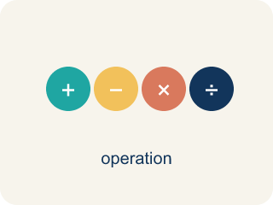
Divide Multi-Digit Numbers (Dividir números de varias cifras) — Separate a multi-digit number into equal groups to find a quotient.
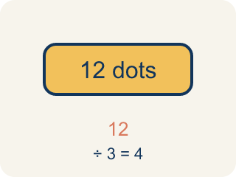
Dividend (Dividendo) — The number you are splitting up in a division problem.
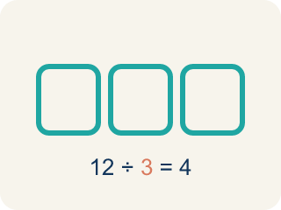
Divisor (Divisor) — The number you split by in a division problem.
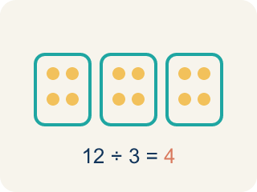
Quotient (Cociente) — The answer when you divide.
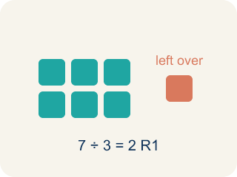
Remainder (Residuo) — What is left over when a number does not divide evenly.
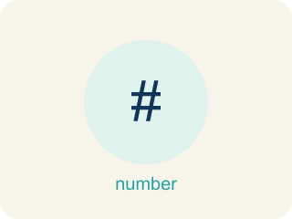
Long division (División larga) — A method that repeats four steps — divide, multiply, subtract, bring down — until there are no digits left to bring down.

Bring down (Bajar el dígito) — The fourth step of long division: move the next digit of the dividend down next to what is left, then start the cycle again.

Practice
Show your work. Use the blank space under each problem.
1. A warehouse has 2,184 items to pack into boxes of 14. How many boxes are needed?
A. 156 boxes
B. 146 boxes
C. 166 boxes
D. 155 boxes
______________________________________________________________________
2. Spot the Mistake in 2,058 ÷ 14
Step 1 (Problem): Divide 2,058 ÷ 14 with long division. Dividend = 2,058, divisor = 14.
Step 2 (Divide, Multiply, Subtract): 14 does not fit into 2, so start with 20. 20 ÷ 14 → 1. 1 × 14 = 14, and 20 − 14 = 6
Step 3 (Bring down, repeat): Bring down the 5 to make 65. 65 ÷ 14 → 4. 4 × 14 = 56, and 65 − 56 = 9
Step 4 (Bring down, repeat): Bring down the 8 to make 98. 98 ÷ 14 → 8. 8 × 14 = 112, and 98 − 112 = −14
Step 5 (Final answer): Quotient = 148
Which step has the mistake? Explain and fix it:
______________________________________________________________________
______________________________________________________________________
______________________________________________________________________
3. Find Sonia's Mistake
Step 1 (Problem): 1,536 ÷ 16
Step 2 (Divide): 16 does not fit into 1 or 15, so start with 153. 153 ÷ 16 → 9, written above the 3
Step 3 (Multiply): 9 × 16 = 144, written under the 153
Step 4 (Subtract): 153 − 144 = 19
Step 5 (Bring down): Bring down the 6 to make 196
Step 6 (Final answer): Quotient = 9 with 196 left over
Which step has the mistake? Explain and fix it:
______________________________________________________________________
______________________________________________________________________
______________________________________________________________________
4. The station must load 3,360 ration packs equally into 14 storage pods. Solve it with long division. Name each step — divide, multiply, subtract, bring down — and check your answer by multiplying.
Sentence starter: 3,360 ÷ 14 = ___. I divided ___ by 14 and wrote ___ , then multiplied, subtracted and brought down the next digit each time. I checked by multiplying: 14 × ___ = 3,360.
______________________________________________________________________
______________________________________________________________________
______________________________________________________________________
______________________________________________________________________

Answer Key (Teacher)
1. A. 156 boxes
2,184 ÷ 14 = 156. Check: 14 × 156 = 14 × 150 + 14 × 6 = 2,100 + 84 = 2,184.
Watch for: A common mistake in Divide Multi-Digit Numbers is skipping a placeholder zero in the quotient when a digit doesn't divide evenly, which shifts every digit after it out of place. For example, dividing 3,216 ÷ 3: 3 ÷ 3 = 1, but the next digit 2 doesn't divide by 3, so a 0 must be written before continuing — bring down the 1 to make 21 ÷ 3 = 7, then bring down 6 ÷ 3 = 2, giving the correct quotient 1,072. A student who skips writing that 0 and jumps straight to 21 ÷ 3 = 7 ends up with 172 instead of 1,072 — an answer off by a factor of ten. Always check: does a digit in your quotient go missing every time you 'can't divide'? If so, you dropped a placeholder zero.
2. Spot the Mistake in 2,058 ÷ 14
The mistake is in Step 4.
Correct work: The DIVIDE step in the last cycle chose a digit that is too big: 8 × 14 = 112 is more than the 98 you have to subtract from, and you can never subtract more than the working number. The right digit is 7, since 7 × 14 = 98 and 98 − 98 = 0. The quotient is 147 with remainder 0, and 14 × 147 = 2,058 rebuilds the dividend.
Watch for: The last DIVIDE step is where it breaks: the student wrote 8, but 8 × 14 = 112 is larger than the 98 they had to subtract from, so the difference came out negative. The largest digit that fits is 7, since 7 × 14 = 98 leaves 0, so the quotient is 147 and 14 × 147 = 2,058 checks out.
3. Find Sonia's Mistake
The mistake is in Step 4.
Correct work: The SUBTRACT step is wrong: 153 − 144 = 9, not 19. Long division has a built-in warning here — the difference after you subtract must always be SMALLER than the divisor, and 19 is bigger than 16. With the correct difference of 9, bring down the 6 to make 96, then DIVIDE 96 ÷ 16 → 6 and SUBTRACT 96 − 96 = 0. The quotient is 96 with remainder 0, and 16 × 96 = 1,536.
Watch for: Step 3 is the break: 153 − 144 = 9, not 19. Long division has a built-in warning here — if the difference after SUBTRACT is as big as the divisor, another whole group still fits. With the correct difference of 9, bringing down the 6 gives 96, and 96 ÷ 16 → 6 with nothing left, so the quotient is 96 and 16 × 96 = 1,536 confirms it.
4. Open response — answers will vary.
Look for key words: divide, multiply, subtract, bring down, 240, 3360, 14, check.

