UNIT 2 · LESSON 6 STANDARD 6.NOS.2

Divide Multi-Digit Numbers Using an Algorithm
Student Notes Packet
Name: ______________________ Date: ____________ Period: ________

Today's Goals
Content: I can divide multi-digit whole numbers and explain the meaning of the quotient and remainder.
Language: I can explain my division using the words dividend, divisor, quotient, and remainder.

Key Vocabulary
Look at the picture, read the word, then read what it means.
 | Divide Multi-Digit Numbers Dividir números de varias cifras  Separate a multi-digit number into equal groups to find a quotient.  Example: 1,344 ÷ 12 = 112
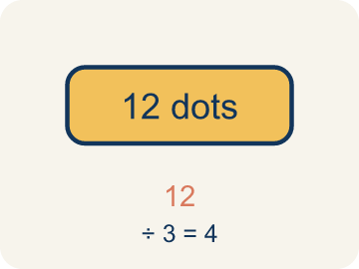 | Dividend Dividendo  The number you are splitting up in a division problem.  Example: In 156 ÷ 12 = 13, the dividend is 156 — it is the total being split up
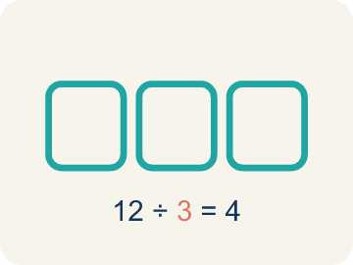 | Divisor Divisor  The number you split by in a division problem.  Example: In 156 ÷ 12 = 13, the divisor is 12 — it is the size of each group
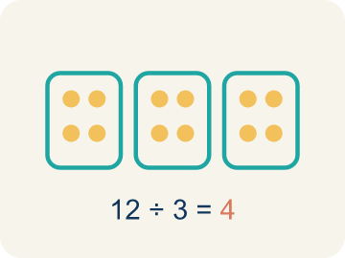 | Quotient Cociente  The answer when you divide.  Example: In 156 ÷ 12 = 13, the quotient is 13 — there are 13 groups
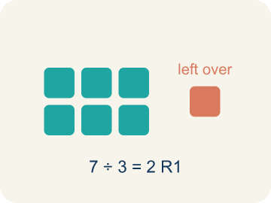 | Remainder Residuo  What is left over when a number does not divide evenly.  Example: 17 ÷ 5 = 3 R 2 means 3 groups of 5 with 2 left over
 | Long division División larga  A method that repeats four steps — divide, multiply, subtract, bring down — until there are no digits left to bring down.  Example: 1,344 ÷ 12 → divide, multiply, subtract, bring down, repeat
 | Bring down Bajar el dígito  The fourth step of long division: move the next digit of the dividend down next to what is left, then start the cycle again.  Example: 13 − 12 = 1, then bring down the 4 to make 14

Guided Notes
Fill in each blank as we go. Use the Word Bank to help you.
WORD BANK
Divide Multi-Digit Numbers • Dividend • Divisor • Quotient • Remainder • Long division • Bring down

1. __________ — Separate a multi-digit number into equal groups to find a quotient.
2. In 84 ÷ 7, the number 84 being divided is the ___.
3. In 84 ÷ 7, the number 7 that we divide by is the ___.
4. The answer to a division problem is called the ___.
5. When a number does not divide evenly, the amount left over is the ___.
6. The method that repeats divide, multiply, subtract, and bring down is called ___.
7. After you subtract in long division, the next step is to ___ the next digit.

Write About the Math
Use the support level you need. Every level answers the same math question.

1. Understand the Question explain
How does multi-digit division help the school figure out how many pencils each classroom gets?
Your job: Answer the question. Use math evidence. Explain how the evidence proves your answer.
Responde la pregunta. Usa evidencia matemática. Explica cómo la evidencia demuestra tu respuesta.

2. Plan Your Math Words check at least two
☐ Divide Multi-Digit Numbers — Separate a multi-digit number into equal groups to find a quotient.
Dividir números de varias cifras — Separar un número de varias cifras en grupos iguales para hallar un cociente.
☐ Dividend — The number you are splitting up in a division problem.
Dividendo — El número que estás repartiendo en una división.
☐ Divisor — The number you split by in a division problem.
Divisor — El número entre el que divides en una división.
☐ Quotient — The answer when you divide.
Cociente — La respuesta cuando divides.
☐ Remainder — What is left over when a number does not divide evenly.
Residuo — Lo que sobra cuando un número no se divide de forma exacta.
Say it first: Say your idea to a partner or quietly to yourself before you write.
Each classroom gets ___ pencils because 1,680 ÷ 24 = ___.
Di tu respuesta primero: Mi respuesta es ___ porque ___.

3. Build Your Explanation choose your support
This model shows the parts of an explanation. It does not answer your writing question.
Claim: Estimating with friendly numbers checks whether the quotient is reasonable.
Evidence: Students estimate using 1,200 ÷ 12 = 100 (or similar) to predict roughly 100+ bars per section, identifying 1,344 as the dividend and 12 as the divisor.
Reasoning: This evidence connects the definition of divide multi-digit numbers to the mathematical claim.

Start Most language support
Complete the frames. Use the word bank.
Completa las oraciones. Usa el banco de palabras.
Each classroom gets ___ pencils because 1,680 ÷ 24 = ___.
My answer is ___.
Mi respuesta es ___.

Build Some language support
Write two connected sentences. Use because, so, or but.
Escribe dos oraciones conectadas. Usa porque, entonces o pero.
My claim is ___.
Mi afirmación es ___.
I know because ___.
Lo sé porque ___.
So ___.
Entonces ___.

Explain Light language support
Write a claim, give math evidence, and explain your reasoning.
Escribe una afirmación, da evidencia matemática y explica tu razonamiento.
My claim is ___.
Mi afirmación es ___.
My math evidence is ___.
Mi evidencia matemática es ___.
This proves ___ because ___.
Esto demuestra ___ porque ___.

4. Check Your Explanation five quick checks
☐ I answered the question.
Respondí la pregunta.
☐ I used math evidence: numbers, an equation, a model, or a comparison.
Usé evidencia matemática: números, una ecuación, un modelo o una comparación.
☐ I explained how the evidence proves my answer.
Expliqué cómo la evidencia demuestra mi respuesta.
☐ I used at least two math words.
Usé por lo menos dos palabras matemáticas.
☐ I reread complete sentences and punctuation.
Volví a leer mis oraciones completas y la puntuación.

Worked Example

Watch & Read I Do — follow along with your teacher
Space Station Supply Division
The space station has 1,344 nutrition bars that must be divided equally among 12 crew sections for a 4-week rotation. How many bars does each section receive?

Think about:
• What total amount needs to be divided?
• How many groups are the supplies being split into?
• Will each section get the same amount with none left over?
• What strategy would you use to divide such a large number?

Solved Example I Do — watch each step
Problem: What is 936 ÷ 12?
A) 78
B) 87
C) 68
D) 76
Step 1: 12 × 78 = 936.
Step 2: You can verify: 12 × 70 = 840, 12 × 8 = 96, 840 + 96 = 936.
Answer: A. 78

Guided Practice

Solve Together We Do — work with your class
Problem: What is 2,485 ÷ 5?
A) 497
B) 487
C) 507
D) 496
Step 1:

Step 2:

Answer:

A school is ordering 1,680 pencils to distribute equally to 24 classrooms for the school year.
How does multi-digit division help the school figure out how many pencils each classroom gets?

Sentence frame: Each classroom gets ___ pencils because 1,680 ÷ 24 = ___.

Turn & Talk discuss with a partner
1. [Launch] The station must divide 1,344 nutrition bars equally among 12 crew sections. Before dividing, about how many bars should each section get, and how do you know?
Start with: Each section gets about ___ bars because 1,344 is close to ___.
Cada sección recibe unas ___ barras porque 1,344 está cerca de ___.
Word bank: dividend, divisor, quotient, estimate, bring down
2. [Explore] You used long division for 1,344 ÷ 12. Walk through your divide, multiply, subtract, and bring down steps — what did each one tell you?
Start with: First I divided ___ by 12 and wrote ___ in the quotient.
Primero dividí ___ entre 12 y escribí ___ en el cociente.
Word bank: bring down, dividend, divisor, quotient, remainder
3. [Connect] The station's observation deck seats 2,160 visitors equally across 18 viewing sections. How does multi-digit division tell each section's seat count, and how can you check it?
Start with: Each section gets ___ seats because 2,160 ÷ 18 = ___.
Cada sección recibe ___ asientos porque 2,160 ÷ 18 = ___.
Word bank: dividend, divisor, quotient, bring down, equally
4. [Reflect] In a division problem, what is the difference between the quotient and the remainder, and what does each one tell you?
Start with: The quotient tells me ___, and the remainder tells me ___.
El cociente me dice ___, y el residuo me dice ___.
Word bank: quotient, remainder, dividend, divisor, divide
5. [Practice] During practice on Divide Multi-Digit Numbers, what strategy did you use when a problem felt tricky?
Start with: First I divided ___ by 12 and wrote ___ in the quotient.
Primero dividí ___ entre 12 y escribí ___ en el cociente.
Word bank: Dividend, Divisor, Quotient, Remainder

Independent Practice

On Your Own You Do — show your work
Solve each problem. Show your thinking in the work box.

Level 1 Support extra scaffolding
1. What is 756 ÷ 9?
A) 84
B) 83
C) 94
D) 86

2. What is 1,125 ÷ 9?
A) 125
B) 115
C) 135
D) 124

On Level grade-level practice
3. A warehouse has 2,184 items to pack into boxes of 14. How many boxes are needed?
A) 156 boxes
B) 146 boxes
C) 166 boxes
D) 155 boxes

Exit Ticket
Answer on your own. This shows what you learned today.
★ What is 2,352 ÷ 16?
A) 147
B) 137
C) 157
D) 146

Answer Key & Teacher Guide
Teacher reference — remove or fold back before distributing to students.

Guided Notes (Fill-in)
Notes 1: Divide Multi-Digit Numbers
Notes 2: Dividend
Notes 3: Divisor
Notes 4: Quotient
Notes 5: Remainder
Notes 6: Long division
Notes 7: Bring down

Worked Notes (I Do / We Do)
I Do: A. 78
We Do: A. 497

Independent Practice
Watch for this mistake: A common mistake in Divide Multi-Digit Numbers is skipping a placeholder zero in the quotient when a digit doesn't divide evenly, which shifts every digit after it out of place. For example, dividing 3,216 ÷ 3: 3 ÷ 3 = 1, but the next digit 2 doesn't divide by 3, so a 0 must be written before continuing — bring down the 1 to make 21 ÷ 3 = 7, then bring down 6 ÷ 3 = 2, giving the correct quotient 1,072. A student who skips writing that 0 and jumps straight to 21 ÷ 3 = 7 ends up with 172 instead of 1,072 — an answer off by a factor of ten. Always check: does a digit in your quotient go missing every time you 'can't divide'? If so, you dropped a placeholder zero.

Level 1 Support
1. A) 84 — 9 × 84 = 756. Running the cycle: 75 ÷ 9 → 8 with 3 left, then 36 ÷ 9 → 4 with 0 left, so the quotient is 84 and the remainder is 0.
2. A) 125 — 9 × 125 = 1,125. Running the cycle: 11 ÷ 9 → 1 with 2 left, 22 ÷ 9 → 2 with 4 left, 45 ÷ 9 → 5 with 0 left, so the quotient is 125.

On Level
3. A) 156 boxes — 2,184 ÷ 14 = 156. Check: 14 × 156 = 14 × 150 + 14 × 6 = 2,100 + 84 = 2,184.

Exit Ticket
A) 147 — 16 × 147 = 2,352. Running the cycle: 23 ÷ 16 → 1 with 7 left, 75 ÷ 16 → 4 with 11 left, 112 ÷ 16 → 7 with 0 left, so the quotient is 147 with no remainder.

Math Writing Criteria
The support level changes the amount of language scaffolding, not the mathematical expectation.
☐ I answered the question.
☐ I used math evidence: numbers, an equation, a model, or a comparison.
☐ I explained how the evidence proves my answer.
☐ I used at least two math words.
☐ I reread complete sentences and punctuation.

