Divide Multi-Digit Numbers Using an Algorithm — Homework
Lesson 2-6 • Standard 6.NOS.2
Name: ______________________ Period: ______ Date: ____________

Today's Goals
Content: I can divide multi-digit whole numbers and explain the meaning of the quotient and remainder.
Language: I can explain my division using the words dividend, divisor, quotient, and remainder.

Key Words
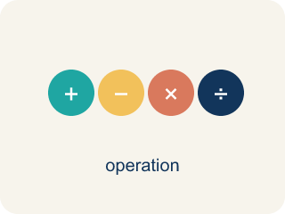
Divide Multi-Digit Numbers (Dividir números de varias cifras) — Separate a multi-digit number into equal groups to find a quotient.
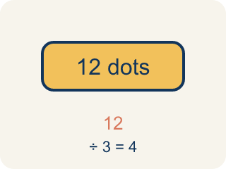
Dividend (Dividendo) — The number you are splitting up in a division problem.
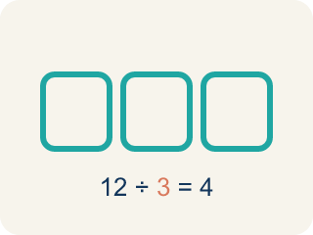
Divisor (Divisor) — The number you split by in a division problem.
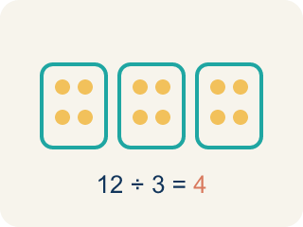
Quotient (Cociente) — The answer when you divide.
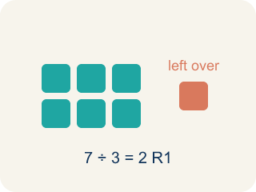
Remainder (Residuo) — What is left over when a number does not divide evenly.
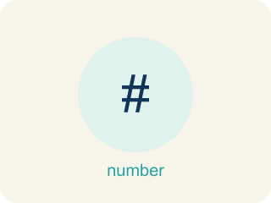
Long division (División larga) — A method that repeats four steps — divide, multiply, subtract, bring down — until there are no digits left to bring down.

Bring down (Bajar el dígito) — The fourth step of long division: move the next digit of the dividend down next to what is left, then start the cycle again.

Practice
Show your work. Use the blank space under each problem.
1. What is 936 ÷ 12?
A. 78
B. 87
C. 68
D. 76
______________________________________________________________________
2. What is 2,485 ÷ 5?
A. 497
B. 487
C. 507
D. 496
______________________________________________________________________
3. Complete each division problem.
Division Problem | Quotient
672 ÷ 8
2,208 ÷ 16
2,016 ÷ 14
1,560 ÷ 15
3,276 ÷ 12
______________________________________________________________________
4. Match each division problem to its quotient.
Item | Answer choices
____ 450 ÷ 18 | F. 73
____ 1,008 ÷ 16 | E. 72
____ 1,440 ÷ 24 | D. 140
____ 2,100 ÷ 15 | C. 60
____ 864 ÷ 12 | B. 63
____ 1,825 ÷ 25 | A. 25
______________________________________________________________________
5. A warehouse has 2,184 items to pack into boxes of 14. How many boxes are needed?
A. 156 boxes
B. 146 boxes
C. 166 boxes
D. 155 boxes
______________________________________________________________________
6. Sort each division problem: does it divide evenly (no remainder), or does it have a remainder?
Groups: Divides Evenly | Has a Remainder
• 144 ÷ 12 = 12 → __________________
• 480 ÷ 16 = 30 → __________________
• 1,000 ÷ 8 = 125 → __________________
• 100 ÷ 7 = 14 R 2 → __________________
• 500 ÷ 13 = 38 R 6 → __________________
• 250 ÷ 9 = 27 R 7 → __________________
______________________________________________________________________
7. Spot the Mistake in 2,058 ÷ 14
Step 1 (Problem): Divide 2,058 ÷ 14 with long division. Dividend = 2,058, divisor = 14.
Step 2 (Divide, Multiply, Subtract): 14 does not fit into 2, so start with 20. 20 ÷ 14 → 1. 1 × 14 = 14, and 20 − 14 = 6
Step 3 (Bring down, repeat): Bring down the 5 to make 65. 65 ÷ 14 → 4. 4 × 14 = 56, and 65 − 56 = 9
Step 4 (Bring down, repeat): Bring down the 8 to make 98. 98 ÷ 14 → 8. 8 × 14 = 112, and 98 − 112 = −14
Step 5 (Final answer): Quotient = 148
Which step has the mistake? Explain and fix it:
______________________________________________________________________
______________________________________________________________________
______________________________________________________________________
8. What is 4,896 ÷ 12?
A. 408
B. 48
C. 480
D. 380
______________________________________________________________________
9. What is 7,225 ÷ 25?
A. 289
B. 29
C. 2,890
D. 389
______________________________________________________________________
10. A school orders 3,648 pencils packed 24 to a box. How many boxes are there?
A. 152
B. 148
C. 160
D. 144
______________________________________________________________________

Answer Key (Teacher)
1. A. 78
12 × 78 = 936. You can verify: 12 × 70 = 840, 12 × 8 = 96, 840 + 96 = 936.
Watch for: A common mistake in Divide Multi-Digit Numbers is skipping a placeholder zero in the quotient when a digit doesn't divide evenly, which shifts every digit after it out of place. For example, dividing 3,216 ÷ 3: 3 ÷ 3 = 1, but the next digit 2 doesn't divide by 3, so a 0 must be written before continuing — bring down the 1 to make 21 ÷ 3 = 7, then bring down 6 ÷ 3 = 2, giving the correct quotient 1,072. A student who skips writing that 0 and jumps straight to 21 ÷ 3 = 7 ends up with 172 instead of 1,072 — an answer off by a factor of ten. Always check: does a digit in your quotient go missing every time you 'can't divide'? If so, you dropped a placeholder zero.
2. A. 497
5 × 497 = 2,485. Running the cycle: 24 ÷ 5 → 4 with 4 left, 48 ÷ 5 → 9 with 3 left, 35 ÷ 5 → 7 with 0 left, so the quotient is 497 and the remainder is 0.
Watch for: A common mistake in Divide Multi-Digit Numbers is skipping a placeholder zero in the quotient when a digit doesn't divide evenly, which shifts every digit after it out of place. For example, dividing 3,216 ÷ 3: 3 ÷ 3 = 1, but the next digit 2 doesn't divide by 3, so a 0 must be written before continuing — bring down the 1 to make 21 ÷ 3 = 7, then bring down 6 ÷ 3 = 2, giving the correct quotient 1,072. A student who skips writing that 0 and jumps straight to 21 ÷ 3 = 7 ends up with 172 instead of 1,072 — an answer off by a factor of ten. Always check: does a digit in your quotient go missing every time you 'can't divide'? If so, you dropped a placeholder zero.
3. Complete each division problem.
672 ÷ 8 → 84
2,208 ÷ 16 → 138
2,016 ÷ 14 → 144
1,560 ÷ 15 → 104
3,276 ÷ 12 → 273

4. Matches:
450 ÷ 18 → 25
1,008 ÷ 16 → 63
1,440 ÷ 24 → 60
2,100 ÷ 15 → 140
864 ÷ 12 → 72
1,825 ÷ 25 → 73

5. A. 156 boxes
2,184 ÷ 14 = 156. Check: 14 × 156 = 14 × 150 + 14 × 6 = 2,100 + 84 = 2,184.
Watch for: A common mistake in Divide Multi-Digit Numbers is skipping a placeholder zero in the quotient when a digit doesn't divide evenly, which shifts every digit after it out of place. For example, dividing 3,216 ÷ 3: 3 ÷ 3 = 1, but the next digit 2 doesn't divide by 3, so a 0 must be written before continuing — bring down the 1 to make 21 ÷ 3 = 7, then bring down 6 ÷ 3 = 2, giving the correct quotient 1,072. A student who skips writing that 0 and jumps straight to 21 ÷ 3 = 7 ends up with 172 instead of 1,072 — an answer off by a factor of ten. Always check: does a digit in your quotient go missing every time you 'can't divide'? If so, you dropped a placeholder zero.
6. Correct groups:
144 ÷ 12 = 12 → Divides Evenly
480 ÷ 16 = 30 → Divides Evenly
1,000 ÷ 8 = 125 → Divides Evenly
100 ÷ 7 = 14 R 2 → Has a Remainder
500 ÷ 13 = 38 R 6 → Has a Remainder
250 ÷ 9 = 27 R 7 → Has a Remainder

7. Spot the Mistake in 2,058 ÷ 14
The mistake is in Step 4.
Correct work: The DIVIDE step in the last cycle chose a digit that is too big: 8 × 14 = 112 is more than the 98 you have to subtract from, and you can never subtract more than the working number. The right digit is 7, since 7 × 14 = 98 and 98 − 98 = 0. The quotient is 147 with remainder 0, and 14 × 147 = 2,058 rebuilds the dividend.
Watch for: The last DIVIDE step is where it breaks: the student wrote 8, but 8 × 14 = 112 is larger than the 98 they had to subtract from, so the difference came out negative. The largest digit that fits is 7, since 7 × 14 = 98 leaves 0, so the quotient is 147 and 14 × 147 = 2,058 checks out.
8. A. 408
12 × 408 = 4,896.
Watch for: A common mistake in Divide Multi-Digit Numbers is skipping a placeholder zero in the quotient when a digit doesn't divide evenly, which shifts every digit after it out of place. For example, dividing 3,216 ÷ 3: 3 ÷ 3 = 1, but the next digit 2 doesn't divide by 3, so a 0 must be written before continuing — bring down the 1 to make 21 ÷ 3 = 7, then bring down 6 ÷ 3 = 2, giving the correct quotient 1,072. A student who skips writing that 0 and jumps straight to 21 ÷ 3 = 7 ends up with 172 instead of 1,072 — an answer off by a factor of ten. Always check: does a digit in your quotient go missing every time you 'can't divide'? If so, you dropped a placeholder zero.
9. A. 289
25 × 289 = 7,225.
Watch for: A common mistake in Divide Multi-Digit Numbers is skipping a placeholder zero in the quotient when a digit doesn't divide evenly, which shifts every digit after it out of place. For example, dividing 3,216 ÷ 3: 3 ÷ 3 = 1, but the next digit 2 doesn't divide by 3, so a 0 must be written before continuing — bring down the 1 to make 21 ÷ 3 = 7, then bring down 6 ÷ 3 = 2, giving the correct quotient 1,072. A student who skips writing that 0 and jumps straight to 21 ÷ 3 = 7 ends up with 172 instead of 1,072 — an answer off by a factor of ten. Always check: does a digit in your quotient go missing every time you 'can't divide'? If so, you dropped a placeholder zero.
10. A. 152
3,648 ÷ 24 = 152 boxes.
Watch for: A common mistake in Divide Multi-Digit Numbers is skipping a placeholder zero in the quotient when a digit doesn't divide evenly, which shifts every digit after it out of place. For example, dividing 3,216 ÷ 3: 3 ÷ 3 = 1, but the next digit 2 doesn't divide by 3, so a 0 must be written before continuing — bring down the 1 to make 21 ÷ 3 = 7, then bring down 6 ÷ 3 = 2, giving the correct quotient 1,072. A student who skips writing that 0 and jumps straight to 21 ÷ 3 = 7 ends up with 172 instead of 1,072 — an answer off by a factor of ten. Always check: does a digit in your quotient go missing every time you 'can't divide'? If so, you dropped a placeholder zero.

