1.4–1.7 Catch-Up — Homework
Lesson 2-7-catchup • Standard 6.NOS.3
Name: ______________________ Period: ______ Date: ____________

Today's Goals
Content: I can show I am caught up on Lessons 1.4–1.7 by using each lesson's big idea in mixed practice.
Language: I can explain which lesson's big idea I used and how, using key vocabulary from Lessons 1.4–1.7.

Key Words
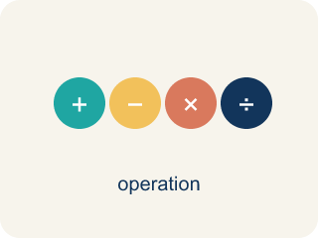
Divide Multi-Digit Numbers (Dividir números de varias cifras) — Separate a multi-digit number into equal groups to find a quotient.
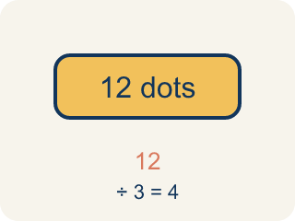
Dividend (Dividendo) — The number you are splitting up in a division problem.

Add and Subtract Decimals (Sumar y restar decimales) — Combine or find the difference between decimals by lining up equal place values.
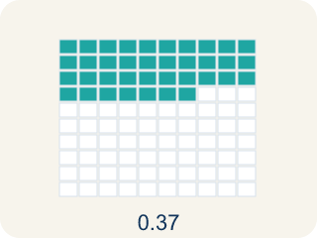
Decimal (Decimal) — A number with a dot, like 0.5, that shows a part less than one.

Multiply Decimals (Multiplicar decimales) — Find the product of decimals, then use place value to place the decimal point.
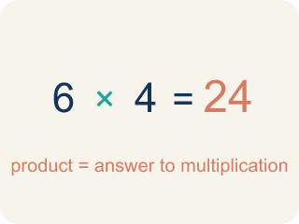
Product (Producto) — The answer when you multiply.

Divide Decimals (Dividir decimales) — Find a quotient with decimals by making the divisor a whole number first.
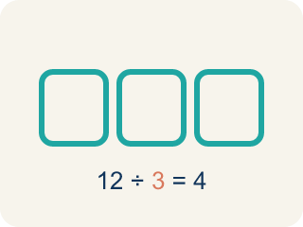
Divisor (Divisor) — The number you split by in a division problem.
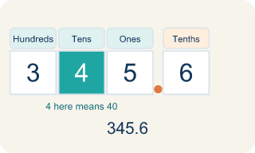
Place value (Valor posicional) — What a digit is worth based on where it sits in a number.
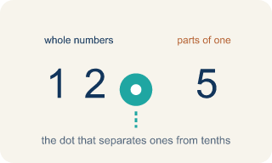
Decimal point (Punto decimal) — The dot that splits the whole number from the part after it.

Practice
Show your work. Use the blank space under each problem.
1. (Lesson 1.4) What is 936 ÷ 12?
A. 78
B. 87
C. 68
D. 76
______________________________________________________________________
2. (Lesson 1.4) What is 2,485 ÷ 5?
A. 497
B. 487
C. 507
D. 496
______________________________________________________________________
3. (Lesson 1.4) A warehouse has 2,184 items to pack into boxes of 14. How many boxes are needed?
A. 156 boxes
B. 146 boxes
C. 166 boxes
D. 155 boxes
______________________________________________________________________
4. (Lesson 1.4) Spot the Mistake in 2,058 ÷ 14
Step 1 (Problem): Divide 2,058 ÷ 14 with long division. Dividend = 2,058, divisor = 14.
Step 2 (Divide, Multiply, Subtract): 14 does not fit into 2, so start with 20. 20 ÷ 14 → 1. 1 × 14 = 14, and 20 − 14 = 6
Step 3 (Bring down, repeat): Bring down the 5 to make 65. 65 ÷ 14 → 4. 4 × 14 = 56, and 65 − 56 = 9
Step 4 (Bring down, repeat): Bring down the 8 to make 98. 98 ÷ 14 → 8. 8 × 14 = 112, and 98 − 112 = −14
Step 5 (Final answer): Quotient = 148
Which step has the mistake? Explain and fix it:
______________________________________________________________________
______________________________________________________________________
______________________________________________________________________
5. (Lesson 1.5) A student buys items costing $4.59, $12.75, and $3.80. What is the total cost?
A. $21.14
B. $20.14
C. $21.04
D. $21.24
______________________________________________________________________
6. (Lesson 1.5) Spot the Mistake — Subtracting Without a Placeholder
Step 1 (Problem): Subtract 12.5 − 3.45
Step 2 (Set up): Left 12.5 as one decimal place instead of annexing a zero
Step 3 (Subtract): 12.5 − 3.45 = 9.5
Step 4 (Final answer): 9.5
Which step has the mistake? Explain and fix it:
______________________________________________________________________
______________________________________________________________________
______________________________________________________________________
7. (Lesson 1.6) A car travels 55.5 miles per hour for 2.4 hours. How far does it go?
A. 133.2 miles
B. 13.32 miles
C. 1,332 miles
D. 57.9 miles
______________________________________________________________________
8. (Lesson 1.6) Spot the Common Mistake — Placing the Decimal Point
Step 1 (Problem): 1.5 × 2.4
Step 2 (Multiply as whole numbers): 15 × 24 = 360
Step 3 (Count decimal places): 1.5 has 1 decimal place and 2.4 has 1 decimal place → 2 total
Step 4 (Place the decimal point): Move the point 2 places in 360 to get 0.36
Which step has the mistake? Explain and fix it:
______________________________________________________________________
______________________________________________________________________
______________________________________________________________________
9. (Lesson 1.7) A water tank holds 19.2 liters. It is poured into bottles that each hold 1.6 liters. How many bottles can be filled?
A. 12 bottles
B. 11 bottles
C. 13 bottles
D. 1.2 bottles
______________________________________________________________________
10. (Lesson 1.7) Spot the Common Mistake
Step 1 (Problem): Solve 9.6 ÷ 0.12.
Step 2 (Count how far to move): 0.12 has 2 decimal places, so BOTH numbers move 2 places right. The divisor: 0.12 → 12.
Step 3 (Move the dividend the same 2 places): 9.6 only has one digit after the point, so the student moved it just 1 place: 9.6 → 96. New problem: 96 ÷ 12 = 8.
Which step has the mistake? Explain and fix it:
______________________________________________________________________
______________________________________________________________________
______________________________________________________________________

Answer Key (Teacher)
1. A. 78
12 × 78 = 936. You can verify: 12 × 70 = 840, 12 × 8 = 96, 840 + 96 = 936.
Watch for: A common mistake in Divide Decimals is moving the decimal point in the divisor but forgetting to move it the same number of places in the dividend. For example, in 6.4 ÷ 0.8 a student changes 0.8 to 8 but leaves the dividend as 6.4, then divides 6.4 ÷ 8 = 0.8 instead of moving both points to get 64 ÷ 8 = 8. A second version of this mistake happens when the divisor has two decimal places, like 0.12: students move both points only 1 place instead of 2, turning 9.6 ÷ 0.12 into 96 ÷ 1.2 instead of the correct 960 ÷ 12. Count the divisor's decimal places first, then move BOTH points that same number of places.
2. A. 497
5 × 497 = 2,485. Running the cycle: 24 ÷ 5 → 4 with 4 left, 48 ÷ 5 → 9 with 3 left, 35 ÷ 5 → 7 with 0 left, so the quotient is 497 and the remainder is 0.
Watch for: A common mistake in Divide Decimals is moving the decimal point in the divisor but forgetting to move it the same number of places in the dividend. For example, in 6.4 ÷ 0.8 a student changes 0.8 to 8 but leaves the dividend as 6.4, then divides 6.4 ÷ 8 = 0.8 instead of moving both points to get 64 ÷ 8 = 8. A second version of this mistake happens when the divisor has two decimal places, like 0.12: students move both points only 1 place instead of 2, turning 9.6 ÷ 0.12 into 96 ÷ 1.2 instead of the correct 960 ÷ 12. Count the divisor's decimal places first, then move BOTH points that same number of places.
3. A. 156 boxes
2,184 ÷ 14 = 156. Check: 14 × 156 = 14 × 150 + 14 × 6 = 2,100 + 84 = 2,184.
Watch for: A common mistake in Divide Decimals is moving the decimal point in the divisor but forgetting to move it the same number of places in the dividend. For example, in 6.4 ÷ 0.8 a student changes 0.8 to 8 but leaves the dividend as 6.4, then divides 6.4 ÷ 8 = 0.8 instead of moving both points to get 64 ÷ 8 = 8. A second version of this mistake happens when the divisor has two decimal places, like 0.12: students move both points only 1 place instead of 2, turning 9.6 ÷ 0.12 into 96 ÷ 1.2 instead of the correct 960 ÷ 12. Count the divisor's decimal places first, then move BOTH points that same number of places.
4. (Lesson 1.4) Spot the Mistake in 2,058 ÷ 14
The mistake is in Step 4.
Correct work: The DIVIDE step in the last cycle chose a digit that is too big: 8 × 14 = 112 is more than the 98 you have to subtract from, and you can never subtract more than the working number. The right digit is 7, since 7 × 14 = 98 and 98 − 98 = 0. The quotient is 147 with remainder 0, and 14 × 147 = 2,058 rebuilds the dividend.
Watch for: The last DIVIDE step is where it breaks: the student wrote 8, but 8 × 14 = 112 is larger than the 98 they had to subtract from, so the difference came out negative. The largest digit that fits is 7, since 7 × 14 = 98 leaves 0, so the quotient is 147 and 14 × 147 = 2,058 checks out.
5. A. $21.14
4.59 + 12.75 + 3.80 = 21.14. Line up decimal points and add column by column.
Watch for: A common mistake in Divide Decimals is moving the decimal point in the divisor but forgetting to move it the same number of places in the dividend. For example, in 6.4 ÷ 0.8 a student changes 0.8 to 8 but leaves the dividend as 6.4, then divides 6.4 ÷ 8 = 0.8 instead of moving both points to get 64 ÷ 8 = 8. A second version of this mistake happens when the divisor has two decimal places, like 0.12: students move both points only 1 place instead of 2, turning 9.6 ÷ 0.12 into 96 ÷ 1.2 instead of the correct 960 ÷ 12. Count the divisor's decimal places first, then move BOTH points that same number of places.
6. (Lesson 1.5) Spot the Mistake — Subtracting Without a Placeholder
The mistake is in Step 2.
Correct work: The student did not annex a zero, so the hundredths place had nothing to subtract from. Write 12.5 as 12.50, then line up the decimal points: 12.50 − 3.45. Hundredths: 0 − 5 → borrow → 10 − 5 = 5. Tenths: 4 − 4 = 0 (after borrowing). Ones: 2 − 3 → borrow → 12 − 3 = 9. Tens: 0 (after borrowing). The correct difference is 9.05.
Watch for: The Set up step is the problem: 12.5 was left with one decimal place while 3.45 has two, so the hundredths column had nothing to subtract from. Write 12.5 as 12.50 and subtract with the points aligned — 0 − 5 needs a borrow, giving 5 hundredths, then 4 − 4 = 0 tenths and 12 − 3 = 9 ones. The correct difference is 9.05, not 9.5.
7. A. 133.2 miles
555 × 24 = 13,320. Total decimal places: 1 + 1 = 2. Answer: 133.20 = 133.2 miles.
Watch for: A common mistake in Divide Decimals is moving the decimal point in the divisor but forgetting to move it the same number of places in the dividend. For example, in 6.4 ÷ 0.8 a student changes 0.8 to 8 but leaves the dividend as 6.4, then divides 6.4 ÷ 8 = 0.8 instead of moving both points to get 64 ÷ 8 = 8. A second version of this mistake happens when the divisor has two decimal places, like 0.12: students move both points only 1 place instead of 2, turning 9.6 ÷ 0.12 into 96 ÷ 1.2 instead of the correct 960 ÷ 12. Count the divisor's decimal places first, then move BOTH points that same number of places.
8. (Lesson 1.6) Spot the Common Mistake — Placing the Decimal Point
The mistake is in Step 4.
Correct work: The whole-number product 15 × 24 = 360 and the count of 2 decimal places are both correct. The mistake is in placing the point: moving it 2 places from the right in 360 gives 3.60, not 0.36. So 1.5 × 2.4 = 3.6. An estimate of 2 × 2 = 4 confirms 3.6 is reasonable, while 0.36 is far too small.
Watch for: The digits 15 × 24 = 360 and the count of 2 decimal places are both correct; only the placement is off. Counting 2 places from the right end of 360 lands the point between the 3 and the 6, giving 3.60 = 3.6. An estimate of 2 × 2 = 4 confirms that 3.6 is the reasonable size and 0.36 is about ten times too small.
9. A. 12 bottles
19.2 ÷ 1.6: multiply both by 10 → 192 ÷ 16 = 12 bottles.
Watch for: A common mistake in Divide Decimals is moving the decimal point in the divisor but forgetting to move it the same number of places in the dividend. For example, in 6.4 ÷ 0.8 a student changes 0.8 to 8 but leaves the dividend as 6.4, then divides 6.4 ÷ 8 = 0.8 instead of moving both points to get 64 ÷ 8 = 8. A second version of this mistake happens when the divisor has two decimal places, like 0.12: students move both points only 1 place instead of 2, turning 9.6 ÷ 0.12 into 96 ÷ 1.2 instead of the correct 960 ÷ 12. Count the divisor's decimal places first, then move BOTH points that same number of places.
10. (Lesson 1.7) Spot the Common Mistake
The mistake is in Step 3.
Correct work: Both numbers must move the SAME number of places — 2, not 1. 9.6 runs out of digits after one place, so you add a placeholder zero to move the second place: 9.6 → 96 → 960. The real problem is 960 ÷ 12 = 80, so 9.6 ÷ 0.12 = 80. Estimate to confirm: 0.12 is tiny, so many of them fit in 9.6 — the quotient must be large, not 8. Check: 80 × 0.12 = 9.6. ✓
Watch for: In the last step the dividend moved only 1 place while the divisor moved 2, so the two numbers no longer match. Adding a placeholder zero lets 9.6 move both places to 960, making the real problem 960 ÷ 12 = 80. That size is reasonable, because a great many 0.12s fit inside 9.6.

