2.7 Small Group · Group 1 — Homework
Lesson 2-7-group1 • Standard 6.NOS.3
Name: ______________________ Period: ______ Date: ____________

Today's Goals
Content: With my small group, I can divide with decimals by making the divisor a whole number first — one step at a time, with support.
Language: I can talk through each step out loud using a sentence frame and the lesson's key words.

Key Words
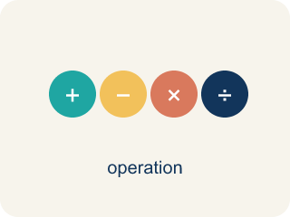
Divide Decimals (Dividir decimales) — Find a quotient with decimals by making the divisor a whole number first.
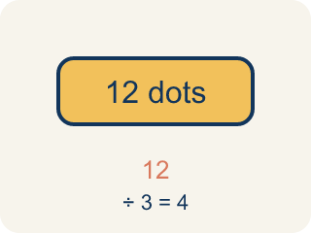
Dividend (Dividendo) — The number you are splitting up in a division problem.
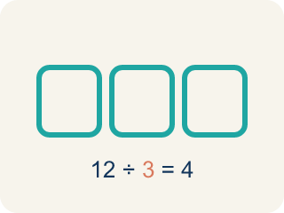
Divisor (Divisor) — The number you split by in a division problem.
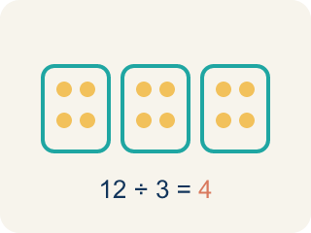
Quotient (Cociente) — The answer when you divide.
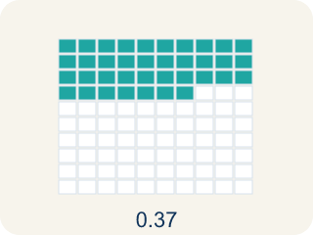
Decimal division (División decimal) — Dividing with decimals. First move the point to make the number you divide by whole, then run the long-division cycle.
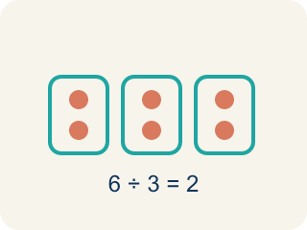
Equivalent division (División equivalente) — Multiplying both numbers by 10 or 100 gives the same answer.

Practice
Show your work. Use the blank space under each problem.
1. What is 14.4 ÷ 1.2?
A. 12
B. 1.2
C. 120
D. 0.12
______________________________________________________________________
2. What is 3.78 ÷ 0.6?
A. 6.3
B. 63
C. 0.63
D. 0.063
______________________________________________________________________
3. What is 4.8 ÷ 0.6?
A. 8
B. 0.8
C. 80
D. 4.2
______________________________________________________________________
4. What is 9.45 ÷ 0.9?
A. 10.5
B. 1.05
C. 105
D. 9.5
______________________________________________________________________
5. A ribbon is 7.2 meters long and is cut into 0.8-meter pieces. How many pieces are there?
A. 9
B. 8
C. 7
D. 10
______________________________________________________________________
6. What is 15 ÷ 0.25?
A. 60
B. 6
C. 1.5
D. 0.6
______________________________________________________________________
7. Table 1 splits a $15.00 lunch bill equally among 4 friends. How much does each friend pay?
A. $3.75
B. $3.05
C. $5.30
D. $37.50
______________________________________________________________________
8. A recipe uses 9.6 cups of flour to make 3 equal batches of muffins. How many cups of flour go in each batch?
A. 3.2 cups
B. 2.3 cups
C. 32 cups
D. 6.6 cups
______________________________________________________________________

Answer Key (Teacher)
1. A. 12
Multiply both by 10: 144 ÷ 12 = 12.
Watch for: A common mistake in Divide Decimals is moving the decimal point in the divisor but forgetting to move it the same number of places in the dividend. For example, in 6.4 ÷ 0.8 a student changes 0.8 to 8 but leaves the dividend as 6.4, then divides 6.4 ÷ 8 = 0.8 instead of moving both points to get 64 ÷ 8 = 8. A second version of this mistake happens when the divisor has two decimal places, like 0.12: students move both points only 1 place instead of 2, turning 9.6 ÷ 0.12 into 96 ÷ 1.2 instead of the correct 960 ÷ 12. Count the divisor's decimal places first, then move BOTH points that same number of places.
2. A. 6.3
Multiply both by 10: 37.8 ÷ 6 = 6.3.
Watch for: A common mistake in Divide Decimals is moving the decimal point in the divisor but forgetting to move it the same number of places in the dividend. For example, in 6.4 ÷ 0.8 a student changes 0.8 to 8 but leaves the dividend as 6.4, then divides 6.4 ÷ 8 = 0.8 instead of moving both points to get 64 ÷ 8 = 8. A second version of this mistake happens when the divisor has two decimal places, like 0.12: students move both points only 1 place instead of 2, turning 9.6 ÷ 0.12 into 96 ÷ 1.2 instead of the correct 960 ÷ 12. Count the divisor's decimal places first, then move BOTH points that same number of places.
3. A. 8
Multiply both by 10: 48 ÷ 6 = 8.
Watch for: A common mistake in Divide Decimals is moving the decimal point in the divisor but forgetting to move it the same number of places in the dividend. For example, in 6.4 ÷ 0.8 a student changes 0.8 to 8 but leaves the dividend as 6.4, then divides 6.4 ÷ 8 = 0.8 instead of moving both points to get 64 ÷ 8 = 8. A second version of this mistake happens when the divisor has two decimal places, like 0.12: students move both points only 1 place instead of 2, turning 9.6 ÷ 0.12 into 96 ÷ 1.2 instead of the correct 960 ÷ 12. Count the divisor's decimal places first, then move BOTH points that same number of places.
4. A. 10.5
Multiply both by 10: 94.5 ÷ 9 = 10.5.
Watch for: A common mistake in Divide Decimals is moving the decimal point in the divisor but forgetting to move it the same number of places in the dividend. For example, in 6.4 ÷ 0.8 a student changes 0.8 to 8 but leaves the dividend as 6.4, then divides 6.4 ÷ 8 = 0.8 instead of moving both points to get 64 ÷ 8 = 8. A second version of this mistake happens when the divisor has two decimal places, like 0.12: students move both points only 1 place instead of 2, turning 9.6 ÷ 0.12 into 96 ÷ 1.2 instead of the correct 960 ÷ 12. Count the divisor's decimal places first, then move BOTH points that same number of places.
5. A. 9
7.2 ÷ 0.8 = 72 ÷ 8 = 9 pieces.
Watch for: A common mistake in Divide Decimals is moving the decimal point in the divisor but forgetting to move it the same number of places in the dividend. For example, in 6.4 ÷ 0.8 a student changes 0.8 to 8 but leaves the dividend as 6.4, then divides 6.4 ÷ 8 = 0.8 instead of moving both points to get 64 ÷ 8 = 8. A second version of this mistake happens when the divisor has two decimal places, like 0.12: students move both points only 1 place instead of 2, turning 9.6 ÷ 0.12 into 96 ÷ 1.2 instead of the correct 960 ÷ 12. Count the divisor's decimal places first, then move BOTH points that same number of places.
6. A. 60
Dividing by 0.25 is like multiplying by 4: 15 × 4 = 60.
Watch for: A common mistake in Divide Decimals is moving the decimal point in the divisor but forgetting to move it the same number of places in the dividend. For example, in 6.4 ÷ 0.8 a student changes 0.8 to 8 but leaves the dividend as 6.4, then divides 6.4 ÷ 8 = 0.8 instead of moving both points to get 64 ÷ 8 = 8. A second version of this mistake happens when the divisor has two decimal places, like 0.12: students move both points only 1 place instead of 2, turning 9.6 ÷ 0.12 into 96 ÷ 1.2 instead of the correct 960 ÷ 12. Count the divisor's decimal places first, then move BOTH points that same number of places.
7. A. $3.75
$15.00 ÷ 4 = $3.75. Each friend pays $3.75.
Watch for: A common mistake in Divide Decimals is moving the decimal point in the divisor but forgetting to move it the same number of places in the dividend. For example, in 6.4 ÷ 0.8 a student changes 0.8 to 8 but leaves the dividend as 6.4, then divides 6.4 ÷ 8 = 0.8 instead of moving both points to get 64 ÷ 8 = 8. A second version of this mistake happens when the divisor has two decimal places, like 0.12: students move both points only 1 place instead of 2, turning 9.6 ÷ 0.12 into 96 ÷ 1.2 instead of the correct 960 ÷ 12. Count the divisor's decimal places first, then move BOTH points that same number of places.
8. A. 3.2 cups
9.6 ÷ 3 = 3.2 cups in each batch.
Watch for: A common mistake in Divide Decimals is moving the decimal point in the divisor but forgetting to move it the same number of places in the dividend. For example, in 6.4 ÷ 0.8 a student changes 0.8 to 8 but leaves the dividend as 6.4, then divides 6.4 ÷ 8 = 0.8 instead of moving both points to get 64 ÷ 8 = 8. A second version of this mistake happens when the divisor has two decimal places, like 0.12: students move both points only 1 place instead of 2, turning 9.6 ÷ 0.12 into 96 ÷ 1.2 instead of the correct 960 ÷ 12. Count the divisor's decimal places first, then move BOTH points that same number of places.

