2.7 Small Group · Group 2 — Homework
Lesson 2-7-group2 • Standard 6.NOS.3
Name: ______________________ Period: ______ Date: ____________

Today's Goals
Content: I can divide with decimals by making the divisor a whole number first, explain why the method works, and use it on a problem I have not seen before.
Language: I can justify my answer to a skeptic and connect it to a second strategy or representation.

Key Words
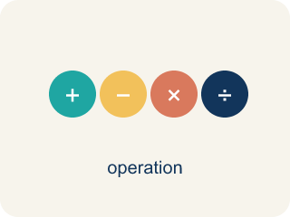
Divide Decimals (Dividir decimales) — Find a quotient with decimals by making the divisor a whole number first.
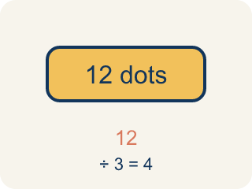
Dividend (Dividendo) — The number you are splitting up in a division problem.
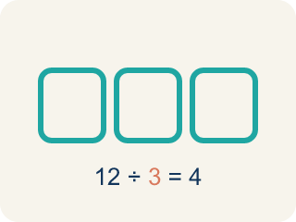
Divisor (Divisor) — The number you split by in a division problem.
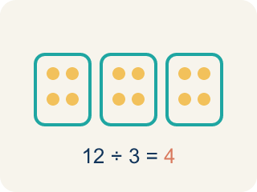
Quotient (Cociente) — The answer when you divide.
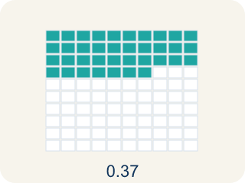
Decimal division (División decimal) — Dividing with decimals. First move the point to make the number you divide by whole, then run the long-division cycle.
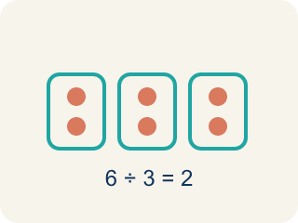
Equivalent division (División equivalente) — Multiplying both numbers by 10 or 100 gives the same answer.

Practice
Show your work. Use the blank space under each problem.
1. A water tank holds 19.2 liters. It is poured into bottles that each hold 1.6 liters. How many bottles can be filled?
A. 12 bottles
B. 11 bottles
C. 13 bottles
D. 1.2 bottles
______________________________________________________________________
2. Spot the Common Mistake
Step 1 (Problem): Solve 9.6 ÷ 0.12.
Step 2 (Count how far to move): 0.12 has 2 decimal places, so BOTH numbers move 2 places right. The divisor: 0.12 → 12.
Step 3 (Move the dividend the same 2 places): 9.6 only has one digit after the point, so the student moved it just 1 place: 9.6 → 96. New problem: 96 ÷ 12 = 8.
Which step has the mistake? Explain and fix it:
______________________________________________________________________
______________________________________________________________________
______________________________________________________________________
3. Find Derek's Mistake
Step 1 (Problem): 7.2 ÷ 0.45
Step 2 (Multiply divisor by 10): 0.45 × 10 = 4.5
Step 3 (Multiply dividend by 10): 7.2 × 10 = 72
Step 4 (Divide): 72 ÷ 4.5 = 16
Which step has the mistake? Explain and fix it:
______________________________________________________________________
______________________________________________________________________
______________________________________________________________________
4. A gas station sells fuel at $3.45 per gallon. A customer pays $27.60 total. How many gallons did the customer buy? Set up the decimal division, show how to convert it to whole-number division, and solve.
Sentence starter: The equation is $27.60 ÷ $3.45 = ___. I multiply both by ___ to get ___ ÷ ___ = ___ gallons.
______________________________________________________________________
______________________________________________________________________
______________________________________________________________________
______________________________________________________________________

Answer Key (Teacher)
1. A. 12 bottles
19.2 ÷ 1.6: multiply both by 10 → 192 ÷ 16 = 12 bottles.
Watch for: A common mistake in Divide Decimals is moving the decimal point in the divisor but forgetting to move it the same number of places in the dividend. For example, in 6.4 ÷ 0.8 a student changes 0.8 to 8 but leaves the dividend as 6.4, then divides 6.4 ÷ 8 = 0.8 instead of moving both points to get 64 ÷ 8 = 8. A second version of this mistake happens when the divisor has two decimal places, like 0.12: students move both points only 1 place instead of 2, turning 9.6 ÷ 0.12 into 96 ÷ 1.2 instead of the correct 960 ÷ 12. Count the divisor's decimal places first, then move BOTH points that same number of places.
2. Spot the Common Mistake
The mistake is in Step 3.
Correct work: Both numbers must move the SAME number of places — 2, not 1. 9.6 runs out of digits after one place, so you add a placeholder zero to move the second place: 9.6 → 96 → 960. The real problem is 960 ÷ 12 = 80, so 9.6 ÷ 0.12 = 80. Estimate to confirm: 0.12 is tiny, so many of them fit in 9.6 — the quotient must be large, not 8. Check: 80 × 0.12 = 9.6. ✓
Watch for: In the last step the dividend moved only 1 place while the divisor moved 2, so the two numbers no longer match. Adding a placeholder zero lets 9.6 move both places to 960, making the real problem 960 ÷ 12 = 80. That size is reasonable, because a great many 0.12s fit inside 9.6.
3. Find Derek's Mistake
The mistake is in Step 2.
Correct work: Derek only multiplied by 10, but the divisor 0.45 has two decimal places. He should multiply both numbers by 100: 720 ÷ 45 = 16. He got the right answer by luck this time, but his method is unreliable because the divisor is still a decimal (4.5).
Watch for: In the step where Derek multiplied by 10, the divisor only became 4.5 — still a decimal, so the setup was never finished. Because 0.45 has two decimal places, both numbers need ×100, giving 720 ÷ 45 = 16. The quotient does not change, but leaving a decimal divisor makes the long division far harder than it needs to be.
4. Open response — answers will vary.
Look for key words: divide, decimal, quotient, multiply by 100, 8, whole number, equivalent.

