8.1–8.3 Catch-Up — Homework
Lesson 2-9-catchup • Standard 6.DS.6c
Name: ______________________ Period: ______ Date: ____________

Today's Goals
Content: I can show I am caught up on Lessons 8.1–8.3 by using each lesson's big idea in mixed practice.
Language: I can explain which lesson's big idea I used and how, using key vocabulary from Lessons 8.1–8.3.

Key Words
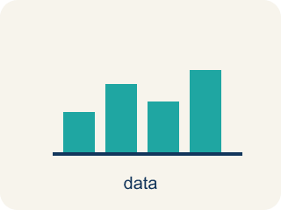
Statistical Questions and Data (Preguntas estadísticas y datos) — A statistical question expects varied answers that can be collected as data.
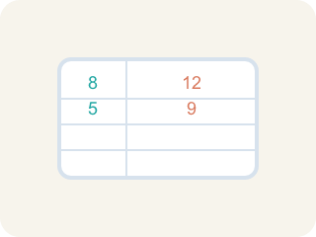
Statistical Question (Pregunta estadística) — A question where the answers will be different for different people.

Mean, Median, and Mode (Media, mediana y moda) — Measures that describe a data set's center: average, middle value, and most frequent value.
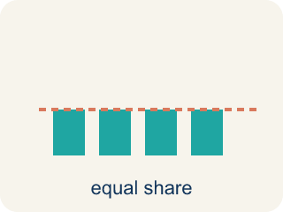
Mean (Media) — The average. Add all the numbers, then divide by how many there are.
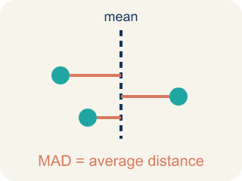
Mean Absolute Deviation (Desviación media absoluta) — The average distance of data values from the mean; it describes spread.

Deviation (Desviación) — How far a number is from the mean.

Non-statistical Question (Pregunta no estadística) — A question that has just one fixed answer that is the same no matter who you ask, so there is no data to collect.
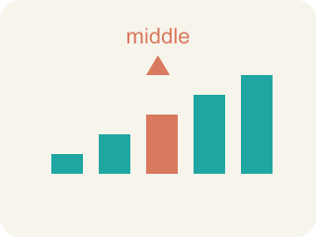
Median (Mediana) — The middle number when you put them in order.

Practice
Show your work. Use the blank space under each problem.
1. (Lesson 8.1) Which of the following is a statistical question?
A. How many points did each player score this season?
B. How many points are scored for a free throw?
C. What sport does this team play?
D. How many halves are in a soccer game?
______________________________________________________________________
2. (Lesson 8.1) Which question is NOT a statistical question?
A. How many innings are in a baseball game?
B. How many home runs did each player hit this year?
C. How many miles does each runner train per week?
D. How tall is each player on the basketball team?
______________________________________________________________________
3. (Lesson 8.1) A coach asks: "How many hours does each athlete on the track team sleep the night before a meet?" Why is this a statistical question?
A. Because the answers will vary from athlete to athlete
B. Because it is about sports
C. Because it has a numerical answer
D. Because the coach asked it
______________________________________________________________________
4. (Lesson 8.1) Spot the Common Mistake
Step 1 (Question): How many points does the team need to win a game?
Step 2 (Student decision): This IS a statistical question.
Step 3 (Student reason): It is about basketball and the answer is a number, so it must be statistical.
Which step has the mistake? Explain and fix it:
______________________________________________________________________
______________________________________________________________________
______________________________________________________________________
5. (Lesson 8.2) Data set: 4, 6, 6, 8, 10, 12. What is the median?
A. 7
B. 6
C. 8
D. 7.67
______________________________________________________________________
6. (Lesson 8.2) The Even-Count Median Mistake
Step 1 (Data set): Points per game, in order: 3, 8, 10, 14, 16, 20 (6 values)
Step 2 (Goal): Find the MEDIAN number of points.
Step 3 (Pick the middle): With 6 values the student grabs a single middle number and says median = 10.
Step 4 (Answer): Median = 10
Which step has the mistake? Explain and fix it:
______________________________________________________________________
______________________________________________________________________
______________________________________________________________________
7. (Lesson 8.3) Two runners have the same average time of 60 seconds. Runner A's MAD is 1.2 seconds. Runner B's MAD is 5.8 seconds. Which runner is the coach more likely to pick for a relay race that needs a reliable time?
A. Runner A — lower MAD means more consistent times
B. Runner B — higher MAD means faster potential
C. Either — they have the same average
D. Neither — MAD doesn't matter for relay races
______________________________________________________________________
8. (Lesson 8.3) Spot the Common Mistake
Step 1 (Data set): A swimmer's lap times: 2, 5, 8, 9. Mean = (2 + 5 + 8 + 9) ÷ 4 = 24 ÷ 4 = 6.
Step 2 (Find each absolute deviation): |2 − 6| = 4, |5 − 6| = 1, |8 − 6| = 2, |9 − 6| = 3
Step 3 (Find the MAD): Sum of absolute deviations = 4 + 1 + 2 + 3 = 10. MAD = 10 ÷ 3 ≈ 3.33
Which step has the mistake? Explain and fix it:
______________________________________________________________________
______________________________________________________________________
______________________________________________________________________
9. (Lesson 8.1) The team analyst writes four questions for the scouting report. Which one is a statistical question?
A. How many rebounds does each player grab per game?
B. How many points is a single free throw worth?
C. What is the height of the basketball rim?
D. How many timeouts does each team get per half?
______________________________________________________________________
10. (Lesson 8.2) A player scored 4, 8, 6, 10, and 2 points across five quarters. What is the MEAN number of points?
A. 6
B. 8
C. 30
D. 10
______________________________________________________________________

Answer Key (Teacher)
1. A. How many points did each player score this season?
"How many points did each player score?" is statistical because different players will have different scores — there is variability in the data.
Watch for: A common mistake in Mean Absolute Deviation is adding the signed deviations (value − mean) instead of their absolute values, so the positives and negatives cancel out to 0. For 6, 8, 10, 12 (mean = 9), the deviations are −3, −1, 1, 3 — they sum to 0, but that is NOT the MAD. Before averaging, take the absolute value of every deviation so each becomes a positive distance: |−3| = 3, |−1| = 1, |1| = 1, |3| = 3. Sum = 8, so MAD = 8 ÷ 4 = 2. A MAD of exactly 0 is a warning sign — it only happens if every value in the data set equals the mean.
2. A. How many innings are in a baseball game?
"How many innings are in a baseball game?" has one fixed answer (9) — no variability. The other questions all produce different answers for different people.
Watch for: A common mistake in Mean Absolute Deviation is adding the signed deviations (value − mean) instead of their absolute values, so the positives and negatives cancel out to 0. For 6, 8, 10, 12 (mean = 9), the deviations are −3, −1, 1, 3 — they sum to 0, but that is NOT the MAD. Before averaging, take the absolute value of every deviation so each becomes a positive distance: |−3| = 3, |−1| = 1, |1| = 1, |3| = 3. Sum = 8, so MAD = 8 ÷ 4 = 2. A MAD of exactly 0 is a warning sign — it only happens if every value in the data set equals the mean.
3. A. Because the answers will vary from athlete to athlete
A statistical question anticipates variability. Different athletes sleep different amounts, so the data collected will vary.
Watch for: A common mistake in Mean Absolute Deviation is adding the signed deviations (value − mean) instead of their absolute values, so the positives and negatives cancel out to 0. For 6, 8, 10, 12 (mean = 9), the deviations are −3, −1, 1, 3 — they sum to 0, but that is NOT the MAD. Before averaging, take the absolute value of every deviation so each becomes a positive distance: |−3| = 3, |−1| = 1, |1| = 1, |3| = 3. Sum = 8, so MAD = 8 ÷ 4 = 2. A MAD of exactly 0 is a warning sign — it only happens if every value in the data set equals the mean.
4. (Lesson 8.1) Spot the Common Mistake
The mistake is in Step 3.
Correct work: The reason is wrong. Being about basketball or having a number does not make a question statistical. "How many points does the team need to win a game?" has one fixed answer — you only need to score more than the other team — so the answers do not vary. This is NOT a statistical question.
Watch for: The reasoning step says a basketball topic and a numerical answer make a question statistical, but neither one does. The points needed to win has a single fixed answer — more than the other team — so nothing varies, and the question is not statistical.
5. A. 7
With 6 values, the median is the average of the 3rd and 4th values: (6 + 8) ÷ 2 = 7.
Watch for: A common mistake in Mean Absolute Deviation is adding the signed deviations (value − mean) instead of their absolute values, so the positives and negatives cancel out to 0. For 6, 8, 10, 12 (mean = 9), the deviations are −3, −1, 1, 3 — they sum to 0, but that is NOT the MAD. Before averaging, take the absolute value of every deviation so each becomes a positive distance: |−3| = 3, |−1| = 1, |1| = 1, |3| = 3. Sum = 8, so MAD = 8 ÷ 4 = 2. A MAD of exactly 0 is a warning sign — it only happens if every value in the data set equals the mean.
6. (Lesson 8.2) The Even-Count Median Mistake
The mistake is in Step 3.
Correct work: When a data set has an EVEN number of values there is no single middle number. You must average the TWO middle values. Here the 3rd and 4th values are 10 and 14, so the median = (10 + 14) ÷ 2 = 12, not 10.
Watch for: With 6 values there is no single number sitting in the middle — positions 3 and 4 tie for the center. The 3rd and 4th values are 10 and 14, so the median is their average, (10 + 14) ÷ 2 = 12, not just the lower one.
7. A. Runner A — lower MAD means more consistent times
Runner A's MAD of 1.2 means times are usually within 1.2 seconds of 60. Runner B's times vary more widely. For reliability, pick Runner A.
Watch for: A common mistake in Mean Absolute Deviation is adding the signed deviations (value − mean) instead of their absolute values, so the positives and negatives cancel out to 0. For 6, 8, 10, 12 (mean = 9), the deviations are −3, −1, 1, 3 — they sum to 0, but that is NOT the MAD. Before averaging, take the absolute value of every deviation so each becomes a positive distance: |−3| = 3, |−1| = 1, |1| = 1, |3| = 3. Sum = 8, so MAD = 8 ÷ 4 = 2. A MAD of exactly 0 is a warning sign — it only happens if every value in the data set equals the mean.
8. (Lesson 8.3) Spot the Common Mistake
The mistake is in Step 3.
Correct work: Divide by the NUMBER OF VALUES, not one less. There are 4 values, so MAD = 10 ÷ 4 = 2.5. The student divided by 3 instead of 4.
Watch for: The absolute deviations 4, 1, 2, and 3 are all correct, and they total 10. The mistake is in the "Find the MAD" step, which divides by 3 instead of by the 4 values in the data set. MAD = 10 ÷ 4 = 2.5, so the swimmer's times sit an average of 2.5 away from the mean of 6.
9. A. How many rebounds does each player grab per game?
"How many rebounds does each player grab per game?" anticipates variability — different players grab different numbers of rebounds, so you must collect data. The other three each have one fixed answer.
Watch for: A common mistake in Mean Absolute Deviation is adding the signed deviations (value − mean) instead of their absolute values, so the positives and negatives cancel out to 0. For 6, 8, 10, 12 (mean = 9), the deviations are −3, −1, 1, 3 — they sum to 0, but that is NOT the MAD. Before averaging, take the absolute value of every deviation so each becomes a positive distance: |−3| = 3, |−1| = 1, |1| = 1, |3| = 3. Sum = 8, so MAD = 8 ÷ 4 = 2. A MAD of exactly 0 is a warning sign — it only happens if every value in the data set equals the mean.
10. A. 6
Add the points: 4 + 8 + 6 + 10 + 2 = 30. Divide by 5 quarters: 30 ÷ 5 = 6.
Watch for: A common mistake in Mean Absolute Deviation is adding the signed deviations (value − mean) instead of their absolute values, so the positives and negatives cancel out to 0. For 6, 8, 10, 12 (mean = 9), the deviations are −3, −1, 1, 3 — they sum to 0, but that is NOT the MAD. Before averaging, take the absolute value of every deviation so each becomes a positive distance: |−3| = 3, |−1| = 1, |1| = 1, |3| = 3. Sum = 8, so MAD = 8 ÷ 4 = 2. A MAD of exactly 0 is a warning sign — it only happens if every value in the data set equals the mean.

