2.9 Small Group · Group 1 — Homework
Lesson 2-9-group1 • Standard 6.DS.6c
Name: ______________________ Period: ______ Date: ____________

Today's Goals
Content: With my small group, I can find the mean absolute deviation (MAD) to describe how spread out data is — one step at a time, with support.
Language: I can talk through each step out loud using a sentence frame and the lesson's key words.

Key Words
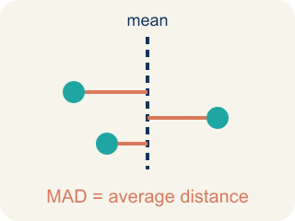
Mean Absolute Deviation (Desviación media absoluta) — The average distance of data values from the mean; it describes spread.

Deviation (Desviación) — How far a number is from the mean.
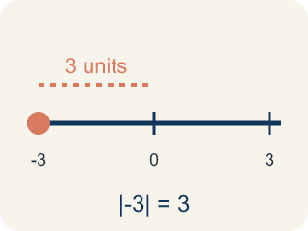
Absolute Value (Valor absoluto) — How far a number is from zero. It is never negative.
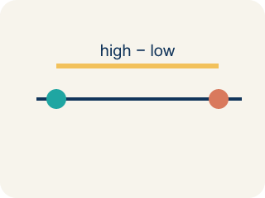
Spread (Dispersión) — How far apart the numbers are.
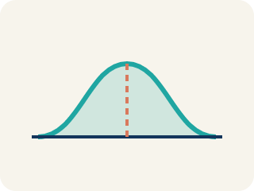
Data distribution (Distribución de datos) — How the data looks: where it sits and how spread out it is.

Variability (Variabilidad) — How spread out the numbers are.

Practice
Show your work. Use the blank space under each problem.
1. The mean of a data set is 15. One value is 11. What is the absolute deviation of that value from the mean?
A. 4
B. −4
C. 26
D. 11
______________________________________________________________________
2. A data set has absolute deviations of 3, 1, 5, 2, 4. What is the MAD?
A. 3
B. 5
C. 15
D. 1
______________________________________________________________________
3. A guard scored 2, 4, 6, 8 points in four scrimmages, so the mean is 5 points. The distances from the mean are 3, 1, 1, 3. What is the mean absolute deviation (MAD)?
A. 1
B. 2
C. 5
D. 8
______________________________________________________________________
4. Two shooters average 11 points a game. Shooter A's MAD is 2 points and Shooter B's MAD is 6 points. Which shooter is MORE consistent?
A. Shooter A, because a smaller MAD means scores stay closer to the average
B. Shooter B, because a bigger MAD means a bigger average
C. They are equally consistent because they have the same mean
D. You cannot tell consistency from MAD
______________________________________________________________________
5. Level 2 Extension — The Deviations That Vanished
Step 1 (Data set): A center's rebounds: 3, 7, 11, 15, 19
Step 2 (Find the mean): Sum = 55, Count = 5, Mean = 55 ÷ 5 = 11
Step 3 (Find each deviation (value − mean)): −8, −4, 0, 4, 8
Step 4 (Find the MAD): MAD = (−8 + −4 + 0 + 4 + 8) ÷ 5 = 0 ÷ 5 = 0
Which step has the mistake? Explain and fix it:
______________________________________________________________________
______________________________________________________________________
______________________________________________________________________
6. Find the MAD Error
Step 1 (Data set): 5, 10, 15, 20, 25
Step 2 (Find mean): Sum = 75, Count = 5, Mean = 15
Step 3 (Find deviations): −10, −5, 0, 5, 10
Step 4 (Find MAD): MAD = (−10 + −5 + 0 + 5 + 10) ÷ 5 = 0
Which step has the mistake? Explain and fix it:
______________________________________________________________________
______________________________________________________________________
______________________________________________________________________
7. Two basketball teams both average 75 points per game. Team A's last 5 scores: 73, 76, 74, 77, 75. Team B's last 5 scores: 60, 90, 65, 85, 75. Calculate the MAD for each team and explain which team a coach would prefer if they need predictable scoring.
Sentence starter: Team A's MAD = ___. Team B's MAD = ___. Team A is ___ because ___. A coach would prefer Team ___ for predictable scoring because ___.
______________________________________________________________________
______________________________________________________________________
______________________________________________________________________
______________________________________________________________________

Answer Key (Teacher)
1. A. 4
Deviation = 11 − 15 = −4. Absolute deviation = |−4| = 4.
Watch for: A common mistake in Mean Absolute Deviation is adding the signed deviations (value − mean) instead of their absolute values, so the positives and negatives cancel out to 0. For 6, 8, 10, 12 (mean = 9), the deviations are −3, −1, 1, 3 — they sum to 0, but that is NOT the MAD. Before averaging, take the absolute value of every deviation so each becomes a positive distance: |−3| = 3, |−1| = 1, |1| = 1, |3| = 3. Sum = 8, so MAD = 8 ÷ 4 = 2. A MAD of exactly 0 is a warning sign — it only happens if every value in the data set equals the mean.
2. A. 3
Sum of absolute deviations = 3 + 1 + 5 + 2 + 4 = 15. MAD = 15 ÷ 5 = 3.
Watch for: A common mistake in Mean Absolute Deviation is adding the signed deviations (value − mean) instead of their absolute values, so the positives and negatives cancel out to 0. For 6, 8, 10, 12 (mean = 9), the deviations are −3, −1, 1, 3 — they sum to 0, but that is NOT the MAD. Before averaging, take the absolute value of every deviation so each becomes a positive distance: |−3| = 3, |−1| = 1, |1| = 1, |3| = 3. Sum = 8, so MAD = 8 ÷ 4 = 2. A MAD of exactly 0 is a warning sign — it only happens if every value in the data set equals the mean.
3. B. 2
Add the distances: 3 + 1 + 1 + 3 = 8. Divide by the 4 games: 8 ÷ 4 = 2. The MAD is 2 points.
Watch for: A common mistake in Mean Absolute Deviation is adding the signed deviations (value − mean) instead of their absolute values, so the positives and negatives cancel out to 0. For 6, 8, 10, 12 (mean = 9), the deviations are −3, −1, 1, 3 — they sum to 0, but that is NOT the MAD. Before averaging, take the absolute value of every deviation so each becomes a positive distance: |−3| = 3, |−1| = 1, |1| = 1, |3| = 3. Sum = 8, so MAD = 8 ÷ 4 = 2. A MAD of exactly 0 is a warning sign — it only happens if every value in the data set equals the mean.
4. A. Shooter A, because a smaller MAD means scores stay closer to the average
A smaller MAD means the scores hug the mean. Shooter A's MAD of 2 is smaller than Shooter B's 6, so Shooter A is more consistent.
Watch for: A common mistake in Mean Absolute Deviation is adding the signed deviations (value − mean) instead of their absolute values, so the positives and negatives cancel out to 0. For 6, 8, 10, 12 (mean = 9), the deviations are −3, −1, 1, 3 — they sum to 0, but that is NOT the MAD. Before averaging, take the absolute value of every deviation so each becomes a positive distance: |−3| = 3, |−1| = 1, |1| = 1, |3| = 3. Sum = 8, so MAD = 8 ÷ 4 = 2. A MAD of exactly 0 is a warning sign — it only happens if every value in the data set equals the mean.
5. Level 2 Extension — The Deviations That Vanished
The mistake is in Step 4.
Correct work: MAD uses the ABSOLUTE value (the distance) of each deviation, so the positives and negatives can't cancel out. |−8| = 8, |−4| = 4, |0| = 0, |4| = 4, |8| = 8. MAD = (8 + 4 + 0 + 4 + 8) ÷ 5 = 24 ÷ 5 = 4.8 rebounds.
Watch for: The mean of 11 and the deviations −8, −4, 0, 4, 8 are correct, but the "Find the MAD" step adds them with their signs, so every negative cancels a matching positive and the total is forced to 0. Signed deviations always sum to zero, which is exactly why MAD uses distances: 8, 4, 0, 4, 8 total 24, so MAD = 24 ÷ 5 = 4.8 rebounds.
6. Find the MAD Error
The mistake is in Step 4.
Correct work: You must use absolute values of the deviations: |−10| = 10, |−5| = 5, |0| = 0, |5| = 5, |10| = 10. MAD = (10 + 5 + 0 + 5 + 10) ÷ 5 = 30 ÷ 5 = 6.
Watch for: The mean of 15 and the deviations −10, −5, 0, 5, 10 are all correct. The "Find MAD" step is where it breaks: adding signed deviations always gives 0, because the values below the mean exactly balance the ones above. Use absolute values instead — 10, 5, 0, 5, 10 — which sum to 30, so MAD = 30 ÷ 5 = 6.
7. Open response — answers will vary.
Look for key words: MAD, consistent, spread, lower, higher, predictable, absolute deviation.

