2.9 Small Group · Group 2 — Homework
Lesson 2-9-group2 • Standard 6.DS.6c
Name: ______________________ Period: ______ Date: ____________

Today's Goals
Content: I can find the mean absolute deviation (MAD) to describe how spread out data is, explain how I can tell, and judge a case I have not seen before.
Language: I can justify my answer to a skeptic and connect it to a second strategy or representation.

Key Words
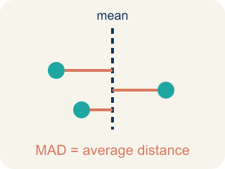
Mean Absolute Deviation (Desviación media absoluta) — The average distance of data values from the mean; it describes spread.

Deviation (Desviación) — How far a number is from the mean.
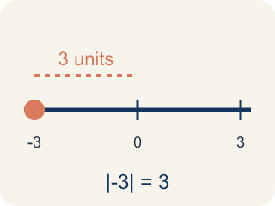
Absolute Value (Valor absoluto) — How far a number is from zero. It is never negative.
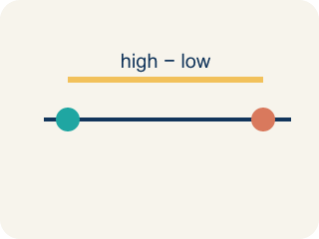
Spread (Dispersión) — How far apart the numbers are.
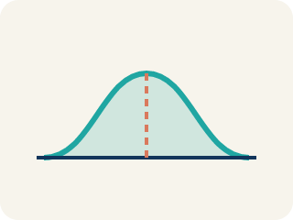
Data distribution (Distribución de datos) — How the data looks: where it sits and how spread out it is.

Variability (Variabilidad) — How spread out the numbers are.

Practice
Show your work. Use the blank space under each problem.
1. Two runners have the same average time of 60 seconds. Runner A's MAD is 1.2 seconds. Runner B's MAD is 5.8 seconds. Which runner is the coach more likely to pick for a relay race that needs a reliable time?
A. Runner A — lower MAD means more consistent times
B. Runner B — higher MAD means faster potential
C. Either — they have the same average
D. Neither — MAD doesn't matter for relay races
______________________________________________________________________
2. Spot the Common Mistake
Step 1 (Data set): A swimmer's lap times: 2, 5, 8, 9. Mean = (2 + 5 + 8 + 9) ÷ 4 = 24 ÷ 4 = 6.
Step 2 (Find each absolute deviation): |2 − 6| = 4, |5 − 6| = 1, |8 − 6| = 2, |9 − 6| = 3
Step 3 (Find the MAD): Sum of absolute deviations = 4 + 1 + 2 + 3 = 10. MAD = 10 ÷ 3 ≈ 3.33
Which step has the mistake? Explain and fix it:
______________________________________________________________________
______________________________________________________________________
______________________________________________________________________
3. Find the MAD Error
Step 1 (Data set): 5, 10, 15, 20, 25
Step 2 (Find mean): Sum = 75, Count = 5, Mean = 15
Step 3 (Find deviations): −10, −5, 0, 5, 10
Step 4 (Find MAD): MAD = (−10 + −5 + 0 + 5 + 10) ÷ 5 = 0
Which step has the mistake? Explain and fix it:
______________________________________________________________________
______________________________________________________________________
______________________________________________________________________
4. Two basketball teams both average 75 points per game. Team A's last 5 scores: 73, 76, 74, 77, 75. Team B's last 5 scores: 60, 90, 65, 85, 75. Calculate the MAD for each team and explain which team a coach would prefer if they need predictable scoring.
Sentence starter: Team A's MAD = ___. Team B's MAD = ___. Team A is ___ because ___. A coach would prefer Team ___ for predictable scoring because ___.
______________________________________________________________________
______________________________________________________________________
______________________________________________________________________
______________________________________________________________________

Answer Key (Teacher)
1. A. Runner A — lower MAD means more consistent times
Runner A's MAD of 1.2 means times are usually within 1.2 seconds of 60. Runner B's times vary more widely. For reliability, pick Runner A.
Watch for: A common mistake in Mean Absolute Deviation is adding the signed deviations (value − mean) instead of their absolute values, so the positives and negatives cancel out to 0. For 6, 8, 10, 12 (mean = 9), the deviations are −3, −1, 1, 3 — they sum to 0, but that is NOT the MAD. Before averaging, take the absolute value of every deviation so each becomes a positive distance: |−3| = 3, |−1| = 1, |1| = 1, |3| = 3. Sum = 8, so MAD = 8 ÷ 4 = 2. A MAD of exactly 0 is a warning sign — it only happens if every value in the data set equals the mean.
2. Spot the Common Mistake
The mistake is in Step 3.
Correct work: Divide by the NUMBER OF VALUES, not one less. There are 4 values, so MAD = 10 ÷ 4 = 2.5. The student divided by 3 instead of 4.
Watch for: The absolute deviations 4, 1, 2, and 3 are all correct, and they total 10. The mistake is in the "Find the MAD" step, which divides by 3 instead of by the 4 values in the data set. MAD = 10 ÷ 4 = 2.5, so the swimmer's times sit an average of 2.5 away from the mean of 6.
3. Find the MAD Error
The mistake is in Step 4.
Correct work: You must use absolute values of the deviations: |−10| = 10, |−5| = 5, |0| = 0, |5| = 5, |10| = 10. MAD = (10 + 5 + 0 + 5 + 10) ÷ 5 = 30 ÷ 5 = 6.
Watch for: The mean of 15 and the deviations −10, −5, 0, 5, 10 are all correct. The "Find MAD" step is where it breaks: adding signed deviations always gives 0, because the values below the mean exactly balance the ones above. Use absolute values instead — 10, 5, 0, 5, 10 — which sum to 30, so MAD = 30 ÷ 5 = 6.
4. Open response — answers will vary.
Look for key words: MAD, consistent, spread, lower, higher, predictable, absolute deviation.

