Describe Data by Mean Absolute Deviation — Homework
Lesson 2-9 • Standard 6.DS.6c
Name: ______________________ Period: ______ Date: ____________

Today's Goals
Content: I can find the mean absolute deviation (MAD) to describe how spread out data is.
Language: I can explain my work using the words mean absolute deviation, deviation, absolute value, and spread.

Key Words
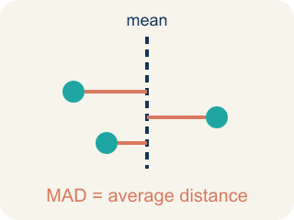
Mean Absolute Deviation (Desviación media absoluta) — The average distance of data values from the mean; it describes spread.

Deviation (Desviación) — How far a number is from the mean.
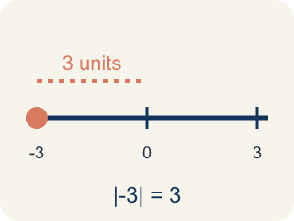
Absolute Value (Valor absoluto) — How far a number is from zero. It is never negative.
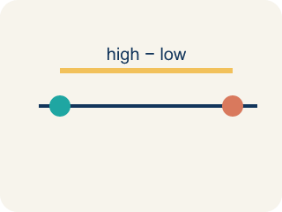
Spread (Dispersión) — How far apart the numbers are.
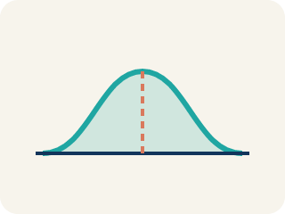
Data distribution (Distribución de datos) — How the data looks: where it sits and how spread out it is.

Variability (Variabilidad) — How spread out the numbers are.

Practice
Show your work. Use the blank space under each problem.
1. The mean of a data set is 15. One value is 11. What is the absolute deviation of that value from the mean?
A. 4
B. −4
C. 26
D. 11
______________________________________________________________________
2. A data set has absolute deviations of 3, 1, 5, 2, 4. What is the MAD?
A. 3
B. 5
C. 15
D. 1
______________________________________________________________________
3. Complete the table.
Score | Deviation (Score − Mean) | Absolute Deviation
12
8
10
14
6
______________________________________________________________________
4. Match each MAD value to what it tells you about the data.
Item | Answer choices
____ MAD = 1.5 | D. Moderate spread
____ MAD = 8.0 | C. All values are identical
____ MAD = 0 | B. Very spread out data
____ MAD = 4.2 | A. Very consistent data
______________________________________________________________________
5. Sort these data sets from LEAST spread out (lowest MAD) to MOST spread out (highest MAD).
Groups: Least to most spread out
______________________________________________________________________
6. Two runners have the same average time of 60 seconds. Runner A's MAD is 1.2 seconds. Runner B's MAD is 5.8 seconds. Which runner is the coach more likely to pick for a relay race that needs a reliable time?
A. Runner A — lower MAD means more consistent times
B. Runner B — higher MAD means faster potential
C. Either — they have the same average
D. Neither — MAD doesn't matter for relay races
______________________________________________________________________
7. Spot the Common Mistake
Step 1 (Data set): A swimmer's lap times: 2, 5, 8, 9. Mean = (2 + 5 + 8 + 9) ÷ 4 = 24 ÷ 4 = 6.
Step 2 (Find each absolute deviation): |2 − 6| = 4, |5 − 6| = 1, |8 − 6| = 2, |9 − 6| = 3
Step 3 (Find the MAD): Sum of absolute deviations = 4 + 1 + 2 + 3 = 10. MAD = 10 ÷ 3 ≈ 3.33
Which step has the mistake? Explain and fix it:
______________________________________________________________________
______________________________________________________________________
______________________________________________________________________
8. A guard scored 2, 4, 6, 8 points in four scrimmages, so the mean is 5 points. The distances from the mean are 3, 1, 1, 3. What is the mean absolute deviation (MAD)?
A. 1
B. 2
C. 5
D. 8
______________________________________________________________________
9. Two shooters average 11 points a game. Shooter A's MAD is 2 points and Shooter B's MAD is 6 points. Which shooter is MORE consistent?
A. Shooter A, because a smaller MAD means scores stay closer to the average
B. Shooter B, because a bigger MAD means a bigger average
C. They are equally consistent because they have the same mean
D. You cannot tell consistency from MAD
______________________________________________________________________
10. Each player's points are listed. Match each player's data set to its correct MAD. (Hint: find the mean first, then average the distances.)
Item | Answer choices
____ Bench: 8, 10, 12, 14 | C. MAD = 5 points
____ Rookie: 4, 4, 4, 4 | B. MAD = 0 points
____ Starter: 5, 15, 5, 15 | A. MAD = 2 points
______________________________________________________________________

Answer Key (Teacher)
1. A. 4
Deviation = 11 − 15 = −4. Absolute deviation = |−4| = 4.
Watch for: A common mistake in Mean Absolute Deviation is adding the signed deviations (value − mean) instead of their absolute values, so the positives and negatives cancel out to 0. For 6, 8, 10, 12 (mean = 9), the deviations are −3, −1, 1, 3 — they sum to 0, but that is NOT the MAD. Before averaging, take the absolute value of every deviation so each becomes a positive distance: |−3| = 3, |−1| = 1, |1| = 1, |3| = 3. Sum = 8, so MAD = 8 ÷ 4 = 2. A MAD of exactly 0 is a warning sign — it only happens if every value in the data set equals the mean.
2. A. 3
Sum of absolute deviations = 3 + 1 + 5 + 2 + 4 = 15. MAD = 15 ÷ 5 = 3.
Watch for: A common mistake in Mean Absolute Deviation is adding the signed deviations (value − mean) instead of their absolute values, so the positives and negatives cancel out to 0. For 6, 8, 10, 12 (mean = 9), the deviations are −3, −1, 1, 3 — they sum to 0, but that is NOT the MAD. Before averaging, take the absolute value of every deviation so each becomes a positive distance: |−3| = 3, |−1| = 1, |1| = 1, |3| = 3. Sum = 8, so MAD = 8 ÷ 4 = 2. A MAD of exactly 0 is a warning sign — it only happens if every value in the data set equals the mean.
3. Table
12 — Deviation (Score − Mean): 2
12 — Absolute Deviation: 2
8 — Deviation (Score − Mean): -2
8 — Absolute Deviation: 2
10 — Deviation (Score − Mean): 0
10 — Absolute Deviation: 0
14 — Deviation (Score − Mean): 4
14 — Absolute Deviation: 4
6 — Deviation (Score − Mean): -4
6 — Absolute Deviation: 4

4. Matches:
MAD = 1.5 → Very consistent data
MAD = 8.0 → Very spread out data
MAD = 0 → All values are identical
MAD = 4.2 → Moderate spread

5. Correct groups:

6. A. Runner A — lower MAD means more consistent times
Runner A's MAD of 1.2 means times are usually within 1.2 seconds of 60. Runner B's times vary more widely. For reliability, pick Runner A.
Watch for: A common mistake in Mean Absolute Deviation is adding the signed deviations (value − mean) instead of their absolute values, so the positives and negatives cancel out to 0. For 6, 8, 10, 12 (mean = 9), the deviations are −3, −1, 1, 3 — they sum to 0, but that is NOT the MAD. Before averaging, take the absolute value of every deviation so each becomes a positive distance: |−3| = 3, |−1| = 1, |1| = 1, |3| = 3. Sum = 8, so MAD = 8 ÷ 4 = 2. A MAD of exactly 0 is a warning sign — it only happens if every value in the data set equals the mean.
7. Spot the Common Mistake
The mistake is in Step 3.
Correct work: Divide by the NUMBER OF VALUES, not one less. There are 4 values, so MAD = 10 ÷ 4 = 2.5. The student divided by 3 instead of 4.
Watch for: The absolute deviations 4, 1, 2, and 3 are all correct, and they total 10. The mistake is in the "Find the MAD" step, which divides by 3 instead of by the 4 values in the data set. MAD = 10 ÷ 4 = 2.5, so the swimmer's times sit an average of 2.5 away from the mean of 6.
8. B. 2
Add the distances: 3 + 1 + 1 + 3 = 8. Divide by the 4 games: 8 ÷ 4 = 2. The MAD is 2 points.
Watch for: A common mistake in Mean Absolute Deviation is adding the signed deviations (value − mean) instead of their absolute values, so the positives and negatives cancel out to 0. For 6, 8, 10, 12 (mean = 9), the deviations are −3, −1, 1, 3 — they sum to 0, but that is NOT the MAD. Before averaging, take the absolute value of every deviation so each becomes a positive distance: |−3| = 3, |−1| = 1, |1| = 1, |3| = 3. Sum = 8, so MAD = 8 ÷ 4 = 2. A MAD of exactly 0 is a warning sign — it only happens if every value in the data set equals the mean.
9. A. Shooter A, because a smaller MAD means scores stay closer to the average
A smaller MAD means the scores hug the mean. Shooter A's MAD of 2 is smaller than Shooter B's 6, so Shooter A is more consistent.
Watch for: A common mistake in Mean Absolute Deviation is adding the signed deviations (value − mean) instead of their absolute values, so the positives and negatives cancel out to 0. For 6, 8, 10, 12 (mean = 9), the deviations are −3, −1, 1, 3 — they sum to 0, but that is NOT the MAD. Before averaging, take the absolute value of every deviation so each becomes a positive distance: |−3| = 3, |−1| = 1, |1| = 1, |3| = 3. Sum = 8, so MAD = 8 ÷ 4 = 2. A MAD of exactly 0 is a warning sign — it only happens if every value in the data set equals the mean.
10. Matches:
Bench: 8, 10, 12, 14 → MAD = 2 points
Rookie: 4, 4, 4, 4 → MAD = 0 points
Starter: 5, 15, 5, 15 → MAD = 5 points

