3.1 Small Group · Group 1 — Homework
Lesson 3-1-group1 • Standard 6.AT.1
Name: ______________________ Period: ______ Date: ____________

Today's Goals
Content: With my small group, I can write and describe a ratio that compares two quantities — one step at a time, with support.
Language: I can talk through each step out loud using a sentence frame and the lesson's key words.

Key Words
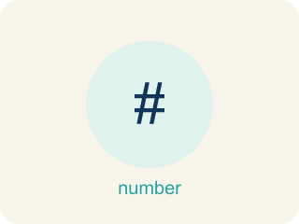
Understand Ratios (Comprender razones) — Use a ratio to compare two quantities by division.
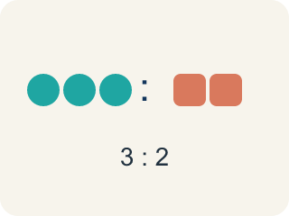
Ratio (Razón) — A way to compare two amounts, like 3 to 2.

Comparison (Comparación) — Looking at two or more amounts to see how they are related.
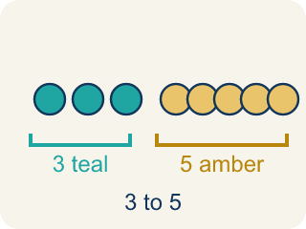
Part-to-part (Parte a parte) — A ratio comparing one part of a group to another part.
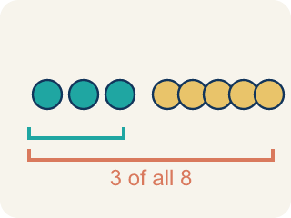
Part-to-whole (Parte a todo) — A ratio comparing one part to the whole group.

Colon notation (Notación con dos puntos) — Writing a ratio with two dots between the numbers, like 3:2.

Practice
Show your work. Use the blank space under each problem.
1. A recipe uses 4 cups of milk and 1 cup of cream. What is the ratio of milk to cream?
A. 4:1
B. 1:4
C. 4:5
D. 5:1
______________________________________________________________________
2. Chef Reyes uses 6 strawberries and 2 bananas in a smoothie. What is the part-to-whole ratio of bananas to total fruit?
A. 2:8
B. 6:2
C. 2:6
D. 8:2
______________________________________________________________________
3. A parking lot has 10 cars and 6 trucks. What is the part-to-whole ratio of trucks to total vehicles?
A. 6:16
B. 10:6
C. 6:10
D. 16:6
______________________________________________________________________
4. Spot the Mistake — Part-to-Whole Ratio
Step 1 (Read the problem): A class has 9 boys and 6 girls. Write the part-to-whole ratio of girls to the whole class.
Step 2 (Count the whole): 9 + 6 = 15 students in all.
Step 3 (Write the ratio): A student writes girls to the whole class as 6:9.
Step 4 (Answer): The part-to-whole ratio of girls to the whole class is 6:9.
Which step has the mistake? Explain and fix it:
______________________________________________________________________
______________________________________________________________________
______________________________________________________________________
5. Prep Bowl A: Chef Reyes stirs 7 cups of flour with 4 cups of water to make dough. What is the part-to-part ratio of flour to water?
A. 7:4
B. 4:7
C. 7:11
D. 11:4
______________________________________________________________________
6. A class has 5 chefs and 7 helpers (12 total). What is the part-to-whole ratio of chefs to the whole class?
A. 5:12
B. 5:7
C. 7:12
D. 12:5
______________________________________________________________________
7. “For every” language: Chef Reyes says, “My glaze uses 9 spoons of honey for every 4 spoons of lemon.” Written in colon notation, the ratio of honey to lemon is:
A. 9:4
B. 4:9
C. 9:13
D. 13:4
______________________________________________________________________
8. Level 2 Extension — Chef Mateo's Pizza Topping Ratio
Step 1 (Read the problem): A pizza has 6 olives, 2 peppers, and 4 tomato slices. Write the part-to-whole ratio of peppers to the total toppings.
Step 2 (Count the whole): 6 + 2 + 4 = 12 total toppings.
Step 3 (Write the ratio): Chef Mateo writes peppers to total as 2:6.
Step 4 (Answer): The ratio of peppers to total toppings is 2:6.
Which step has the mistake? Explain and fix it:
______________________________________________________________________
______________________________________________________________________
______________________________________________________________________

Answer Key (Teacher)
1. A. 4:1
A ratio compares quantities in the order given. Milk to cream = 4 to 1, or 4:1.
Watch for: A common mistake in Understand Ratios is writing the ratio in the wrong order: when asked for the ratio of apple juice to sparkling water in a recipe that uses 3 cups of apple juice for every 2 cups of sparkling water, some students write 2:3 (sparkling water to apple juice) because they list the ingredients in whatever order comes to mind rather than the order the question asks for. The two ratios describe different drinks — 3:2 means 3 cups of juice for every 2 cups of water, while 2:3 would mean only 2 cups of juice for every 3 cups of water. Always match the order of your ratio to the order named in the question: "apple juice to sparkling water" means the apple juice number comes first, giving 3:2.
2. A. 2:8
Total fruit = 6 + 2 = 8. The part-to-whole ratio of bananas to total fruit is 2:8.
Watch for: A common mistake in Understand Ratios is writing the ratio in the wrong order: when asked for the ratio of apple juice to sparkling water in a recipe that uses 3 cups of apple juice for every 2 cups of sparkling water, some students write 2:3 (sparkling water to apple juice) because they list the ingredients in whatever order comes to mind rather than the order the question asks for. The two ratios describe different drinks — 3:2 means 3 cups of juice for every 2 cups of water, while 2:3 would mean only 2 cups of juice for every 3 cups of water. Always match the order of your ratio to the order named in the question: "apple juice to sparkling water" means the apple juice number comes first, giving 3:2.
3. A. 6:16
Total vehicles = 10 + 6 = 16. The ratio of trucks to total is 6:16.
Watch for: A common mistake in Understand Ratios is writing the ratio in the wrong order: when asked for the ratio of apple juice to sparkling water in a recipe that uses 3 cups of apple juice for every 2 cups of sparkling water, some students write 2:3 (sparkling water to apple juice) because they list the ingredients in whatever order comes to mind rather than the order the question asks for. The two ratios describe different drinks — 3:2 means 3 cups of juice for every 2 cups of water, while 2:3 would mean only 2 cups of juice for every 3 cups of water. Always match the order of your ratio to the order named in the question: "apple juice to sparkling water" means the apple juice number comes first, giving 3:2.
4. Spot the Mistake — Part-to-Whole Ratio
The mistake is in Step 3.
Correct work: Part-to-whole compares the part to the WHOLE (15), not to the other part. There are 6 girls and 15 students total, so the correct ratio is 6:15.
Watch for: The whole is counted correctly: 9 + 6 = 15 students. The mistake is in the ratio itself — it compares the 6 girls to the 9 boys instead of to the whole class. A part-to-whole ratio has to use the total, so girls to the whole class is 6:15.
5. A. 7:4
Part-to-part compares the two ingredients in the order named. Flour to water = 7 to 4, written 7:4.
Watch for: A common mistake in Understand Ratios is writing the ratio in the wrong order: when asked for the ratio of apple juice to sparkling water in a recipe that uses 3 cups of apple juice for every 2 cups of sparkling water, some students write 2:3 (sparkling water to apple juice) because they list the ingredients in whatever order comes to mind rather than the order the question asks for. The two ratios describe different drinks — 3:2 means 3 cups of juice for every 2 cups of water, while 2:3 would mean only 2 cups of juice for every 3 cups of water. Always match the order of your ratio to the order named in the question: "apple juice to sparkling water" means the apple juice number comes first, giving 3:2.
6. A. 5:12
The whole class is 5 + 7 = 12 students. Part-to-whole compares one part to the total, so chefs to whole class is 5:12.
Watch for: A common mistake in Understand Ratios is writing the ratio in the wrong order: when asked for the ratio of apple juice to sparkling water in a recipe that uses 3 cups of apple juice for every 2 cups of sparkling water, some students write 2:3 (sparkling water to apple juice) because they list the ingredients in whatever order comes to mind rather than the order the question asks for. The two ratios describe different drinks — 3:2 means 3 cups of juice for every 2 cups of water, while 2:3 would mean only 2 cups of juice for every 3 cups of water. Always match the order of your ratio to the order named in the question: "apple juice to sparkling water" means the apple juice number comes first, giving 3:2.
7. A. 9:4
“For every 9 honey to 4 lemon” is a part-to-part comparison. In colon notation, honey to lemon is 9:4.
Watch for: A common mistake in Understand Ratios is writing the ratio in the wrong order: when asked for the ratio of apple juice to sparkling water in a recipe that uses 3 cups of apple juice for every 2 cups of sparkling water, some students write 2:3 (sparkling water to apple juice) because they list the ingredients in whatever order comes to mind rather than the order the question asks for. The two ratios describe different drinks — 3:2 means 3 cups of juice for every 2 cups of water, while 2:3 would mean only 2 cups of juice for every 3 cups of water. Always match the order of your ratio to the order named in the question: "apple juice to sparkling water" means the apple juice number comes first, giving 3:2.
8. Level 2 Extension — Chef Mateo's Pizza Topping Ratio
The mistake is in Step 3.
Correct work: Part-to-whole compares the part to the WHOLE (12), not to one other part. The peppers are 2 and the whole is 12, so the correct ratio is 2:12.
Watch for: Chef Mateo counted the whole correctly: 6 + 2 + 4 = 12 toppings. The error is in the ratio — he compared the 2 peppers to the 6 olives instead of to the whole pizza. A part-to-whole ratio uses the total, so peppers to total toppings is 2:12.

