3.1 Small Group · Group 2 — Homework
Lesson 3-1-group2 • Standard 6.AT.1
Name: ______________________ Period: ______ Date: ____________

Today's Goals
Content: I can write and describe a ratio that compares two quantities, explain what each part stands for, and build one for a situation I have not seen before.
Language: I can justify my answer to a skeptic and connect it to a second strategy or representation.

Key Words
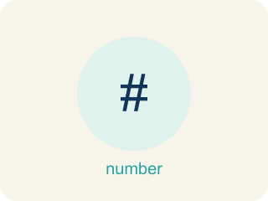
Understand Ratios (Comprender razones) — Use a ratio to compare two quantities by division.
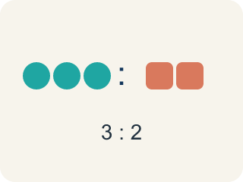
Ratio (Razón) — A way to compare two amounts, like 3 to 2.

Comparison (Comparación) — Looking at two or more amounts to see how they are related.
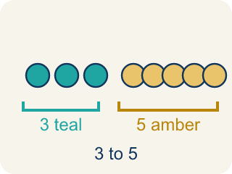
Part-to-part (Parte a parte) — A ratio comparing one part of a group to another part.
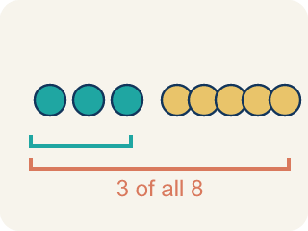
Part-to-whole (Parte a todo) — A ratio comparing one part to the whole group.

Colon notation (Notación con dos puntos) — Writing a ratio with two dots between the numbers, like 3:2.

Practice
Show your work. Use the blank space under each problem.
1. A fruit salad has 5 pieces of melon, 3 pieces of pineapple, and 2 grapes. What is the ratio of pineapple to melon?
A. 3:5
B. 5:3
C. 3:10
D. 3:2
______________________________________________________________________
2. A parking lot has 10 cars and 6 trucks. What is the part-to-whole ratio of trucks to total vehicles?
A. 6:16
B. 10:6
C. 6:10
D. 16:6
______________________________________________________________________
3. Spot the Mistake — Part-to-Whole Ratio
Step 1 (Read the problem): A class has 9 boys and 6 girls. Write the part-to-whole ratio of girls to the whole class.
Step 2 (Count the whole): 9 + 6 = 15 students in all.
Step 3 (Write the ratio): A student writes girls to the whole class as 6:9.
Step 4 (Answer): The part-to-whole ratio of girls to the whole class is 6:9.
Which step has the mistake? Explain and fix it:
______________________________________________________________________
______________________________________________________________________
______________________________________________________________________
4. Find Aliya's Mistake
Step 1 (Read the problem): A trail mix has 6 almonds, 4 raisins, and 2 cashews. Write the ratio of raisins to total pieces.
Step 2 (Count total pieces): 6 + 4 + 2 = 12
Step 3 (Write the ratio): 4:8
Step 4 (Answer): The ratio of raisins to total is 4:8.
Which step has the mistake? Explain and fix it:
______________________________________________________________________
______________________________________________________________________
______________________________________________________________________

Answer Key (Teacher)
1. A. 3:5
The ratio of pineapple to melon compares pineapple (3) to melon (5), so the ratio is 3:5.
Watch for: A common mistake in Understand Ratios is writing the ratio in the wrong order: when asked for the ratio of apple juice to sparkling water in a recipe that uses 3 cups of apple juice for every 2 cups of sparkling water, some students write 2:3 (sparkling water to apple juice) because they list the ingredients in whatever order comes to mind rather than the order the question asks for. The two ratios describe different drinks — 3:2 means 3 cups of juice for every 2 cups of water, while 2:3 would mean only 2 cups of juice for every 3 cups of water. Always match the order of your ratio to the order named in the question: "apple juice to sparkling water" means the apple juice number comes first, giving 3:2.
2. A. 6:16
Total vehicles = 10 + 6 = 16. The ratio of trucks to total is 6:16.
Watch for: A common mistake in Understand Ratios is writing the ratio in the wrong order: when asked for the ratio of apple juice to sparkling water in a recipe that uses 3 cups of apple juice for every 2 cups of sparkling water, some students write 2:3 (sparkling water to apple juice) because they list the ingredients in whatever order comes to mind rather than the order the question asks for. The two ratios describe different drinks — 3:2 means 3 cups of juice for every 2 cups of water, while 2:3 would mean only 2 cups of juice for every 3 cups of water. Always match the order of your ratio to the order named in the question: "apple juice to sparkling water" means the apple juice number comes first, giving 3:2.
3. Spot the Mistake — Part-to-Whole Ratio
The mistake is in Step 3.
Correct work: Part-to-whole compares the part to the WHOLE (15), not to the other part. There are 6 girls and 15 students total, so the correct ratio is 6:15.
Watch for: The whole is counted correctly: 9 + 6 = 15 students. The mistake is in the ratio itself — it compares the 6 girls to the 9 boys instead of to the whole class. A part-to-whole ratio has to use the total, so girls to the whole class is 6:15.
4. Find Aliya's Mistake
The mistake is in Step 3.
Correct work: The total is 12, not 8. The correct ratio is 4:12.
Watch for: Aliya counted the total correctly: 6 + 4 + 2 = 12 pieces. But the ratio she wrote uses 8, which is not the total — it is only the almonds and raisins together. Comparing the 4 raisins to the whole 12 pieces gives 4:12.

