3.10 Small Group · Group 1 — Homework
Lesson 3-10-group1 • Standard 6.AT.3c
Name: ______________________ Period: ______ Date: ____________

Today's Goals
Content: With my small group, I can convert measurement units using ratios and conversion factors — one step at a time, with support.
Language: I can talk through each step out loud using a sentence frame and the lesson's key words.

Key Words
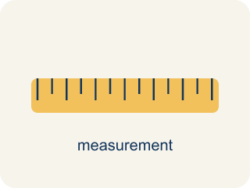
Convert Measurement Units (Convertir unidades de medida) — Rename a measurement in a different unit without changing its amount.
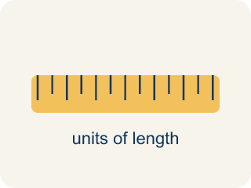
Conversion Factor (Factor de conversión) — A ratio that helps you change one unit into another.

Unit (Unidad) — A standard amount used to measure, like an inch or a liter.
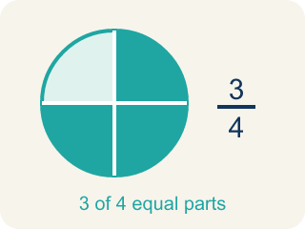
Equivalent (Equivalente) — Having the same value, just in different units.
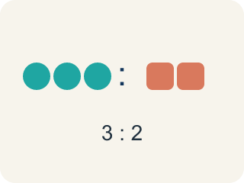
Ratio (Razón) — A way to compare two amounts, like 3 to 2.

Customary units (Unidades usuales (sistema inglés)) — The U.S. way of measuring, like inches, feet, and pounds.

Metric units (Unidades métricas) — A way of measuring by 10s, like meters, liters, and grams.
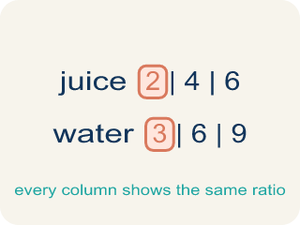
Ratio table (Tabla de razones) — A table of equal ratios that shows a pattern.

Practice
Show your work. Use the blank space under each problem.
1. How many inches are in 7 feet?
A. 84 inches
B. 72 inches
C. 70 inches
D. 96 inches
______________________________________________________________________
2. How many feet are in 3 yards?
A. 9 feet
B. 6 feet
C. 12 feet
D. 36 feet
______________________________________________________________________
3. Leg 1: The joystick rod is 3 feet long, but the parts catalog lists it in inches. How many inches is that? (1 ft = 12 in)
A. 36 inches
B. 15 inches
C. 30 inches
D. 33 inches
______________________________________________________________________
4. Leg 2: A power cable on the cabinet plan measures 2.5 kilometers across the whole arcade network. How many meters is that? (1 km = 1,000 m)
A. 2,500 meters
B. 250 meters
C. 25 meters
D. 25,000 meters
______________________________________________________________________
5. Leg 3: The coin box weighs 5 pounds, but the shipping label needs the weight in ounces. How many ounces is that? (1 lb = 16 oz)
A. 80 ounces
B. 21 ounces
C. 75 ounces
D. 16 ounces
______________________________________________________________________
6. Level 2 Extension — Multiply or Divide?
Step 1 (Convert 4 feet of side panel to inches): 4 feet → inches
Step 2 (Use the conversion factor): 1 foot = 12 inches
Step 3 (Operate): 4 ÷ 12 = 0.33 inches
Step 4 (Final answer): 4 feet ≈ 0.33 inches
Which step has the mistake? Explain and fix it:
______________________________________________________________________
______________________________________________________________________
______________________________________________________________________
7. Final Leg: The finished cabinet ships in a crate holding 8 quarts of packing gel, but the supplier sells gel by the gallon. How many gallons is that? (4 qt = 1 gal)
A. 2 gallons
B. 32 gallons
C. 4 gallons
D. 12 gallons
______________________________________________________________________
8. Find the Conversion Error
Step 1 (Convert 6 feet to yards): 6 feet → yards
Step 2 (Use conversion factor): 1 yard = 3 feet
Step 3 (Multiply): 6 × 3 = 18 yards
Step 4 (Final answer): 6 feet = 18 yards
Which step has the mistake? Explain and fix it:
______________________________________________________________________
______________________________________________________________________
______________________________________________________________________

Answer Key (Teacher)
1. A. 84 inches
7 × 12 = 84 inches.
Watch for: A common mistake in Convert Measurement Units is applying the conversion factor in the wrong direction — for example, converting 4 feet to inches by dividing (4 ÷ 12 = 0.33 inches) instead of multiplying (4 × 12 = 48 inches), or converting 80 ounces to pounds by multiplying (80 × 16 = 1,280 pounds) instead of dividing (80 ÷ 16 = 5 pounds). Before you answer, ask: am I changing to a SMALLER unit (there will be MORE of them, so multiply) or a BIGGER unit (there will be FEWER of them, so divide)?
2. A. 9 feet
1 yard = 3 feet. 3 × 3 = 9 feet.
Watch for: A common mistake in Convert Measurement Units is applying the conversion factor in the wrong direction — for example, converting 4 feet to inches by dividing (4 ÷ 12 = 0.33 inches) instead of multiplying (4 × 12 = 48 inches), or converting 80 ounces to pounds by multiplying (80 × 16 = 1,280 pounds) instead of dividing (80 ÷ 16 = 5 pounds). Before you answer, ask: am I changing to a SMALLER unit (there will be MORE of them, so multiply) or a BIGGER unit (there will be FEWER of them, so divide)?
3. A. 36 inches
Inches are smaller than feet, so multiply: 3 × 12 = 36 inches.
Watch for: A common mistake in Convert Measurement Units is applying the conversion factor in the wrong direction — for example, converting 4 feet to inches by dividing (4 ÷ 12 = 0.33 inches) instead of multiplying (4 × 12 = 48 inches), or converting 80 ounces to pounds by multiplying (80 × 16 = 1,280 pounds) instead of dividing (80 ÷ 16 = 5 pounds). Before you answer, ask: am I changing to a SMALLER unit (there will be MORE of them, so multiply) or a BIGGER unit (there will be FEWER of them, so divide)?
4. A. 2,500 meters
Meters are smaller than kilometers, so multiply: 2.5 × 1,000 = 2,500 meters.
Watch for: A common mistake in Convert Measurement Units is applying the conversion factor in the wrong direction — for example, converting 4 feet to inches by dividing (4 ÷ 12 = 0.33 inches) instead of multiplying (4 × 12 = 48 inches), or converting 80 ounces to pounds by multiplying (80 × 16 = 1,280 pounds) instead of dividing (80 ÷ 16 = 5 pounds). Before you answer, ask: am I changing to a SMALLER unit (there will be MORE of them, so multiply) or a BIGGER unit (there will be FEWER of them, so divide)?
5. A. 80 ounces
Ounces are smaller than pounds, so multiply: 5 × 16 = 80 ounces.
Watch for: A common mistake in Convert Measurement Units is applying the conversion factor in the wrong direction — for example, converting 4 feet to inches by dividing (4 ÷ 12 = 0.33 inches) instead of multiplying (4 × 12 = 48 inches), or converting 80 ounces to pounds by multiplying (80 × 16 = 1,280 pounds) instead of dividing (80 ÷ 16 = 5 pounds). Before you answer, ask: am I changing to a SMALLER unit (there will be MORE of them, so multiply) or a BIGGER unit (there will be FEWER of them, so divide)?
6. Level 2 Extension — Multiply or Divide?
The mistake is in Step 3.
Correct work: Inches are smaller than feet, so you multiply (not divide): 4 × 12 = 48 inches. The answer should be larger, not smaller, when changing to a smaller unit.
Watch for: The Operate step divided when the conversion calls for multiplying. Inches are smaller than feet, so each of the 4 feet becomes 12 inches: 4 × 12 = 48 inches. A side panel measuring 0.33 inches would be smaller than a fingertip, which is another sign the operation was flipped.
7. A. 2 gallons
Gallons are bigger than quarts, so divide: 8 ÷ 4 = 2 gallons.
Watch for: A common mistake in Convert Measurement Units is applying the conversion factor in the wrong direction — for example, converting 4 feet to inches by dividing (4 ÷ 12 = 0.33 inches) instead of multiplying (4 × 12 = 48 inches), or converting 80 ounces to pounds by multiplying (80 × 16 = 1,280 pounds) instead of dividing (80 ÷ 16 = 5 pounds). Before you answer, ask: am I changing to a SMALLER unit (there will be MORE of them, so multiply) or a BIGGER unit (there will be FEWER of them, so divide)?
8. Find the Conversion Error
The mistake is in Step 3.
Correct work: Since 3 feet = 1 yard, you divide by 3 (not multiply). 6 ÷ 3 = 2 yards.
Watch for: Feet are smaller than yards, so 6 feet has to become a smaller number of yards, not a bigger one. Since 3 feet make 1 yard, divide: 6 ÷ 3 = 2 yards. Multiplying by 3 moved in the wrong direction and produced 18 yards, which is 9 times too long.

