3.10 Small Group · Group 2 — Homework
Lesson 3-10-group2 • Standard 6.AT.3c
Name: ______________________ Period: ______ Date: ____________

Today's Goals
Content: I can convert measurement units using ratios and conversion factors, explain why the method works, and use it on a problem I have not seen before.
Language: I can justify my answer to a skeptic and connect it to a second strategy or representation.

Key Words
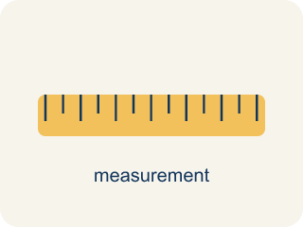
Convert Measurement Units (Convertir unidades de medida) — Rename a measurement in a different unit without changing its amount.
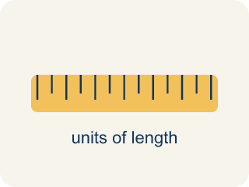
Conversion Factor (Factor de conversión) — A ratio that helps you change one unit into another.

Unit (Unidad) — A standard amount used to measure, like an inch or a liter.
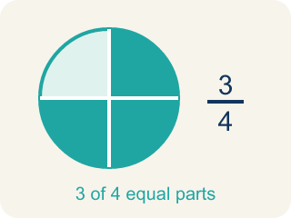
Equivalent (Equivalente) — Having the same value, just in different units.
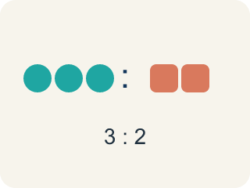
Ratio (Razón) — A way to compare two amounts, like 3 to 2.

Customary units (Unidades usuales (sistema inglés)) — The U.S. way of measuring, like inches, feet, and pounds.

Metric units (Unidades métricas) — A way of measuring by 10s, like meters, liters, and grams.
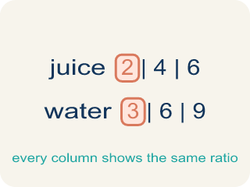
Ratio table (Tabla de razones) — A table of equal ratios that shows a pattern.

Practice
Show your work. Use the blank space under each problem.
1. A shelf is 30 inches long. How many feet and inches is that?
A. 2 feet 6 inches
B. 3 feet 0 inches
C. 2 feet 8 inches
D. 1 foot 18 inches
______________________________________________________________________
2. Spot the Common Mistake
Step 1 (Convert 80 ounces of bolts to pounds): 80 ounces → pounds
Step 2 (Use the conversion factor): 1 pound = 16 ounces
Step 3 (Operate): 80 × 16 = 1,280 pounds
Step 4 (Final answer): 80 ounces = 1,280 pounds
Which step has the mistake? Explain and fix it:
______________________________________________________________________
______________________________________________________________________
______________________________________________________________________
3. Find the Conversion Error
Step 1 (Convert 6 feet to yards): 6 feet → yards
Step 2 (Use conversion factor): 1 yard = 3 feet
Step 3 (Multiply): 6 × 3 = 18 yards
Step 4 (Final answer): 6 feet = 18 yards
Which step has the mistake? Explain and fix it:
______________________________________________________________________
______________________________________________________________________
______________________________________________________________________
4. A recipe says you need 5 feet of ribbon, but the store only sells ribbon in inches. Another recipe says you need 2 yards of fabric, but your ruler measures in feet. Convert both measurements and explain the steps you used. Which conversion factor did you use each time?
Sentence starter: 5 feet = ___ inches because ___. 2 yards = ___ feet because ___. The conversion factors I used were ___.
______________________________________________________________________
______________________________________________________________________
______________________________________________________________________
______________________________________________________________________

Answer Key (Teacher)
1. A. 2 feet 6 inches
30 ÷ 12 = 2 remainder 6. So 30 inches = 2 feet 6 inches.
Watch for: A common mistake in Convert Measurement Units is applying the conversion factor in the wrong direction — for example, converting 4 feet to inches by dividing (4 ÷ 12 = 0.33 inches) instead of multiplying (4 × 12 = 48 inches), or converting 80 ounces to pounds by multiplying (80 × 16 = 1,280 pounds) instead of dividing (80 ÷ 16 = 5 pounds). Before you answer, ask: am I changing to a SMALLER unit (there will be MORE of them, so multiply) or a BIGGER unit (there will be FEWER of them, so divide)?
2. Spot the Common Mistake
The mistake is in Step 3.
Correct work: Ounces are smaller than pounds, so you divide (not multiply): 80 ÷ 16 = 5 pounds. Changing to a bigger unit gives a smaller number.
Watch for: The Operate step multiplied when it should have divided. Pounds are bigger than ounces, so the 80 ounces bundle into 80 ÷ 16 = 5 pounds. An answer of 1,280 pounds should stand out immediately — a container of bolts that weighs 80 ounces is only about 5 pounds.
3. Find the Conversion Error
The mistake is in Step 3.
Correct work: Since 3 feet = 1 yard, you divide by 3 (not multiply). 6 ÷ 3 = 2 yards.
Watch for: Feet are smaller than yards, so 6 feet has to become a smaller number of yards, not a bigger one. Since 3 feet make 1 yard, divide: 6 ÷ 3 = 2 yards. Multiplying by 3 moved in the wrong direction and produced 18 yards, which is 9 times too long.
4. Open response — answers will vary.
Look for key words: 60 inches, 6 feet, 12 inches per foot, 3 feet per yard, multiply, conversion factor.

