Convert Measurement Units — Homework
Lesson 3-10 • Standard 6.AT.3c
Name: ______________________ Period: ______ Date: ____________

Today's Goals
Content: I can convert measurement units using ratios and conversion factors.
Language: I can explain my conversion using the words conversion factor, unit, equivalent, and ratio.

Key Words
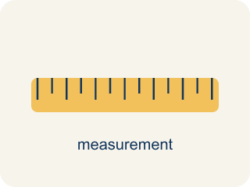
Convert Measurement Units (Convertir unidades de medida) — Rename a measurement in a different unit without changing its amount.
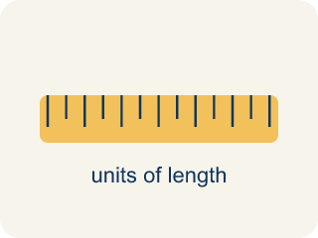
Conversion Factor (Factor de conversión) — A ratio that helps you change one unit into another.

Unit (Unidad) — A standard amount used to measure, like an inch or a liter.
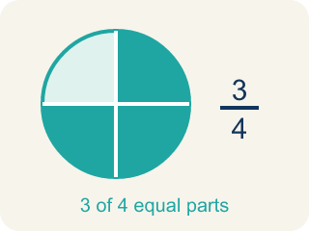
Equivalent (Equivalente) — Having the same value, just in different units.
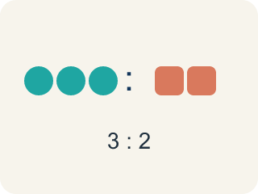
Ratio (Razón) — A way to compare two amounts, like 3 to 2.

Customary units (Unidades usuales (sistema inglés)) — The U.S. way of measuring, like inches, feet, and pounds.

Metric units (Unidades métricas) — A way of measuring by 10s, like meters, liters, and grams.
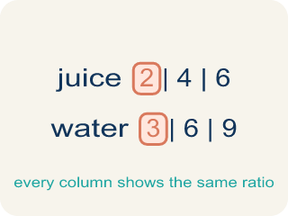
Ratio table (Tabla de razones) — A table of equal ratios that shows a pattern.

Practice
Show your work. Use the blank space under each problem.
1. How many inches are in 7 feet?
A. 84 inches
B. 72 inches
C. 70 inches
D. 96 inches
______________________________________________________________________
2. How many feet are in 3 yards?
A. 9 feet
B. 6 feet
C. 12 feet
D. 36 feet
______________________________________________________________________
3. Match each item on the left to its answer on the right.
Item | Answer choices
____ 3 yards | F. 48 ounces
____ 4 feet | E. 3 feet
____ 5 pounds | D. 72 inches
____ 2 yards | C. 80 ounces
____ 36 inches | B. 48 inches
____ 3 pounds | A. 9 feet
______________________________________________________________________
4. A shelf is 30 inches long. How many feet and inches is that?
A. 2 feet 6 inches
B. 3 feet 0 inches
C. 2 feet 8 inches
D. 1 foot 18 inches
______________________________________________________________________
5. An arcade cabinet has parts measured in different units. Convert each to the target unit.
Part | Measurement | Target Unit | Converted
Power cord | 2 yards | inches
Top panel | 54 inches | feet
Weight | 96 ounces | pounds
Side rail | 5 feet | inches
______________________________________________________________________
6. When converting, do you multiply or divide? Sort each conversion by the correct operation.
Groups: Multiply | Divide
• Feet → inches → __________________
• Yards → feet → __________________
• Pounds → ounces → __________________
• Inches → feet → __________________
• Ounces → pounds → __________________
• Feet → yards → __________________
______________________________________________________________________
7. Spot the Common Mistake
Step 1 (Convert 80 ounces of bolts to pounds): 80 ounces → pounds
Step 2 (Use the conversion factor): 1 pound = 16 ounces
Step 3 (Operate): 80 × 16 = 1,280 pounds
Step 4 (Final answer): 80 ounces = 1,280 pounds
Which step has the mistake? Explain and fix it:
______________________________________________________________________
______________________________________________________________________
______________________________________________________________________
8. Leg 1: The joystick rod is 3 feet long, but the parts catalog lists it in inches. How many inches is that? (1 ft = 12 in)
A. 36 inches
B. 15 inches
C. 30 inches
D. 33 inches
______________________________________________________________________
9. Leg 2: A power cable on the cabinet plan measures 2.5 kilometers across the whole arcade network. How many meters is that? (1 km = 1,000 m)
A. 2,500 meters
B. 250 meters
C. 25 meters
D. 25,000 meters
______________________________________________________________________
10. Leg 3: The coin box weighs 5 pounds, but the shipping label needs the weight in ounces. How many ounces is that? (1 lb = 16 oz)
A. 80 ounces
B. 21 ounces
C. 75 ounces
D. 16 ounces
______________________________________________________________________

Answer Key (Teacher)
1. A. 84 inches
7 × 12 = 84 inches.
Watch for: A common mistake in Convert Measurement Units is applying the conversion factor in the wrong direction — for example, converting 4 feet to inches by dividing (4 ÷ 12 = 0.33 inches) instead of multiplying (4 × 12 = 48 inches), or converting 80 ounces to pounds by multiplying (80 × 16 = 1,280 pounds) instead of dividing (80 ÷ 16 = 5 pounds). Before you answer, ask: am I changing to a SMALLER unit (there will be MORE of them, so multiply) or a BIGGER unit (there will be FEWER of them, so divide)?
2. A. 9 feet
1 yard = 3 feet. 3 × 3 = 9 feet.
Watch for: A common mistake in Convert Measurement Units is applying the conversion factor in the wrong direction — for example, converting 4 feet to inches by dividing (4 ÷ 12 = 0.33 inches) instead of multiplying (4 × 12 = 48 inches), or converting 80 ounces to pounds by multiplying (80 × 16 = 1,280 pounds) instead of dividing (80 ÷ 16 = 5 pounds). Before you answer, ask: am I changing to a SMALLER unit (there will be MORE of them, so multiply) or a BIGGER unit (there will be FEWER of them, so divide)?
3. Matches:
3 yards → 9 feet
4 feet → 48 inches
5 pounds → 80 ounces
2 yards → 72 inches
36 inches → 3 feet
3 pounds → 48 ounces

4. A. 2 feet 6 inches
30 ÷ 12 = 2 remainder 6. So 30 inches = 2 feet 6 inches.
Watch for: A common mistake in Convert Measurement Units is applying the conversion factor in the wrong direction — for example, converting 4 feet to inches by dividing (4 ÷ 12 = 0.33 inches) instead of multiplying (4 × 12 = 48 inches), or converting 80 ounces to pounds by multiplying (80 × 16 = 1,280 pounds) instead of dividing (80 ÷ 16 = 5 pounds). Before you answer, ask: am I changing to a SMALLER unit (there will be MORE of them, so multiply) or a BIGGER unit (there will be FEWER of them, so divide)?
5. An arcade cabinet has parts measured in different units. Convert each to the target unit.
Power cord — Converted: 72 inches
Top panel — Converted: 4.5 feet
Weight — Converted: 6 pounds
Side rail — Converted: 60 inches

6. Correct groups:
Feet → inches → Multiply
Yards → feet → Multiply
Pounds → ounces → Multiply
Inches → feet → Divide
Ounces → pounds → Divide
Feet → yards → Divide

7. Spot the Common Mistake
The mistake is in Step 3.
Correct work: Ounces are smaller than pounds, so you divide (not multiply): 80 ÷ 16 = 5 pounds. Changing to a bigger unit gives a smaller number.
Watch for: The Operate step multiplied when it should have divided. Pounds are bigger than ounces, so the 80 ounces bundle into 80 ÷ 16 = 5 pounds. An answer of 1,280 pounds should stand out immediately — a container of bolts that weighs 80 ounces is only about 5 pounds.
8. A. 36 inches
Inches are smaller than feet, so multiply: 3 × 12 = 36 inches.
Watch for: A common mistake in Convert Measurement Units is applying the conversion factor in the wrong direction — for example, converting 4 feet to inches by dividing (4 ÷ 12 = 0.33 inches) instead of multiplying (4 × 12 = 48 inches), or converting 80 ounces to pounds by multiplying (80 × 16 = 1,280 pounds) instead of dividing (80 ÷ 16 = 5 pounds). Before you answer, ask: am I changing to a SMALLER unit (there will be MORE of them, so multiply) or a BIGGER unit (there will be FEWER of them, so divide)?
9. A. 2,500 meters
Meters are smaller than kilometers, so multiply: 2.5 × 1,000 = 2,500 meters.
Watch for: A common mistake in Convert Measurement Units is applying the conversion factor in the wrong direction — for example, converting 4 feet to inches by dividing (4 ÷ 12 = 0.33 inches) instead of multiplying (4 × 12 = 48 inches), or converting 80 ounces to pounds by multiplying (80 × 16 = 1,280 pounds) instead of dividing (80 ÷ 16 = 5 pounds). Before you answer, ask: am I changing to a SMALLER unit (there will be MORE of them, so multiply) or a BIGGER unit (there will be FEWER of them, so divide)?
10. A. 80 ounces
Ounces are smaller than pounds, so multiply: 5 × 16 = 80 ounces.
Watch for: A common mistake in Convert Measurement Units is applying the conversion factor in the wrong direction — for example, converting 4 feet to inches by dividing (4 ÷ 12 = 0.33 inches) instead of multiplying (4 × 12 = 48 inches), or converting 80 ounces to pounds by multiplying (80 × 16 = 1,280 pounds) instead of dividing (80 ÷ 16 = 5 pounds). Before you answer, ask: am I changing to a SMALLER unit (there will be MORE of them, so multiply) or a BIGGER unit (there will be FEWER of them, so divide)?

