3.2 Small Group · Group 1 — Homework
Lesson 3-2-group1 • Standard 6.AT.2
Name: ______________________ Period: ______ Date: ____________

Today's Goals
Content: With my small group, I can find a unit rate to compare prices and decide the better buy — one step at a time, with support.
Language: I can talk through each step out loud using a sentence frame and the lesson's key words.

Key Words
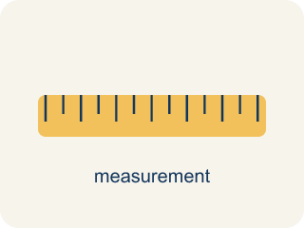
Rates and Unit Rates (Tasas y tasas unitarias) — A rate compares different units; a unit rate compares a quantity to 1 unit.
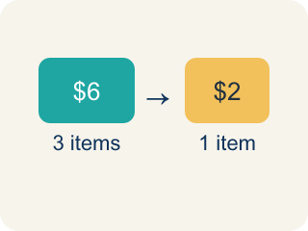
Rate (Tasa) — A ratio comparing two amounts with different units, like miles per hour.

Unit Rate (Tasa unitaria) — A rate for just 1 of something, like cost for 1 item.

Per (Por) — For each one. Example: 5 dollars per book.
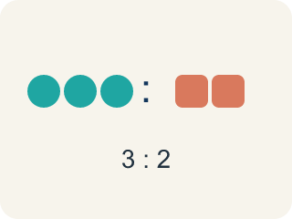
Ratio (Razón) — A way to compare two amounts, like 3 to 2.

Better Buy (Mejor compra) — The choice that costs less for each item.
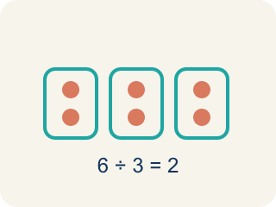
Divide (Dividir) — Splitting a total into equal groups.

Practice
Show your work. Use the blank space under each problem.
1. A booth charges $4.50 for 9 games. What is the unit rate?
A. $0.50 per game
B. $0.45 per game
C. $2.00 per game
D. $4.50 per game
______________________________________________________________________
2. A car travels 180 miles using 6 gallons of gas. What is the unit rate in miles per gallon?
A. 30 miles per gallon
B. 6 miles per gallon
C. 180 miles per gallon
D. 36 miles per gallon
______________________________________________________________________
3. Runner A completes 4 laps in 12 minutes. Runner B completes 5 laps in 14 minutes. Who runs more laps per minute?
A. Runner B
B. Runner A
C. Same rate
D. Cannot determine
______________________________________________________________________
4. The Star Blaster cabinet scored 90 points in 3 games. What is the unit rate in points per game?
A. 30 points per game
B. 270 points per game
C. 3 points per game
D. 93 points per game
______________________________________________________________________
5. Nova: 78 points in 6 min. Pulse: 75 points in 5 min. Which scores faster (more points per minute)?
A. Pulse, at 15 points per minute
B. Nova, at 13 points per minute
C. They score at the same rate
D. There is not enough information
______________________________________________________________________
6. Machine A: 150 coins for 5 plays. Machine B: 168 coins for 8 plays. Which is the better value (fewer coins per play)?
A. Machine B, at 21 coins per play
B. Machine A, at 30 coins per play
C. They are the same value
D. Machine A, because it costs fewer coins total
______________________________________________________________________
7. Level 2 Extension — Inverted Unit Rate: Points per Minute
Step 1 (Find the scoring rate in points per minute: 96 points in 6 minutes): 96 points in 6 minutes
Step 2 (Set up the division): 6 ÷ 96 = 0.0625
Step 3 (Write the unit rate): The unit rate is 0.0625 points per minute
Which step has the mistake? Explain and fix it:
______________________________________________________________________
______________________________________________________________________
______________________________________________________________________
8. Find the Rate Error
Step 1 (Find the unit rate: 12 tickets for $8): 12 tickets for $8
Step 2 (Set up the division): 12 ÷ 8 = 1.5
Step 3 (Write the unit rate): The unit rate is $1.50 per ticket
Which step has the mistake? Explain and fix it:
______________________________________________________________________
______________________________________________________________________
______________________________________________________________________

Answer Key (Teacher)
1. A. $0.50 per game
$4.50 ÷ 9 = $0.50 per game.
Watch for: A common mistake in Rates and Unit Rates is comparing total costs instead of unit rates: a student sees Pack X at $4.00 for 10 tokens and Pack Y at $6.00 for 16 tokens and picks Pack X just because $4.00 is the smaller number, without dividing to find the cost per token ($0.40 for Pack X vs. $0.375 for Pack Y — Pack Y is actually the better buy). A second common mistake is dividing backwards — finding tokens ÷ cost instead of cost ÷ tokens — which turns 'dollars per token' into 'tokens per dollar' and gives an answer that looks reasonable but answers the wrong question. Always divide the total cost by the number of items, and check that your unit rate answers 'the cost for ONE item,' not the reverse.
2. A. 30 miles per gallon
180 miles ÷ 6 gallons = 30 miles per gallon.
Watch for: A common mistake in Rates and Unit Rates is comparing total costs instead of unit rates: a student sees Pack X at $4.00 for 10 tokens and Pack Y at $6.00 for 16 tokens and picks Pack X just because $4.00 is the smaller number, without dividing to find the cost per token ($0.40 for Pack X vs. $0.375 for Pack Y — Pack Y is actually the better buy). A second common mistake is dividing backwards — finding tokens ÷ cost instead of cost ÷ tokens — which turns 'dollars per token' into 'tokens per dollar' and gives an answer that looks reasonable but answers the wrong question. Always divide the total cost by the number of items, and check that your unit rate answers 'the cost for ONE item,' not the reverse.
3. A. Runner B
Runner A: 4÷12 ≈ 0.33 laps/min. Runner B: 5÷14 ≈ 0.36 laps/min. Runner B runs slightly more laps per minute.
Watch for: A common mistake in Rates and Unit Rates is comparing total costs instead of unit rates: a student sees Pack X at $4.00 for 10 tokens and Pack Y at $6.00 for 16 tokens and picks Pack X just because $4.00 is the smaller number, without dividing to find the cost per token ($0.40 for Pack X vs. $0.375 for Pack Y — Pack Y is actually the better buy). A second common mistake is dividing backwards — finding tokens ÷ cost instead of cost ÷ tokens — which turns 'dollars per token' into 'tokens per dollar' and gives an answer that looks reasonable but answers the wrong question. Always divide the total cost by the number of items, and check that your unit rate answers 'the cost for ONE item,' not the reverse.
4. A. 30 points per game
Divide points by games: 90 ÷ 3 = 30 points per game.
Watch for: A common mistake in Rates and Unit Rates is comparing total costs instead of unit rates: a student sees Pack X at $4.00 for 10 tokens and Pack Y at $6.00 for 16 tokens and picks Pack X just because $4.00 is the smaller number, without dividing to find the cost per token ($0.40 for Pack X vs. $0.375 for Pack Y — Pack Y is actually the better buy). A second common mistake is dividing backwards — finding tokens ÷ cost instead of cost ÷ tokens — which turns 'dollars per token' into 'tokens per dollar' and gives an answer that looks reasonable but answers the wrong question. Always divide the total cost by the number of items, and check that your unit rate answers 'the cost for ONE item,' not the reverse.
5. A. Pulse, at 15 points per minute
Nova: 78 ÷ 6 = 13 points per minute. Pulse: 75 ÷ 5 = 15 points per minute. 15 > 13, so Pulse is faster.
Watch for: A common mistake in Rates and Unit Rates is comparing total costs instead of unit rates: a student sees Pack X at $4.00 for 10 tokens and Pack Y at $6.00 for 16 tokens and picks Pack X just because $4.00 is the smaller number, without dividing to find the cost per token ($0.40 for Pack X vs. $0.375 for Pack Y — Pack Y is actually the better buy). A second common mistake is dividing backwards — finding tokens ÷ cost instead of cost ÷ tokens — which turns 'dollars per token' into 'tokens per dollar' and gives an answer that looks reasonable but answers the wrong question. Always divide the total cost by the number of items, and check that your unit rate answers 'the cost for ONE item,' not the reverse.
6. A. Machine B, at 21 coins per play
Machine A: 150 ÷ 5 = 30 coins per play. Machine B: 168 ÷ 8 = 21 coins per play. 21 < 30, so Machine B is the better value.
Watch for: A common mistake in Rates and Unit Rates is comparing total costs instead of unit rates: a student sees Pack X at $4.00 for 10 tokens and Pack Y at $6.00 for 16 tokens and picks Pack X just because $4.00 is the smaller number, without dividing to find the cost per token ($0.40 for Pack X vs. $0.375 for Pack Y — Pack Y is actually the better buy). A second common mistake is dividing backwards — finding tokens ÷ cost instead of cost ÷ tokens — which turns 'dollars per token' into 'tokens per dollar' and gives an answer that looks reasonable but answers the wrong question. Always divide the total cost by the number of items, and check that your unit rate answers 'the cost for ONE item,' not the reverse.
7. Level 2 Extension — Inverted Unit Rate: Points per Minute
The mistake is in Step 2.
Correct work: To find points per minute, divide points by minutes: 96 ÷ 6 = 16 points per minute. The student divided minutes by points (the wrong way), which gives minutes per point, not points per minute.
Watch for: The two quantities were divided backwards. "Points per minute" puts points on top, so the correct division is 96 ÷ 6 = 16 points per minute. The student's 6 ÷ 96 = 0.0625 answers minutes per point instead, and scoring 96 points in 6 minutes is clearly much faster than 0.0625 points a minute.
8. Find the Rate Error
The mistake is in Step 2.
Correct work: To find cost per ticket, divide $8 ÷ 12 = $0.67 per ticket (rounded). The student divided tickets by cost instead of cost by tickets.
Watch for: The two quantities were divided in the wrong order. "Dollars per ticket" puts dollars on top, so the correct division is $8 ÷ 12 ≈ $0.67 per ticket. The student's 12 ÷ 8 = 1.5 answers a different question, and $1.50 per ticket would mean 12 tickets cost $18 instead of $8.

