3.2 Small Group · Group 2 — Homework
Lesson 3-2-group2 • Standard 6.AT.2
Name: ______________________ Period: ______ Date: ____________

Today's Goals
Content: I can find a unit rate to compare prices and decide the better buy, explain how I can tell, and judge a case I have not seen before.
Language: I can justify my answer to a skeptic and connect it to a second strategy or representation.

Key Words
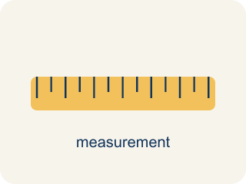
Rates and Unit Rates (Tasas y tasas unitarias) — A rate compares different units; a unit rate compares a quantity to 1 unit.
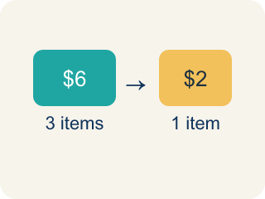
Rate (Tasa) — A ratio comparing two amounts with different units, like miles per hour.

Unit Rate (Tasa unitaria) — A rate for just 1 of something, like cost for 1 item.

Per (Por) — For each one. Example: 5 dollars per book.
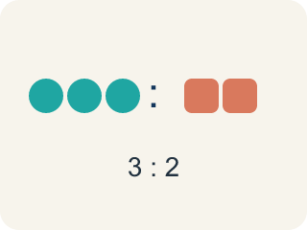
Ratio (Razón) — A way to compare two amounts, like 3 to 2.

Better Buy (Mejor compra) — The choice that costs less for each item.
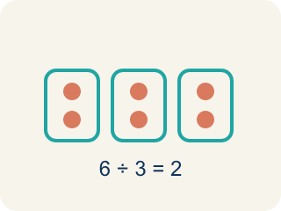
Divide (Dividir) — Splitting a total into equal groups.

Practice
Show your work. Use the blank space under each problem.
1. Which token pack from the table above is the best deal?
A. Pack A
B. Pack B
C. Pack C
D. They are all the same
______________________________________________________________________
2. Runner A completes 4 laps in 12 minutes. Runner B completes 5 laps in 14 minutes. Who runs more laps per minute?
A. Runner B
B. Runner A
C. Same rate
D. Cannot determine
______________________________________________________________________
3. Spot the Common Mistake
Step 1 (Read the problem): Pack X is 10 tokens for $4.00. Pack Y is 16 tokens for $6.00. Which is the better buy (lower cost per token)?
Step 2 (Compare the deals): Pack X costs $4.00 and Pack Y costs $6.00. The student says Pack X is the better buy because $4.00 is the lower total price.
Step 3 (State the answer): The student chooses Pack X.
Which step has the mistake? Explain and fix it:
______________________________________________________________________
______________________________________________________________________
______________________________________________________________________
4. Find the Rate Error
Step 1 (Find the unit rate: 12 tickets for $8): 12 tickets for $8
Step 2 (Set up the division): 12 ÷ 8 = 1.5
Step 3 (Write the unit rate): The unit rate is $1.50 per ticket
Which step has the mistake? Explain and fix it:
______________________________________________________________________
______________________________________________________________________
______________________________________________________________________

Answer Key (Teacher)
1. B. Pack B
Pack B has a unit rate of $0.20 per token, which is the lowest cost per token.
Watch for: A common mistake in Rates and Unit Rates is comparing total costs instead of unit rates: a student sees Pack X at $4.00 for 10 tokens and Pack Y at $6.00 for 16 tokens and picks Pack X just because $4.00 is the smaller number, without dividing to find the cost per token ($0.40 for Pack X vs. $0.375 for Pack Y — Pack Y is actually the better buy). A second common mistake is dividing backwards — finding tokens ÷ cost instead of cost ÷ tokens — which turns 'dollars per token' into 'tokens per dollar' and gives an answer that looks reasonable but answers the wrong question. Always divide the total cost by the number of items, and check that your unit rate answers 'the cost for ONE item,' not the reverse.
2. A. Runner B
Runner A: 4÷12 ≈ 0.33 laps/min. Runner B: 5÷14 ≈ 0.36 laps/min. Runner B runs slightly more laps per minute.
Watch for: A common mistake in Rates and Unit Rates is comparing total costs instead of unit rates: a student sees Pack X at $4.00 for 10 tokens and Pack Y at $6.00 for 16 tokens and picks Pack X just because $4.00 is the smaller number, without dividing to find the cost per token ($0.40 for Pack X vs. $0.375 for Pack Y — Pack Y is actually the better buy). A second common mistake is dividing backwards — finding tokens ÷ cost instead of cost ÷ tokens — which turns 'dollars per token' into 'tokens per dollar' and gives an answer that looks reasonable but answers the wrong question. Always divide the total cost by the number of items, and check that your unit rate answers 'the cost for ONE item,' not the reverse.
3. Spot the Common Mistake
The mistake is in Step 2.
Correct work: Compare unit rates, not total prices. Pack X: $4.00 ÷ 10 = $0.40 per token. Pack Y: $6.00 ÷ 16 = $0.375 per token. Pack Y has the lower cost per token, so Pack Y is the better buy.
Watch for: Comparing the two total prices is not a fair comparison, because Pack X holds 10 tokens and Pack Y holds 16. Dividing gives the cost per token: $4.00 ÷ 10 = $0.40 and $6.00 ÷ 16 = $0.375. Pack Y costs less for each token, so Pack Y is the better buy even though its total price is higher.
4. Find the Rate Error
The mistake is in Step 2.
Correct work: To find cost per ticket, divide $8 ÷ 12 = $0.67 per ticket (rounded). The student divided tickets by cost instead of cost by tickets.
Watch for: The two quantities were divided in the wrong order. "Dollars per ticket" puts dollars on top, so the correct division is $8 ÷ 12 ≈ $0.67 per ticket. The student's 12 ÷ 8 = 1.5 answers a different question, and $1.50 per ticket would mean 12 tickets cost $18 instead of $8.

