3.3 Small Group · Group 1 — Homework
Lesson 3-3-group1 • Standard 6.AT.3a
Name: ______________________ Period: ______ Date: ____________

Today's Goals
Content: With my small group, I can use a ratio table to find equivalent ratios — one step at a time, with support.
Language: I can talk through each step out loud using a sentence frame and the lesson's key words.

Key Words
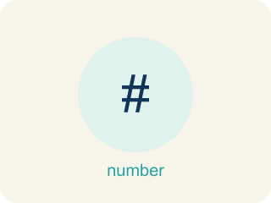
Ratio Tables (Tablas de razones) — Tables that organize pairs of equivalent ratios.
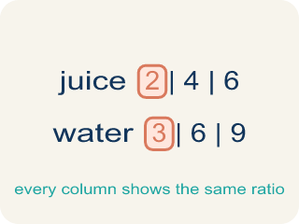
Ratio table (Tabla de razones) — A table of equal ratios that shows a pattern.
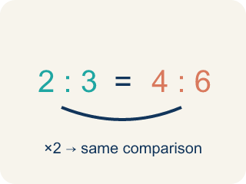
Equivalent ratio (Razón equivalente) — Two ratios that mean the same thing, like 1:2 and 2:4.
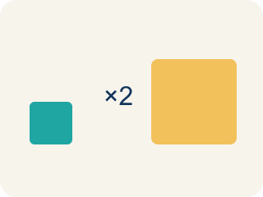
Scale factor (Factor de escala) — The number you multiply both parts of a ratio by to get an equal ratio.
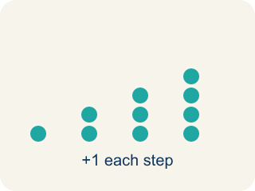
Pattern (Patrón) — A rule that numbers follow again and again.

Additive pattern (Patrón aditivo) — Adding the same amount to both parts of a ratio table to make new rows.

Practice
Show your work. Use the blank space under each problem.
1. A recipe uses 3 eggs for every 5 cups of flour. How many eggs are needed for 15 cups of flour?
A. 9
B. 6
C. 10
D. 12
______________________________________________________________________
2. Which row does NOT belong in a ratio table for 4:5?
A. 6:10
B. 8:10
C. 12:15
D. 16:20
______________________________________________________________________
3. A ratio table shows 5:8, 10:16, 15:24. What scale factor was used from the first row to the third row?
A. 3
B. 2
C. 5
D. 8
______________________________________________________________________
4. Catch Marcus's Mistake
Step 1 (Read the table): A ratio table starts with 3:8. Marcus needs to find the row where the first value is 12.
Step 2 (Find the change): Marcus sees the first value went from 3 to 12, a difference of 9.
Step 3 (Apply the change): Marcus adds 9 to the second value: 8 + 9 = 17
Step 4 (Write the new row): Marcus's answer: 12:17
Which step has the mistake? Explain and fix it:
______________________________________________________________________
______________________________________________________________________
______________________________________________________________________
5. The food truck sells tacos at a steady rate: 2 tacos cost $5. At that rate, how much do 6 tacos cost?
A. $15
B. $11
C. $12
D. $30
______________________________________________________________________
6. A smoothie recipe at the truck uses 4 cups of mango for every 3 cups of pineapple. How many cups of mango are needed for 9 cups of pineapple?
A. 12
B. 10
C. 13
D. 9
______________________________________________________________________
7. Level 2 Extension — Catch the Food Truck Error
Step 1 (Read the order): The hot sauce mix uses a ratio of 2 spoons of pepper to 5 spoons of tomato (2:5). Find an equivalent row for a bigger batch.
Step 2 (Pick a scale factor): To make the batch bigger, Maya picks a scale factor of 3. A scale factor should multiply BOTH parts.
Step 3 (Scale the pepper): 2 + 1 = 3 spoons of pepper
Step 4 (Scale the tomato): 5 + 1 = 6 spoons of tomato
Which step has the mistake? Explain and fix it:
______________________________________________________________________
______________________________________________________________________
______________________________________________________________________
8. Find Devon's Mistake
Step 1 (Read the problem): A recipe uses 5 cups of oats for every 2 cups of honey. Complete the table for 3 batches.
Step 2 (Find the scale factor): 3 batches → multiply by 3
Step 3 (Scale the oats): 5 × 3 = 15 cups of oats
Step 4 (Scale the honey): 2 + 3 = 5 cups of honey
Which step has the mistake? Explain and fix it:
______________________________________________________________________
______________________________________________________________________
______________________________________________________________________

Answer Key (Teacher)
1. A. 9
The scale factor is 15 ÷ 5 = 3. Multiply the eggs by 3: 3 × 3 = 9 eggs.
Watch for: A common mistake in Ratio Tables is scaling only ONE part of the ratio, or adding the scale factor to a part instead of multiplying by it — for example, turning 2:3 into 6:3 (multiplying only the first number by 3 and forgetting the second) or into 4:5 (adding the scale factor 2 to the second number instead of multiplying, since 3+2=5 but 3×2=6). Before you submit, multiply BOTH numbers by the same scale factor and check that your new ratio simplifies back to the original.
2. A. 6:10
6:10 simplifies to 3:5, not 4:5. The other ratios (8:10, 12:15, 16:20) all simplify to 4:5.
Watch for: A common mistake in Ratio Tables is scaling only ONE part of the ratio, or adding the scale factor to a part instead of multiplying by it — for example, turning 2:3 into 6:3 (multiplying only the first number by 3 and forgetting the second) or into 4:5 (adding the scale factor 2 to the second number instead of multiplying, since 3+2=5 but 3×2=6). Before you submit, multiply BOTH numbers by the same scale factor and check that your new ratio simplifies back to the original.
3. A. 3
From 5 to 15: 15 ÷ 5 = 3. From 8 to 24: 24 ÷ 8 = 3. The scale factor is 3.
Watch for: A common mistake in Ratio Tables is scaling only ONE part of the ratio, or adding the scale factor to a part instead of multiplying by it — for example, turning 2:3 into 6:3 (multiplying only the first number by 3 and forgetting the second) or into 4:5 (adding the scale factor 2 to the second number instead of multiplying, since 3+2=5 but 3×2=6). Before you submit, multiply BOTH numbers by the same scale factor and check that your new ratio simplifies back to the original.
4. Catch Marcus's Mistake
The mistake is in Step 2.
Correct work: Marcus subtracted instead of finding a scale factor. The scale factor from 3 to 12 is 12 ÷ 3 = 4 (not a difference of 9). Multiply the second value by that same scale factor: 8 × 4 = 32, so the correct row is 12:32.
Watch for: In the 'Find the change' step Marcus subtracted 12 − 3 = 9 and then added that 9 to the second value, but rows of a ratio table are connected by multiplication. The scale factor is 12 ÷ 3 = 4, so the second value becomes 8 × 4 = 32 and the correct row is 12:32.
5. A. $15
6 tacos is 3 times 2 tacos, so multiply the cost by 3: $5 x 3 = $15.
Watch for: A common mistake in Ratio Tables is scaling only ONE part of the ratio, or adding the scale factor to a part instead of multiplying by it — for example, turning 2:3 into 6:3 (multiplying only the first number by 3 and forgetting the second) or into 4:5 (adding the scale factor 2 to the second number instead of multiplying, since 3+2=5 but 3×2=6). Before you submit, multiply BOTH numbers by the same scale factor and check that your new ratio simplifies back to the original.
6. A. 12
The scale factor is 9 div 3 = 3. Multiply the mango by 3: 4 x 3 = 12 cups.
Watch for: A common mistake in Ratio Tables is scaling only ONE part of the ratio, or adding the scale factor to a part instead of multiplying by it — for example, turning 2:3 into 6:3 (multiplying only the first number by 3 and forgetting the second) or into 4:5 (adding the scale factor 2 to the second number instead of multiplying, since 3+2=5 but 3×2=6). Before you submit, multiply BOTH numbers by the same scale factor and check that your new ratio simplifies back to the original.
7. Level 2 Extension — Catch the Food Truck Error
The mistake is in Step 3.
Correct work: Maya added 1 to each part instead of multiplying. To scale 2:5 by a scale factor of 3, multiply BOTH parts: 2 x 3 = 6 spoons of pepper and 5 x 3 = 15 spoons of tomato, giving 6:15.
Watch for: In the pepper step Maya wrote 2 + 1 = 3 and then 5 + 1 = 6, adding 1 instead of using the scale factor of 3 she had just chosen. Multiplying both parts by 3 gives 2 × 3 = 6 spoons of pepper and 5 × 3 = 15 spoons of tomato, so the equivalent row is 6:15.
8. Find Devon's Mistake
The mistake is in Step 4.
Correct work: 2 × 3 = 6 cups of honey (multiply, don't add the scale factor)
Watch for: Devon multiplied the oats by the scale factor (5 × 3 = 15) but switched to addition for the honey (2 + 3 = 5). Both quantities have to use the same operation and the same scale factor, so the honey is 2 × 3 = 6 cups.

