3.3 Small Group · Group 2 — Homework
Lesson 3-3-group2 • Standard 6.AT.3a
Name: ______________________ Period: ______ Date: ____________

Today's Goals
Content: I can use a ratio table to find equivalent ratios, explain why the method works, and use it on a problem I have not seen before.
Language: I can justify my answer to a skeptic and connect it to a second strategy or representation.

Key Words
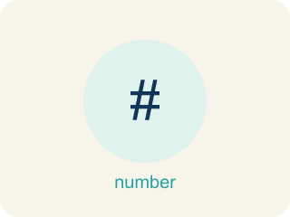
Ratio Tables (Tablas de razones) — Tables that organize pairs of equivalent ratios.
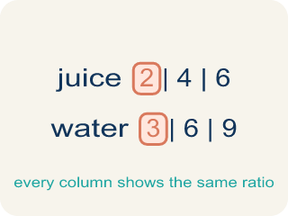
Ratio table (Tabla de razones) — A table of equal ratios that shows a pattern.
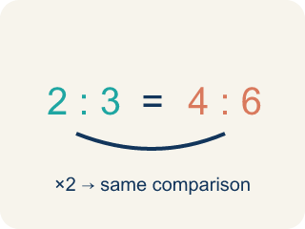
Equivalent ratio (Razón equivalente) — Two ratios that mean the same thing, like 1:2 and 2:4.
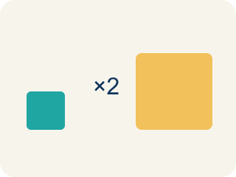
Scale factor (Factor de escala) — The number you multiply both parts of a ratio by to get an equal ratio.
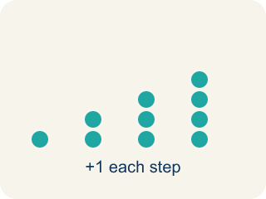
Pattern (Patrón) — A rule that numbers follow again and again.

Additive pattern (Patrón aditivo) — Adding the same amount to both parts of a ratio table to make new rows.

Practice
Show your work. Use the blank space under each problem.
1. In a ratio table, the ratio of sugar to butter is 3:2. If you use 12 cups of sugar, how many cups of butter do you need?
A. 8
B. 6
C. 10
D. 9
______________________________________________________________________
2. A ratio table shows 5:8, 10:16, 15:24. What scale factor was used from the first row to the third row?
A. 3
B. 2
C. 5
D. 8
______________________________________________________________________
3. Catch Marcus's Mistake
Step 1 (Read the table): A ratio table starts with 3:8. Marcus needs to find the row where the first value is 12.
Step 2 (Find the change): Marcus sees the first value went from 3 to 12, a difference of 9.
Step 3 (Apply the change): Marcus adds 9 to the second value: 8 + 9 = 17
Step 4 (Write the new row): Marcus's answer: 12:17
Which step has the mistake? Explain and fix it:
______________________________________________________________________
______________________________________________________________________
______________________________________________________________________
4. Find Devon's Mistake
Step 1 (Read the problem): A recipe uses 5 cups of oats for every 2 cups of honey. Complete the table for 3 batches.
Step 2 (Find the scale factor): 3 batches → multiply by 3
Step 3 (Scale the oats): 5 × 3 = 15 cups of oats
Step 4 (Scale the honey): 2 + 3 = 5 cups of honey
Which step has the mistake? Explain and fix it:
______________________________________________________________________
______________________________________________________________________
______________________________________________________________________

Answer Key (Teacher)
1. A. 8
Scale factor: 12 ÷ 3 = 4. Multiply butter by 4: 2 × 4 = 8 cups of butter.
Watch for: A common mistake in Ratio Tables is scaling only ONE part of the ratio, or adding the scale factor to a part instead of multiplying by it — for example, turning 2:3 into 6:3 (multiplying only the first number by 3 and forgetting the second) or into 4:5 (adding the scale factor 2 to the second number instead of multiplying, since 3+2=5 but 3×2=6). Before you submit, multiply BOTH numbers by the same scale factor and check that your new ratio simplifies back to the original.
2. A. 3
From 5 to 15: 15 ÷ 5 = 3. From 8 to 24: 24 ÷ 8 = 3. The scale factor is 3.
Watch for: A common mistake in Ratio Tables is scaling only ONE part of the ratio, or adding the scale factor to a part instead of multiplying by it — for example, turning 2:3 into 6:3 (multiplying only the first number by 3 and forgetting the second) or into 4:5 (adding the scale factor 2 to the second number instead of multiplying, since 3+2=5 but 3×2=6). Before you submit, multiply BOTH numbers by the same scale factor and check that your new ratio simplifies back to the original.
3. Catch Marcus's Mistake
The mistake is in Step 2.
Correct work: Marcus subtracted instead of finding a scale factor. The scale factor from 3 to 12 is 12 ÷ 3 = 4 (not a difference of 9). Multiply the second value by that same scale factor: 8 × 4 = 32, so the correct row is 12:32.
Watch for: In the 'Find the change' step Marcus subtracted 12 − 3 = 9 and then added that 9 to the second value, but rows of a ratio table are connected by multiplication. The scale factor is 12 ÷ 3 = 4, so the second value becomes 8 × 4 = 32 and the correct row is 12:32.
4. Find Devon's Mistake
The mistake is in Step 4.
Correct work: 2 × 3 = 6 cups of honey (multiply, don't add the scale factor)
Watch for: Devon multiplied the oats by the scale factor (5 × 3 = 15) but switched to addition for the honey (2 + 3 = 5). Both quantities have to use the same operation and the same scale factor, so the honey is 2 × 3 = 6 cups.

