3.1–3.3 Catch-Up — Homework
Lesson 3-4-catchup • Standard 6.AT.3a
Name: ______________________ Period: ______ Date: ____________

Today's Goals
Content: I can show I am caught up on Lessons 3.1–3.3 by using each lesson's big idea in mixed practice.
Language: I can explain which lesson's big idea I used and how, using key vocabulary from Lessons 3.1–3.3.

Key Words
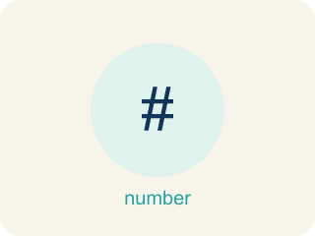
Understand Ratios (Comprender razones) — Use a ratio to compare two quantities by division.
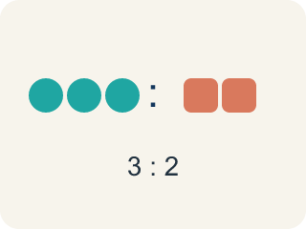
Ratio (Razón) — A way to compare two amounts, like 3 to 2.

Ratio Tables (Tablas de razones) — Tables that organize pairs of equivalent ratios.
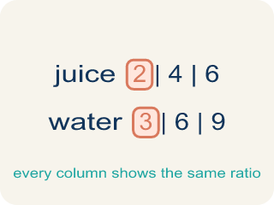
Ratio table (Tabla de razones) — A table of equal ratios that shows a pattern.
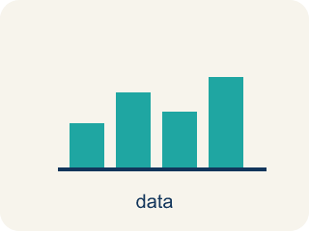
Graph Ratio Tables (Representar tablas de razones en una gráfica) — Plot the paired values from a ratio table as ordered pairs.
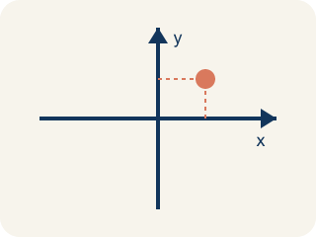
Coordinate plane (Plano cartesiano) — A grid with a line going across and a line going up to plot points.

Comparison (Comparación) — Looking at two or more amounts to see how they are related.
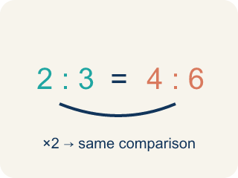
Equivalent ratio (Razón equivalente) — Two ratios that mean the same thing, like 1:2 and 2:4.
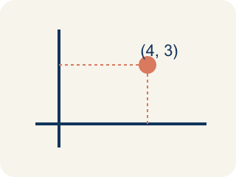
Ordered pair (Par ordenado) — Two numbers (x, y) that tell where a point is on a grid.

Practice
Show your work. Use the blank space under each problem.
1. (Lesson 3.1) A recipe uses 4 cups of milk and 1 cup of cream. What is the ratio of milk to cream?
A. 4:1
B. 1:4
C. 4:5
D. 5:1
______________________________________________________________________
2. (Lesson 3.1) Chef Reyes uses 6 strawberries and 2 bananas in a smoothie. What is the part-to-whole ratio of bananas to total fruit?
A. 2:8
B. 6:2
C. 2:6
D. 8:2
______________________________________________________________________
3. (Lesson 3.1) A fruit salad has 5 pieces of melon, 3 pieces of pineapple, and 2 grapes. What is the ratio of pineapple to melon?
A. 3:5
B. 5:3
C. 3:10
D. 3:2
______________________________________________________________________
4. (Lesson 3.1) A parking lot has 10 cars and 6 trucks. What is the part-to-whole ratio of trucks to total vehicles?
A. 6:16
B. 10:6
C. 6:10
D. 16:6
______________________________________________________________________
5. (Lesson 3.2) In a ratio table, the ratio of sugar to butter is 3:2. If you use 12 cups of sugar, how many cups of butter do you need?
A. 8
B. 6
C. 10
D. 9
______________________________________________________________________
6. (Lesson 3.2) A ratio table shows 5:8, 10:16, 15:24. What scale factor was used from the first row to the third row?
A. 3
B. 2
C. 5
D. 8
______________________________________________________________________
7. (Lesson 3.3) Points from a ratio table are plotted at (1, 4), (2, 8), and (3, 12). What is the ratio of y to x for each point?
A. 4:1
B. 1:4
C. 2:8
D. 3:4
______________________________________________________________________
8. (Lesson 3.3) Two students graph ratio tables. Student A plots (1,2), (2,4), (3,6). Student B plots (1,3), (2,6), (3,9). Whose line is steeper?
A. Student B
B. Student A
C. Same steepness
D. Cannot tell
______________________________________________________________________
9. (Lesson 3.1) Prep Bowl A: Chef Reyes stirs 7 cups of flour with 4 cups of water to make dough. What is the part-to-part ratio of flour to water?
A. 7:4
B. 4:7
C. 7:11
D. 11:4
______________________________________________________________________
10. (Lesson 3.2) The food truck sells tacos at a steady rate: 2 tacos cost $5. At that rate, how much do 6 tacos cost?
A. $15
B. $11
C. $12
D. $30
______________________________________________________________________

Answer Key (Teacher)
1. A. 4:1
A ratio compares quantities in the order given. Milk to cream = 4 to 1, or 4:1.
Watch for: A common mistake in Graph Ratio Tables is writing the ordered pair in the wrong order — putting the second table value first instead of matching (x, y) to the table's column order. For example, if a recipe table shows 2 cups of sugar for every 4 cups of flour, a student might plot (4, 2) instead of (2, 4), landing the point in a completely different spot on the grid. Before you plot, check: which quantity goes on the x-axis, and does your ordered pair start with that number?
2. A. 2:8
Total fruit = 6 + 2 = 8. The part-to-whole ratio of bananas to total fruit is 2:8.
Watch for: A common mistake in Graph Ratio Tables is writing the ordered pair in the wrong order — putting the second table value first instead of matching (x, y) to the table's column order. For example, if a recipe table shows 2 cups of sugar for every 4 cups of flour, a student might plot (4, 2) instead of (2, 4), landing the point in a completely different spot on the grid. Before you plot, check: which quantity goes on the x-axis, and does your ordered pair start with that number?
3. A. 3:5
The ratio of pineapple to melon compares pineapple (3) to melon (5), so the ratio is 3:5.
Watch for: A common mistake in Graph Ratio Tables is writing the ordered pair in the wrong order — putting the second table value first instead of matching (x, y) to the table's column order. For example, if a recipe table shows 2 cups of sugar for every 4 cups of flour, a student might plot (4, 2) instead of (2, 4), landing the point in a completely different spot on the grid. Before you plot, check: which quantity goes on the x-axis, and does your ordered pair start with that number?
4. A. 6:16
Total vehicles = 10 + 6 = 16. The ratio of trucks to total is 6:16.
Watch for: A common mistake in Graph Ratio Tables is writing the ordered pair in the wrong order — putting the second table value first instead of matching (x, y) to the table's column order. For example, if a recipe table shows 2 cups of sugar for every 4 cups of flour, a student might plot (4, 2) instead of (2, 4), landing the point in a completely different spot on the grid. Before you plot, check: which quantity goes on the x-axis, and does your ordered pair start with that number?
5. A. 8
Scale factor: 12 ÷ 3 = 4. Multiply butter by 4: 2 × 4 = 8 cups of butter.
Watch for: A common mistake in Graph Ratio Tables is writing the ordered pair in the wrong order — putting the second table value first instead of matching (x, y) to the table's column order. For example, if a recipe table shows 2 cups of sugar for every 4 cups of flour, a student might plot (4, 2) instead of (2, 4), landing the point in a completely different spot on the grid. Before you plot, check: which quantity goes on the x-axis, and does your ordered pair start with that number?
6. A. 3
From 5 to 15: 15 ÷ 5 = 3. From 8 to 24: 24 ÷ 8 = 3. The scale factor is 3.
Watch for: A common mistake in Graph Ratio Tables is writing the ordered pair in the wrong order — putting the second table value first instead of matching (x, y) to the table's column order. For example, if a recipe table shows 2 cups of sugar for every 4 cups of flour, a student might plot (4, 2) instead of (2, 4), landing the point in a completely different spot on the grid. Before you plot, check: which quantity goes on the x-axis, and does your ordered pair start with that number?
7. A. 4:1
For each point: 4÷1 = 4, 8÷2 = 4, 12÷3 = 4. The ratio of y to x is always 4:1.
Watch for: A common mistake in Graph Ratio Tables is writing the ordered pair in the wrong order — putting the second table value first instead of matching (x, y) to the table's column order. For example, if a recipe table shows 2 cups of sugar for every 4 cups of flour, a student might plot (4, 2) instead of (2, 4), landing the point in a completely different spot on the grid. Before you plot, check: which quantity goes on the x-axis, and does your ordered pair start with that number?
8. A. Student B
Student A's ratio is 1:2 (y goes up 2 for each 1 in x). Student B's ratio is 1:3 (y goes up 3 for each 1 in x). A higher rate of change means a steeper line, so Student B's is steeper.
Watch for: A common mistake in Graph Ratio Tables is writing the ordered pair in the wrong order — putting the second table value first instead of matching (x, y) to the table's column order. For example, if a recipe table shows 2 cups of sugar for every 4 cups of flour, a student might plot (4, 2) instead of (2, 4), landing the point in a completely different spot on the grid. Before you plot, check: which quantity goes on the x-axis, and does your ordered pair start with that number?
9. A. 7:4
Part-to-part compares the two ingredients in the order named. Flour to water = 7 to 4, written 7:4.
Watch for: A common mistake in Graph Ratio Tables is writing the ordered pair in the wrong order — putting the second table value first instead of matching (x, y) to the table's column order. For example, if a recipe table shows 2 cups of sugar for every 4 cups of flour, a student might plot (4, 2) instead of (2, 4), landing the point in a completely different spot on the grid. Before you plot, check: which quantity goes on the x-axis, and does your ordered pair start with that number?
10. A. $15
6 tacos is 3 times 2 tacos, so multiply the cost by 3: $5 x 3 = $15.
Watch for: A common mistake in Graph Ratio Tables is writing the ordered pair in the wrong order — putting the second table value first instead of matching (x, y) to the table's column order. For example, if a recipe table shows 2 cups of sugar for every 4 cups of flour, a student might plot (4, 2) instead of (2, 4), landing the point in a completely different spot on the grid. Before you plot, check: which quantity goes on the x-axis, and does your ordered pair start with that number?

