3.4 Small Group · Group 1 — Homework
Lesson 3-4-group1 • Standard 6.AT.3a
Name: ______________________ Period: ______ Date: ____________

Today's Goals
Content: With my small group, I can graph the values from a ratio table as points on the coordinate plane — one step at a time, with support.
Language: I can talk through each step out loud using a sentence frame and the lesson's key words.

Key Words
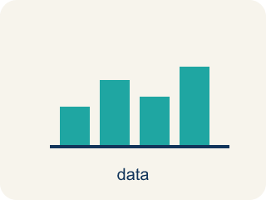
Graph Ratio Tables (Representar tablas de razones en una gráfica) — Plot the paired values from a ratio table as ordered pairs.
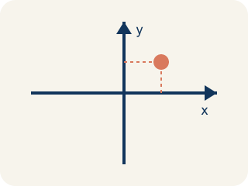
Coordinate plane (Plano cartesiano) — A grid with a line going across and a line going up to plot points.
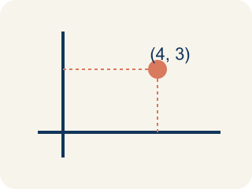
Ordered pair (Par ordenado) — Two numbers (x, y) that tell where a point is on a grid.
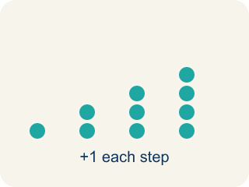
Linear pattern (Patrón lineal) — Points that make a straight line on a grid.
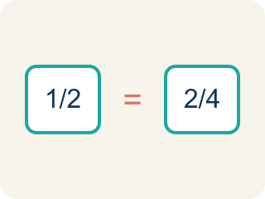
Proportional (Proporcional) — Two amounts that grow together at the same rate.
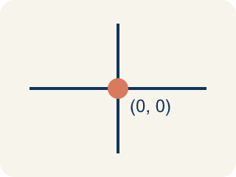
Origin (Origen) — The point (0, 0) where the two grid lines cross.
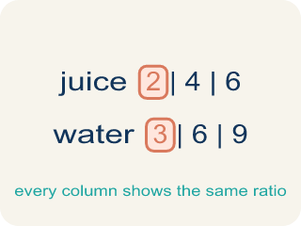
Ratio table (Tabla de razones) — A table of equal ratios that shows a pattern.

Practice
Show your work. Use the blank space under each problem.
1. A ratio table shows (2, 6), (4, 12), and (6, 18). Which ordered pair comes next if the pattern continues?
A. (8, 24)
B. (7, 20)
C. (8, 22)
D. (10, 24)
______________________________________________________________________
2. When you graph equivalent ratios, the points will always form what shape?
A. A straight line through the origin
B. A curved line
C. A zigzag
D. A circle
______________________________________________________________________
3. Two students graph ratio tables. Student A plots (1,2), (2,4), (3,6). Student B plots (1,3), (2,6), (3,9). Whose line is steeper?
A. Student B
B. Student A
C. Same steepness
D. Cannot tell
______________________________________________________________________
4. On Level — Spot the Common Mistake
Step 1 (Read the ratio): A recipe uses 4 cups of water for every 1 cup of rice (rule: y = 4x). A student is plotting points for the line.
Step 2 (List the points): (1, 4), (2, 8), (3, 12)
Step 3 (Add another point): The student also plots (4, 14) and says it belongs on the same line.
Step 4 (Conclusion): All four points form a straight line.
Which step has the mistake? Explain and fix it:
______________________________________________________________________
______________________________________________________________________
______________________________________________________________________
5. Recipe: 1 cup berries to 2 scoops yogurt. With cups on x and scoops on y, which pair shows 3 cups?
A. (3, 6)
B. (6, 3)
C. (3, 5)
D. (3, 3)
______________________________________________________________________
6. On the smoothie graph, every point follows the rule scoops = 2 × cups. Which equation describes the pattern between x (cups) and y (scoops)?
A. y = 2x
B. y = x + 2
C. y = x ÷ 2
D. x = 2y
______________________________________________________________________
7. Level 2 Extension — The Swapped Smoothie Point
Step 1 (Read the table): Cups of blueberries: 2 | Scoops of yogurt: 4 (rule: 2 scoops per cup)
Step 2 (Name the axes): Cups go on the x-axis, scoops go on the y-axis
Step 3 (Write the ordered pair): (4, 2)
Step 4 (Plot the point): Go right 4, up 2 on the grid
Which step has the mistake? Explain and fix it:
______________________________________________________________________
______________________________________________________________________
______________________________________________________________________
8. Find Jada's Mistake
Step 1 (Read the ratio table): Cookies: 2, 4, 6 | Cups of milk: 1, 2, 3
Step 2 (Write ordered pairs): (1, 2), (2, 4), (3, 6)
Step 3 (Plot the points): Plotted (1,2), (2,4), (3,6) on the grid
Step 4 (Conclusion): The x-axis is cookies and y-axis is cups of milk
Which step has the mistake? Explain and fix it:
______________________________________________________________________
______________________________________________________________________
______________________________________________________________________

Answer Key (Teacher)
1. A. (8, 24)
The pattern adds 2 to x and 6 to y each time. After (6, 18): x = 6+2 = 8, y = 18+6 = 24. The next point is (8, 24).
Watch for: A common mistake in Graph Ratio Tables is writing the ordered pair in the wrong order — putting the second table value first instead of matching (x, y) to the table's column order. For example, if a recipe table shows 2 cups of sugar for every 4 cups of flour, a student might plot (4, 2) instead of (2, 4), landing the point in a completely different spot on the grid. Before you plot, check: which quantity goes on the x-axis, and does your ordered pair start with that number?
2. A. A straight line through the origin
Equivalent ratios are proportional, so their graph is always a straight line that passes through the origin (0, 0).
Watch for: A common mistake in Graph Ratio Tables is writing the ordered pair in the wrong order — putting the second table value first instead of matching (x, y) to the table's column order. For example, if a recipe table shows 2 cups of sugar for every 4 cups of flour, a student might plot (4, 2) instead of (2, 4), landing the point in a completely different spot on the grid. Before you plot, check: which quantity goes on the x-axis, and does your ordered pair start with that number?
3. A. Student B
Student A's ratio is 1:2 (y goes up 2 for each 1 in x). Student B's ratio is 1:3 (y goes up 3 for each 1 in x). A higher rate of change means a steeper line, so Student B's is steeper.
Watch for: A common mistake in Graph Ratio Tables is writing the ordered pair in the wrong order — putting the second table value first instead of matching (x, y) to the table's column order. For example, if a recipe table shows 2 cups of sugar for every 4 cups of flour, a student might plot (4, 2) instead of (2, 4), landing the point in a completely different spot on the grid. Before you plot, check: which quantity goes on the x-axis, and does your ordered pair start with that number?
4. On Level — Spot the Common Mistake
The mistake is in Step 3.
Correct work: The point (4, 14) is off the line. Using the rule y = 4x, when x = 4 the y-value must be 4 × 4 = 16, so the correct point is (4, 16). Because (4, 14) does not satisfy y = 4x, it does not land on the line through the other points.
Watch for: The first three points all follow y = 4x, but the extra point (4, 14) does not: when x = 4 the rule requires y = 4 × 4 = 16. Since (4, 14) breaks the rule, it falls below the line instead of on it, and the correct fourth point is (4, 16).
5. A. (3, 6)
Cups (x) come first, scoops (y) second. 3 cups need 3 × 2 = 6 scoops, so the point is (3, 6).
Watch for: A common mistake in Graph Ratio Tables is writing the ordered pair in the wrong order — putting the second table value first instead of matching (x, y) to the table's column order. For example, if a recipe table shows 2 cups of sugar for every 4 cups of flour, a student might plot (4, 2) instead of (2, 4), landing the point in a completely different spot on the grid. Before you plot, check: which quantity goes on the x-axis, and does your ordered pair start with that number?
6. A. y = 2x
Each cup needs 2 scoops, so y (scoops) is always 2 times x (cups): y = 2x. For 4 cups, y = 2 × 4 = 8.
Watch for: A common mistake in Graph Ratio Tables is writing the ordered pair in the wrong order — putting the second table value first instead of matching (x, y) to the table's column order. For example, if a recipe table shows 2 cups of sugar for every 4 cups of flour, a student might plot (4, 2) instead of (2, 4), landing the point in a completely different spot on the grid. Before you plot, check: which quantity goes on the x-axis, and does your ordered pair start with that number?
7. Level 2 Extension — The Swapped Smoothie Point
The mistake is in Step 3.
Correct work: The ordered pair should be (2, 4). The x-coordinate is cups (2) and the y-coordinate is scoops (4), so it is (cups, scoops) = (2, 4) — right 2, up 4. Marco swapped x and y and wrote (4, 2) instead.
Watch for: Marco named the axes correctly — cups on x, scoops on y — but then wrote the numbers backwards as (4, 2). An ordered pair is always (x, y), so with 2 cups and 4 scoops the point is (2, 4): right 2, up 4.
8. Find Jada's Mistake
The mistake is in Step 2.
Correct work: The ordered pairs should be (2, 1), (4, 2), (6, 3) — cookies go on x and milk on y, matching the table's column order.
Watch for: Jada wrote the milk value first, so her pairs came out as (1, 2), (2, 4), (3, 6). Her own conclusion says cookies belong on the x-axis, so the cookie value has to come first: the pairs are (2, 1), (4, 2), and (6, 3).

