3.4 Small Group · Group 2 — Homework
Lesson 3-4-group2 • Standard 6.AT.3a
Name: ______________________ Period: ______ Date: ____________

Today's Goals
Content: I can graph the values from a ratio table as points on the coordinate plane, explain what each part stands for, and build one for a situation I have not seen before.
Language: I can justify my answer to a skeptic and connect it to a second strategy or representation.

Key Words
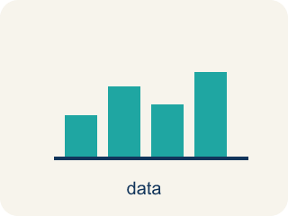
Graph Ratio Tables (Representar tablas de razones en una gráfica) — Plot the paired values from a ratio table as ordered pairs.
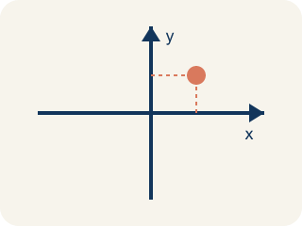
Coordinate plane (Plano cartesiano) — A grid with a line going across and a line going up to plot points.
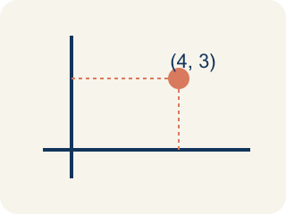
Ordered pair (Par ordenado) — Two numbers (x, y) that tell where a point is on a grid.
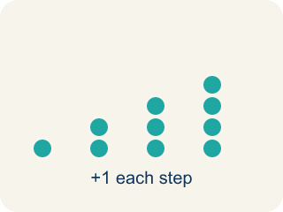
Linear pattern (Patrón lineal) — Points that make a straight line on a grid.
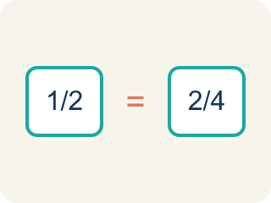
Proportional (Proporcional) — Two amounts that grow together at the same rate.
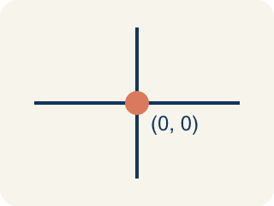
Origin (Origen) — The point (0, 0) where the two grid lines cross.
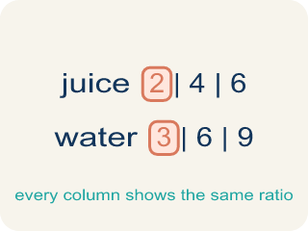
Ratio table (Tabla de razones) — A table of equal ratios that shows a pattern.

Practice
Show your work. Use the blank space under each problem.
1. Points from a ratio table are plotted at (1, 4), (2, 8), and (3, 12). What is the ratio of y to x for each point?
A. 4:1
B. 1:4
C. 2:8
D. 3:4
______________________________________________________________________
2. Two students graph ratio tables. Student A plots (1,2), (2,4), (3,6). Student B plots (1,3), (2,6), (3,9). Whose line is steeper?
A. Student B
B. Student A
C. Same steepness
D. Cannot tell
______________________________________________________________________
3. On Level — Spot the Common Mistake
Step 1 (Read the ratio): A recipe uses 4 cups of water for every 1 cup of rice (rule: y = 4x). A student is plotting points for the line.
Step 2 (List the points): (1, 4), (2, 8), (3, 12)
Step 3 (Add another point): The student also plots (4, 14) and says it belongs on the same line.
Step 4 (Conclusion): All four points form a straight line.
Which step has the mistake? Explain and fix it:
______________________________________________________________________
______________________________________________________________________
______________________________________________________________________
4. Find Jada's Mistake
Step 1 (Read the ratio table): Cookies: 2, 4, 6 | Cups of milk: 1, 2, 3
Step 2 (Write ordered pairs): (1, 2), (2, 4), (3, 6)
Step 3 (Plot the points): Plotted (1,2), (2,4), (3,6) on the grid
Step 4 (Conclusion): The x-axis is cookies and y-axis is cups of milk
Which step has the mistake? Explain and fix it:
______________________________________________________________________
______________________________________________________________________
______________________________________________________________________

Answer Key (Teacher)
1. A. 4:1
For each point: 4÷1 = 4, 8÷2 = 4, 12÷3 = 4. The ratio of y to x is always 4:1.
Watch for: A common mistake in Graph Ratio Tables is writing the ordered pair in the wrong order — putting the second table value first instead of matching (x, y) to the table's column order. For example, if a recipe table shows 2 cups of sugar for every 4 cups of flour, a student might plot (4, 2) instead of (2, 4), landing the point in a completely different spot on the grid. Before you plot, check: which quantity goes on the x-axis, and does your ordered pair start with that number?
2. A. Student B
Student A's ratio is 1:2 (y goes up 2 for each 1 in x). Student B's ratio is 1:3 (y goes up 3 for each 1 in x). A higher rate of change means a steeper line, so Student B's is steeper.
Watch for: A common mistake in Graph Ratio Tables is writing the ordered pair in the wrong order — putting the second table value first instead of matching (x, y) to the table's column order. For example, if a recipe table shows 2 cups of sugar for every 4 cups of flour, a student might plot (4, 2) instead of (2, 4), landing the point in a completely different spot on the grid. Before you plot, check: which quantity goes on the x-axis, and does your ordered pair start with that number?
3. On Level — Spot the Common Mistake
The mistake is in Step 3.
Correct work: The point (4, 14) is off the line. Using the rule y = 4x, when x = 4 the y-value must be 4 × 4 = 16, so the correct point is (4, 16). Because (4, 14) does not satisfy y = 4x, it does not land on the line through the other points.
Watch for: The first three points all follow y = 4x, but the extra point (4, 14) does not: when x = 4 the rule requires y = 4 × 4 = 16. Since (4, 14) breaks the rule, it falls below the line instead of on it, and the correct fourth point is (4, 16).
4. Find Jada's Mistake
The mistake is in Step 2.
Correct work: The ordered pairs should be (2, 1), (4, 2), (6, 3) — cookies go on x and milk on y, matching the table's column order.
Watch for: Jada wrote the milk value first, so her pairs came out as (1, 2), (2, 4), (3, 6). Her own conclusion says cookies belong on the x-axis, so the cookie value has to come first: the pairs are (2, 1), (4, 2), and (6, 3).

