3.5 Small Group · Group 1 — Homework
Lesson 3-5-group1 • Standard 6.AT.3
Name: ______________________ Period: ______ Date: ____________

Today's Goals
Content: With my small group, I can compare ratios by finding unit rates or using equivalent ratios — one step at a time, with support.
Language: I can talk through each step out loud using a sentence frame and the lesson's key words.

Key Words
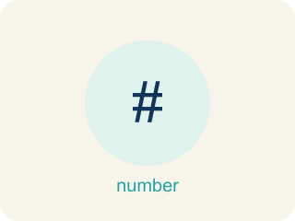
Compare Ratios (Comparar razones) — Decide which ratio is greater, less, or equal by using equivalent ratios or unit rates.
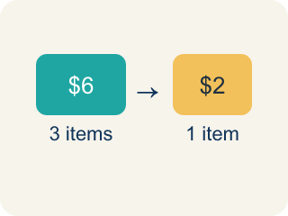
Unit rate (Tasa unitaria) — A rate for just 1 of something, like cost for 1 item.
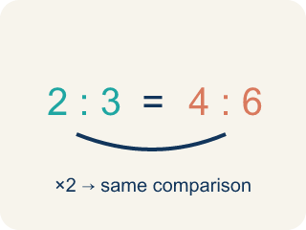
Equivalent ratio (Razón equivalente) — Two ratios that mean the same thing.
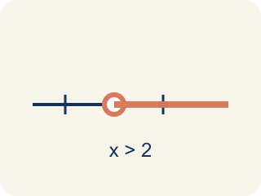
Compare (Comparar) — To look at ratios and see which is bigger, smaller, or equal.
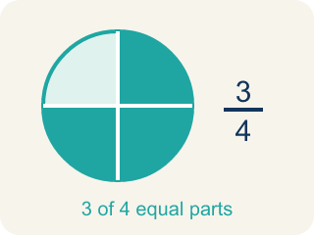
Simplify (Simplificar) — To make a ratio as small as possible while keeping the same comparison.

Common denominator (Denominador común) — A bottom number that two fractions can share so you can compare them.

Practice
Show your work. Use the blank space under each problem.
1. Chef A uses 2 cups of cheese for every 8 crackers. Chef B uses 3 cups of cheese for every 9 crackers. Who uses more cheese per cracker?
A. Chef B
B. Chef A
C. They use the same amount
D. Cannot determine
______________________________________________________________________
2. Which ratio is greater: 3:4 or 5:8?
A. 3:4
B. 5:8
C. They are equal
D. Cannot determine
______________________________________________________________________
3. Chef Academy's snack bar sells 3 mini quiches for $6 or 5 mini quiches for $8. Which is the better deal per quiche?
A. 5 quiches for $8
B. 3 quiches for $6
C. They cost the same
D. Cannot determine
______________________________________________________________________
4. Two soup recipes use salt. Recipe A uses 4 tsp salt for 10 cups of broth. Recipe B uses 3 tsp salt for 8 cups of broth. Which soup is saltier per cup?
A. Recipe B
B. Recipe A
C. They are equally salty
D. Cannot determine
______________________________________________________________________
5. Chef Mara's lemon glaze uses 6 oz of lemon juice for 9 cupcakes. Chef Devi's uses 4 oz for 7 cupcakes. Whose glaze has more lemon per cupcake?
A. Chef Mara
B. Chef Devi
C. Same amount
D. Cannot determine
______________________________________________________________________
6. Level 2 Extension — Chef Omar's Glaze Comparison
Step 1 (Read the problem): Chef Omar compares two glazes: 3 oz syrup for 8 oz water and 5 oz syrup for 16 oz water. Which is sweeter per ounce of water?
Step 2 (Look at the syrup): Glaze 1 has 3 oz syrup. Glaze 2 has 5 oz syrup.
Step 3 (Compare the syrup amounts): Since 5 > 3, Glaze 2 must have more syrup per ounce of water.
Step 4 (Conclusion): Glaze 2 is sweeter per ounce of water.
Which step has the mistake? Explain and fix it:
______________________________________________________________________
______________________________________________________________________
______________________________________________________________________
7. Find Kai's Mistake
Step 1 (Read the problem): Compare 3:5 and 4:7. Which ratio is greater?
Step 2 (Find common denominator): LCD of 5 and 7 is 35
Step 3 (Scale the ratios): 3:5 = 21:35 (3 × 7 = 21). For 4:7, Kai multiplies by 7 again: 4 × 7 = 28, giving 28:35.
Step 4 (Conclusion): Since 28 > 21, the ratio 4:7 is greater.
Which step has the mistake? Explain and fix it:
______________________________________________________________________
______________________________________________________________________
______________________________________________________________________
8.
______________________________________________________________________
______________________________________________________________________
______________________________________________________________________
______________________________________________________________________

Answer Key (Teacher)
1. A. Chef B
Chef A: 2÷8 = 0.25 cups per cracker. Chef B: 3÷9 ≈ 0.33 cups per cracker. Chef B uses more cheese per cracker.
Watch for: A common mistake in Compare Ratios is thinking the ratio with the bigger raw number automatically wins — like assuming Chef Tran's 8 tablespoons of cocoa must be more chocolatey than Chef Reyes's 6 tablespoons, without checking that the milk amounts (14 oz vs. 10 oz) are different. Never compare the raw numbers alone — always scale both ratios to the same amount or find each unit rate first.
2. A. 3:4
Convert to the same denominator: 3:4 = 6:8. Since 6:8 > 5:8, the ratio 3:4 is greater.
Watch for: A common mistake in Compare Ratios is thinking the ratio with the bigger raw number automatically wins — like assuming Chef Tran's 8 tablespoons of cocoa must be more chocolatey than Chef Reyes's 6 tablespoons, without checking that the milk amounts (14 oz vs. 10 oz) are different. Never compare the raw numbers alone — always scale both ratios to the same amount or find each unit rate first.
3. A. 5 quiches for $8
3 for $6 is $6 / 3 = $2.00 per quiche. 5 for $8 is $8 / 5 = $1.60 per quiche. $1.60 < $2.00, so 5 quiches for $8 is the better deal.
Watch for: A common mistake in Compare Ratios is thinking the ratio with the bigger raw number automatically wins — like assuming Chef Tran's 8 tablespoons of cocoa must be more chocolatey than Chef Reyes's 6 tablespoons, without checking that the milk amounts (14 oz vs. 10 oz) are different. Never compare the raw numbers alone — always scale both ratios to the same amount or find each unit rate first.
4. B. Recipe A
Recipe A: 4 / 10 = 0.4 tsp per cup. Recipe B: 3 / 8 = 0.375 tsp per cup. Since 0.4 > 0.375, Recipe A is saltier per cup.
Watch for: A common mistake in Compare Ratios is thinking the ratio with the bigger raw number automatically wins — like assuming Chef Tran's 8 tablespoons of cocoa must be more chocolatey than Chef Reyes's 6 tablespoons, without checking that the milk amounts (14 oz vs. 10 oz) are different. Never compare the raw numbers alone — always scale both ratios to the same amount or find each unit rate first.
5. A. Chef Mara
Chef Mara: 6 / 9 = 0.666... oz per cupcake. Chef Devi: 4 / 7 = 0.571... oz per cupcake. Since 0.67 > 0.57, Chef Mara's glaze has more lemon per cupcake.
Watch for: A common mistake in Compare Ratios is thinking the ratio with the bigger raw number automatically wins — like assuming Chef Tran's 8 tablespoons of cocoa must be more chocolatey than Chef Reyes's 6 tablespoons, without checking that the milk amounts (14 oz vs. 10 oz) are different. Never compare the raw numbers alone — always scale both ratios to the same amount or find each unit rate first.
6. Level 2 Extension — Chef Omar's Glaze Comparison
The mistake is in Step 3.
Correct work: You cannot just compare the syrup amounts because the water amounts are different (8 oz vs 16 oz). Find the unit rate: Glaze 1 = 3 ÷ 8 = 0.375 oz syrup per oz water; Glaze 2 = 5 ÷ 16 = 0.3125 oz syrup per oz water. Since 0.375 > 0.3125, Glaze 1 is actually sweeter per ounce — the 'bigger syrup number wins' shortcut gives the WRONG glaze.
Watch for: Comparing 5 oz of syrup to 3 oz proves nothing while the water amounts differ (12 oz vs. 8 oz). The unit rates decide it: Glaze 1 is 3 ÷ 8 = 0.375 oz of syrup per ounce of water and Glaze 2 is 5 ÷ 12 ≈ 0.417, so Glaze 2 is sweeter — but the unit rates are what prove it, not the raw syrup amounts.
7. Find Kai's Mistake
The mistake is in Step 3.
Correct work: To scale 4:7 to 35ths, multiply by 35 ÷ 7 = 5, not by 7 again: 4 × 5 = 20, so 4:7 = 20:35 (not 28:35). Now compare correctly: 21:35 vs. 20:35. Since 21 > 20, the ratio 3:5 is actually greater, not 4:7.
Watch for: Kai reused the multiplier 7 that belonged to the first ratio instead of finding the one 4:7 actually needs. To reach 35ths you multiply by 35 ÷ 7 = 5, so 4:7 = 20:35, not 28:35. Comparing 21:35 with 20:35 shows 3:5 is the greater ratio — the opposite of the conclusion.
8. Open response — answers will vary.
Sample: The student's reasoning is not valid — getting more items does not mean a lower price per item. Store A: $12 ÷ 5 = $2.40 per notebook. Store B: $20 ÷ 8 = $2.50 per notebook. Store A is actually cheaper per notebook, even though Store B offers more notebooks per purchase.
Look for key words: $2.40, $2.50, Store A, cheaper, unit rate, not valid.

