3.5 Small Group · Group 2 — Homework
Lesson 3-5-group2 • Standard 6.AT.3
Name: ______________________ Period: ______ Date: ____________

Today's Goals
Content: I can compare ratios by finding unit rates or using equivalent ratios, explain how I can tell, and judge a case I have not seen before.
Language: I can justify my answer to a skeptic and connect it to a second strategy or representation.

Key Words

Compare Ratios (Comparar razones) — Decide which ratio is greater, less, or equal by using equivalent ratios or unit rates.
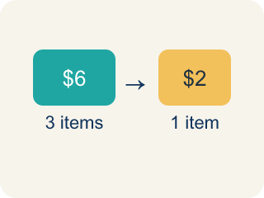
Unit rate (Tasa unitaria) — A rate for just 1 of something, like cost for 1 item.
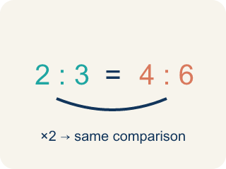
Equivalent ratio (Razón equivalente) — Two ratios that mean the same thing.
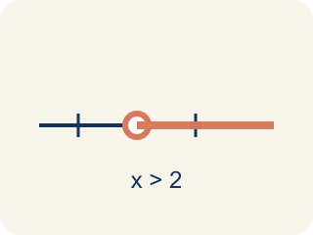
Compare (Comparar) — To look at ratios and see which is bigger, smaller, or equal.
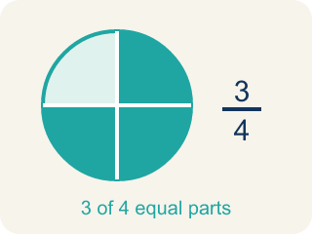
Simplify (Simplificar) — To make a ratio as small as possible while keeping the same comparison.

Common denominator (Denominador común) — A bottom number that two fractions can share so you can compare them.

Practice
Show your work. Use the blank space under each problem.
1. Store A sells 3 mangoes for $6. Store B sells 5 mangoes for $9. Which store offers a better price per mango?
A. Store B
B. Store A
C. Same price
D. Cannot determine
______________________________________________________________________
2. Spot the Common Mistake
Step 1 (Read the problem): Compare Chef Reyes's dressing (4 tbsp oil : 6 tbsp vinegar) to Chef Tran's dressing (5 tbsp oil : 8 tbsp vinegar). Which dressing is oilier?
Step 2 (Find a common denominator): LCD of 6 and 8 is 24.
Step 3 (Scale each ratio): Chef Reyes: 6 × 4 = 24, so oil = 4 × 4 = 16, giving 16:24. Chef Tran: to reach 24 he also multiplies by 4: oil = 5 × 4 = 20, giving 20:24.
Step 4 (Conclusion): Since 20 > 16, Chef Tran's dressing is oilier.
Which step has the mistake? Explain and fix it:
______________________________________________________________________
______________________________________________________________________
______________________________________________________________________
3. Find Kai's Mistake
Step 1 (Read the problem): Compare 3:5 and 4:7. Which ratio is greater?
Step 2 (Find common denominator): LCD of 5 and 7 is 35
Step 3 (Scale the ratios): 3:5 = 21:35 (3 × 7 = 21). For 4:7, Kai multiplies by 7 again: 4 × 7 = 28, giving 28:35.
Step 4 (Conclusion): Since 28 > 21, the ratio 4:7 is greater.
Which step has the mistake? Explain and fix it:
______________________________________________________________________
______________________________________________________________________
______________________________________________________________________
4.
______________________________________________________________________
______________________________________________________________________
______________________________________________________________________
______________________________________________________________________

Answer Key (Teacher)
1. A. Store B
Store A: $6÷3 = $2.00 per mango. Store B: $9÷5 = $1.80 per mango. Store B has the better (lower) price per mango.
Watch for: A common mistake in Compare Ratios is thinking the ratio with the bigger raw number automatically wins — like assuming Chef Tran's 8 tablespoons of cocoa must be more chocolatey than Chef Reyes's 6 tablespoons, without checking that the milk amounts (14 oz vs. 10 oz) are different. Never compare the raw numbers alone — always scale both ratios to the same amount or find each unit rate first.
2. Spot the Common Mistake
The mistake is in Step 3.
Correct work: Each ratio needs its own multiplier to reach 24 — Chef Reyes and Chef Tran do not use the same multiplier. Chef Tran's vinegar is 8, and 8 × 3 = 24 (not 8 × 4 = 32), so multiply BOTH parts of his ratio by 3, not 4: oil = 5 × 3 = 15, giving 15:24. Now compare with equal vinegar (24): Chef Reyes has 16 tbsp oil and Chef Tran has 15 tbsp oil. Since 16 > 15, Chef Reyes's dressing is actually oilier.
Watch for: Each ratio needs its own multiplier to reach 24. Chef Reyes's vinegar 6 × 4 = 24 is right, but Chef Tran's vinegar is 8, and 8 × 3 = 24, so both parts of his ratio scale by 3: 5 × 3 = 15, giving 15:24 instead of 20:24. Compared at equal vinegar, 16 tbsp of oil beats 15, so Chef Reyes's dressing is the oilier one.
3. Find Kai's Mistake
The mistake is in Step 3.
Correct work: To scale 4:7 to 35ths, multiply by 35 ÷ 7 = 5, not by 7 again: 4 × 5 = 20, so 4:7 = 20:35 (not 28:35). Now compare correctly: 21:35 vs. 20:35. Since 21 > 20, the ratio 3:5 is actually greater, not 4:7.
Watch for: Kai reused the multiplier 7 that belonged to the first ratio instead of finding the one 4:7 actually needs. To reach 35ths you multiply by 35 ÷ 7 = 5, so 4:7 = 20:35, not 28:35. Comparing 21:35 with 20:35 shows 3:5 is the greater ratio — the opposite of the conclusion.
4. Open response — answers will vary.
Sample: The student's reasoning is not valid — getting more items does not mean a lower price per item. Store A: $12 ÷ 5 = $2.40 per notebook. Store B: $20 ÷ 8 = $2.50 per notebook. Store A is actually cheaper per notebook, even though Store B offers more notebooks per purchase.
Look for key words: $2.40, $2.50, Store A, cheaper, unit rate, not valid.

