3.6 Small Group · Group 1 — Homework
Lesson 3-6-group1 • Standard 6.AT.3
Name: ______________________ Period: ______ Date: ____________

Today's Goals
Content: With my small group, I can use ratio reasoning to solve problems with proportions and scaling — one step at a time, with support.
Language: I can talk through each step out loud using a sentence frame and the lesson's key words.

Key Words

Ratio Reasoning (Razonamiento con razones) — Use equivalent ratios, tables, graphs, or unit rates to solve a problem.
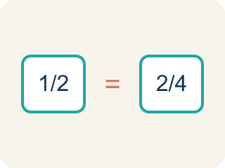
Proportion (Proporción) — A math sentence saying two ratios are equal.

Cross-multiply (Multiplicación cruzada) — Multiplying across two ratios to check if they are equal.
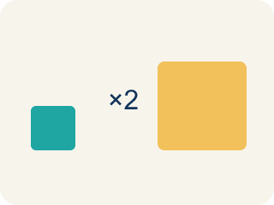
Scale (Escalar) — To multiply or divide both parts of a ratio by the same number.
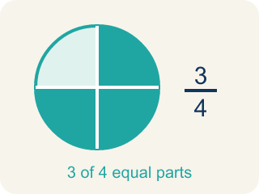
Equivalent (Equivalente) — Having the same value.
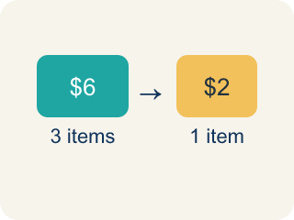
Unit rate (Tasa unitaria) — A rate for just 1 of something. You find it by dividing.
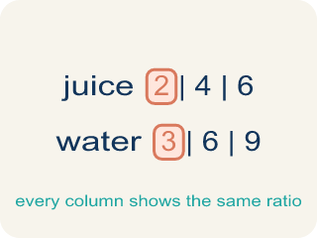
Ratio table (Tabla de razones) — A table of equal ratios that shows a pattern.

Practice
Show your work. Use the blank space under each problem.
1. A recipe uses 4 cups of broth for every 10 servings. How many cups of broth are needed for 30 servings?
A. 12
B. 8
C. 14
D. 40
______________________________________________________________________
2. Are the ratios 6:9 and 2:3 equivalent?
A. Yes, both simplify to 2:3
B. No, 6 ≠ 2
C. Yes, because 6 + 9 = 15
D. No, because 9 - 6 ≠ 3 - 2
______________________________________________________________________
3. Chef Reyes's pasta dough uses 2 eggs for every 3 cups of flour. For a banquet, the kitchen mixes 9 cups of flour. How many eggs are needed to keep the same ratio?
A. 6 eggs
B. 5 eggs
C. 8 eggs
D. 4 eggs
______________________________________________________________________
4. A marinara recipe uses 4 cups of tomatoes for every 6 servings. The chef needs 18 servings. How many cups of tomatoes should she use?
A. 12 cups
B. 10 cups
C. 16 cups
D. 9 cups
______________________________________________________________________
5. During a cooking-team relay, a chef plates 3 finished dishes for every 5 minutes she works. At the same rate, how many dishes will she plate in 20 minutes?
A. 12 dishes
B. 10 dishes
C. 15 dishes
D. 8 dishes
______________________________________________________________________
6. Level 2 Extension — Catch the Scaling Mistake
Step 1 (Read the recipe): Bread dough uses 7 cups of flour for every 2 eggs.
Step 2 (Find the scale factor): The chef needs 21 cups of flour. 21 divided by 7 = 3.
Step 3 (Scale the flour): 7 x 3 = 21 cups of flour.
Step 4 (Write the eggs): Eggs stay at 2, so use 2 eggs.
Which step has the mistake? Explain and fix it:
______________________________________________________________________
______________________________________________________________________
______________________________________________________________________
7. Find Priya's Mistake
Step 1 (Set up the proportion): 5/8 = x/32
Step 2 (Find the scale factor): 32 ÷ 8 = 4
Step 3 (Solve for x): 5 + 4 = 9
Step 4 (Answer): x = 9
Which step has the mistake? Explain and fix it:
______________________________________________________________________
______________________________________________________________________
______________________________________________________________________
8.
______________________________________________________________________
______________________________________________________________________
______________________________________________________________________
______________________________________________________________________

Answer Key (Teacher)
1. A. 12
Scale factor: 30 ÷ 10 = 3. Multiply broth by 3: 4 × 3 = 12 cups.
Watch for: A common mistake in Use Ratio Reasoning is scaling by adding instead of multiplying: since the banquet has 120 − 8 = 112 more guests than the recipe serves, some students add 112 to the ingredient amount instead of finding the scale factor. For Chef Reyes's recipe that serves 8 people with 5 cups of tomatoes, scaling up to 120 guests this way gives 5 + 112 = 117 cups of tomatoes — a wildly wrong answer. Ratios scale multiplicatively, not additively: find the scale factor first (120 ÷ 8 = 15), then multiply the ingredient by that same scale factor: 5 × 15 = 75 cups of tomatoes. Before you submit, check that you multiplied every part of the ratio by the same scale factor instead of adding the same amount to each.
2. A. Yes, both simplify to 2:3
Divide 6:9 by 3 to get 2:3. Since both ratios simplify to 2:3, they are equivalent.
Watch for: A common mistake in Use Ratio Reasoning is scaling by adding instead of multiplying: since the banquet has 120 − 8 = 112 more guests than the recipe serves, some students add 112 to the ingredient amount instead of finding the scale factor. For Chef Reyes's recipe that serves 8 people with 5 cups of tomatoes, scaling up to 120 guests this way gives 5 + 112 = 117 cups of tomatoes — a wildly wrong answer. Ratios scale multiplicatively, not additively: find the scale factor first (120 ÷ 8 = 15), then multiply the ingredient by that same scale factor: 5 × 15 = 75 cups of tomatoes. Before you submit, check that you multiplied every part of the ratio by the same scale factor instead of adding the same amount to each.
3. A. 6 eggs
Scale factor: 9 cups divided by 3 cups = 3. Multiply the eggs by the same factor: 2 x 3 = 6 eggs.
Watch for: A common mistake in Use Ratio Reasoning is scaling by adding instead of multiplying: since the banquet has 120 − 8 = 112 more guests than the recipe serves, some students add 112 to the ingredient amount instead of finding the scale factor. For Chef Reyes's recipe that serves 8 people with 5 cups of tomatoes, scaling up to 120 guests this way gives 5 + 112 = 117 cups of tomatoes — a wildly wrong answer. Ratios scale multiplicatively, not additively: find the scale factor first (120 ÷ 8 = 15), then multiply the ingredient by that same scale factor: 5 × 15 = 75 cups of tomatoes. Before you submit, check that you multiplied every part of the ratio by the same scale factor instead of adding the same amount to each.
4. A. 12 cups
Scale factor: 18 servings divided by 6 servings = 3. Multiply the tomatoes by 3: 4 x 3 = 12 cups.
Watch for: A common mistake in Use Ratio Reasoning is scaling by adding instead of multiplying: since the banquet has 120 − 8 = 112 more guests than the recipe serves, some students add 112 to the ingredient amount instead of finding the scale factor. For Chef Reyes's recipe that serves 8 people with 5 cups of tomatoes, scaling up to 120 guests this way gives 5 + 112 = 117 cups of tomatoes — a wildly wrong answer. Ratios scale multiplicatively, not additively: find the scale factor first (120 ÷ 8 = 15), then multiply the ingredient by that same scale factor: 5 × 15 = 75 cups of tomatoes. Before you submit, check that you multiplied every part of the ratio by the same scale factor instead of adding the same amount to each.
5. A. 12 dishes
Scale factor: 20 minutes divided by 5 minutes = 4. Multiply the dishes by 4: 3 x 4 = 12 dishes.
Watch for: A common mistake in Use Ratio Reasoning is scaling by adding instead of multiplying: since the banquet has 120 − 8 = 112 more guests than the recipe serves, some students add 112 to the ingredient amount instead of finding the scale factor. For Chef Reyes's recipe that serves 8 people with 5 cups of tomatoes, scaling up to 120 guests this way gives 5 + 112 = 117 cups of tomatoes — a wildly wrong answer. Ratios scale multiplicatively, not additively: find the scale factor first (120 ÷ 8 = 15), then multiply the ingredient by that same scale factor: 5 × 15 = 75 cups of tomatoes. Before you submit, check that you multiplied every part of the ratio by the same scale factor instead of adding the same amount to each.
6. Level 2 Extension — Catch the Scaling Mistake
The mistake is in Step 4.
Correct work: Multiply the eggs by the SAME scale factor of 3: 2 x 3 = 6 eggs. Both parts of the ratio must be scaled, not just the flour.
Watch for: The last step kept the eggs at 2 even though the flour had just been multiplied by the scale factor of 3. A ratio stays equivalent only when both parts are scaled the same way, so the eggs become 2 × 3 = 6 and the recipe reads 21 cups of flour to 6 eggs.
7. Find Priya's Mistake
The mistake is in Step 3.
Correct work: 5 × 4 = 20 (multiply by the scale factor, don't add it)
Watch for: In the solving step Priya added the scale factor to 5 instead of multiplying by it. Since 32 is 8 × 4, the top of the fraction scales the same way: 5 × 4 = 20, so x = 20 and 20/32 simplifies right back to 5/8.
8. Open response — answers will vary.
Sample: Method 1 (scale factor): 15 ÷ 6 = 2.5. Multiply rice by 2.5: 4 × 2.5 = 10 cups. Method 2 (unit rate): 4 ÷ 6 = 2/3 cup per person. For 15 people: 2/3 × 15 = 10 cups. Both methods give 10 cups of rice.
Look for key words: 10 cups, 2.5, scale factor, unit rate, 2/3, both methods.

