3.6 Small Group · Group 2 — Homework
Lesson 3-6-group2 • Standard 6.AT.3
Name: ______________________ Period: ______ Date: ____________

Today's Goals
Content: I can use ratio reasoning to solve problems with proportions and scaling, explain why the method works, and use it on a problem I have not seen before.
Language: I can justify my answer to a skeptic and connect it to a second strategy or representation.

Key Words

Ratio Reasoning (Razonamiento con razones) — Use equivalent ratios, tables, graphs, or unit rates to solve a problem.
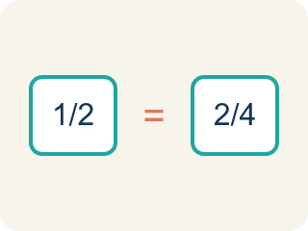
Proportion (Proporción) — A math sentence saying two ratios are equal.

Cross-multiply (Multiplicación cruzada) — Multiplying across two ratios to check if they are equal.
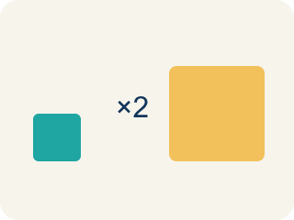
Scale (Escalar) — To multiply or divide both parts of a ratio by the same number.
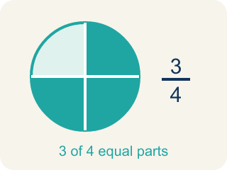
Equivalent (Equivalente) — Having the same value.
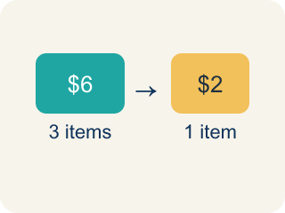
Unit rate (Tasa unitaria) — A rate for just 1 of something. You find it by dividing.
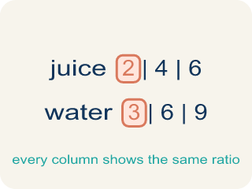
Ratio table (Tabla de razones) — A table of equal ratios that shows a pattern.

Practice
Show your work. Use the blank space under each problem.
1. A chef uses the proportion 3/7 = x/28 to scale a recipe. What is x?
A. 12
B. 14
C. 9
D. 21
______________________________________________________________________
2. Spot the Common Mistake
Step 1 (Set up the proportion): A recipe uses 4 cups of sugar for every 9 cups of flour: 4/9 = x/27.
Step 2 (Find the scale factor): 27 ÷ 9 = 3.
Step 3 (Solve for x): 4 + 3 = 7, so x = 7 cups of sugar.
Step 4 (Answer): Use 7 cups of sugar.
Which step has the mistake? Explain and fix it:
______________________________________________________________________
______________________________________________________________________
______________________________________________________________________
3. Find Priya's Mistake
Step 1 (Set up the proportion): 5/8 = x/32
Step 2 (Find the scale factor): 32 ÷ 8 = 4
Step 3 (Solve for x): 5 + 4 = 9
Step 4 (Answer): x = 9
Which step has the mistake? Explain and fix it:
______________________________________________________________________
______________________________________________________________________
______________________________________________________________________
4.
______________________________________________________________________
______________________________________________________________________
______________________________________________________________________
______________________________________________________________________

Answer Key (Teacher)
1. A. 12
Scale factor: 28 ÷ 7 = 4. Multiply: 3 × 4 = 12. So x = 12.
Watch for: A common mistake in Use Ratio Reasoning is scaling by adding instead of multiplying: since the banquet has 120 − 8 = 112 more guests than the recipe serves, some students add 112 to the ingredient amount instead of finding the scale factor. For Chef Reyes's recipe that serves 8 people with 5 cups of tomatoes, scaling up to 120 guests this way gives 5 + 112 = 117 cups of tomatoes — a wildly wrong answer. Ratios scale multiplicatively, not additively: find the scale factor first (120 ÷ 8 = 15), then multiply the ingredient by that same scale factor: 5 × 15 = 75 cups of tomatoes. Before you submit, check that you multiplied every part of the ratio by the same scale factor instead of adding the same amount to each.
2. Spot the Common Mistake
The mistake is in Step 3.
Correct work: Multiply by the scale factor instead of adding it: 4 × 3 = 12 cups of sugar. To keep ratios equivalent you multiply both parts by the scale factor — you never add it.
Watch for: The solving step added the scale factor instead of multiplying by it. Because 27 is 9 × 3, the sugar has to grow the same way: 4 × 3 = 12 cups. Adding would break the relationship, since 7/27 is not equivalent to 4/9 but 12/27 is.
3. Find Priya's Mistake
The mistake is in Step 3.
Correct work: 5 × 4 = 20 (multiply by the scale factor, don't add it)
Watch for: In the solving step Priya added the scale factor to 5 instead of multiplying by it. Since 32 is 8 × 4, the top of the fraction scales the same way: 5 × 4 = 20, so x = 20 and 20/32 simplifies right back to 5/8.
4. Open response — answers will vary.
Sample: Method 1 (scale factor): 15 ÷ 6 = 2.5. Multiply rice by 2.5: 4 × 2.5 = 10 cups. Method 2 (unit rate): 4 ÷ 6 = 2/3 cup per person. For 15 people: 2/3 × 15 = 10 cups. Both methods give 10 cups of rice.
Look for key words: 10 cups, 2.5, scale factor, unit rate, 2/3, both methods.

