3.4–3.7 Catch-Up — Homework
Lesson 3-7-catchup • Standard 6.AT.3
Name: ______________________ Period: ______ Date: ____________

Today's Goals
Content: I can show I am caught up on Lessons 3.4–3.7 by using each lesson's big idea in mixed practice.
Language: I can explain which lesson's big idea I used and how, using key vocabulary from Lessons 3.4–3.7.

Key Words
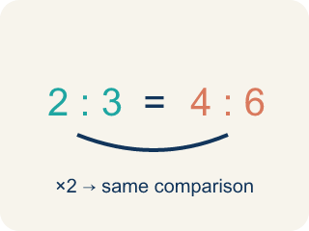
Equivalent Ratios (Razones equivalentes) — Ratios that compare quantities in the same relationship.
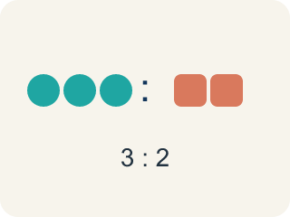
Ratio (Razón) — A way to compare two amounts, like 3 to 2.

Compare Ratios (Comparar razones) — Decide which ratio is greater, less, or equal by using equivalent ratios or unit rates.
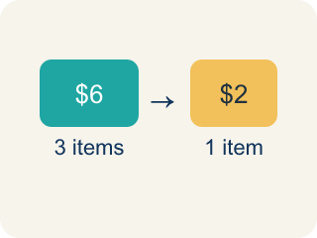
Unit rate (Tasa unitaria) — A rate for just 1 of something, like cost for 1 item.

Ratio Reasoning (Razonamiento con razones) — Use equivalent ratios, tables, graphs, or unit rates to solve a problem.
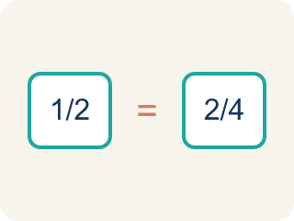
Proportion (Proporción) — A math sentence saying two ratios are equal.

Ratio and Rate Problem Solving (Resolución de problemas de razones y tasas) — Use ratios and rates to compare quantities and solve real-world problems.

Rate (Tasa) — A ratio comparing two amounts with different units, like miles per hour.

Equivalent ratio (Razón equivalente) — Two ratios that mean the same thing.

Cross-multiply (Multiplicación cruzada) — Multiplying across two ratios to check if they are equal.
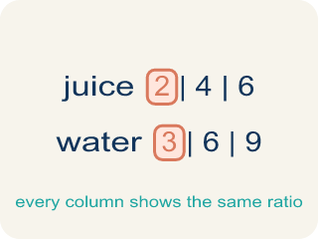
Ratio table (Tabla de razones) — A table of equal ratios that shows a pattern.

Practice
Show your work. Use the blank space under each problem.
1. (Lesson 3.4) Which ratio is equivalent to 2:5?
A. 4:10
B. 3:6
C. 2:10
D. 5:2
______________________________________________________________________
2. (Lesson 3.4) A recipe uses 4 eggs for every 6 cups of flour. Which ratio is equivalent?
A. 2:3
B. 8:10
C. 4:3
D. 6:4
______________________________________________________________________
3. (Lesson 3.4) Marcus earns $45 for every 3 hours of work. How much does he earn in 8 hours?
A. $120
B. $90
C. $135
D. $105
______________________________________________________________________
4. (Lesson 3.4) Spot the Common Mistake — Simplifying a Ratio
Step 1 (Set up the ratio): A student wants to write 12:18 in simplest form.
Step 2 (Find the common factor): Both 12 and 18 can be divided by 6.
Step 3 (Divide each part): 12 ÷ 6 = 2 and 18 ÷ 3 = 6, so they wrote 2:6.
Step 4 (Answer): 12:18 simplifies to 2:6
Which step has the mistake? Explain and fix it:
______________________________________________________________________
______________________________________________________________________
______________________________________________________________________
5. (Lesson 3.5) Store A sells 3 mangoes for $6. Store B sells 5 mangoes for $9. Which store offers a better price per mango?
A. Store B
B. Store A
C. Same price
D. Cannot determine
______________________________________________________________________
6. (Lesson 3.5) Spot the Common Mistake
Step 1 (Read the problem): Compare Chef Reyes's dressing (4 tbsp oil : 6 tbsp vinegar) to Chef Tran's dressing (5 tbsp oil : 8 tbsp vinegar). Which dressing is oilier?
Step 2 (Find a common denominator): LCD of 6 and 8 is 24.
Step 3 (Scale each ratio): Chef Reyes: 6 × 4 = 24, so oil = 4 × 4 = 16, giving 16:24. Chef Tran: to reach 24 he also multiplies by 4: oil = 5 × 4 = 20, giving 20:24.
Step 4 (Conclusion): Since 20 > 16, Chef Tran's dressing is oilier.
Which step has the mistake? Explain and fix it:
______________________________________________________________________
______________________________________________________________________
______________________________________________________________________
7. (Lesson 3.6) A chef uses the proportion 3/7 = x/28 to scale a recipe. What is x?
A. 12
B. 14
C. 9
D. 21
______________________________________________________________________
8. (Lesson 3.6) Spot the Common Mistake
Step 1 (Set up the proportion): A recipe uses 4 cups of sugar for every 9 cups of flour: 4/9 = x/27.
Step 2 (Find the scale factor): 27 ÷ 9 = 3.
Step 3 (Solve for x): 4 + 3 = 7, so x = 7 cups of sugar.
Step 4 (Answer): Use 7 cups of sugar.
Which step has the mistake? Explain and fix it:
______________________________________________________________________
______________________________________________________________________
______________________________________________________________________
9. (Lesson 3.7) A car travels 150 miles in 3 hours. A bus travels 200 miles in 5 hours. Which vehicle is faster?
A. The car
B. The bus
C. Same speed
D. Cannot determine
______________________________________________________________________
10. (Lesson 3.7) Spot the Smoothie Mistake
Step 1 (Read the problem): A smoothie stand makes 18 smoothies in 6 minutes. How many smoothies can it make in 10 minutes at the same rate?
Step 2 (Find the unit rate): 6 minutes ÷ 18 smoothies = 0.33 minute per smoothie
Step 3 (Find smoothies in 10 minutes): 0.33 × 10 = about 3.3 smoothies
Step 4 (Answer): About 3 smoothies in 10 minutes
Which step has the mistake? Explain and fix it:
______________________________________________________________________
______________________________________________________________________
______________________________________________________________________

Answer Key (Teacher)
1. A. 4:10
Multiply both parts by 2: 2×2 = 4 and 5×2 = 10, so 4:10 is equivalent to 2:5.
Watch for: A common mistake in Ratio and Rate Problem Solving is dividing in the wrong order when setting up the unit rate — for example, finding "minutes per smoothie" (6 ÷ 18) instead of "smoothies per minute" (18 ÷ 6) — or using addition instead of multiplication to scale the unit rate, like adding $0.75 + 10 instead of multiplying $0.75 × 10. Before you submit, check: does your unit rate match the units the question is asking for, and did you multiply (not add) to scale it to the new amount?
2. A. 2:3
Divide both by 2: 4÷2 = 2 and 6÷2 = 3. The ratio 2:3 is equivalent to 4:6.
Watch for: A common mistake in Ratio and Rate Problem Solving is dividing in the wrong order when setting up the unit rate — for example, finding "minutes per smoothie" (6 ÷ 18) instead of "smoothies per minute" (18 ÷ 6) — or using addition instead of multiplication to scale the unit rate, like adding $0.75 + 10 instead of multiplying $0.75 × 10. Before you submit, check: does your unit rate match the units the question is asking for, and did you multiply (not add) to scale it to the new amount?
3. A. $120
Unit rate: $45 ÷ 3 = $15/hour. In 8 hours: $15 × 8 = $120.
Watch for: A common mistake in Ratio and Rate Problem Solving is dividing in the wrong order when setting up the unit rate — for example, finding "minutes per smoothie" (6 ÷ 18) instead of "smoothies per minute" (18 ÷ 6) — or using addition instead of multiplication to scale the unit rate, like adding $0.75 + 10 instead of multiplying $0.75 × 10. Before you submit, check: does your unit rate match the units the question is asking for, and did you multiply (not add) to scale it to the new amount?
4. (Lesson 3.4) Spot the Common Mistake — Simplifying a Ratio
The mistake is in Step 3.
Correct work: Divide BOTH parts by the same number: 12 ÷ 6 = 2 and 18 ÷ 6 = 3, so 12:18 simplifies to 2:3.
Watch for: The "Divide each part" step uses two different divisors: 12 ÷ 6 but 18 ÷ 3. Simplifying only keeps a ratio equivalent when both parts are divided by the same number, so 12 ÷ 6 = 2 and 18 ÷ 6 = 3 give 2:3. The student's 2:6 simplifies to 1:3, which is not the same comparison as 12:18.
5. A. Store B
Store A: $6÷3 = $2.00 per mango. Store B: $9÷5 = $1.80 per mango. Store B has the better (lower) price per mango.
Watch for: A common mistake in Ratio and Rate Problem Solving is dividing in the wrong order when setting up the unit rate — for example, finding "minutes per smoothie" (6 ÷ 18) instead of "smoothies per minute" (18 ÷ 6) — or using addition instead of multiplication to scale the unit rate, like adding $0.75 + 10 instead of multiplying $0.75 × 10. Before you submit, check: does your unit rate match the units the question is asking for, and did you multiply (not add) to scale it to the new amount?
6. (Lesson 3.5) Spot the Common Mistake
The mistake is in Step 3.
Correct work: Each ratio needs its own multiplier to reach 24 — Chef Reyes and Chef Tran do not use the same multiplier. Chef Tran's vinegar is 8, and 8 × 3 = 24 (not 8 × 4 = 32), so multiply BOTH parts of his ratio by 3, not 4: oil = 5 × 3 = 15, giving 15:24. Now compare with equal vinegar (24): Chef Reyes has 16 tbsp oil and Chef Tran has 15 tbsp oil. Since 16 > 15, Chef Reyes's dressing is actually oilier.
Watch for: Each ratio needs its own multiplier to reach 24. Chef Reyes's vinegar 6 × 4 = 24 is right, but Chef Tran's vinegar is 8, and 8 × 3 = 24, so both parts of his ratio scale by 3: 5 × 3 = 15, giving 15:24 instead of 20:24. Compared at equal vinegar, 16 tbsp of oil beats 15, so Chef Reyes's dressing is the oilier one.
7. A. 12
Scale factor: 28 ÷ 7 = 4. Multiply: 3 × 4 = 12. So x = 12.
Watch for: A common mistake in Ratio and Rate Problem Solving is dividing in the wrong order when setting up the unit rate — for example, finding "minutes per smoothie" (6 ÷ 18) instead of "smoothies per minute" (18 ÷ 6) — or using addition instead of multiplication to scale the unit rate, like adding $0.75 + 10 instead of multiplying $0.75 × 10. Before you submit, check: does your unit rate match the units the question is asking for, and did you multiply (not add) to scale it to the new amount?
8. (Lesson 3.6) Spot the Common Mistake
The mistake is in Step 3.
Correct work: Multiply by the scale factor instead of adding it: 4 × 3 = 12 cups of sugar. To keep ratios equivalent you multiply both parts by the scale factor — you never add it.
Watch for: The solving step added the scale factor instead of multiplying by it. Because 27 is 9 × 3, the sugar has to grow the same way: 4 × 3 = 12 cups. Adding would break the relationship, since 7/27 is not equivalent to 4/9 but 12/27 is.
9. A. The car
Car: 150÷3 = 50 mph. Bus: 200÷5 = 40 mph. The car travels faster at 50 mph vs. 40 mph.
Watch for: A common mistake in Ratio and Rate Problem Solving is dividing in the wrong order when setting up the unit rate — for example, finding "minutes per smoothie" (6 ÷ 18) instead of "smoothies per minute" (18 ÷ 6) — or using addition instead of multiplication to scale the unit rate, like adding $0.75 + 10 instead of multiplying $0.75 × 10. Before you submit, check: does your unit rate match the units the question is asking for, and did you multiply (not add) to scale it to the new amount?
10. (Lesson 3.7) Spot the Smoothie Mistake
The mistake is in Step 2.
Correct work: The unit rate was divided in the wrong order. The question asks for smoothies, so find smoothies per minute: 18 smoothies ÷ 6 minutes = 3 smoothies per minute. Then 3 × 10 = 30 smoothies in 10 minutes.
Watch for: The unit rate step divides 6 minutes by 18 smoothies, which answers 'how long per smoothie' when the question asks how many smoothies. Put the quantity you want on top: 18 ÷ 6 = 3 smoothies per minute, so 3 × 10 = 30 smoothies in 10 minutes.

