3.7 Small Group · Group 1 — Homework
Lesson 3-7-group1 • Standard 6.AT.3
Name: ______________________ Period: ______ Date: ____________

Today's Goals
Content: With my small group, I can solve real-world rate problems by finding and using unit rates — one step at a time, with support.
Language: I can talk through each step out loud using a sentence frame and the lesson's key words.

Key Words

Ratio and Rate Problem Solving (Resolución de problemas de razones y tasas) — Use ratios and rates to compare quantities and solve real-world problems.
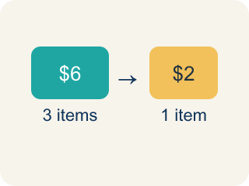
Rate (Tasa) — A ratio comparing two amounts with different units, like miles per hour.

Unit rate (Tasa unitaria) — A rate for just 1 of something, like cost for 1 item.

Per (Por) — For each one. Example: 5 dollars per book.
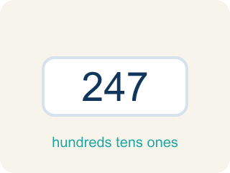
Problem solving (Resolución de problemas) — Using ratios and rates to find a missing amount.
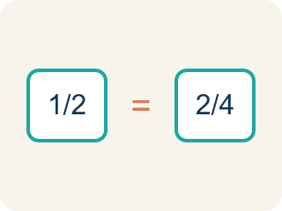
Proportion (Proporción) — A math sentence saying two ratios are equal. It helps find a missing number.
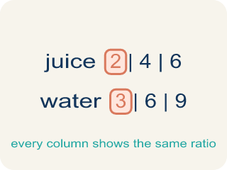
Ratio table (Tabla de razones) — A table of equal ratios that shows a pattern.

Practice
Show your work. Use the blank space under each problem.
1. A bakery makes 24 cookies in 3 batches. What is the unit rate of cookies per batch?
A. 8 cookies per batch
B. 3 cookies per batch
C. 24 cookies per batch
D. 6 cookies per batch
______________________________________________________________________
2. Apples cost $5 for 4 pounds. What is the cost per pound?
A. $1.25
B. $0.80
C. $1.50
D. $4.00
______________________________________________________________________
3. Spot the Smoothie Mistake
Step 1 (Read the problem): A smoothie stand makes 18 smoothies in 6 minutes. How many smoothies can it make in 10 minutes at the same rate?
Step 2 (Find the unit rate): 6 minutes ÷ 18 smoothies = 0.33 minute per smoothie
Step 3 (Find smoothies in 10 minutes): 0.33 × 10 = about 3.3 smoothies
Step 4 (Answer): About 3 smoothies in 10 minutes
Which step has the mistake? Explain and fix it:
______________________________________________________________________
______________________________________________________________________
______________________________________________________________________
4. In the kitchen, 3 pizzas feed exactly 12 people. At the same rate, how many pizzas are needed to feed 20 people?
A. 5 pizzas
B. 4 pizzas
C. 6 pizzas
D. 8 pizzas
______________________________________________________________________
5. A line cook chops 8 carrots in 2 minutes. Working at the same steady rate, how many carrots can the cook chop in 7 minutes?
A. 28 carrots
B. 24 carrots
C. 32 carrots
D. 16 carrots
______________________________________________________________________
6. Level 2 Extension — Mixed review: A recipe uses 18 ounces of flour to make 3 loaves of bread. How many ounces of flour are needed to make 7 loaves at the same rate?
A. 42 ounces
B. 36 ounces
C. 48 ounces
D. 21 ounces
______________________________________________________________________
7. Level 2 Extension — Catch the Recipe Mistake
Step 1 (Read the problem): 9 cups of batter fill 12 muffin cups. How many cups of batter are needed for 16 muffin cups?
Step 2 (Set up the unit rate): 12 muffins ÷ 9 cups = about 1.33 muffins per cup
Step 3 (Multiply for 16 muffins): 1.33 × 16 = about 21.3 cups
Step 4 (Answer): About 21.3 cups of batter are needed
Which step has the mistake? Explain and fix it:
______________________________________________________________________
______________________________________________________________________
______________________________________________________________________
8. Find Mia's Mistake
Step 1 (Read the problem): A store sells 6 oranges for $4.50. What is the cost of 10 oranges?
Step 2 (Find the unit rate): $4.50 ÷ 6 = $0.75 per orange
Step 3 (Multiply for 10 oranges): $0.75 + 10 = $10.75
Step 4 (Answer): 10 oranges cost $10.75
Which step has the mistake? Explain and fix it:
______________________________________________________________________
______________________________________________________________________
______________________________________________________________________

Answer Key (Teacher)
1. A. 8 cookies per batch
Unit rate: 24 cookies ÷ 3 batches = 8 cookies per batch.
Watch for: A common mistake in Ratio and Rate Problem Solving is dividing in the wrong order when setting up the unit rate — for example, finding "minutes per smoothie" (6 ÷ 18) instead of "smoothies per minute" (18 ÷ 6) — or using addition instead of multiplication to scale the unit rate, like adding $0.75 + 10 instead of multiplying $0.75 × 10. Before you submit, check: does your unit rate match the units the question is asking for, and did you multiply (not add) to scale it to the new amount?
2. A. $1.25
Unit rate: $5 ÷ 4 pounds = $1.25 per pound.
Watch for: A common mistake in Ratio and Rate Problem Solving is dividing in the wrong order when setting up the unit rate — for example, finding "minutes per smoothie" (6 ÷ 18) instead of "smoothies per minute" (18 ÷ 6) — or using addition instead of multiplication to scale the unit rate, like adding $0.75 + 10 instead of multiplying $0.75 × 10. Before you submit, check: does your unit rate match the units the question is asking for, and did you multiply (not add) to scale it to the new amount?
3. Spot the Smoothie Mistake
The mistake is in Step 2.
Correct work: The unit rate was divided in the wrong order. The question asks for smoothies, so find smoothies per minute: 18 smoothies ÷ 6 minutes = 3 smoothies per minute. Then 3 × 10 = 30 smoothies in 10 minutes.
Watch for: The unit rate step divides 6 minutes by 18 smoothies, which answers 'how long per smoothie' when the question asks how many smoothies. Put the quantity you want on top: 18 ÷ 6 = 3 smoothies per minute, so 3 × 10 = 30 smoothies in 10 minutes.
4. A. 5 pizzas
First find the unit rate: 12 people ÷ 3 pizzas = 4 people per pizza. Then 20 people ÷ 4 people per pizza = 5 pizzas.
Watch for: A common mistake in Ratio and Rate Problem Solving is dividing in the wrong order when setting up the unit rate — for example, finding "minutes per smoothie" (6 ÷ 18) instead of "smoothies per minute" (18 ÷ 6) — or using addition instead of multiplication to scale the unit rate, like adding $0.75 + 10 instead of multiplying $0.75 × 10. Before you submit, check: does your unit rate match the units the question is asking for, and did you multiply (not add) to scale it to the new amount?
5. A. 28 carrots
Unit rate: 8 carrots ÷ 2 minutes = 4 carrots per minute. In 7 minutes: 4 × 7 = 28 carrots.
Watch for: A common mistake in Ratio and Rate Problem Solving is dividing in the wrong order when setting up the unit rate — for example, finding "minutes per smoothie" (6 ÷ 18) instead of "smoothies per minute" (18 ÷ 6) — or using addition instead of multiplication to scale the unit rate, like adding $0.75 + 10 instead of multiplying $0.75 × 10. Before you submit, check: does your unit rate match the units the question is asking for, and did you multiply (not add) to scale it to the new amount?
6. A. 42 ounces
Unit rate: 18 ounces ÷ 3 loaves = 6 ounces per loaf. For 7 loaves: 6 × 7 = 42 ounces. The equivalent ratio 18/3 = 42/7 confirms it.
Watch for: A common mistake in Ratio and Rate Problem Solving is dividing in the wrong order when setting up the unit rate — for example, finding "minutes per smoothie" (6 ÷ 18) instead of "smoothies per minute" (18 ÷ 6) — or using addition instead of multiplication to scale the unit rate, like adding $0.75 + 10 instead of multiplying $0.75 × 10. Before you submit, check: does your unit rate match the units the question is asking for, and did you multiply (not add) to scale it to the new amount?
7. Level 2 Extension — Catch the Recipe Mistake
The mistake is in Step 2.
Correct work: The unit rate was set up in the wrong order. Divide cups by muffins: 9 cups ÷ 12 muffins = 0.75 cup per muffin. Then 0.75 × 16 = 12 cups of batter.
Watch for: The unit rate step divides 12 muffins by 9 cups, giving muffins per cup when the question asks for cups of batter. Flip the division: 9 ÷ 12 = 0.75 cup per muffin, so 16 muffin cups need 0.75 × 16 = 12 cups of batter — less than the 21.3 the student reported, which should have looked too large.
8. Find Mia's Mistake
The mistake is in Step 3.
Correct work: $0.75 × 10 = $7.50 (multiply the unit rate, don't add)
Watch for: Mia's unit rate $4.50 ÷ 6 = $0.75 per orange is correct, but she then wrote $0.75 + 10 instead of multiplying. Ten oranges at $0.75 each cost $0.75 × 10 = $7.50.

