3.7 Small Group · Group 2 — Homework
Lesson 3-7-group2 • Standard 6.AT.3
Name: ______________________ Period: ______ Date: ____________

Today's Goals
Content: I can solve real-world rate problems by finding and using unit rates, explain why the method works, and use it on a problem I have not seen before.
Language: I can justify my answer to a skeptic and connect it to a second strategy or representation.

Key Words

Ratio and Rate Problem Solving (Resolución de problemas de razones y tasas) — Use ratios and rates to compare quantities and solve real-world problems.
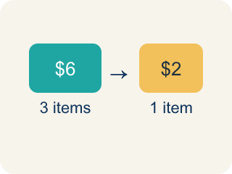
Rate (Tasa) — A ratio comparing two amounts with different units, like miles per hour.

Unit rate (Tasa unitaria) — A rate for just 1 of something, like cost for 1 item.

Per (Por) — For each one. Example: 5 dollars per book.
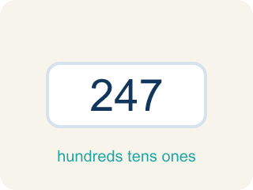
Problem solving (Resolución de problemas) — Using ratios and rates to find a missing amount.
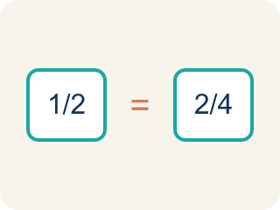
Proportion (Proporción) — A math sentence saying two ratios are equal. It helps find a missing number.
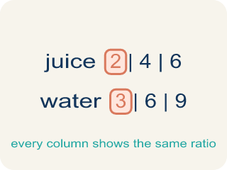
Ratio table (Tabla de razones) — A table of equal ratios that shows a pattern.

Practice
Show your work. Use the blank space under each problem.
1. A car travels 150 miles in 3 hours. A bus travels 200 miles in 5 hours. Which vehicle is faster?
A. The car
B. The bus
C. Same speed
D. Cannot determine
______________________________________________________________________
2. Spot the Smoothie Mistake
Step 1 (Read the problem): A smoothie stand makes 18 smoothies in 6 minutes. How many smoothies can it make in 10 minutes at the same rate?
Step 2 (Find the unit rate): 6 minutes ÷ 18 smoothies = 0.33 minute per smoothie
Step 3 (Find smoothies in 10 minutes): 0.33 × 10 = about 3.3 smoothies
Step 4 (Answer): About 3 smoothies in 10 minutes
Which step has the mistake? Explain and fix it:
______________________________________________________________________
______________________________________________________________________
______________________________________________________________________
3. Find Mia's Mistake
Step 1 (Read the problem): A store sells 6 oranges for $4.50. What is the cost of 10 oranges?
Step 2 (Find the unit rate): $4.50 ÷ 6 = $0.75 per orange
Step 3 (Multiply for 10 oranges): $0.75 + 10 = $10.75
Step 4 (Answer): 10 oranges cost $10.75
Which step has the mistake? Explain and fix it:
______________________________________________________________________
______________________________________________________________________
______________________________________________________________________
4.
______________________________________________________________________
______________________________________________________________________
______________________________________________________________________
______________________________________________________________________

Answer Key (Teacher)
1. A. The car
Car: 150÷3 = 50 mph. Bus: 200÷5 = 40 mph. The car travels faster at 50 mph vs. 40 mph.
Watch for: A common mistake in Ratio and Rate Problem Solving is dividing in the wrong order when setting up the unit rate — for example, finding "minutes per smoothie" (6 ÷ 18) instead of "smoothies per minute" (18 ÷ 6) — or using addition instead of multiplication to scale the unit rate, like adding $0.75 + 10 instead of multiplying $0.75 × 10. Before you submit, check: does your unit rate match the units the question is asking for, and did you multiply (not add) to scale it to the new amount?
2. Spot the Smoothie Mistake
The mistake is in Step 2.
Correct work: The unit rate was divided in the wrong order. The question asks for smoothies, so find smoothies per minute: 18 smoothies ÷ 6 minutes = 3 smoothies per minute. Then 3 × 10 = 30 smoothies in 10 minutes.
Watch for: The unit rate step divides 6 minutes by 18 smoothies, which answers 'how long per smoothie' when the question asks how many smoothies. Put the quantity you want on top: 18 ÷ 6 = 3 smoothies per minute, so 3 × 10 = 30 smoothies in 10 minutes.
3. Find Mia's Mistake
The mistake is in Step 3.
Correct work: $0.75 × 10 = $7.50 (multiply the unit rate, don't add)
Watch for: Mia's unit rate $4.50 ÷ 6 = $0.75 per orange is correct, but she then wrote $0.75 + 10 instead of multiplying. Ten oranges at $0.75 each cost $0.75 × 10 = $7.50.
4. Open response — answers will vary.
Sample: Factory A: 240 ÷ 8 = 30 widgets/hour. Factory B: 200 ÷ 5 = 40 widgets/hour. Factory B is faster. Together: (30 + 40) × 10 = 70 × 10 = 700 widgets in 10 hours.
Look for key words: 30, 40, Factory B, faster, 700, together.

