4.4–4.7 Catch-Up — Homework
Lesson 3-8-catchup • Standard 6.AT.2
Name: ______________________ Period: ______ Date: ____________

Today's Goals
Content: I can show I am caught up on Lessons 4.4–4.7 by using each lesson's big idea in mixed practice.
Language: I can explain which lesson's big idea I used and how, using key vocabulary from Lessons 4.4–4.7.

Key Words
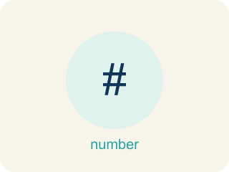
Percent of a Number (Porcentaje de un número) — A part of a number found by multiplying the number by the percent written as a decimal.
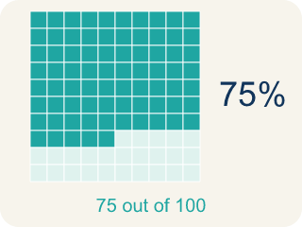
Percent (Porcentaje) — A way to compare a number to 100, shown with the % sign.

Percent Problem Solving (Resolución de problemas con porcentajes) — Use a percent to find a part, a whole, or a percent change in a real situation.
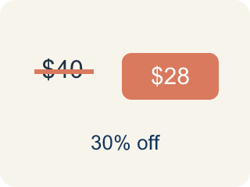
Discount (Descuento) — Money taken off the first price to make it cheaper.
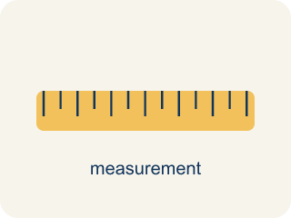
Convert Measurement Units (Convertir unidades de medida) — Rename a measurement in a different unit without changing its amount.
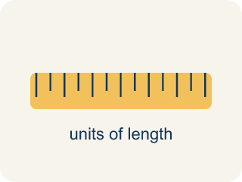
Conversion Factor (Factor de conversión) — A ratio that helps you change one unit into another.

Unit Rate Problem Solving (Resolución de problemas con tasas unitarias) — Find an amount per 1 unit and use it to compare choices or solve a problem.
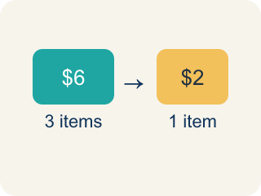
Unit Rate (Tasa unitaria) — A rate for just 1 of something, like cost for 1 item.
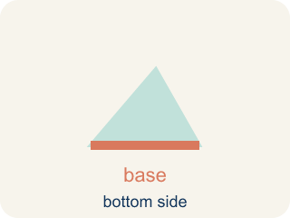
Base (Base) — The number you take the percent OF — it is the number right after the word 'of'.
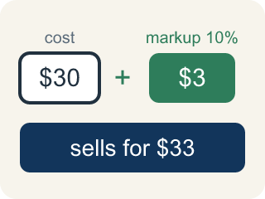
Markup (Recargo (margen)) — Money added to the cost to set the selling price.

Unit (Unidad) — A standard amount used to measure, like an inch or a liter.

Better Buy (Mejor compra) — The choice that costs less for each item.

Practice
Show your work. Use the blank space under each problem.
1. (Lesson 4.4) What is 20% of 150?
A. 30
B. 20
C. 35
D. 75
______________________________________________________________________
2. (Lesson 4.4) What is 50% of 84?
A. 42
B. 50
C. 34
D. 168
______________________________________________________________________
3. (Lesson 4.4) An arcade prize costs 240 tickets. If you have a coupon for 15% off, how many tickets do you save?
A. 36 tickets
B. 24 tickets
C. 15 tickets
D. 204 tickets
______________________________________________________________________
4. (Lesson 4.4) A student scored 72 out of 90 on a test. What percent did they score?
A. 80%
B. 72%
C. 75%
D. 90%
______________________________________________________________________
5. (Lesson 4.5) A store marks up a $30 item by 40%, then a customer gets 10% off. What is the final price?
A. $37.80
B. $39.00
C. $42.00
D. $36.00
______________________________________________________________________
6. (Lesson 4.5) A restaurant bill is $35. You want to leave a 20% tip. What is the total amount you pay?
A. $42.00
B. $40.00
C. $38.50
D. $55.00
______________________________________________________________________
7. (Lesson 4.6) A shelf is 30 inches long. How many feet and inches is that?
A. 2 feet 6 inches
B. 3 feet 0 inches
C. 2 feet 8 inches
D. 1 foot 18 inches
______________________________________________________________________
8. (Lesson 4.6) Spot the Common Mistake
Step 1 (Convert 80 ounces of bolts to pounds): 80 ounces → pounds
Step 2 (Use the conversion factor): 1 pound = 16 ounces
Step 3 (Operate): 80 × 16 = 1,280 pounds
Step 4 (Final answer): 80 ounces = 1,280 pounds
Which step has the mistake? Explain and fix it:
______________________________________________________________________
______________________________________________________________________
______________________________________________________________________
9. (Lesson 4.7) A machine dispenses 24 tokens in 3 minutes. At this rate, how many tokens does it dispense in 10 minutes?
A. 80 tokens
B. 60 tokens
C. 72 tokens
D. 240 tokens
______________________________________________________________________
10. (Lesson 4.7) A factory produces 360 widgets in 8 hours. At the same rate, how many widgets are produced in a 12-hour shift?
A. 540 widgets
B. 480 widgets
C. 360 widgets
D. 720 widgets
______________________________________________________________________

Answer Key (Teacher)
1. A. 30
20% = 0.20. Multiply: 0.20 × 150 = 30.
Watch for: A common mistake in Solve Problems with Unit Rates is comparing the total prices instead of the cost per item — the deal with the smaller total can still cost more per unit. Always reduce each option to its unit rate before you decide, then pick the lower one.
2. A. 42
50% = 0.50. Multiply: 0.50 × 84 = 42. (Or simply divide by 2: 84 ÷ 2 = 42.)
Watch for: A common mistake in Solve Problems with Unit Rates is comparing the total prices instead of the cost per item — the deal with the smaller total can still cost more per unit. Always reduce each option to its unit rate before you decide, then pick the lower one.
3. A. 36 tickets
15% of 240 = 0.15 × 240 = 36 tickets saved.
Watch for: A common mistake in Solve Problems with Unit Rates is comparing the total prices instead of the cost per item — the deal with the smaller total can still cost more per unit. Always reduce each option to its unit rate before you decide, then pick the lower one.
4. A. 80%
72/90 simplifies to 8/10, and 10 × 10 = 100, so 8 × 10 = 80. That makes 72/90 = 80/100 = 80%.
Watch for: A common mistake in Solve Problems with Unit Rates is comparing the total prices instead of the cost per item — the deal with the smaller total can still cost more per unit. Always reduce each option to its unit rate before you decide, then pick the lower one.
5. A. $37.80
Markup: $30 × 1.40 = $42. Discount: $42 × 0.10 = $4.20. Final: $42 − $4.20 = $37.80.
Watch for: A common mistake in Solve Problems with Unit Rates is comparing the total prices instead of the cost per item — the deal with the smaller total can still cost more per unit. Always reduce each option to its unit rate before you decide, then pick the lower one.
6. A. $42.00
Tip: 0.20 × $35 = $7.00. Total: $35 + $7 = $42.00.
Watch for: A common mistake in Solve Problems with Unit Rates is comparing the total prices instead of the cost per item — the deal with the smaller total can still cost more per unit. Always reduce each option to its unit rate before you decide, then pick the lower one.
7. A. 2 feet 6 inches
30 ÷ 12 = 2 remainder 6. So 30 inches = 2 feet 6 inches.
Watch for: A common mistake in Solve Problems with Unit Rates is comparing the total prices instead of the cost per item — the deal with the smaller total can still cost more per unit. Always reduce each option to its unit rate before you decide, then pick the lower one.
8. (Lesson 4.6) Spot the Common Mistake
The mistake is in Step 3.
Correct work: Ounces are smaller than pounds, so you divide (not multiply): 80 ÷ 16 = 5 pounds. Changing to a bigger unit gives a smaller number.
Watch for: The Operate step multiplied when it should have divided. Pounds are bigger than ounces, so the 80 ounces bundle into 80 ÷ 16 = 5 pounds. An answer of 1,280 pounds should stand out immediately — a container of bolts that weighs 80 ounces is only about 5 pounds.
9. A. 80 tokens
Unit rate: 24 ÷ 3 = 8 tokens per minute. In 10 minutes: 8 × 10 = 80 tokens.
Watch for: A common mistake in Solve Problems with Unit Rates is comparing the total prices instead of the cost per item — the deal with the smaller total can still cost more per unit. Always reduce each option to its unit rate before you decide, then pick the lower one.
10. A. 540 widgets
Unit rate: 360 ÷ 8 = 45 widgets per hour. In 12 hours: 45 × 12 = 540 widgets.
Watch for: A common mistake in Solve Problems with Unit Rates is comparing the total prices instead of the cost per item — the deal with the smaller total can still cost more per unit. Always reduce each option to its unit rate before you decide, then pick the lower one.

