3.8 Small Group · Group 1 — Homework
Lesson 3-8-group1 • Standard 6.AT.2
Name: ______________________ Period: ______ Date: ____________

Today's Goals
Content: With my small group, I can solve real-world problems by using unit rates to compare options — one step at a time, with support.
Language: I can talk through each step out loud using a sentence frame and the lesson's key words.

Key Words
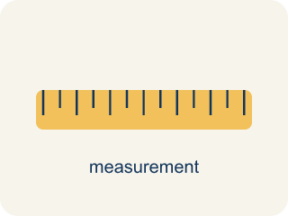
Unit Rate Problem Solving (Resolución de problemas con tasas unitarias) — Find an amount per 1 unit and use it to compare choices or solve a problem.
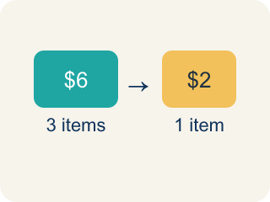
Unit Rate (Tasa unitaria) — A rate for just 1 of something, like cost for 1 item.

Better Buy (Mejor compra) — The choice that costs less for each item.
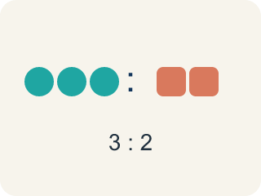
Comparison (Comparación) — Looking at two or more amounts to see how they are related.

Per Unit (Por unidad) — For each single item.

Rate (Tasa) — A ratio comparing two amounts with different units, like miles per hour.
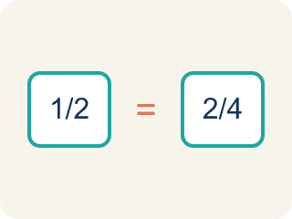
Proportion (Proporción) — A math sentence saying two ratios are equal. It helps find a missing number.

Practice
Show your work. Use the blank space under each problem.
1. Which is the better buy: 6 bouncy balls for $4.50 or 10 bouncy balls for $8.00?
A. 6 for $4.50 — $0.75 each
B. 10 for $8.00 — $0.80 each
C. They cost the same per ball
D. Not enough information
______________________________________________________________________
2. A faucet drips 15 ounces of water in 5 minutes. What is the unit rate?
A. 3 ounces per minute
B. 5 ounces per minute
C. 15 ounces per minute
D. 0.33 ounces per minute
______________________________________________________________________
3. A factory produces 360 widgets in 8 hours. At the same rate, how many widgets are produced in a 12-hour shift?
A. 540 widgets
B. 480 widgets
C. 360 widgets
D. 720 widgets
______________________________________________________________________
4. The snack bar compares two popcorn deals: 12 oz for $3.00 or 20 oz for $4.00. Which is the better buy?
A. 20 oz for $4.00 — $0.20 per oz
B. 12 oz for $3.00 — $0.25 per oz
C. They cost the same per ounce
D. Not enough information
______________________________________________________________________
5. The delivery van brings arcade supplies 150 miles in 3 hours. What is the unit rate in miles per hour?
A. 50 miles per hour
B. 45 miles per hour
C. 153 miles per hour
D. 30 miles per hour
______________________________________________________________________
6. The ticket counter sells redemption tickets two ways: 8 tickets for $2.00 or 15 tickets for $3.00. Which costs less per ticket?
A. 15 tickets for $3.00 — $0.20 each
B. 8 tickets for $2.00 — $0.25 each
C. They cost the same per ticket
D. Cannot determine
______________________________________________________________________
7. Level 2 Extension — Which Water Deal Wins?
Step 1 (Which is the better buy: 4 bottles for $5.00 or 6 bottles for $7.20?): Compare two water deals for the snack bar
Step 2 (Compare the deals): $5.00 is less than $7.20, so the 4-bottle deal is the better buy.
Step 3 (Conclusion): Buy the 4 bottles for $5.00.
Which step has the mistake? Explain and fix it:
______________________________________________________________________
______________________________________________________________________
______________________________________________________________________
8. Find the Unit Rate Error
Step 1 (Which is the better buy: 5 lb for $8.75 or 3 lb for $5.10?): Compare two deals
Step 2 (Find unit rate for Deal 1): 5 ÷ $8.75 = 0.57 lb per dollar
Step 3 (Find unit rate for Deal 2): 3 ÷ $5.10 = 0.59 lb per dollar
Step 4 (Compare): 0.59 > 0.57, so Deal 2 is the better buy
Which step has the mistake? Explain and fix it:
______________________________________________________________________
______________________________________________________________________
______________________________________________________________________

Answer Key (Teacher)
1. A. 6 for $4.50 — $0.75 each
$4.50 ÷ 6 = $0.75 each. $8.00 ÷ 10 = $0.80 each. $0.75 < $0.80, so 6 for $4.50 is the better buy.
Watch for: A common mistake in Solve Problems with Unit Rates is comparing the total prices instead of the cost per item — the deal with the smaller total can still cost more per unit. Always reduce each option to its unit rate before you decide, then pick the lower one.
2. A. 3 ounces per minute
15 ÷ 5 = 3 ounces per minute.
Watch for: A common mistake in Solve Problems with Unit Rates is comparing the total prices instead of the cost per item — the deal with the smaller total can still cost more per unit. Always reduce each option to its unit rate before you decide, then pick the lower one.
3. A. 540 widgets
Unit rate: 360 ÷ 8 = 45 widgets per hour. In 12 hours: 45 × 12 = 540 widgets.
Watch for: A common mistake in Solve Problems with Unit Rates is comparing the total prices instead of the cost per item — the deal with the smaller total can still cost more per unit. Always reduce each option to its unit rate before you decide, then pick the lower one.
4. A. 20 oz for $4.00 — $0.20 per oz
12 oz: $3.00 ÷ 12 = $0.25 per oz. 20 oz: $4.00 ÷ 20 = $0.20 per oz. $0.20 < $0.25, so 20 oz for $4.00 is the better buy.
Watch for: A common mistake in Solve Problems with Unit Rates is comparing the total prices instead of the cost per item — the deal with the smaller total can still cost more per unit. Always reduce each option to its unit rate before you decide, then pick the lower one.
5. A. 50 miles per hour
150 ÷ 3 = 50 miles per hour.
Watch for: A common mistake in Solve Problems with Unit Rates is comparing the total prices instead of the cost per item — the deal with the smaller total can still cost more per unit. Always reduce each option to its unit rate before you decide, then pick the lower one.
6. A. 15 tickets for $3.00 — $0.20 each
8 for $2.00: $2.00 ÷ 8 = $0.25 each. 15 for $3.00: $3.00 ÷ 15 = $0.20 each. $0.20 < $0.25, so 15 for $3.00 is cheaper per ticket.
Watch for: A common mistake in Solve Problems with Unit Rates is comparing the total prices instead of the cost per item — the deal with the smaller total can still cost more per unit. Always reduce each option to its unit rate before you decide, then pick the lower one.
7. Level 2 Extension — Which Water Deal Wins?
The mistake is in Step 2.
Correct work: You must compare the unit rate (cost per bottle), not the totals. 4 for $5.00: $5.00 ÷ 4 = $1.25 per bottle. 6 for $7.20: $7.20 ÷ 6 = $1.20 per bottle. $1.20 < $1.25, so the 6-bottle deal for $7.20 is actually the better buy.
Watch for: The comparison step looked only at the totals, but $5.00 buys 4 bottles while $7.20 buys 6. Per bottle it is $5.00 ÷ 4 = $1.25 against $7.20 ÷ 6 = $1.20, so the 6-bottle deal is the better buy.
8. Find the Unit Rate Error
The mistake is in Step 2.
Correct work: To find cost per pound, divide price by pounds: $8.75 ÷ 5 = $1.75 per lb, $5.10 ÷ 3 = $1.70 per lb. Deal 2 ($1.70/lb) is still the better buy — but the correct unit rates are dollars per pound, not pounds per dollar.
Watch for: The first unit-rate step divided pounds by dollars, which gives pounds per dollar instead of the cost per pound the question asks about. Dividing price by weight gives $8.75 ÷ 5 = $1.75 per pound and $5.10 ÷ 3 = $1.70 per pound, so Deal 2 is cheaper — the same choice, now backed by the rate that was actually requested.

