3.8 Small Group · Group 2 — Homework
Lesson 3-8-group2 • Standard 6.AT.2
Name: ______________________ Period: ______ Date: ____________

Today's Goals
Content: I can solve real-world problems by using unit rates to compare options, explain how I can tell, and judge a case I have not seen before.
Language: I can justify my answer to a skeptic and connect it to a second strategy or representation.

Key Words
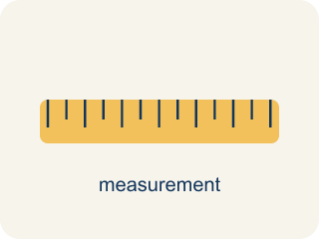
Unit Rate Problem Solving (Resolución de problemas con tasas unitarias) — Find an amount per 1 unit and use it to compare choices or solve a problem.
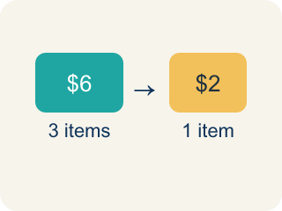
Unit Rate (Tasa unitaria) — A rate for just 1 of something, like cost for 1 item.

Better Buy (Mejor compra) — The choice that costs less for each item.
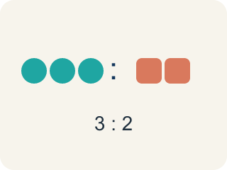
Comparison (Comparación) — Looking at two or more amounts to see how they are related.

Per Unit (Por unidad) — For each single item.

Rate (Tasa) — A ratio comparing two amounts with different units, like miles per hour.
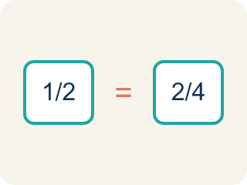
Proportion (Proporción) — A math sentence saying two ratios are equal. It helps find a missing number.

Practice
Show your work. Use the blank space under each problem.
1. A machine dispenses 24 tokens in 3 minutes. At this rate, how many tokens does it dispense in 10 minutes?
A. 80 tokens
B. 60 tokens
C. 72 tokens
D. 240 tokens
______________________________________________________________________
2. A factory produces 360 widgets in 8 hours. At the same rate, how many widgets are produced in a 12-hour shift?
A. 540 widgets
B. 480 widgets
C. 360 widgets
D. 720 widgets
______________________________________________________________________
3. Spot the Common Mistake
Step 1 (Read): A vending machine dispenses 24 tokens in 3 minutes. How many tokens per minute is that?
Step 2 (Attempt): A student writes: 3 ÷ 24 = 0.125, so the machine dispenses 0.125 tokens per minute.
Step 3 (Check): The student divided minutes by tokens, which gives minutes per token, not tokens per minute.
Which step has the mistake? Explain and fix it:
______________________________________________________________________
______________________________________________________________________
______________________________________________________________________
4. Find the Unit Rate Error
Step 1 (Which is the better buy: 5 lb for $8.75 or 3 lb for $5.10?): Compare two deals
Step 2 (Find unit rate for Deal 1): 5 ÷ $8.75 = 0.57 lb per dollar
Step 3 (Find unit rate for Deal 2): 3 ÷ $5.10 = 0.59 lb per dollar
Step 4 (Compare): 0.59 > 0.57, so Deal 2 is the better buy
Which step has the mistake? Explain and fix it:
______________________________________________________________________
______________________________________________________________________
______________________________________________________________________

Answer Key (Teacher)
1. A. 80 tokens
Unit rate: 24 ÷ 3 = 8 tokens per minute. In 10 minutes: 8 × 10 = 80 tokens.
Watch for: A common mistake in Solve Problems with Unit Rates is comparing the total prices instead of the cost per item — the deal with the smaller total can still cost more per unit. Always reduce each option to its unit rate before you decide, then pick the lower one.
2. A. 540 widgets
Unit rate: 360 ÷ 8 = 45 widgets per hour. In 12 hours: 45 × 12 = 540 widgets.
Watch for: A common mistake in Solve Problems with Unit Rates is comparing the total prices instead of the cost per item — the deal with the smaller total can still cost more per unit. Always reduce each option to its unit rate before you decide, then pick the lower one.
3. Spot the Common Mistake
The mistake is in Step 2.
Correct work: For tokens per minute, divide the tokens by the minutes: 24 ÷ 3 = 8 tokens per minute. The student divided in the wrong order, so they got the rate upside down.
Watch for: The attempt divided minutes by tokens, which answers a different question — how many minutes each token takes. The phrase "tokens per minute" puts tokens first, so the division is 24 ÷ 3 = 8 tokens per minute.
4. Find the Unit Rate Error
The mistake is in Step 2.
Correct work: To find cost per pound, divide price by pounds: $8.75 ÷ 5 = $1.75 per lb, $5.10 ÷ 3 = $1.70 per lb. Deal 2 ($1.70/lb) is still the better buy — but the correct unit rates are dollars per pound, not pounds per dollar.
Watch for: The first unit-rate step divided pounds by dollars, which gives pounds per dollar instead of the cost per pound the question asks about. Dividing price by weight gives $8.75 ÷ 5 = $1.75 per pound and $5.10 ÷ 3 = $1.70 per pound, so Deal 2 is cheaper — the same choice, now backed by the rate that was actually requested.

