UNIT 3 · LESSON 8 STANDARD 6.AT.2

Solve Problems with Unit Rates
Student Notes Packet
Name: ______________________ Date: ____________ Period: ________

Today's Goals
Content: I can solve real-world problems by using unit rates to compare options.
Language: I can explain my comparison using the words unit rate, better buy, per unit, and rate.

Key Vocabulary
Look at the picture, read the word, then read what it means.
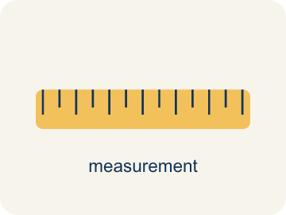 | Unit Rate Problem Solving Resolución de problemas con tasas unitarias  Find an amount per 1 unit and use it to compare choices or solve a problem.  Example: $12 for 4 items = $3 per item.
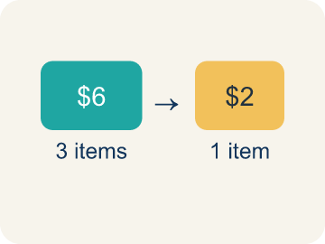 | Unit Rate Tasa unitaria  A rate for just 1 of something, like cost for 1 item.  Example: $2.50 per pound means $2.50 for every 1 pound
 | Better Buy Mejor compra  The choice that costs less for each item.  Example: $0.10 each vs $0.15 each — the $0.10 option is the better buy
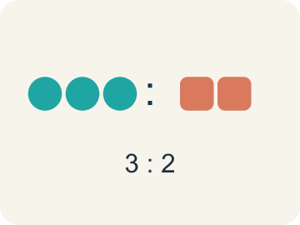 | Comparison Comparación  Looking at two or more amounts to see how they are related.  Example: $3 per game < $4 per game
 | Per Unit Por unidad  For each single item.  Example: $0.50 per token means each token costs $0.50
 | Rate Tasa  A ratio comparing two amounts with different units, like miles per hour.  Example: 120 miles in 3 hours is a rate (miles and hours are different units)
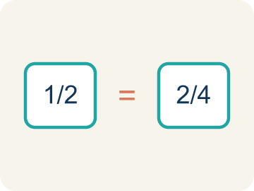 | Proportion Proporción  A math sentence saying two ratios are equal. It helps find a missing number.  Example: 5/3 = x/12 → x = 20

Guided Notes
Fill in each blank as we go. Use the Word Bank to help you.
WORD BANK
Unit Rate Problem Solving • Unit Rate • Better Buy • Comparison • Per Unit • Rate • Proportion

1. __________ — Find an amount per 1 unit and use it to compare choices or solve a problem.
2. A rate that gives the amount for exactly one unit is a ___.
3. The option that costs less per item, found by comparing unit rates, is the ___.
4. Showing how two amounts relate to each other is a ___.
5. The cost or amount for a single item is the cost ___.
6. A ratio comparing two quantities with different units is a ___.
7. An equation stating that two ratios are equal is a ___.

Write About the Math
Use the support level you need. Every level answers the same math question.

1. Understand the Question explain
Which printer should the manager choose, and how long will it take to print all 600 tickets?
Your job: Answer the question. Use math evidence. Explain how the evidence proves your answer.
Responde la pregunta. Usa evidencia matemática. Explica cómo la evidencia demuestra tu respuesta.

2. Plan Your Math Words check at least two
☐ Unit Rate Problem Solving — Find an amount per 1 unit and use it to compare choices or solve a problem.
Resolución de problemas con tasas unitarias — Hallar una cantidad por 1 unidad y usarla para comparar opciones o resolver un problema.
☐ Unit Rate — A rate for just 1 of something, like cost for 1 item.
Tasa unitaria — Una tasa para solo 1 de algo, como el precio de 1 artículo.
☐ Better Buy — The choice that costs less for each item.
Mejor compra — La opción que cuesta menos por cada artículo.
☐ Comparison — Looking at two or more amounts to see how they are related.
Comparación — Mirar dos o más cantidades para ver cómo se relacionan.
☐ Per Unit — For each single item.
Por unidad — Por cada artículo.
Say it first: Say your idea to a partner or quietly to yourself before you write.
Printer A prints ___ tickets per minute. Printer B prints ___ tickets per minute. The manager should use Printer ___ because it is faster. It will take ___ minutes to print 600 tickets.
Di tu respuesta primero: Mi respuesta es ___ porque ___.

3. Build Your Explanation choose your support
This model shows the parts of an explanation. It does not answer your writing question.
Claim: Finding the cost per one token lets me compare deals fairly even when the package sizes differ.
Evidence: Students explain the packages have different quantities, so the per-unit cost (unit rate) is needed to compare deals fairly.
Reasoning: This evidence connects the definition of unit rate to the mathematical claim.

Start Most language support
Complete the frames. Use the word bank.
Completa las oraciones. Usa el banco de palabras.
Printer A prints ___ tickets per minute. Printer B prints ___ tickets per minute. The manager should use Printer ___ because it is faster. It will take ___ minutes to print 600 tickets.
My answer is ___.
Mi respuesta es ___.

Build Some language support
Write two connected sentences. Use because, so, or but.
Escribe dos oraciones conectadas. Usa porque, entonces o pero.
My claim is ___.
Mi afirmación es ___.
I know because ___.
Lo sé porque ___.
So ___.
Entonces ___.

Explain Light language support
Write a claim, give math evidence, and explain your reasoning.
Escribe una afirmación, da evidencia matemática y explica tu razonamiento.
My claim is ___.
Mi afirmación es ___.
My math evidence is ___.
Mi evidencia matemática es ___.
This proves ___ because ___.
Esto demuestra ___ porque ___.

4. Check Your Explanation five quick checks
☐ I answered the question.
Respondí la pregunta.
☐ I used math evidence: numbers, an equation, a model, or a comparison.
Usé evidencia matemática: números, una ecuación, un modelo o una comparación.
☐ I explained how the evidence proves my answer.
Expliqué cómo la evidencia demuestra mi respuesta.
☐ I used at least two math words.
Usé por lo menos dos palabras matemáticas.
☐ I reread complete sentences and punctuation.
Volví a leer mis oraciones completas y la puntuación.

Worked Example

Watch & Read I Do — follow along with your teacher
Arcade Builder Challenge
You're the new supply manager for the arcade! You need to order tokens, prizes, and snacks from different suppliers. Each supplier offers a different package deal. Your job is to find the unit rate for each deal and figure out which supplier gives you the best value for every item you need to order.

Think about:
• How can you compare deals when the quantities are different?
• What operation helps you find the cost for just one item?
• Does the biggest package always give the best unit rate?
• How can unit rates help you make smart spending decisions?

Solved Example I Do — watch each step
Problem: Which is the better buy: 6 bouncy balls for $4.50 or 10 bouncy balls for $8.00?
A) 6 for $4.50 — $0.75 each
B) 10 for $8.00 — $0.80 each
C) They cost the same per ball
D) Not enough information
Step 1: $4.50 ÷ 6 = $0.75 each.
Step 2: $8.00 ÷ 10 = $0.80 each.
Step 3: $0.75 < $0.80, so 6 for $4.50 is the better buy.
Answer: A. 6 for $4.50 — $0.75 each

Guided Practice

Solve Together We Do — work with your class
Problem: A faucet drips 15 ounces of water in 5 minutes. What is the unit rate?
A) 3 ounces per minute
B) 5 ounces per minute
C) 15 ounces per minute
D) 0.33 ounces per minute
Step 1:

Step 2:

Step 3:

Answer:

The arcade needs 600 prize tickets printed. Printer A prints 150 tickets in 5 minutes. Printer B prints 200 tickets in 8 minutes. The manager wants to use the faster printer.
Which printer should the manager choose, and how long will it take to print all 600 tickets?

Sentence frame: Printer A prints ___ tickets per minute. Printer B prints ___ tickets per minute. The manager should use Printer ___ because it is faster. It will take ___ minutes to print 600 tickets.

Turn & Talk discuss with a partner
1. [Launch] As supply manager you compare token deals like 500 for $60 and 350 for $38.50. You can't compare totals directly, so what does finding the cost 'per unit' let you do?
Start with: I can't compare the totals because ___.
No puedo comparar los totales porque ___.
Word bank: unit rate, per unit, comparison, rate
2. [Explore] How did the unit rate help you decide the better buy between the two token suppliers in your table?
Start with: The unit rate for ___ is $___ per token.
La tasa unitaria de ___ es $___ por ficha.
Word bank: unit rate, better buy, per unit, comparison, rate
3. [Connect] Printer A makes 150 tickets in 5 minutes and Printer B makes 200 in 8 minutes. The manager needs 600 tickets fast. How do unit rates decide the faster printer and the time needed?
Start with: Printer A prints ___ tickets per minute and Printer B prints ___.
La impresora A imprime ___ boletos por minuto y la B imprime ___.
Word bank: unit rate, rate, per unit, comparison, proportion
4. [Practice] During practice on Solve Problems with Unit Rates, what strategy did you use when a problem felt tricky?
Start with: The unit rate for ___ is $___ per token.
La tasa unitaria de ___ es $___ por ficha.
Word bank: Unit Rate, Better Buy, Comparison, Per Unit

Independent Practice

On Your Own You Do — show your work
Solve each problem. Show your thinking in the work box.

Level 1 Support extra scaffolding
1. A printer prints 42 pages in 6 minutes. How many pages does it print in 15 minutes at the same rate?
A) 105 pages
B) 90 pages
C) 70 pages
D) 120 pages

2. Store A sells 5 notebooks for $8. Store B sells 3 notebooks for $5.25. Which has the lower price per notebook?
A) Store A ($1.60 each)
B) Store B ($1.75 each)
C) Same price
D) Cannot determine

On Level grade-level practice
3. A machine dispenses 24 tokens in 3 minutes. At this rate, how many tokens does it dispense in 10 minutes?
A) 80 tokens
B) 60 tokens
C) 72 tokens
D) 240 tokens

4. A factory produces 360 widgets in 8 hours. At the same rate, how many widgets are produced in a 12-hour shift?
A) 540 widgets
B) 480 widgets
C) 360 widgets
D) 720 widgets

Exit Ticket
Answer on your own. This shows what you learned today.
★ A car travels 195 miles on 6 gallons of gas. What is the unit rate in miles per gallon?
A) 32.5 miles per gallon
B) 33 miles per gallon
C) 30 miles per gallon
D) 1,170 miles per gallon

