Solve Problems with Unit Rates — Homework
Lesson 3-8 • Standard 6.AT.2
Name: ______________________ Period: ______ Date: ____________

Today's Goals
Content: I can solve real-world problems by using unit rates to compare options.
Language: I can explain my comparison using the words unit rate, better buy, per unit, and rate.

Key Words
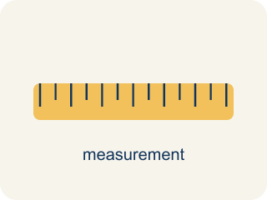
Unit Rate Problem Solving (Resolución de problemas con tasas unitarias) — Find an amount per 1 unit and use it to compare choices or solve a problem.
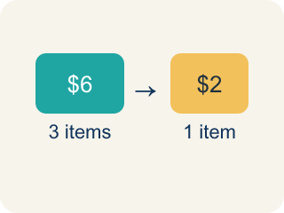
Unit Rate (Tasa unitaria) — A rate for just 1 of something, like cost for 1 item.

Better Buy (Mejor compra) — The choice that costs less for each item.
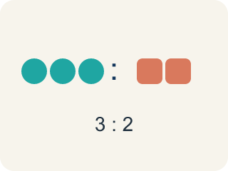
Comparison (Comparación) — Looking at two or more amounts to see how they are related.

Per Unit (Por unidad) — For each single item.

Rate (Tasa) — A ratio comparing two amounts with different units, like miles per hour.
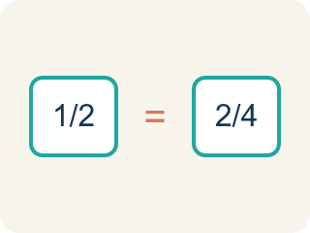
Proportion (Proporción) — A math sentence saying two ratios are equal. It helps find a missing number.

Practice
Show your work. Use the blank space under each problem.
1. Which is the better buy: 6 bouncy balls for $4.50 or 10 bouncy balls for $8.00?
A. 6 for $4.50 — $0.75 each
B. 10 for $8.00 — $0.80 each
C. They cost the same per ball
D. Not enough information
______________________________________________________________________
2. A faucet drips 15 ounces of water in 5 minutes. What is the unit rate?
A. 3 ounces per minute
B. 5 ounces per minute
C. 15 ounces per minute
D. 0.33 ounces per minute
______________________________________________________________________
3. Find the unit rate for each deal and identify the better buy.
Option | Deal | Unit Rate
Store A Batteries | 8 for $6.00
Store B Batteries | 12 for $8.40
Store A Candy | 15 for $6.75
Store B Candy | 20 for $8.00
______________________________________________________________________
4. A machine dispenses 24 tokens in 3 minutes. At this rate, how many tokens does it dispense in 10 minutes?
A. 80 tokens
B. 60 tokens
C. 72 tokens
D. 240 tokens
______________________________________________________________________
5. Three friends each walked different distances in different times. Sort them from fastest to slowest.
Groups: Fastest | Middle | Slowest
• Aiden: 6 miles in 2 hours (3 mph) → __________________
• Bella: 10 miles in 4 hours (2.5 mph) → __________________
• Carlos: 4 miles in 2 hours (2 mph) → __________________
______________________________________________________________________
6. A factory produces 360 widgets in 8 hours. At the same rate, how many widgets are produced in a 12-hour shift?
A. 540 widgets
B. 480 widgets
C. 360 widgets
D. 720 widgets
______________________________________________________________________
7. Spot the Common Mistake
Step 1 (Read): A vending machine dispenses 24 tokens in 3 minutes. How many tokens per minute is that?
Step 2 (Attempt): A student writes: 3 ÷ 24 = 0.125, so the machine dispenses 0.125 tokens per minute.
Step 3 (Check): The student divided minutes by tokens, which gives minutes per token, not tokens per minute.
Which step has the mistake? Explain and fix it:
______________________________________________________________________
______________________________________________________________________
______________________________________________________________________
8. The snack bar compares two popcorn deals: 12 oz for $3.00 or 20 oz for $4.00. Which is the better buy?
A. 20 oz for $4.00 — $0.20 per oz
B. 12 oz for $3.00 — $0.25 per oz
C. They cost the same per ounce
D. Not enough information
______________________________________________________________________
9. The delivery van brings arcade supplies 150 miles in 3 hours. What is the unit rate in miles per hour?
A. 50 miles per hour
B. 45 miles per hour
C. 153 miles per hour
D. 30 miles per hour
______________________________________________________________________
10. The ticket counter sells redemption tickets two ways: 8 tickets for $2.00 or 15 tickets for $3.00. Which costs less per ticket?
A. 15 tickets for $3.00 — $0.20 each
B. 8 tickets for $2.00 — $0.25 each
C. They cost the same per ticket
D. Cannot determine
______________________________________________________________________

Answer Key (Teacher)
1. A. 6 for $4.50 — $0.75 each
$4.50 ÷ 6 = $0.75 each. $8.00 ÷ 10 = $0.80 each. $0.75 < $0.80, so 6 for $4.50 is the better buy.
Watch for: A common mistake in Solve Problems with Unit Rates is comparing the total prices instead of the cost per item — the deal with the smaller total can still cost more per unit. Always reduce each option to its unit rate before you decide, then pick the lower one.
2. A. 3 ounces per minute
15 ÷ 5 = 3 ounces per minute.
Watch for: A common mistake in Solve Problems with Unit Rates is comparing the total prices instead of the cost per item — the deal with the smaller total can still cost more per unit. Always reduce each option to its unit rate before you decide, then pick the lower one.
3. Find the unit rate for each deal and identify the better buy.
Store A Batteries — Unit Rate: $0.75 each
Store B Batteries — Unit Rate: $0.70 each
Store A Candy — Unit Rate: $0.45 each
Store B Candy — Unit Rate: $0.40 each

4. A. 80 tokens
Unit rate: 24 ÷ 3 = 8 tokens per minute. In 10 minutes: 8 × 10 = 80 tokens.
Watch for: A common mistake in Solve Problems with Unit Rates is comparing the total prices instead of the cost per item — the deal with the smaller total can still cost more per unit. Always reduce each option to its unit rate before you decide, then pick the lower one.
5. Correct groups:
Aiden: 6 miles in 2 hours (3 mph) → Fastest
Bella: 10 miles in 4 hours (2.5 mph) → Middle
Carlos: 4 miles in 2 hours (2 mph) → Slowest

6. A. 540 widgets
Unit rate: 360 ÷ 8 = 45 widgets per hour. In 12 hours: 45 × 12 = 540 widgets.
Watch for: A common mistake in Solve Problems with Unit Rates is comparing the total prices instead of the cost per item — the deal with the smaller total can still cost more per unit. Always reduce each option to its unit rate before you decide, then pick the lower one.
7. Spot the Common Mistake
The mistake is in Step 2.
Correct work: For tokens per minute, divide the tokens by the minutes: 24 ÷ 3 = 8 tokens per minute. The student divided in the wrong order, so they got the rate upside down.
Watch for: The attempt divided minutes by tokens, which answers a different question — how many minutes each token takes. The phrase "tokens per minute" puts tokens first, so the division is 24 ÷ 3 = 8 tokens per minute.
8. A. 20 oz for $4.00 — $0.20 per oz
12 oz: $3.00 ÷ 12 = $0.25 per oz. 20 oz: $4.00 ÷ 20 = $0.20 per oz. $0.20 < $0.25, so 20 oz for $4.00 is the better buy.
Watch for: A common mistake in Solve Problems with Unit Rates is comparing the total prices instead of the cost per item — the deal with the smaller total can still cost more per unit. Always reduce each option to its unit rate before you decide, then pick the lower one.
9. A. 50 miles per hour
150 ÷ 3 = 50 miles per hour.
Watch for: A common mistake in Solve Problems with Unit Rates is comparing the total prices instead of the cost per item — the deal with the smaller total can still cost more per unit. Always reduce each option to its unit rate before you decide, then pick the lower one.
10. A. 15 tickets for $3.00 — $0.20 each
8 for $2.00: $2.00 ÷ 8 = $0.25 each. 15 for $3.00: $3.00 ÷ 15 = $0.20 each. $0.20 < $0.25, so 15 for $3.00 is cheaper per ticket.
Watch for: A common mistake in Solve Problems with Unit Rates is comparing the total prices instead of the cost per item — the deal with the smaller total can still cost more per unit. Always reduce each option to its unit rate before you decide, then pick the lower one.

