3.9 Small Group · Group 2 — Homework
Lesson 3-9-group2 • Standard 6.AT.3
Name: ______________________ Period: ______ Date: ____________

Today's Goals
Content: I can find and check equivalent ratios using multiplication and division, explain why the method works, and use it on a problem I have not seen before.
Language: I can justify my answer to a skeptic and connect it to a second strategy or representation.

Key Words
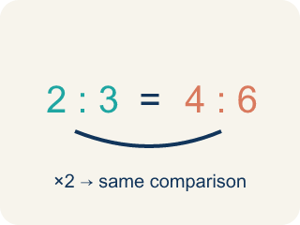
Equivalent Ratios (Razones equivalentes) — Ratios that compare quantities in the same relationship.
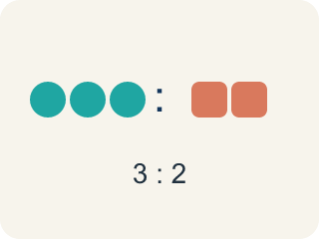
Ratio (Razón) — A way to compare two amounts, like 3 to 2.
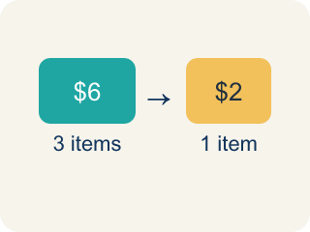
Rate (Tasa) — A ratio comparing two amounts with different units, like miles per hour.
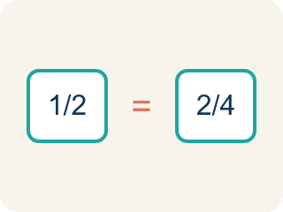
Proportion (Proporción) — A math sentence saying two ratios are equal.
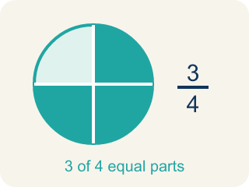
Simplify (Simplificar) — To make a ratio smaller while keeping the same comparison.
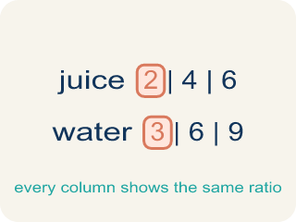
Ratio table (Tabla de razones) — A table of equal ratios that shows a pattern.

Practice
Show your work. Use the blank space under each problem.
1. Marcus earns $45 for every 3 hours of work. How much does he earn in 8 hours?
A. $120
B. $90
C. $135
D. $105
______________________________________________________________________
2. Spot the Common Mistake — Simplifying a Ratio
Step 1 (Set up the ratio): A student wants to write 12:18 in simplest form.
Step 2 (Find the common factor): Both 12 and 18 can be divided by 6.
Step 3 (Divide each part): 12 ÷ 6 = 2 and 18 ÷ 3 = 6, so they wrote 2:6.
Step 4 (Answer): 12:18 simplifies to 2:6
Which step has the mistake? Explain and fix it:
______________________________________________________________________
______________________________________________________________________
______________________________________________________________________
3. Find Marcus's Mistake
Step 1 (Set up the ratio): 3 cups : 5 cups = ? : 20 cups
Step 2 (Find the multiplier): 20 ÷ 5 = 4
Step 3 (Apply to both parts): 3 + 4 = 7
Step 4 (Answer): 7 cups : 20 cups
Which step has the mistake? Explain and fix it:
______________________________________________________________________
______________________________________________________________________
______________________________________________________________________
4.
______________________________________________________________________
______________________________________________________________________
______________________________________________________________________
______________________________________________________________________

Answer Key (Teacher)
1. A. $120
Unit rate: $45 ÷ 3 = $15/hour. In 8 hours: $15 × 8 = $120.
Watch for: A common mistake in Equivalent Ratios is ADDING the scale factor to one part instead of MULTIPLYING both parts by it. For example, scaling 2:5 by a factor of 4 should give 8:20 (2×4 and 5×4) — not 6:9 (2+4 and 5+4). Adding changes the taste of the recipe (and the value of the ratio); only multiplying or dividing both numbers by the same amount keeps it equivalent.
2. Spot the Common Mistake — Simplifying a Ratio
The mistake is in Step 3.
Correct work: Divide BOTH parts by the same number: 12 ÷ 6 = 2 and 18 ÷ 6 = 3, so 12:18 simplifies to 2:3.
Watch for: The "Divide each part" step uses two different divisors: 12 ÷ 6 but 18 ÷ 3. Simplifying only keeps a ratio equivalent when both parts are divided by the same number, so 12 ÷ 6 = 2 and 18 ÷ 6 = 3 give 2:3. The student's 2:6 simplifies to 1:3, which is not the same comparison as 12:18.
3. Find Marcus's Mistake
The mistake is in Step 3.
Correct work: 3 × 4 = 12 (multiply, don't add)
Watch for: In the "Apply to both parts" step Marcus adds the multiplier instead of multiplying by it. Since 5 became 20, the scale factor is × 4, so the first part must be 3 × 4 = 12, giving 12 cups : 20 cups. His 7:20 does not simplify to 3:5, which confirms the ratios are not equivalent.
4. Open response — answers will vary.
Sample: Yes, they are equivalent. Method 1 (simplify): 9:6 ÷ 3 = 3:2, which matches 3:2. Method 2 (cross-multiply): 3 × 6 = 18 and 2 × 9 = 18. Since both cross products are equal, the ratios are equivalent.
Look for key words: equivalent, simplify, 3:2, cross-multiply, 18, equal.

