UNIT 3 · LESSON 9 STANDARD 6.AT.3

Equivalent Ratios
Student Notes Packet
Name: ______________________ Date: ____________ Period: ________

Today's Goals
Content: I can find and check equivalent ratios using multiplication and division.
Language: I can explain my reasoning using the words equivalent ratios, rate, proportion, and simplify.

Key Vocabulary
Look at the picture, read the word, then read what it means.
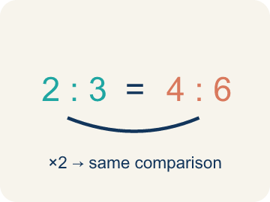 | Equivalent Ratios Razones equivalentes  Ratios that compare quantities in the same relationship.  Example: 2:3 = 4:6 because both parts were multiplied by 2.
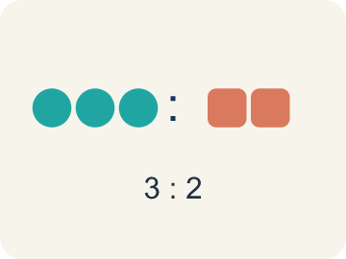 | Ratio Razón  A way to compare two amounts, like 3 to 2.  Example: 3 red apples : 5 green apples
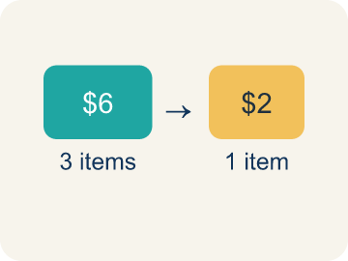 | Rate Tasa  A ratio comparing two amounts with different units, like miles per hour.  Example: 60 miles per 1 hour
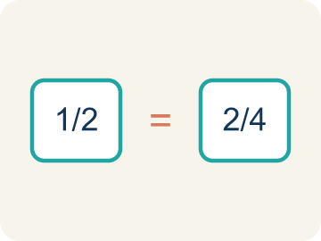 | Proportion Proporción  A math sentence saying two ratios are equal.  Example: 2/3 = 4/6
 | Simplify Simplificar  To make a ratio smaller while keeping the same comparison.  Example: 12:18 → divide both by 6 → 2:3
 | Ratio table Tabla de razones  A table of equal ratios that shows a pattern.  Example: Cups of juice: 2, 4, 6 | Cups of water: 3, 6, 9

Guided Notes
Fill in each blank as we go. Use the Word Bank to help you.
WORD BANK
Equivalent Ratios • Ratio • Rate • Proportion • Simplify • Ratio table

1. __________ — Ratios that compare quantities in the same relationship.
2. A comparison of two quantities is a ___.
3. A ratio that compares two quantities with different units, like miles per hour, is a ___.
4. An equation showing that two ratios are equal is a ___.
5. Writing a ratio in its smallest equal form, like 6:9 = 2:3, is to ___ it.
6. A table that lists equivalent ratios in rows or columns is a ___.

Write About the Math
Use the support level you need. Every level answers the same math question.

1. Understand the Question explain
A local smoothie shop sells a Berry Blast smoothie. The recipe calls for 2 cups of strawberries for every 3 cups of yogurt. Today they need to make 15 cups of yogurt worth of smoothies for a catering order?
Your job: Answer the question. Use math evidence. Explain how the evidence proves your answer.
Responde la pregunta. Usa evidencia matemática. Explica cómo la evidencia demuestra tu respuesta.

2. Plan Your Math Words check at least two
☐ Equivalent Ratios — Ratios that compare quantities in the same relationship.
Razones equivalentes — Razones que comparan cantidades en la misma relación.
☐ Ratio — A way to compare two amounts, like 3 to 2.
Razón — Una manera de comparar dos cantidades, como 3 a 2.
☐ Rate — A ratio comparing two amounts with different units, like miles per hour.
Tasa — Una razón que compara dos cantidades con unidades distintas, como millas por hora.
☐ Proportion — A math sentence saying two ratios are equal.
Proporción — Una oración matemática que dice que dos razones son iguales.
☐ Simplify — To make a ratio smaller while keeping the same comparison.
Simplificar — Hacer una razón más pequeña sin cambiar la comparación.
Say it first: Say your idea to a partner or quietly to yourself before you write.
Find the scale factor (15 ÷ 3) and use it to figure out how many cups of strawberries the shop needs. Show your steps and explain why multiplying both ingredients by the same factor keeps the smoothie tasting the same.
Di tu respuesta primero: Mi respuesta es ___ porque ___.

3. Build Your Explanation choose your support
This model shows the parts of an explanation. It does not answer your writing question.
Claim: 32 is 4 times 8, so she multiplies both ingredients by 4.
Evidence: A strong answer finds the scale factor 4 (32 ÷ 8) and explains both ingredients must be multiplied by 4 to make equivalent ratios.
Reasoning: This evidence connects the definition of equivalent ratios to the mathematical claim.

Start Most language support
Complete the frames. Use the word bank.
Completa las oraciones. Usa el banco de palabras.
Find the scale factor (15 ÷ 3) and use it to figure out how many cups of strawberries the shop needs. Show your steps and explain why multiplying both ingredients by the same factor keeps the smoothie tasting the same.
My answer is ___.
Mi respuesta es ___.

Build Some language support
Write two connected sentences. Use because, so, or but.
Escribe dos oraciones conectadas. Usa porque, entonces o pero.
My claim is ___.
Mi afirmación es ___.
I know because ___.
Lo sé porque ___.
So ___.
Entonces ___.

Explain Light language support
Write a claim, give math evidence, and explain your reasoning.
Escribe una afirmación, da evidencia matemática y explica tu razonamiento.
My claim is ___.
Mi afirmación es ___.
My math evidence is ___.
Mi evidencia matemática es ___.
This proves ___ because ___.
Esto demuestra ___ porque ___.

4. Check Your Explanation five quick checks
☐ I answered the question.
Respondí la pregunta.
☐ I used math evidence: numbers, an equation, a model, or a comparison.
Usé evidencia matemática: números, una ecuación, un modelo o una comparación.
☐ I explained how the evidence proves my answer.
Expliqué cómo la evidencia demuestra mi respuesta.
☐ I used at least two math words.
Usé por lo menos dos palabras matemáticas.
☐ I reread complete sentences and punctuation.
Volví a leer mis oraciones completas y la puntuación.

Worked Example

Watch & Read I Do — follow along with your teacher
Chef Montoya is preparing her famous tomato soup for a school banquet. Her original recipe serves 8 people, but tonight she needs to serve 32 guests. She needs your help to scale the recipe without changing the flavor!

Think about:
• What quantities are being compared in the recipe?
• What stays the same when you multiply both ingredients by the same number?
• How many times bigger is 32 than 8?
• What if we needed to scale DOWN for just 4 people?
• Could we use this same thinking with other recipes?

Solved Example I Do — watch each step
Problem: Which ratio is equivalent to 2:5?
A) 4:10
B) 3:6
C) 2:10
D) 5:2
Step 1: Multiply both parts by 2: 2×2 = 4 and 5×2 = 10, so 4:10 is equivalent to 2:5.
Answer: A. 4:10

Guided Practice

Solve Together We Do — work with your class
Problem: A recipe uses 4 eggs for every 6 cups of flour. Which ratio is equivalent?
A) 2:3
B) 8:10
C) 4:3
D) 6:4
Step 1:

Step 2:

Answer:

A local smoothie shop sells a Berry Blast smoothie. The recipe calls for 2 cups of strawberries for every 3 cups of yogurt. Today they need to make 15 cups of yogurt worth of smoothies for a catering order.

Sentence frame: Find the scale factor (15 ÷ 3) and use it to figure out how many cups of strawberries the shop needs. Show your steps and explain why multiplying both ingredients by the same factor keeps the smoothie tasting the same.

Turn & Talk discuss with a partner
1. [Launch] Chef Montoya's soup serves 8 people, but she needs to serve 32. How many times bigger is the recipe, and what must she do to BOTH ingredients to keep the flavor?
Start with: 32 is ___ times bigger than 8, so I multiply both by ___.
32 es ___ veces más grande que 8, así que multiplico ambos por ___.
Word bank: Equivalent ratios, Proportion, Rate
2. [Explore] Looking at the tomatoes-to-broth table (3:2, 6:4, 9:6, 12:8), how can you PROVE these ratios are all equivalent?
Start with: These ratios are equivalent because each is ___ times ___.
Estas razones son equivalentes porque cada una es ___ veces ___.
Word bank: Equivalent ratios, Simplify, Proportion, Rate
3. [Connect] The smoothie shop uses 2 cups of strawberries for every 3 cups of yogurt and needs 15 cups of yogurt. How is this the same as scaling Chef Montoya's soup?
Start with: This is like our ratio work because ___ and ___ are related by ___.
Esto es como nuestro trabajo con razones porque ___ y ___ se relacionan por ___.
Word bank: Equivalent ratios, Proportion, Simplify, Rate
4. [Practice] During practice on Equivalent Ratios, what strategy did you use when a problem felt tricky?
Start with: These ratios are equivalent because each is ___ times ___.
Estas razones son equivalentes porque cada una es ___ veces ___.
Word bank: Ratio, Equivalent ratios, Rate, Proportion

Independent Practice

On Your Own You Do — show your work
Solve each problem. Show your thinking in the work box.

Level 1 Support extra scaffolding
1. Which ratio is NOT equivalent to 6:9?
A) 3:5
B) 2:3
C) 12:18
D) 18:27

2. What is the simplest form of the ratio 15:25?
A) 3:5
B) 5:3
C) 1:5
D) 15:25

On Level grade-level practice
3. Marcus earns $45 for every 3 hours of work. How much does he earn in 8 hours?
A) $120
B) $90
C) $135
D) $105

Level 2 Enrichment stretch your thinking
4. A store sells 3 pens for $2. Another store sells 9 pens for $6. Are these equivalent ratios? If so, prove it using at least two different methods (simplifying, scaling, or cross-multiplying).

Exit Ticket
Answer on your own. This shows what you learned today.
★ A store sells 5 notebooks for $8. At this rate, how much would 15 notebooks cost?
A) $24
B) $18
C) $20
D) $40

